U.C. Master Gardeners
of Calaveras County
Second Saturdays in the Garden
August 8th 2026 Presentation
Fruit Tree Pruning
Summer and Winter
Summer pruning helps keep trees compact and productive, while winter pruning encourages new shoots to take off in spring.
Aspects of Summer Pruning:
- Maintain a manageable tree size. Used to slow down overly vigorous trees or trees that are too large. It is usually done just after harvest.
- Open up the canopy and interior to light and air circulation
- Remove vigorous upright shoots.
- Head cut and thin branches to control tree height
- May remove up to 30% of the foliage from the tops and sides of the tree without disturbing next year's shoot growth, flowering or fruit production.
Aspects of Winter Pruning:
- Maintain strong tree structure with well-placed scaffolding branches; remove dormant buds to invigorate the remaining buds
- Eliminate dead, broken, crossing, weak, or poorly spaced branches.
- Remove up to 50% of last year’s growth on the fast-growing fruit trees (peach, nectarine)
- Remove up to 20% of last year’s growth from fig, apple, pear and plum.
Types of Pruning Cuts:
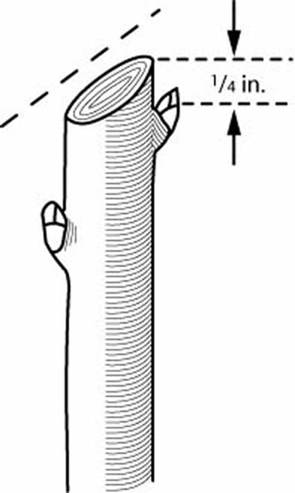
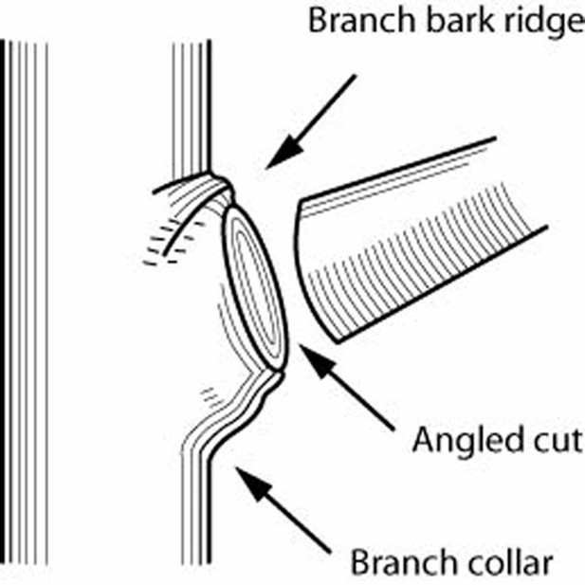
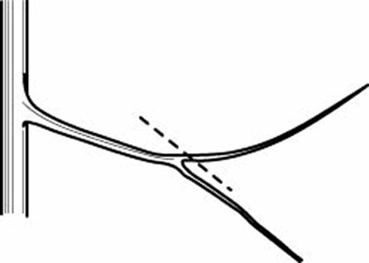
Recognizing and Preserving Fruiting Wood
Fruit Born On This Year’s Growth: Citrus, Figs (2nd crop in late summer/fall), Pomegranates, Quince Because these trees bear fruit on branches growing in spring, care should be taken with any spring pruning.
On One Year Old Wood: Almonds, Apricots, Nectarines, Olives, Peaches, Persimmons, Figs (1st crop in early summer)
On Two Year and Older Wood: Asian Pears (terminal spurs 6-8 yrs.), Apples & European Pears (terminal spurs, 8-10 yrs.), Cherries (lateral spurs 10-12 yrs.), Plums (lateral spurs 6-8 yrs.)
Thinning cuts are used to remove lateral branches at their origin or to shorten branch length by cutting to another lateral that is a minimum of 1/3 the width of the branch section being removed. Lateral cuts should be angled and done just outside of the branch bark ridge and branch collar. Cutting into the branch collar can damage the plant and cause decay.
Heading cuts are when a plant is cut back to a stub, lateral bud or small lateral branch. When heading back to a lateral bud or small lateral branch, the cut should be made at approximately a 45* angle away from the bud or branch and ¼ inch above it. Heading cuts may result in a flush of vigorous, upright growth.

Common Fruit Tree Pruning Shapes: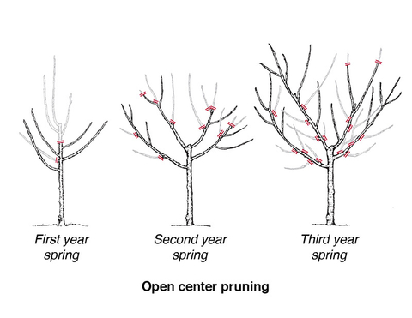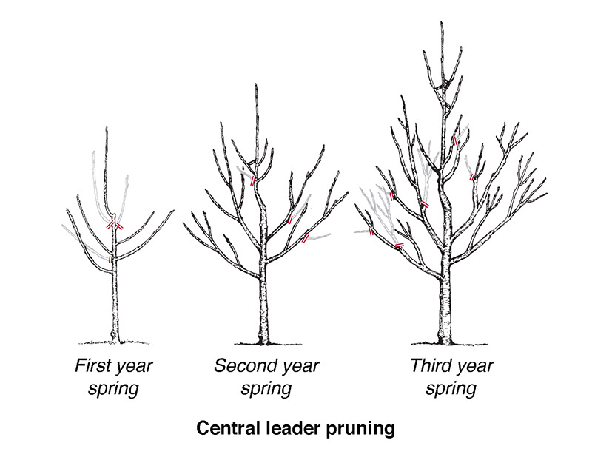
Keep tools sharp to provide clean smooth cuts. Use the right size cutters for the branch to be cut, so the bark left on the tree isn’t damaged below the cut site. If branch is large, use three cut method.
Sanitize tools especially if there is fire blight or other virus or bacterial disease present, or if it is an irreplaceable plant. Do NOT cut through cankers or oozing sores as it is very difficult to get tools fully sanitized again. Can spray or dip using Clorox Bleach (5.25%, max. dilution 1:5), Lysol (max. dilution 1:5), or full strength Pinesol. Note: Rubbing Alcohol and Hydrogen Peroxide were shown as not effective. Lysol was found to be the least damaging to tool metal.

Resources:
“FRUIT TREES: CARE AND MAINTENANCE ~ WINTER AND SUMMER PRUNING” a PowerPoint presentation by Charles Davis & Kim McCue, UC Master Gardeners, link: https://ucanr.edu/sites/default/files/2019-02/298636.pdf
“Pruning Fruit Trees”, a blog by Barbara Kissinger Santos from The Stanislaus Sprout, link: https://my.ucanr.edu/blogs/blogcore/postdetail.cfm?postnum=61420
“Summer pruning for fruit trees”, Article from UC Marin Master Gardeners, by James Campbell, August 9, 2025 Link: https://ucanr.edu/site/uc-marin-master-gardeners/article/summer-pruning-fruit-trees
“How Disinfectants Compare in Preventing Transmission of Fire Blight.” Teviotdale, B, M Wiley, and D Harper. 1991. California Agriculture: The Journal of UC Agriculture and Natural Resources 45 (4): 21–23. Link: https://californiaagriculture.org/article/110385-how-disinfectants-compare-in-preventing-transmission-of-fire-blight
“Sterilized Pruning Tools: Nuisance or Necessity?”, by Dr. Linda Chalker-Scott WSU Puyallup Research and Extension Center Link: https://s3.wp.wsu.edu/uploads/sites/403/2015/03/Pruning.pdf
“Growing stone fruits in the home garden”, by Emily E. Hoover, Emily S. Tepe and Doug Foulk, University of Minnesota Extension, Link: https://extension.umn.edu/gardening-minnesota/growing-stone-fruits-home-garden#open-center-pruning-1137111
The Home Orchard, Technical Editors Chuck A. Ingels, Pamela M. Geisel, and Maxwell V. Norton, UCANR Publication 3485 Link to purchase book: https://anrpublications.org/products/9781627112208_home-orchard
California Master Gardener Handbook, Second Edition, Technical editor Dennis Pittinger UCANR Publication 3382 Link to purchase book: https://anrpublications.org/products/9781601078575_california-master-gardener-handbook

Common Fruit Tree Pruning Shapes:
Keep tools sharp to provide clean smooth cuts. Use the right size cutters for the branch to be cut, so the bark left on the tree isn’t damaged below the cut site. If branch is large, use three cut method.
Sanitize tools especially if there is fire blight or other virus or bacterial disease present, or if it is an irreplaceable plant. Do NOT cut through cankers or oozing sores as it is very difficult to get tools fully sanitized again. Can spray or dip using Clorox Bleach (5.25%, max. dilution 1:5), Lysol (max. dilution 1:5), or full strength Pinesol. Note: Rubbing Alcohol and Hydrogen Peroxide were shown as not effective. Lysol was found to be the least damaging to tool metal.

