Fresno County Master GardenerCommunity Classes Fall 2026

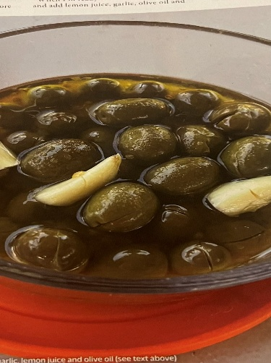
Olives, Olives, Olives
Fresno MGs Marie and Rosa
Learn to cure delicious olives in accordance to the Mediterranean tradition. MG Marie and advice from Master Food Preservers will explore three different curing methods, utilizing both salt curing and lye curing processes. Appropriate for all skill levels.

Saturday, September 5, 2026
9:30-11 AM
Garden of the Sun
1750 N Winery Ave Fresno, CA 93703

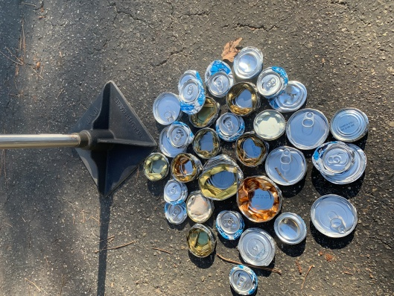
Composting/Worms/Recycling
Madera MG Randy
Master Gardener Randy will share the highlights of composting and keeping worms to make soil amendments, and demonstrate recycling practices that handle nearly all a household’s waste stream. Learn the how’s and why’s of diverting our waste stream in a practical way to handle food scraps, landscape trimmings and household foods and other containers.
Saturday, September 12. 2026
10 – 11:30 AM
Clovis Botanical Garden
945 N Clovis Ave Clovis, CA 93611

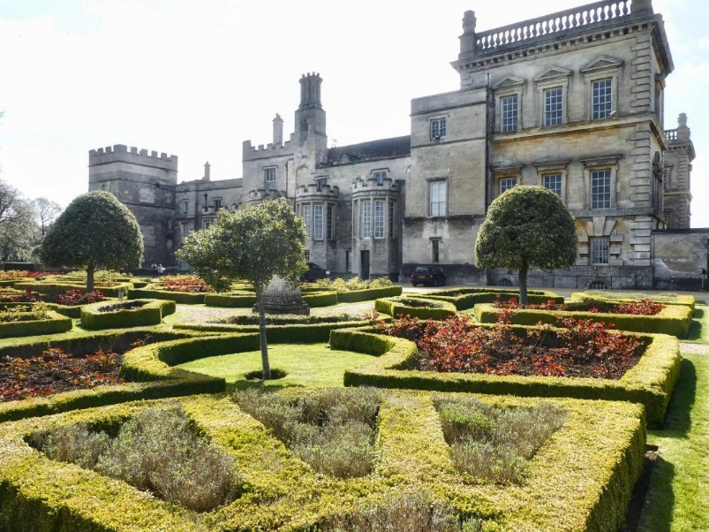
A Brief History of Gardening
Fresno MG Richard
This presentation goes from early farmers with their garden patches in the Neolithic Era, to the establishment of planting for sustenance, pleasure and prestige. From Asian farming to Roman approaches, we connect through time to common practices in California Gardens today, including indigenous Californians land management practices.
Saturday, September 26. 2026
10-11:30 AM
Woodward Park Library
944 E Perrin Ave Fresno, CA 93720

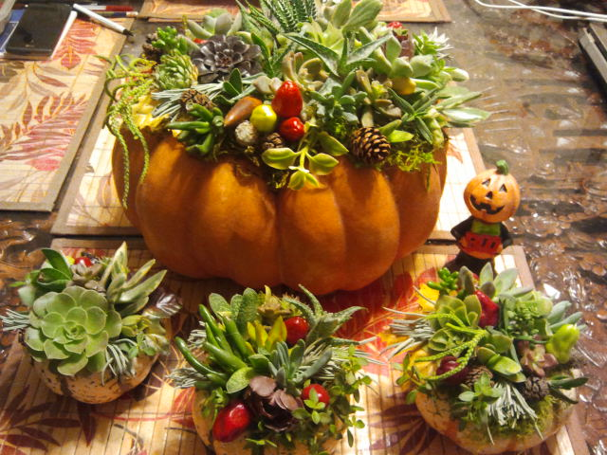
Get Ready for Fall - Succulent Pumpkins
Fresno MG Cathy
Choose a pumpkin of any size, color and shape and add moss, some succulent cuttings, a glue gun and a little creativity to make a centerpiece that will last for months. This demonstration will prepare you to decorate your home with the unique beauty of succulent pumpkins. It’s an great way to begin the holiday season.
Saturday, October 3. 2026
10-11:30 AM
Garden of the Sun
1750 N Winery Ave Fresno, CA 93703

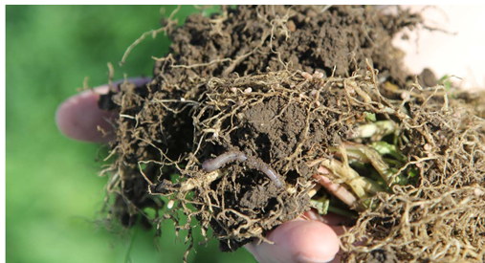
Unlock the Secret of Soils
Fresno MG Tim
New advances in soil health have been made and are available to the home gardener. A healthy garden starts with healthy soil. This class will focus on the USDA program "Unlock the Secrets in the Soil". The four fundamentals of the program and new research will be discussed. You will learn how to use natural soil biology in order to make your garden more beautiful and productive.
Saturday, October 10, 2026
10-11:30 AM
Clovis Botanical Garden
945 N Clovis Ave Clovis, CA 93611

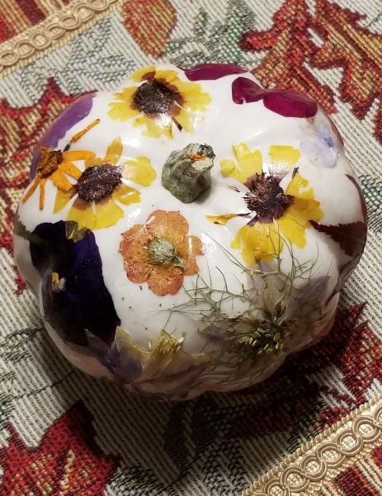

Decorating a White Pumpkin
Fresno MG Sharon
Do you enjoy decorating for the fall season? Join Master Gardener Sharon to decorate a white pumpkin with pressed flowers. All supplies provided. Limit 15 people. Fee $20. (Fees non-refundable)
Saturday, October 17, 2026
10-11:30 AM
Garden of the Sun
1750 N Winery Ave Fresno, CA 93703

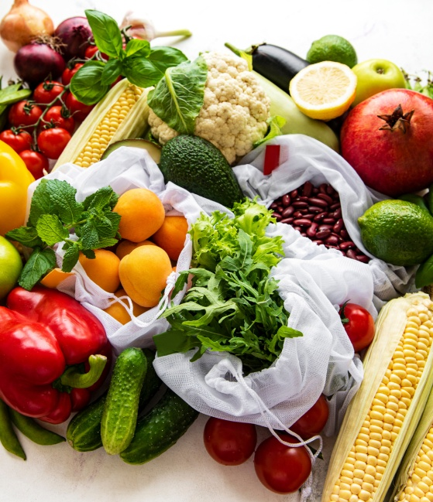
From Grocery Scraps to Garden Magic!
Fresno MG Cyndy
Getting started on a new garden can be pricey! Get tips and tricks on how to use items easily found at your local grocer and scraps you were going to throw away to start growing your own food.

Saturday, October 24, 2026
10-11:30 AM
Garden of the Sun
1750 N Winery Ave Fresno, CA 93703

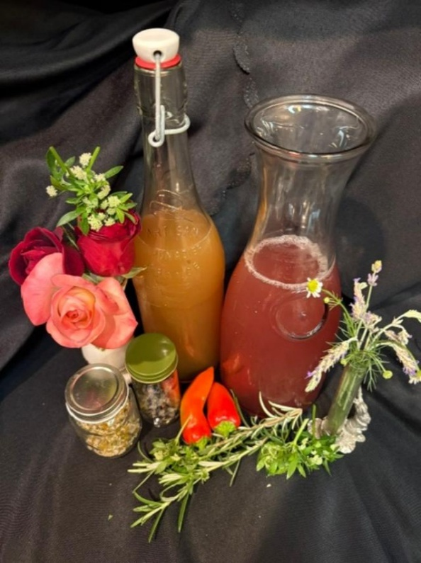
The Art of Botanical Beverages
Fresno MG/MFP Sue
Discover how to craft flavor-rich drinks using herbs, flowers and fruits from your garden. In this class, you’ll learn which herbs, flowers and fruits are best to grow for crafting delicious beverages along with techniques for infusing, blending and balancing botanical ingredients into delicious hot and cold beverages.
Saturday, November 14, 2026
10-11:30 AM
Woodward Park Library
944 E Perrin Ave. Fresno, CA 93720
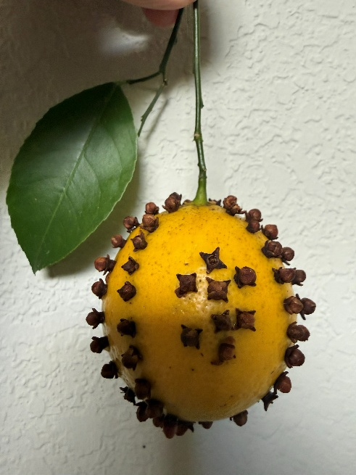
How to Make a Lemon Pomander
Fresno MG Robbie
Get an aromatic start on the winter holiday season: learn to make fresh lemon pomanders! Using local citrus, MG Robbie will show you simple techniques to make fresh citrus pomanders. They can be decorated with ribbon to hang, or displayed in a bowl. All tools and materials will be provided. Limit 15 people. Cost $10. (Fees non-refundable)
Saturday, November 21, 2026
1:00-2:30 PM (NEW TIME)
Garden of the Sun
1750 N Winery Ave Fresno, CA 93703

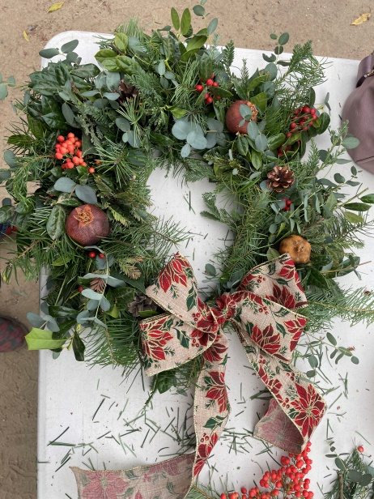
Wreaths and Swags
Fresno MG Robbie
Come join our fourth decade of holiday wreath making! MG Robbie will supply all materials for this popular class, where you will learn the simple techniques needed to make a unique wreath or swag using freshly gathered materials. Wear warm clothing and bring a hand clipper. Everyone will leave with one completed project. Preregistration is required; sorry, we will not be able to accommodate walk-ins. Limit 15 people. Cost $70 (Fees non-refundable)

Saturday, December 5, 2026
9:30 AM-12:30 PM
Garden of the Sun
1750 N Winery Ave Fresno, CA 93703

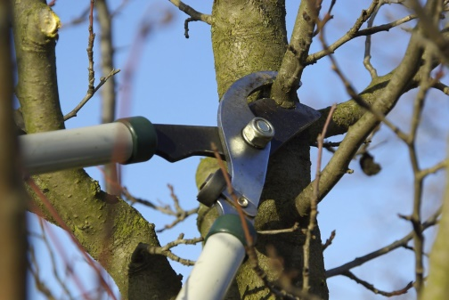

Orchard Care
Fresno MG John and Orchard Team
Join John and this knowledgeable group of MGs for a hands-on demonstration through the Garden of the Sun. They will show you how to prune, which tool to use and why. Maybe a tree in the orchard, a vine in the vineyard, a rose in the rose bed, shaping a shrub – you get the picture.

Saturday, December 12, 2026
10-11:30 AM
Garden of the Sun
1750 N Winery Ave Fresno, CA 93703

