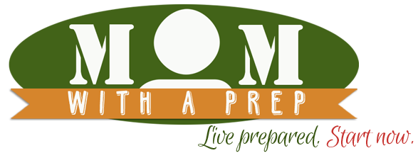
Dehydrating Resources

http://momwithaprep.com/101-dehydrating-recipes/

http://www.backpackingchef.com/

http://www.pickyourown.org/dryingfoods.htm



http://nchfp.uga.edu/how/dry.html

