

Accepting food assistance benefits at certified markets
Questions?
Olivia Henry, UC Cooperative Extension Food Systems Advisor | Capitol Corridor & Placer-Nevada
omhenry@ucanr.edu | 707-389-0723

Overview
This resource provides a brief summary of food assistance programs that can be accepted at certified farmers’ markets. According to a 2023 survey of market managers, accepting these benefits:
- increases farmer sales
- attracts new customers to the market
- promotes access to healthy food

CalFresh or SNAP

How it works
At the manager’s booth, shoppers tell the manager how much they would like to spend at the market, then swipe their card using a SNAP-only point-of-sale machine. The manager hands over scrip (wooden tokens or paper) in that amount, and shoppers spend the tokens at eligible vendors’ booths. At the end of the market, vendors bring back the scrip to the market manager to either pay for stall fees or be paid out in cash. SNAP funds are deposited in the market’s bank account within 48 hours.

Requirements
Market do not need to be certified to accept SNAP. Managers apply with the USDA FNS, complete trainings, operate the point-of-sale machine and reimburse farmers. Reauthorization is every five years.

Allowable purchases
Fruits, vegetables, meats, fish, poultry, dairy products, breads, cereals, seeds and plants which produce food. Hot foods and flowers cannot be purchased using CalFresh benefits.
Next Steps

The first step is to apply to become authorized with the USDA FNS. Managers can also apply to receive free POS equipment via MarketLink. Finally, the manager will need to set up a secure scrip system.

Market Match
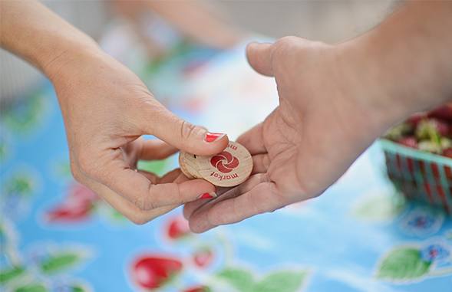
How it works
Market Match is the name of a grant program distributing state and federal dollars to help CalFresh customers buy more fruits and vegetables. When a customer swipes their CalFresh card at the market, the market manager or volunteer gives them additional scrip in a dollar-for-dollar match (up to a daily limit). Customers spend the scrip with vendors, and vendors redeem the scrip for stall fees or cash.

Requirements
Markets must be certified by their county ag department. Managers must apply to the Market Match grant program or work with a partner to apply. Managers complete regular tracking and reporting for invoicing.

Allowable purchases
California-grown fruits and vegetables, fresh-cut herbs and edible plant starts.

Next Steps
Grant funds are limited, contact the Ecology Center at marketmatch@ecologycenter.org.
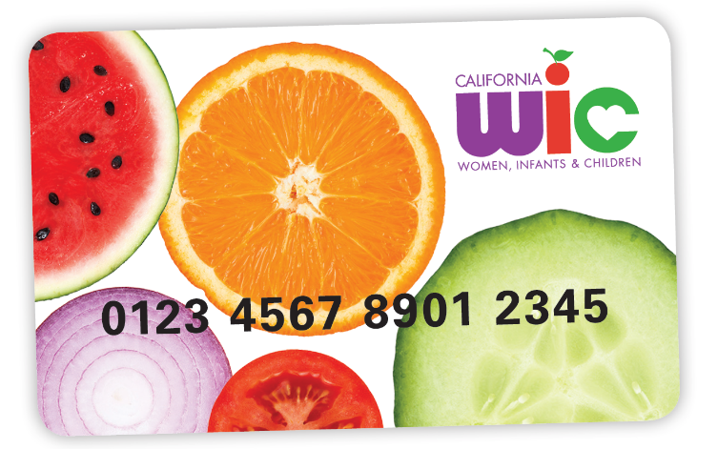
Women, Infants & Children

How it works
WIC participants may spend two kinds of benefits at certified farmers’ markets: One is a year-round, monthly Cash Value Benefit (CVB). The other is the seasonal Farmers’ Market Nutrition Program (FMNP), which offers $30 and runs May to November. The farmer needs a device connected to the internet to open up a vendor portal website, then either take a picture of a QR code or enter a number on the shopper’s card. Next, the shopper enters their PIN number into the portal website and the farmer charges their account. Balances are deposited into the farmer’s account weekly.

Requirements
Market managers and farmers need to submit applications and complete trainings. Once the farmer completes the training, they sign up for the vendor portal to accept benefits. The farmer needs a device connected to the internet. Reauthorization is every three years.

Allowable purchases
Fruits, vegetables and fresh and cut herbs.

Next Steps
Contact CDPH for applications: (855) 942-7867 or wicfmnp@cdph.ca.gov. Applications are the same for WIC CVB, WIC FMNP and Senior FMNP.

Summary of food assistance programs at certified markets

Senior Nutrition

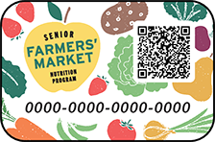

How it works
The Senior Farmers’ Market Nutrition Program is a seasonal program for low-income seniors offering between $20 and $50 from May to November. Benefits are accepted the same way as WIC, but the senior program does not require a PIN to make a purchase. Balances are deposited into the farmer’s account weekly.

Requirements
Both market managers and farmers need to submit applications and complete trainings. Once the farmer completes the training, they sign up for the vendor portal to accept benefits. The farmer needs a device connected to the internet to accept benefits. Reauthorization is every three years.

Allowable purchases
Fruits, vegetables, fresh or cut herbs and honey.

Next Steps
Contact CDPH for applications: (855) 942-7867 or wicfmnp@cdph.ca.gov. Applications are the same for WIC CVB, WIC FMNP and Senior FMNP.

​POTENTIAL BENEFITS | CALFRESH | WIC CVB​ | WIC FMNP​ | SFMNP ​
Recipients​ | CalFresh households  ~ 3.2 million/year | WIC participants​  ~ 1,000,000 / month​ | WIC participants​  ~ 21,850/year​ (2026) | Senior citizens​  ~26,000/year​ (2026)
Benefit Frequency​ | Every month | Every month​ | Once a year​ | Once a year​
Can Be Spent​ | Year-Round | Year-Round​ | May 1 – November 30​ | May 1 – November 30​
Benefit Amount​ | $220 average per month per household | Depends on # of WIC participants in family​ | $30 / season​ | $50 / season​
Approx. Benefits  Available per Year Statewide​ | ~ $1 billion (2024)​ | ~ $15,487,000 (2024)​ | ~ $830,000 (2025)​ | ~ $700,000​ (2025)​

