32nd VERTEBRATE PEST CONFERENCE

March 2-5, 2026
San Diego, California

THE VERTEBRATE PEST COUNCIL


Conference Chair:
Nicki Frey

Program Chair:
Laura Snell

Includes Special Symposia:
Advancing Fertility Control for Vertebrate Pests: Research, Innovation, and Implementation
Commensal Rodents at the Global Crossroads
New Frontiers in Managing Wild Pigs
Working Dogs and Wildlife

Organized by:
The Vertebrate Pest Council
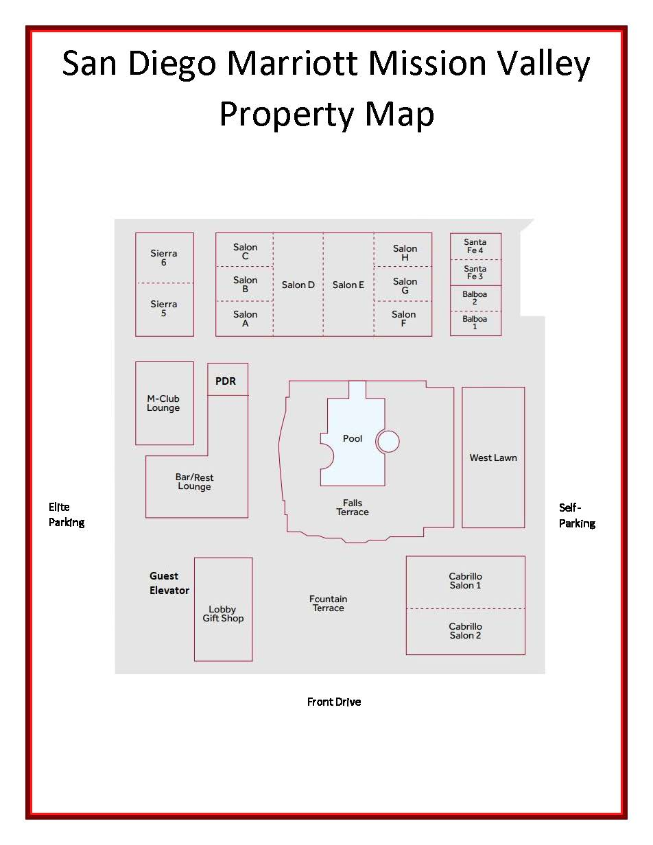

WELCOME

Welcome to the 32nd Vertebrate Pest Conference. We hope you find the conference to be enjoyable and educational. We are excited this year to present the Walter E. ‘Howdy’ Howard Lifetime Achievement Award for Excellence in Vertebrate Pest Management to honor those that have made significant contributions towards the advancement of the field.

We have worked over the years to keep this educational Conference the best of its kind. We welcome your comments (good and bad) concerning it. We are always looking for potential Conference speakers and would appreciate your suggestions for possible speakers or program topics. Contact the chairperson, Nicki Frey, nicki.frey@usu.edu.

CONFERENCE PROCEEDINGS

Individual papers from past Vertebrate Pest Conference Proceedings, Volume 1 (1962) through Volume 31 (2024), are available open-access and can be downloaded from the following website: https://escholarship.org/uc/vertebrate_pest_conference.

ATTENTION TO PRESENTERS

Check in with your session chairperson at the beginning of your session and introduce yourself. Please be careful with your time and respectful of the session chairperson and your fellow speakers. Speakers will have 25 minutes to be introduced, present their talks, and field questions. Session chairpersons will keep speakers on time to ensure people attending concurrent sessions can hear papers presented at their published times.

Preparing Presentations: Upload your presentation onto our conference link (below) prior to the conference. Save your presentation as ‘last name.day.timeofpresentation’ If Jan Smith were presenting at 1pm on Wednesday 4th, she would save her presentation as Smith.Weds.1300 or Smith.Weds.1pm, or similar. Presentations must be uploaded to the following link by March 1, 2026. We will use those versions during the conference. Should you decide to use an alternate version, plan to upload this file during a break prior to your session. Upload link: https://ucdavis.app.box.com/f/add877ea8dd14b499ea377d99440c935

SPEAKERS’ BREAKFAST

There will be breakfast for speakers on Wednesday morning from 6:30 to 8:30 in the Sierra 5/6. This breakfast is only for speakers and poster presenters.

Walter E. ‘Howdy’ Howard Lifetime Achievement Award
for Excellence in Vertebrate Pest Management

The Vertebrate Pest Council is pleased to announce the presentation of the Walter E. “Howdy” Howard Lifetime Achievement Award. This award has been established to acknowledge the tremendous lifetime contributions of individuals in the Vertebrate Pest Management profession.

Walter E. ‘Howdy’ Howard
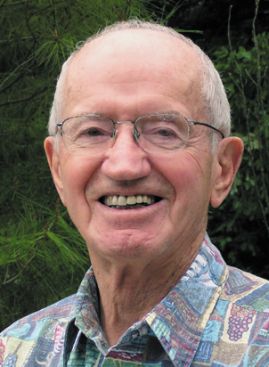
The Walter E. “Howdy” Howard Lifetime Achievement Award is named after a true pioneer and pillar in the vertebrate pest control profession. Born in 1917, Howdy’s love for biology began as a young child. He graduated from U.C. Berkeley, served three years during WWII, primarily focusing on disease and parasite control, and completed his M.S. and Ph.D. at the University of Michigan. He joined the faculty at U.C. Davis in 1947 as professor of Wildlife Ecology. During his lifelong tenure at Davis, he developed the field of vertebrate ecology including vertebrate pest control, making UC Davis a premier international research and teaching institute in this field. His research focused on rodents impacting agriculture and public health, predators especially coyotes, and the politics of dealing with wildlife-human conflicts. He was committed to making state and federal agencies good stewards of wildlife populations and their habitats, and that the political structure ensures wildlife populations and humans coexist. Howdy is especially known for his perspective on the balance of nature and his direct challenge of the arguments posed by groups who are opposed to controlling wildlife populations. Howdy’s impact on our profession and personal legacy lives today through the 44 Ph.D. and M.S. students he advised and mentored at U.C. Davis and the countless professionals influenced by his personal interactions and writing. Howdy passed away in 2018 at the age of 101. It is with great honor that we name this award after Howdy.

Dr. Terrell P. Salmon
Terry received his undergraduate and graduate education at the University of California-Davis, completing his Ph.D. studies under the direction of Dr. Howard in 1979. In that same year, he was hired as Extension Vertebrate Pest Specialist in the Department of Wildlife and Fisheries Biology at UCD, where for ten years he served as a subject matter resource for Cooperative Extension advisors throughout California, conducted applied research to improve methods and strategies for controlling wildlife damage, and supervised students pursuing M.S. and Ph.D. degrees. Recognition of his administrative skills led him to advance to be Regional Director of the Northern Region of UC’s Division of Agriculture and Natural Resources from 1989 through 1999. After relinquishing this position, he returned to his Extension Specialist position at UCD for three years, before assuming the position of County Director and Extension Wildlife Specialist for Cooperative Extension in San Diego County, from which he retired in 2010.

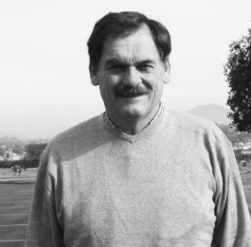
Working with colleagues both in academia and in state government, Terry was very instrumental in initiating and establishing California’s Rodenticide Surcharge Program within the California Department of Food & Agriculture (CDFA). Beginning in 1990 following the implementation of legislation, CDFA collected a per-pound surcharge on all vertebrate pest control materials sold by county Agricultural Commissioners in the state. Receipts from surcharge funds collected from 1991 through 2003 totaled approximately $6.4 million, which through a competitive grant process funded a total of 75 research projects encompassing findings that permitted registration and re-registration of continuing and new pesticides needed to support California agriculture, found new materials to enhance safer use, and found alternative methods for effective use of products within Integrated Pest Management strategies. This program within CDFA continues today, after multiple renewals by the California legislature. Terry published a total of 166 articles as the senior or contributing author, of which 51 were peer-reviewed throughout his career.

Terry has also been instrumental in leadership (as Business Manager, among other tasks) within the Vertebrate Pest Council during his career. He was chair of the Vertebrate Pest Council from 1984 - 1986 and again from 1998 - 2000, and thereby heavily involved in leading the planning for the 12th and 19th Vertebrate Pest Conferences, as well as being a leader of the Council in many other ways.
The Vertebrate Pest Conference thanks these sponsors of our mission

Gold Sponsors




Platinum Sponsors
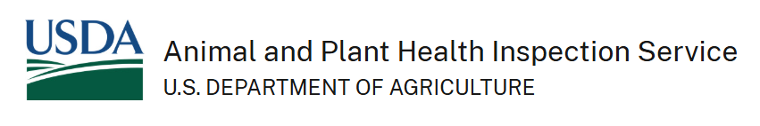
Special Thanks to:



Conference At-A-Glance: Tentative Schedule
Monday, March 2
Optional Field Trip
Sponsored by CATCHMASTER
7:00 AM – 4:30 PM

Tuesday, March 3
Opening Plenary Session
9:00 AM – 12:00 PM
Lunch (on your own)
Posters and Commercial Exhibits open – 1:15 PM
Symposium:  Commensal Rodents at the Global Crossroads  1:20 PM – 5:00 PM | Symposium:  Advancing Fertility Control for Vertebrate Pests: Research, Innovation, and Implementation  1:20 PM – 5:00 PM
5:30 PM No-Host Welcoming Social

Wednesday, March 4
Speaker’s Breakfast 6:30-8:30 AM
Symposium:  Commensal Rodents at the Global Crossroads  8:10 AM – 12:00 PM | Symposium:  New Frontiers in Managing Wild Pigs  8:10 AM – 12:00 PM
Lunch (on your own)
Symposium:  Commensal Rodents at the Global Crossroads  1:20 PM – 5:00 PM | Concurrent Session:  General Session  1:20 PM – 5:00 PM
Workshop: Botstiber Fertility Control Workshop
1:30-5:00 Room Sierra 5/6
6:30 PM: Hors d’oeuvres, Poster Session, and Vendors’ Forum Salon E
Sponsored by USDA-APHIS - Wildlife Services

Thursday, March 5
Symposium:  Commensal and Field Rodent Management  8:10 AM – 12:00 AM | Symposium:  Working Dogs and Wildlife  8:10 AM – 11:35 AM
Lunch (on your own)
Session:
Other Rodent Management
1:20 PM – 3:05 PM
CONTINUING EDUCATION
Attendees seeking Continuing Education credit must sign in and out at the event registration desk. All credits are approximations and are dependent upon your attendance.

California Department of Pesticide Regulation*:
Day | Topic | Other  H:M | Laws and Regulations
3/2 | Field Trip | 3:50
3/3 | Plenary Session | 1:00
3/3 | Commensal Rodents at the Global Crossroads (PM) | 3:50
3/3 | Advancing Fertility Control for Vertebrate Pests | 3:00
3/4 | Commensal Rodents at the Global Crossroads (AM) | 3:20
3/4 | New Frontiers in Managing Wild Pigs | 1:00
3/4 | Commensals at the Crossroads (PM) | 2:30 | 0:30
3/4 | General Session | 2:00
3/5 | Commensal and Field Rodent Management | 2:30
3/5 | Working Dogs and Wildlife | 2:00
3/5 | Other Rodent Management | 2:00

California Department of Public Health*:
Date | Category | Hours | Approval No.
Mar-3 | A | 1.5 | 27-00077
Mar-3 | D | 2.75 | 27-00077
Mar-4 | A | 0.75 | 27-00078
Mar-4 | D | 2 | 27-00078
Mar-5 | A | 2 | 27-00079
Mar-5 | D | 0.5 | 27-00079

Structural Pest Control Board (SPCB) License Holder continuing education day is Wednesday March 4th. Six hours of CEUs have been applied* for. If you are a license holder, you might qualify for a day discount, please contact lillian.mignella@target-specialty.com.
*Applied for hours
CONFERENCE FIELD TRIP (Optional)

The Conference begins with an optional full-day field trip on Monday, March 2. The field trip departs from Mission Valley Marriott at 7:00 AM. The field trip will include a tour of San Diego County, including stops at agricultural sites, stunning lagoons, the beach and more. We'll be learning about rodent management, protecting endangered birds through predator management, rodent detection dogs, and more. Lunch will be provided. Buses will return to the hotel by approximately 4:30 PM. The field trip is sponsored by CATCHMASTER.

Those who have pre-registered for the field trip should gather at the front of the hotel by 7:00am and be prepared to board the chartered bus in front of the hotel before 7:15 AM on Monday morning, March 2. Layered clothing and rain gear are recommended.

Tuesday, March 3 (AM)
PLENARY

9:00 Conference Welcome and Overview
Nicki Frey, Vertebrate Pest Conference Chair

9:20 Keynote Address “Click bait solutions for rat management won’t save us, but implementation science might”
Kaylee Byers, School of Population and Public Health, University of British Columbia; Faculty of Health Sciences, Simon Fraser University; Canadian Wildlife Health Cooperative
10:05 Lifetime Achievement Award
Nicki Frey and Bob Timm, Vertebrate Pest Council

10:25 Break

10:45 The effectiveness of combination lures and sustained trapping in attempting to achieve the localised elimination of brushtail possums on the New Zealand mainland.
Professor James Ross, Lincoln University, Lincoln, Canterbury, New Zealand

11:10 From mice to elephants: tools and trends in the wildlife fertility control landscape
Giovanna Massei, Botstiber Institute for Wildlife Fertility Control, Media, PA

11:35 Forty-five years of removal campaigns for feral ungulates reveal strategies for success and future directions
Nathan P. Snow, USDA National Wildlife Research Center, Fort Collins, CO

12:00 Session Close

Tuesday, March 3 (PM)
SYMPOSIUM: COMMENSAL RODENTS AT THE GLOBAL CROSSROADS

1:20 Session Welcome: Niamh Quinn, University of California Cooperative Extension, Session Chair

1:25 Assessing anticoagulant rodenticide resistance in rattus spp. across urban and agricultural landscapes in California
Niamh Quinn, University of California Agriculture and Natural Resources, Irvine, CA, USA

1:50 Mitigating the risk of rodenticide exposure of aquatic wildlife – a success story?
Julia Regnery, Federal Institute of Hydrology, Department Biochemistry, Ecotoxicology, Koblenz, Germany

2:15 Exposure and potential risk of domestic cats (Felis catus) to rodenticidal compounds
Vesna Cerkvenik-Flajs, Veterinary Faculty, University of Ljubljana, Slovenia

2:40 Genetic resistance to anticoagulant rodenticides in commensal rodents from Ontario, Canada
Luigi F. Richardson, Laurentian University, Vaughan, ON, Canada

3:05 Break

3:20 Efficacy of anticoagulant rodenticides applied to Norway rats (Rattus norvegicus) in the sewer system of Berlin, Germany
Annika Schlötelburg, German Environment Agency, Department of Health Pests and their Control, Berlin, Deutschland

3:45 Bromethalin and anticoagulant rodenticide exposure in non-target wildlife in California
Ryan Bourbour, California Department of Fish and Wildlife, Wildlife Health Laboratory, Rancho Cordova, CA, USA

4:10 Non-invasive surveillance of rodenticide exposure in an urban carnivore using scats
Paul Stapp, CSU Fullerton, Fullerton, CA, USA

4:35 From lab to landscape: tracing isotopically labelled anticoagulant rodenticides (ilars) through urban food webs
Niamh Quinn, University of California Agriculture and Natural Resources, Irvine, CA, USA

5:00 Session Close

Tuesday, March 3 (PM)
SYMPOSIUM: ADVANCING FERTILITY CONTROL FOR VERTEBRATE PESTS:
RESEARCH, INNOVATION, AND IMPLEMENTATION

1:20 Session Welcome: Monique Principi, Botstiber Institute for Wildlife Fertility Control, Session Chair

1:25 Fertility control agents and their mechanisms of action
Doug Eckery, USDA APHIS WS National Wildlife Research Center, Fort Collins, CO, USA

1:50 Immunocontraceptive vaccine for vertebrate pest management: a new approach for population control in rodents and wild pigs
Mohammed Selman, The Amber and Adam Tarshis Foundation, Los Angeles, CA, USA

2:15 Fertility control as an alternative to lethal methods for reducing livestock predation by large carnivores
Cheryl Asa, AZA Reproductive Management Center, Saint Louis Zoo, Norwich, Vermont, USA

2:40 Invasive species management strategies in a One Health system
Katherine August, Natural Resources Institute University of Greenwich, Medway, United Kingdom

3:05 Break

3:20 From the bedroom to the bait station: barriers to rat contraception
Niamh Quinn, University of California Agriculture and Natural Resources, Irvine, CA, USA

3:45 The role of fertility control in managing federally protected wild horses and burros in the U.S.
Stephanie Boyles Griffin, Humane World for Animals/Botstiber Institute for Wildlife Fertility Control, Washington, District of Columbia, USA

4:10 Advances in effective fertility-based management of free-roaming cats
John D. Boone, Great Basin Bird Observatory, Reno, NV, USA

4:35 Speaker Panel on Fertility Control

5:00 Session Close

Wednesday, March 4 (AM)
SYMPOSIUM: COMMENSAL RODENTS AT THE GLOBAL CROSSROADS

8:10 Session Welcome: Dr. Jonathan Richardson, University of Richmond, VA and Gabriel I Gadsden, Yale University School of the Environment Applied Wildlife Ecology Lab, New Haven, CT, USA, Session Chairs

8:15 Population genetics of the Brown Rat (Rattus norvegicus) in a heterogeneous urban landscape
Martin Scaltritti, IEGEBA (UBA-CONICET), Ciudad Autónoma de Buenos Aires, Argentina

8:40 Smoke testing sewer lines helps determine rodent control strategies
Michael Walls, Alameda County Vector Control, Alameda, CA, USA

9:05 The Spread of Norway rats from urbanized to suburbanized portions of Alameda County
James Bohn, Alameda County Vector Control, Alameda, CA, USA

9:30 Assessing the abundance and impact of brown rats in Chicago’s community gardens
Andrea Flores, Lincoln Park Zoo, Chicago, IL, USA

9:55 Break

10:10 Norway rat gut microbiome assessment - evaluating the zoonotic potential and environmental correlates of disease risk in urban rats
Jonathon Richardson, University of Richmond, Richmond, VA, USA

10:35 Re-evaluating the health risks of urban rodent infestations
Changlu Wang, Rutgers University, New Brunswick, NJ, USA

11:00 Beyond numbers: developing a rat risk index to guide context-specific urban management
Sarah J. Robinson, Faculty of Health Sciences, Simon Fraser University, Guelph, ON, Canada

11:35 Mapping urban rat risk: predictive habitat suitability models to guide municipal pest control
Jonathan Richardson, University of Richmond, Richmond, VA, USA

12:00 Session Close
Wednesday, March 4 (AM)
SYMPOSIUM: NEW FRONTIERS IN MANAGING WILD PIGS

8:10 Session Welcome: John M. Tomeček, Associate Professor and Extension Wildlife Specialist, Texas A&M University, Session Chair

8:15 America’s best idea, impaired: Wild pig expansion and management across the National Park Service
Anna C. Racey, Texas A&M University College Station, TX, USA

8:40 What are you doing? Towards a discussion on wild pig management objectives
Michael J. Bodenchuk, Wildlife Biologist, Hondo, TX, USA

9:05 Wildlife Services’ African Swine fever preparedness & response efforts for feral swine
James Grinolds for Michael Glow, USDA/APHIS/WS, Fort Collins, CO, USA

9:30 Break

10:10 ASF surveillance in the United States by USDA Wildlife Services
James Grinolds, USDA/APHIS/WS, Fort Collins, CO, USA

10:35 Evaluating ecological effects on swine carcass decomposition: a meta-analysis with implications for disease management
Mary J. Woodruff, USDA-APHIS Center for Epidemiology and Animal Health, Chicago, IL, USA

11:00 Multiple threats at the border facilitated by an invasive species
David L. Bergman, Independent Researcher, Phoenix, Arizona, USA

11:35 Group Discussion on the Future of Wild Pig Management

12:00 Session Close

Wednesday, March 4 (PM)
SYMPOSIUM: COMMENSAL RODENTS AT THE GLOBAL CROSSROADS

1:20 Session Welcome: Kaylee Byers, School of Population and Public Health, University of British Columbia; Faculty of Health Sciences, Simon Fraser University; Canadian Wildlife Health Cooperative, Session Chair

1:25 Diets of commensal roof rats (Rattus rattus) in southern California
Gabriela Guzman, Department of Biological Science, CSUF; UCANR, Cooperative Extension, Irvine, CA & UBC,
Fullerton, CA, USA

1:50 Global variation in urban rat body size: ecological drivers and implications for pest management
Jeff (Ping Yeng) Tsai, University of Richmond, Richmond, VA, USA

2:15 Caught in the middle: a community development manager’s balancing act with rodent control, regulation, environment and community involvement
Andrew Herndon, Irvine Campus Housing Authority, Irvine, CA, USA

2:40 From pathogens to property damage: the quantified burden of urban rats
Carly Hilbert, University of British Columbia, Vancouver, BC, Canada

3:05 Break

3:20 Foraging behavior of urban rodents inside and outside residential buildings
Changlu Wang, Rutgers University, New Brunswick, NJ, USA

3:45 Pellets not poison: Experimentally evaluating contraception to manage rats in an urban neighborhood
Maureen Murray, Lincoln Park Zoo, Chicago, Illinois, USA

4:10 Ecotoxicology as Part of the Pesticide Registration Process
Alexander S. Kolosovich, California Department of Pesticide Regulation, Sacramento, CA, USA

4:35 Citizen Science or Industry Science? Using Industry Data to Address the Wicked Problem of Urban Rodents
Luis Agurto, Jr., EUREKA/Pestec, San Francisco, CA, USA

5:00 Session Close

Wednesday, March 4 (PM)
CONCURRENT SESSION: GENERAL SESSION

1:20 Session Welcome: James Ross, Lincoln University, Session Chair

1:25 Rise of the raven: A conservation blind spot
Pat Jackson, Great Basin Bird Observatory, Reno, NV

1:50 Effectiveness of starling roost management in Hamamatsu, Shizuoka Prefecture, Japan
Masaki Shirai, Central Research Institute of Electric Power Industry, Abiko, Chiba, Japan

2:15 Infestation of a federal office building by poultry bugs (Haematosiphon inodorus) associated with barn owls (Tyto alba)
Maia Walls, Alameda County Vector Control, Alameda, CA, USA

2:40 Effectiveness of the AVIX Handheld 500 laser as disruptive stimuli to repel birds from a dairy, feed storage area, and feedlot with opportunistic use.
George R Gallagher, Dept. of Animal Science, Cal Poly San Luis Obispo, CA, USA

3:05 Break

3:20 Determining the applicability of new application strategies of zinc phosphide for managing ground squirrels
Roger A. Baldwin, Department of Wildlife, Fish, and Conservation Biology, University of California, Davis, CA, USA

3:45 Lessons and innovations in beaver telemetry
Stacie Robinson, USDA Wildlife Services National Wildlife Research Cetner, Fort Collins, CO, USA

4:10 Space use of altered landscapes by recolonizing California wolves
Christina Winters, University of California, Berkeley, CA, USA

4:35 Using education to change knowledge on wild horse management in youth
Laura K. Snell, University of California Cooperative Extension, Modoc County, Alturas, CA, USA

5:00 Session Close

Thursday, March 5 (AM)
SYMPOSIUM: COMMENSAL AND FIELD RODENT MANAGEMENT

8:10 Session Welcome: Ryan Bourbour, California Department of Fish & Wildlife, Session Chair

8:15 Computational urban ecology of New York City rats
Ralph E Peterson, Basis Research Institute, New York, NY, USA

8:40 Energy efficient homes for rodent control across cityscapes
Gabriel I Gadsden, Yale University School of the Environment Applied Wildlife Ecology Lab, New Haven, CT, USA

9:05 Effectiveness of the AVIX autonomic laser repellent system in behavior modification of Norway rats (rattus norvegicus) in an infested poultry house
George R Gallagher, Dept. of Animal Science, Cal Poly San Luis Obispo, CA, USA

9:30 Smart sensor system for rodent detection and monitoring
Zhongli Pan, Department of Biological and Agricultural Engineering, University of California, Davis, CA, USA

9:55 Break

10:10 Rodent and tick baits for control of pest rodents and parasitizing disease vectors: a method to prevent rodent and vector-borne diseases.
David Poche, Genesis Laboratories, Inc., Wellington, CO, USA

10:35 Utility of Drones and AI for monitoring ground squirrel burrow systems
Sean Hogan, UC ANR IGIS, Shingle Springs, CA, USA

11:00 Field and lab toxic bait trials to improve gray-tailed vole management
Aaron Shiels, USDA APHIS Wildlife Services National Wildlife Research Center, Fort Collins, CO, USA

11:35 Mapping agriculture conflicts with gray-tailed voles via survey of Willamette Valley farmers
Dana Sanchez, Oregon State University Dept Fisheries, Wildlife, & Conservation Sciences, Corvallis, OR, USA

12:00 Session Close

Thursday, March 5 (AM)
SYMPOSIUM: WORKING DOGS AND WILDLIFE

8:10 Session Welcome: Carolyn Whitesell and Dan Macon, University of California Cooperative Extension, Session Chairs

8:15 Wake Atoll Rat Eradication –rodent detection dogs used to inform decision making and confirm success
Tyler Bogardus, USDA-WILDLIFE SERVICES, Kapolei, HI, USA

8:40 Assessing the effectiveness of three carcass search approaches for reducing secondary exposure risk associated with rodenticides
Roger A. Baldwin, Department of Wildlife, Fish, and Conservation Biology, University of California, Davis, CA, USA

9:05 Expanding the vertebrate management toolkit: integrating conservation detection dog teams on islands, urban systems, and anywhere in between.
Pete Coppollilo, Working Dogs for Conservation, Bozeman, MT, USA

9:30 Rethinking rodenticide use through a wildlife-management lens—integrating K9 Detection and Abatement
Kimberly Camera, Urban Canine Pest and Wildlife Solutions, Windsor, South Carolina, USA

9:55 Break

10:10 An overview of livestock guardian dog research and extension programming in California
Dan Macon, UC Cooperative Extension, San Andreas, CA, USA

10:35 Evaluating LGD breeds and their efficacy at protecting livestock and people
Julie Young, Utah State University, Logan, UT, USA

11:00 Livestock guardian dogs and virtual fencing, matchmaking old technology and new technology
Dan Macon, UC Cooperative Extension, San Andreas, CA, USA

11:35 Session Close

Thursday, March 5 (PM)
CONCURRENT SESSION: OTHER RODENT MANAGEMENT

1:20 Session Welcome: Dirk Van Vuren, University of California, Davis, Session Chair

1:25 Field efficacy trial for a new diphacinone oat bait for black-tailed prairie dog management
Aaron Shiels, USDA APHIS Wildlife Services National Wildlife Research Center, Fort Collins, CO, USA

1:50 Conflict with prairie dogs is one of the most challenging kinds of human -wildlife conflict to address on the Western Grasslands
Lindsey Sterling Krank, Humane World for Animals, Boulder, CO, USA

2:15 Managing black-tailed prairie dogs using GonaCon-prairie dog contraceptive vaccine with or without removal
Jason Bruemmer, USDA APHIS Wildlife Services National Wildlife Research Center, Fort Collins, CO, USA

2:40 When pests are also species of conservation concern: Strategies and tools for effective prairie dog (Cynomys sp.) management
Courtney Duchardt, University of Arizona, Camp Verde, AZ, USA

3:05 Session Close

POSTER SESSION
Wednesday, March 4 (6:30-8:00 PM)
Location: Salon E
Session Chair: Roger Baldwin, University of California Cooperative Extension

Evaluating an alternative rodenticide for county use: a data-driven pilot study
Jordan Key, County of San Deigo Department of Agriculture, Weights and Measures

Managing vertebrate pests: protecting agriculture and engaging youth
Mark Nelson, Utah State University Extension

Overnight in-the-trap harassment as a vulture management tool: site and space use outcomes for Black Vultures
Spencer Hudson, USDA APHIS WS

A systematic review of feral swine incidents and response
Jackson VerSteeg, Texas A&M University

The human-rat interface and urban One Health: A scoping review on social-environmental factors of rat activity
Christine Yanagawa, Simon Fraser University

Temporal responses of native and invasive rodents to sugarcane crop succession
Christian Kammerer, UF/IFAS Hendry County Cooperative Extension, University of Florida

Evaluating two widely used rodent control methods–culling and anticoagulant rodenticides–from a One Health perspective
Holly Gerberich, University of Exeter

Relating livestock health and wild pigs on rangelands
Cheyenne Voorhies, Texas A&M Univeristy

Highly pathogenic avian influenza surveillance in feral swine by Wildlife Services
Gregory A. Franckowiak, USDA/APHIS/Wildlife
Services/National Feral Swine Damage Management Program

Detection of helminth parasites (Mastophorous muris and Taenia taeniaeformis) in roof rats (Rattus rattus) collected from residential backyards in Orange County, California, 2023-2024
Laura Krueger, Orange County Mosquito and Vector Control District

Feral swine trap site selection using gps telemetry and landscape characteristics in Central North Carolina
William Mayfield, North Carolina State University, Raleigh, NC

Foreign animal disease monitoring with the SQUEAL ON PIGS! CAMPAIGN
Ariel Mixon, USDA APHIS Wildlife Services; National Feral
Swine Damage Management Program

Rodenticide residues detectable in vertebrate species two years after a house mouse (Mus musculus) eradication attempt on a subtropical coral atoll
Carmen Antaky, USDA National Wildlife Research Center, Hawaii Field Station

Case Study: foreign animal disease surveillance in feral swine in the vicinity of a dump site potentially containing contaminated garbage of international Origin
Evan Casey, Wildlife Services/APHIS/USDA

Swine brucellosis in wild pigs and its potential impact on the pork industry by USDA Wildlife Services
Aubrey Murphy, USDA/APHIS/Wildlife Services /National Feral Swine Damage Management

The use of livestock guardian dogs for swift fox conservation
Haley Sloan, Department of Rangeland, Wildlife, and Fisheries Management, Texas A&M University

Avoidance and habituation responses of crows to a dancing scarecrow: a pilot study
Hitoshi Yamada, D-yorozu Co.,Ltd

Exploring appropriate needle specifications for bird anti-perching devices in rock doves
Masaki Shirai, Central Research Institute of Electric Power Industry

Use of automated telemetry to investigate rodent movement associated with vegetated ditches in agricultural settings
Emily Kelvin, California State University Monterey Bay

Commercial Exhibits
(Tuesday-Thursday)

VM Products
Michael Hovis
mhovis@vmproducts.com
Art Guzman
Modern Methods Sales & Marketing
Guzzer60@gmail.com
https://www.vmproducts.com/#products

Pig Brig
John Kinsey
john@pigbrig.com
https://pigbrig.com/

RCO International
Doug Freeman
rcoinc@earthlink.net
https://rodent-baits.com/

Botstiber Institute for Wildlife Fertility Control
Giovanna Massei
gmassei@botstiber.org
wildlifefertilitycontrol.org

Motomco
Edgar Macias
slockrem@motomco.com
https://www.motomco.com/

Wildlife Control Supplies
Gregg Schumaker
greggschumaker@gmail.com https://www.wildlifecontrolsupplies.com/

Automatic Trap Company
Blair Calder
Blair.calder@hitgroup.ca
https://www.automatictrap.com/

NZ Autotraps Limited
Hayden Steel
haydn@nzautotraps.com
https://nzautotraps.com/

Catchmaster
Ed Dolshun
edolshun@catchmaster.com
https://www.catchmaster.com/

32nd VERTEBRATE PEST CONFERENCE

Conference Chair:
Nicki Frey, Utah State University
(435) 586-1924; E-mail: nicki.frey@usu.edu

Program Chair:
Laura Snell, University of California Cooperative Extension
(530) 233-6400; Email: lksnell@ucanr.edu

Registration:
Jennifer Gonzalez and Lillian Mignella, Target Specialty Products
(831) 562-802; Email: jennifer.gonzalez@target-specialty.com, lillian.mignella@target-specialty.com

Local Arrangements:
Greg Hacker, California Department of Public Health
(916) 686-8083; Email: Greg.Hacker@cdph.ca.gov

Field Trip:
Niamh Quinn, University of California Cooperative Extension
(949) 301-9182; Email: nmquinn@ucanr.edu

Commercial Displays:
Tyler Bogardus, USDA National Wildlife Research Center
Tyler.bogardus@usda.gov

Poster and Student Award Coordinator:
Roger Baldwin, University of California, Davis
(530) 752-4551; Email:rabaldwin@ucdavis.edu

Continuing Education:
Edmund Duarte, Alameda County Agricultural Commissioner’s Office
(926) 245-0853; Email: ed.duarte@acgov.org
Mike Mooney, Alameda County Dept of Environmental Health
(510) 567-6801; Email: michael.mooney@acgov.org

Publicity:
Dirk Van Vuren, University of California, Davis
(530) 752-4181; Email: dhvanvuren@ucdavis.edu

Proceedings:
Robert M. Timm, Extension Wildlife Specialist emeritus, University of California
email: rmtimm@ucdavis.edu
Aaron Shiels, USDA National Wildlife Research Center
(970) 266-6324; Email: aaron.b.shiels@usda.gov

Plan to attend the
33rd Vertebrate Pest Conference
March 6-9, 2028

Hilton Hotel Sonoma Wine Country
Rohnert Park, California

Notes:

