Civil Rights Compliance

County Director/Supervisor Guidance
Working Draft 7/1/25

All UC ANR academics have civil rights compliance responsibilities in their position description; see the position description template webpage. As County Directors/Supervisors, you can help inform academics of the civil rights compliance cycle, reporting requirements due every December, and connect academics with resources.
This graphic describes civil rights compliance reporting responsibilities of all Cooperative Extension Advisors and some other academic titles who serve external clientele. For instructions, trainings, and programmatic examples, see the Project Board Civil Rights Compliance User Manual and UC ANR’s Office of Civil Rights webpage.
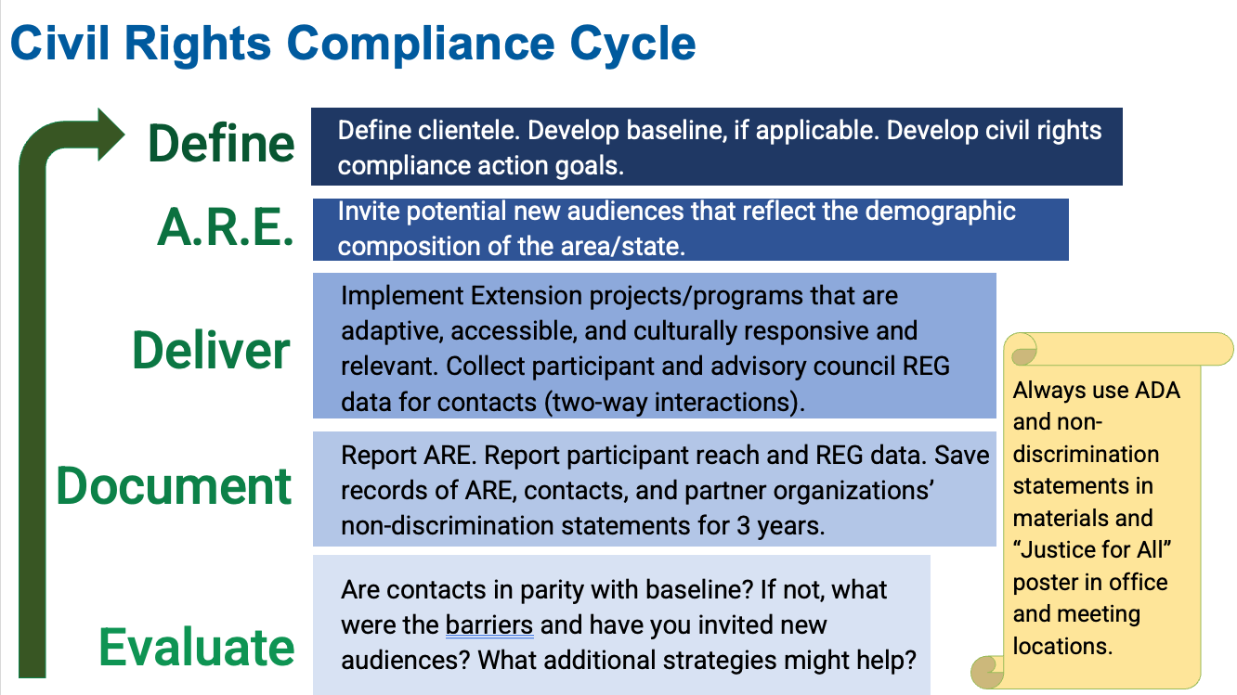

County Director/Supervisor roles in relation to civil rights compliance
Excerpt from Project Board Civil Rights Compliance User Manual:
County Directors/Supervisors are strongly encouraged to schedule an annual conversation about civil rights compliance with academics. Consider combining it with the annual Goal Discussions as per the Calendar of AHR Deadlines on the AHR website.
Role #1: Reflecting on descriptive statistics
The following questions are provided to help supervisors in reflecting with academics about the descriptive statistics provided in Project Board for each academic. Supervisors cannot see each academics’ Project Board and descriptive statistics. Consider asking the academic to meet and share the table(s) or send screenshots of the table(s) for discussing these questions:
- Is parity achieved for each demographic sub-group in each clientele group? If not, what are the barriers and have you invited new audiences?
- Can any improvements be made to the clientele group description, type, or baseline?
  - Does the clientele group(s) reflect the academic’s program?
  - It is recommended to lump, rather than split: Can some clientele groups across counties be lumped into one?
  - Has baseline data been updated in the last 3-4 years? Consider using the baseline data provided by UC ANR on this resources webpage.
Role #2: Developing a plan
The following questions are provided to help supervisors in facilitating a dialogue about civil rights compliance. These conversations should occur annually as part of the performance review meeting, with input/guidance from additional supervisors.
- For demographic groups in parity: How did you achieve this? What should be done to ensure this continues? What methods to invite new audiences worked well?
- For demographic groups not in parity: What methods to invite new audiences worked well or what did not work? What other methods can be used?
- Develop a multi-year plan to achieve civil rights compliance:
  - Get multiple partners involved in developing your plan to increase participation (e.g., co-planning events, leveraging each other’s resources).
  - Consider working towards long term solutions with proven success, such as creating partnerships or hiring program employees who have the experience and expertise in increasing opportunities for program participation.
  - Annually review, celebrate progress, and revise plan.
  - Attend civil rights compliance trainings.

