

Cooperative Extension Fruit Postharvest Area Advisor

Serving Fresno, Madera, Tulare, Kings, and Kern Counties

Position Overview
The University of California, Agriculture and Natural Resources (UC ANR) invites applications for a UC Cooperative Extension Fruit Postharvest Area Advisor serving Fresno, Kern, Kings, Madera, and Tulare Counties, at the Assistant rank. The advisor will develop an innovative multi-county applied research and extension education program to support the fruit industry in the San Joaquin Valley.

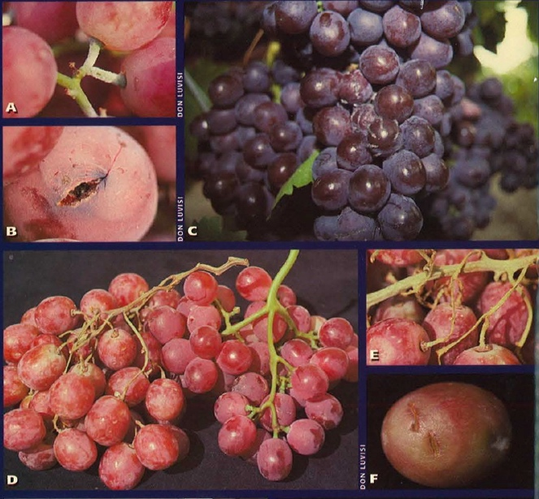
The Central Valley supplies the US and the world with a wide variety of fruits and vegetables, contributing significantly to the state’s economy and international trade. Fruits such as grapes, citrus, berries, and nuts, as well as vegetables like tomatoes, are among the commodities in the area this position will serve. While advanced agricultural practices have significantly increased the productivity of these and other crops, ensuring the quality, safety, and longevity of harvested crops remains a critical challenge. Postharvest losses due to spoilage, damage, and deterioration not only have significant economic implications but contribute to food insecurity and environmental degradation. The Advisor will establish a postharvest research and extension program in the Central Valley to address and improve the postharvest practices for fruit and vegetable crops. The role involves conducting research, developing innovative strategies, and implementing best practices to optimize postharvest processes, minimize losses, and maintain the quality and safety of fruits from harvest to consumption. The Advisor will collaborate with interdisciplinary teams to improve efficiency, sustainability, and profitability in the agricultural supply chain.

UCCE Advisors are responsible for applied research and extension of knowledge. Research activities are applied, needs-based, mission-oriented, and focused on addressing our communities' challenges. Extension activities are the educational practices advisors use to share research results directly with clientele and communities to increase their knowledge and understanding of science-based research results that support and promote the adoption of practices and technologies to solve problems. Extension methods may include individual consultations, presentations, organization of educational workshops and short courses, field demonstrations, farm calls, and site visits. Information may also be disseminated via radio outreach, webinars, fact sheets, policy briefs, news blogs, and social media. Publications are expected in various formats, such as newsletters, articles for the popular press, curriculums, conference proceedings, and peer-reviewed publications. Successful research and extension programs result in new information that improves knowledge or understanding and adoption of new skills, practices, changed attitudes, policies, and improved environmental, health, agricultural, economic, and/or social conditions. UCCE Advisors are evaluated through an academic advancement system based on four criteria: extending knowledge, applied research and creative activity, professional competence and activity, and university and public service. There is an expectation that advisors evolve and grow across their careers and respond to changes in the industry, clientele, and organizational change.

Location Headquarters: The position will be headquartered at the Kearney Agricultural Research and Extension Center located at 9240 S. Riverbend Avenue in Parlier, California.

Position Details
The Advisor will develop a multidisciplinary applied research and extension program to address critical postharvest issues facing orchard and vegetable crops in the five-county area served.

Research will be focused on improving the postharvest practices of various commodities as needed and addressing emerging challenges affecting the postharvest supply chain. Topics appropriate for research include:
- Postharvest technologies
- Extending shelf life
- Export requirements
- Cold and modified atmosphere storage
- Biodegradable packaging
- Pesticide maximum residue limits (MRL)
- Optimizing shipping conditions to maintain fruit quality while reducing storage and shipping costs

Publication of research results and knowledge is expected to include various UC ANR series, technical sheets, and peer-reviewed journals.

The Advisor will conduct outreach to provide science-based information about postharvest issues, disseminating information through workshops, field meetings, webinars, newsletters, industry media outlets, phone calls, and online and social media tools, as appropriate to the target audiences.

This position will play a vital role in collaborating with the agricultural industry to optimize postharvest processes, enhance product quality, and minimize losses through the supply chain. By leveraging their expertise in plant science, physiology, and technology, the Advisor will work closely with industry stakeholders, including growers, processors, distributors, shippers, and retailers, to address key challenges and capitalize on opportunities for improvement. The Postharvest Advisor is also expected to develop strong connections with staff at state agencies, such as the CA Dept of Food and Agriculture, county agencies such as County Agricultural Commissioners, research groups outside of UC (USDA, CSUs), and commodity boards.

Counties of Responsibility. This position has programmatic responsibilities in Fresno, Kern, Kings, Madera, and Tulare Counties.
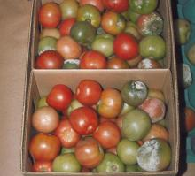
Reporting Relationship: The CE Advisor serves under the administrative guidance of the Director of the UC ANR Kearney Research & Extension Center with input from the UCCE County Directors in the coverage area. It is not a remote position; the candidate must be available to work onsite at the headquarters location in Parlier, CA, and travel to and be present in all five counties served. Specific expectations for maintaining office hours and fieldwork in the geographic area covered by this position will be outlined upon hire by the respective directors and supervisors.

Qualifications and Skills Required
Education: A minimum of a master’s degree in horticulture, pomology, crop physiology, plant biology, or a related field is required at the time of appointment.

Key Qualifications
- A strong background in plant science and chemistry, ideally with a focus on postharvest storage, handling, and shipping.
- Experience in conducting applied, impact-oriented research on topics relevant to this position.
- Capacity or potential to accomplish team-based research and education programs consistent with the values of UCANR.
- Ability and means to travel on a flexible schedule as needed. Proof of liability and property damage insurance on vehicle used is required. Must possess a valid California Driver’s License to drive a county or university vehicle.
Additional Skills Required

- Applicants need to meet appointment criteria for the respective University of California academic title series and evidence for success in meeting required academic advancement criteria as per UC Academic Personnel Manuals. Applications need to document relevant research, extension, and teaching experience, and appropriate scholarly achievements.
- Interest in and a desire to pursue a career in UC Cooperative Extension
- Technical Competence and Impact: The candidate should understand key concepts to optimize engagement and development and be able to design and implement a program that leads to positive changes and impact within the community and beyond.
- Communication: Demonstrated excellence in written, oral, interpersonal, and information technology communication skills.
- Collaboration, Teamwork and Flexibility: The candidate should demonstrate the ability to work collaboratively as a team member with key external stakeholders and county-based staff, as well as with other colleagues within UC ANR.
- Lifelong Learning: There is an expectation that advisors evolve and grow across their career and respond to changes in the industry, clientele, and organizational structure.

Desired Experience

- Experience in building partnerships and multidisciplinary teams.
- Demonstrated ability to effectively plan projects, manage teams, and implement an applied research and outreach program, including setting measurable goals and objectives.
- Experience in seeking and securing grant funding via government agencies, commodity boards, and other sources.

About UC ANR

UC ANR is a division of the University of California (UC) system that bridges the gap between local issues and the expertise of the UC system by providing research-based information, educational programs, and technical expertise to the public in areas such as agriculture, natural resources, nutrition, and youth development. UC ANR is part of a nationwide Cooperative Extension network, which began in the early 20th century to connect research from land-grant universities with the everyday needs of people in communities across the United States. Today, we collaborate with farmers, ranchers, diverse communities, youth and adult educators, and policymakers to address local and statewide issues related to food systems, water, climate change, and sustainable agriculture through a statewide network of campus-based researchers, county-based Advisors, and community educators. Our mission is to cultivate thriving communities, sustainable agriculture, resilient ecosystems, and economic prosperity in California and globally through equitable generation and sharing of collaborative, science-based solutions. Over 180 UCCE Advisors conduct applied research and extension education from county-based UCCE offices serving all 58 counties from 70+ locations. By working and living among those we serve, UC ANR expands the University of California’s reach to engage all people and communities in California, ensuring equal access to the resources UC has to offer. Our vision is that UC ANR will be valued in every California community for meaningful engagement and making a positive difference in people’s lives.

About the UC Kearney Research and Extension Center (KARE)


KARE is a world-class research operation in the heart of California’s San Joaquin Valley. The Center has 170,000 square feet of facilities that include offices, laboratories, greenhouses, a postharvest lab, drying equipment, cold storage, and a conference facility. KARE is strategically located near the agricultural industry hub of the Central Valley in Fresno County, one of the five counties in the area served by this Advisor.

Learn more about
- UC ANR and UC ANR Mission Statement
- Kearney Agricultural Research and Extension Center
- UC ANR administers Statewide Programs and Institutes that focus research and extension on solving priority problems that engage ANR academics and UC faculty in integrated teams
- UC ANR Strategic Initiatives help unify, communicate, and advocate for the work we do.
- UC ANR UC ANR uses seven Public Value statements to communicate how our work makes a difference to the public.
- UC ANR academics are expected to share and exhibit UC ANR’s commitment to UC ANR’s Affirmative Action policy.
- UC ANR is committed to supporting inclusive excellence and is guided by UC ANR's Principles of Community. We strive to create an environment where all individuals, regardless of their background, feel valued and respected and have equal opportunities for growth and success.
- As a condition of employment, the finalist will be required to disclose if they are subject to any final administrative or judicial decisions within the last seven years determining that they committed any misconduct, are currently being investigated for misconduct, left a position during an investigation for alleged misconduct, or have filed an appeal with a previous employer.
“Misconduct” means any violation of the policies or laws governing conduct at the applicant’s previous place of employment, including, but not limited to, violations of policies or laws prohibiting sexual harassment, sexual assault, or other forms of harassment, discrimination, dishonesty, or unethical conduct, as defined by the employer.
UC Sexual Violence and Sexual Harassment Policy
UC Anti-Discrimination Policy for Employees, Students and Third Parties
APM - 035: Affirmative Action and Nondiscrimination in Employment

Salary & Benefits

Salary: The salary range for this Cooperative Extension Advisor position is Assistant Rank, Step I ($82,900) to Step VI ($105,200). Step placement in the advisor series is based on applicable experience and professional qualifications. For information regarding Cooperative Extension Advisor salary scales, please refer to the University of California website: https://ucanr.edu/sites/default/files/2025-01/406198.pdf.

If the successful candidate is currently a UCCE Advisor, the candidate will be offered the position without change to the candidate’s current rank, step, salary and/or appointment terms, and if applicable, is eligible to retain indefinite status.

This position is eligible for indefinite status following three successful reviews and subject to terms noted in UC ANR Policy and Procedure Manual, Section 315 of the ANR Policy and Procedure Manual (PPM):

Benefits: The University of California offers comprehensive benefits including health insurance, retirement plans, two days per month paid vacation, one day per month paid sick leave, and paid holidays. This position is eligible for sabbatical leave privileges as per the terms of the University policy. For more information, refer to the UC Benefits website at: https://ucnet.universityofcalifornia.edu/compensation-and-benefits/index.html.

How to Apply
If you are interested in this position, please visit: https://recruit.ucanr.edu/ and choose “applicants” (refer to position 24-23). An in-person finalist interview may be required as part of the search process.

Closing Date: To assure full consideration, application packets must be received by July 9, 2025
(Open until filled),

Questions?
Contact Kayla Wallace; kahwallace@ucanr.edu

Applicants may wish to explore the UC Davis Services for International Students and Scholars web page at https://siss.ucdavis.edu and the UC ANR Green Card Sponsorship Guidelines & FAQ's for reference.
University of California Cooperative Extension
As a University employee, you will be required to comply with all applicable University policies and/or collective bargaining agreements, as may be amended from time to time. Federal, state, or local government directives may impose additional requirements.

The University of California is an Equal Opportunity Employer. All qualified applicants will receive consideration for employment without regard to race, color, religion, sex, sexual orientation, gender identity, national origin, disability, age, protected veteran status, or other protected status under state or federal law.

As of January 1, 2014, ANR is a smoke- and tobacco-free environment in which smoking, the use of smokeless tobacco products, and the use of unregulated nicotine products (e-cigarettes), is strictly prohibited.

