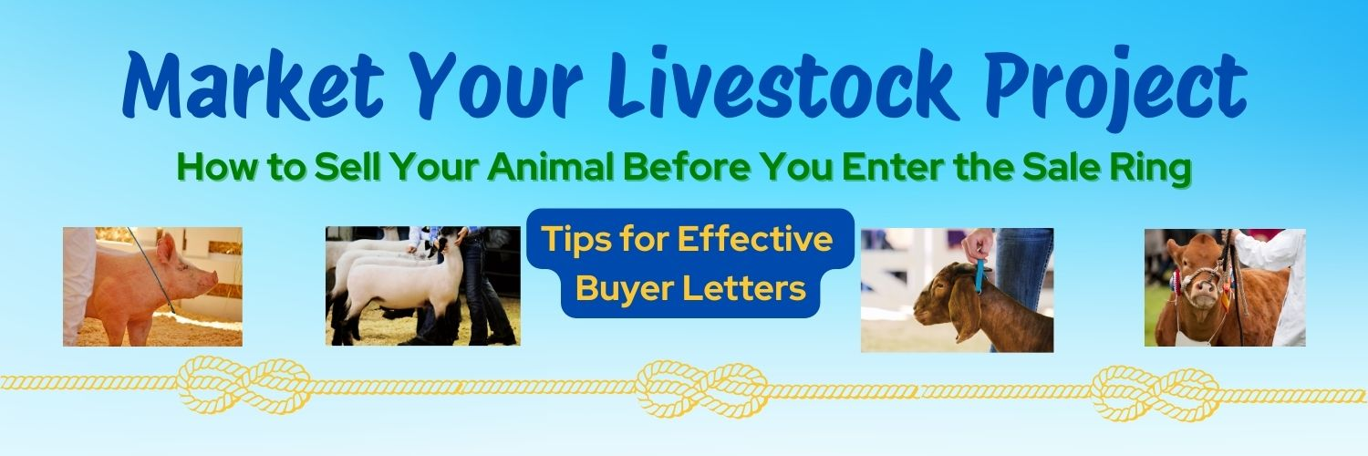

How to Sell Your Animal Before You Enter the Sale Ring!
A 4-H livestock buyer's letter is a personal invitation sent to prospective buyers before livestock auctions or fairs to encourage them to support youth livestock project work. These letters should be engaging, informative, and respectful, aiming to build a relationship with potential buyers and help them understand the value of supporting local youth. Many people and businesses are not aware of the livestock auctions that take place at the fair. With an invitation from you (a buyer letter) they could become potential buyers.

Key Elements of a Good Buyer's Letter:
- Introduction:
Start with a friendly and professional greeting, addressing the buyer by name if possible.
- About Yourself:
Briefly introduce yourself and your involvement in 4-H, including your club and the number of years you've been a member.
- About Your Project:
Describe your project animal, including its breed, name, and unique qualities. Highlight your dedication and hard work in raising the animal and explain something that the project has taught you, like responsibility, perseverance, and .
- Fair and Auction Details:
Clearly state the date, time, and location of the fair and livestock auction, including any specific show times for your animal's breed.
- Call to Action:
Invite the buyer to attend the fair and bid on youth project animals during the Junior Livestock Auction, and consider including a thank you for their support if they've been a buyer before.
- Thank You:
Express gratitude for their time and potential support.
- Personalized:
Keep the letter personalized and avoid using generic or photocopied letters.
- Handwritten or Typed:
Many buyers prefer handwritten letters, but typed letters are also acceptable.
- Consider adding a picture of yourself and/or your animal
A photo of you and your animal helps create a personal touch.
- Consider Hand-delivering Your Letter
You may mail your letter, but potential buyers and businesses appreciate the extra effort you demonstrate when you put on your uniform and visit them in person. By delivering it, you can make that important personal contact, and they will remember you at the fair.
- Proofread! Ask a Parent or Teacher to Review Your Letter
What to Avoid:
- Asking for a Donation: The auction is not for charity, so avoid asking for donations.
- Specific Price Requests: Do not state a desired price or bid.
- Personal Hardships: Refrain from including personal hardship statements in the letter.
- Overly Direct Language: Don't be overly direct or short in your language.
Examples of What to Include:
- "I am a member of the [Club Name] and I'm raising a [Breed] [Animal Type] named [Animal Name] for the [Fair Name] fair and livestock auction."
- "I've put many hours into feeding, watering, and training [Animal Name], and I would love for you to consider bidding on him/her at the [Fair Name] auction."
- "The fair will be held on [Date] at [Location], and the livestock auction will be on [Date] at [Time] in [Location]."
- "Thank you for considering supporting the youth of [County Name] and the hard work we put into our livestock projects."

