

Article originally posted in Spanish

CALIFORNIA
Big logistical challenge involves free food in schools. How to solve it?

School meals require great logistics on the part of the educational authorities. (La Vega Norm)
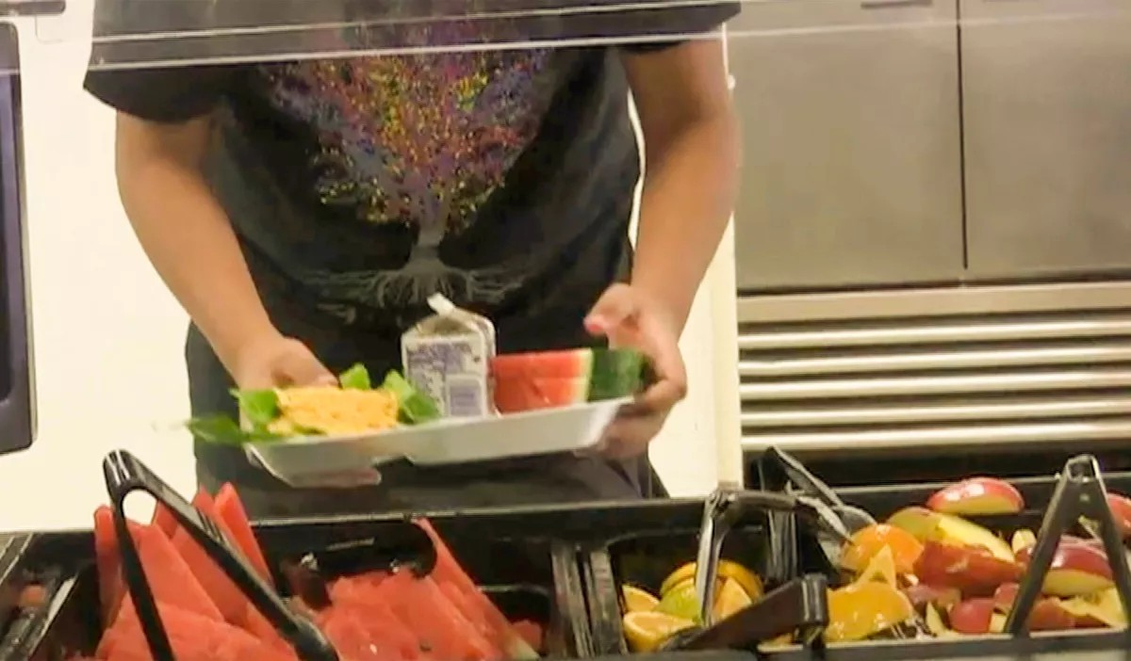
BY NORMA DE LA VEGA | DIVISION OF AGRICULTURE AND NATURAL RESOURCES OF THE UNIVERSITY OF CALIFORNIA

SEP 15, 2022 1:12 PM PT

In order to combat social disparities that make it difficult for children to learn and develop, California extended the Universal School Meals Program starting next school year 2022-2023.

By offering 2 of 3 free meals a day to all children in schools, students will have adequate nutrition to help them learn and reach their potential and the Nutrition Policy Institute, NPI, will be in charge of executing a study to evaluate the enormous logistical challenge that this implies for the schools as they go along and they will have to look for practical solutions to the problems that arise.

“It is going to be a challenge for schools to have such a large increase in the number of students who will be participating in the program,” says Mónica Daniela Zuercher , nutrition expert at NPI, the research unit of the Division of Agriculture and Natural Resources at the University of California.

In a tough economy, when food insecurity reaches unimaginable levels, an old wish of nutrition experts is finally embraced: providing healthy food to all students.

“We have to think in the long term, by having healthy children we will have healthy adults, so there will be savings in medicines. But there is also the cognitive and developmental part, how do we expect a child to learn at school if he is hungry or tired? ” points out the expert.

Permanently, around 6 million students throughout the state will be able to obtain the benefits of the Universal Program without forms and without bothersome questions and the most benefited will be Latinos, because they are the majority in schools, and they represent 55 percent and are the economically disadvantaged group along with African Americans.

There will be well-nourished students, less stressed parents, and in the long run, California will realize health savings as children learn to prefer healthy foods from an early age, preventing health problems such as obesity, diabetes, and chronic disease.

In 2010, a revolution happened in school cafeterias with the establishment of the Healthy Hunger-Free Kids Act. Since then, school cafeterias serve more fruits, vegetables and whole grains, and less fats, sodium, sugar, and sugary drinks have been eliminated.

“Nutritional standards have been established, at the national level, about the nutritional qualities that meals need to have in schools. So, it is important to highlight that not only two free meals are being offered in schools, but it’s also two healthy meals”, Zuercher says.

“It is going to be a challenge for schools to have such a large increase in the number of students who will be participating in the program,” says Mónica Daniela Zuercher , nutrition expert at NPI. (La Vega Norm)
California is the first state to implement free meals permanently. It is a complex logistical process that must be evaluated by experts, and for that reason NPI received funds for 2.4 million dollars, to carry out a follow-up that will last 4 years, to identify problems and issue solutions quickly during this entire period. .

“It is a very exciting study because it evaluates different stages, from its beginnings as a measure generated by COVID19, to the challenge that it will be for schools to have such a large increase in students who will be participating in the program. So we are going to capture the challenge that (schools) had to adapt during the pandemic itself and the problems that will arise along the way,” explains Zuercher.
e California Department of Education and with all those involved in the process: those responsible for food services in schools, parents and students.

The surveys that are part of the study have been planned based on the needs of the school population, so they are being implemented in English and Spanish to reflect the concerns and opinions of Latinos.

Here are some of the preliminary results that for now only include input from school food service directors:

Cafeteria workers did an amazing job during the pandemic crisis to adapt school meals served in schools, into grab-and-go meals. They successfully weathered all sorts of unforeseen changes due to labor shortages and food supply challenges.

Offering school meals to all students has reduced food insecurity among students during the COVID19 emergency.

Increased the number of students participating in school meals.

Reduced the debt of parents whose children did not receive subsidized school meals. A benefit for both schools and families. There was a slight reduction in the stigma surrounding school meals.

School meals have been a staple in the fight against food insecurity, but have generated conflict and social pressure within schools. Surrounding free food are feelings of guilt, rejection, and shame.

Zuercher emphasizes that many parents and students have the misconception that school meals are junk food or poor people's meals.

“We have heard from both food directors and some parents that the old idea that school meals are not healthy still prevails. It is an association, school food is not healthy, it is not fresh food, it is not freshly made, ”says Zuercher.

The hypothesis of the experts is that by extending free school meals to all students, it will also be possible to eliminate the conflict and the social pressure that these generate and that is something that time will be able to corroborate.

* Norma De la Vega works for the Department of Information and Dissemination in Spanish of the Division of Agriculture and Natural Resources of the University of California.

Copyright © 2022, Los Angeles Times | Terms of Service | Privacy | CA Notice of Collection | Do Not Sell My Personal Information

