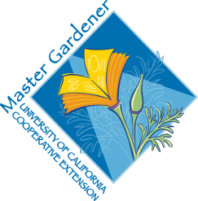

Germination Requirements by species
Plant Germination Requirements Seed Viability

Abutilon Germinate for 14 -21 days at 75 deg. Unknown

Calif. Poppy Soak seed for 30 min. in water at 125 deg; 10 yrs
Germ. 7-21 days at 70 degrees

Carnation Germ. 14-21 days at 60-70 8-10 yrs

Chrysanthemum 14-35 days at 65 deg; may need 1 month 9-10 yrs
stratification

Coneflower 20-30 days in the dark at 60-65 deg. Unknown

Coreopsis Stratify 3-4 wks; germ. 14-28 days in 6yrs
light at 68deg.

Cosmos 14-28 days in light at 70 deg. 5 yrs

Dahlia 10-14 days at 63 2-3 yrs

Gaillardia 14-21 days in light at 70-75 deg. 2-4 yrs

Gerbera Daisy 4-6 wks in sandy, peaty soil at 70deg unknown

Japanese Iris Rub w/sandpaper; germ. 1 month at 68
Degrees, then stratify 1 month, then move
to 50 deg.

Marigold 3-14 days in light at 74 deg. , shallow, vertical 5 yrs

Bonfire salvia Stratify 3 wks; germ. 7-21 days in light 1 yr
at 68 degrees

Mexican bush salvia, Mystic spires salvia, Wendy’s Wish salvia, etc. same as above

Sneezeweed This is a hybrid; do not save seed

Yarrow 10-14 days in light at 68 deg. 4 yrs

Zinnia Soak seed in 125 deg. water for 30 min.; 2-3 yrs Germ. 7-21 days at 70 deg.

