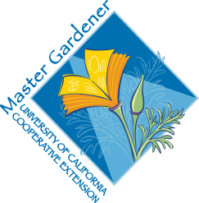

Saving Seeds 101

UC Master Gardeners of Placer County
Public Website pcmg.ucanr.org
Questions? Hotline (530) 889-7388
Rot Line (530) 889-7399
HANDOUTS
Resources Sheet//Veg Families
Easy-Peasy Seeds
Six Tips for Seed Saving
Saving Seeds Chart
Seed Viability

RESOURCE LINKS
Seed Collecting and Storing
https://web.extension.illinois.edu/lmw/downloads/42321.pdf
A Seed Saving Guide
https://seedalliance.org/wp-content/uploads/2010/04/seed_saving_guide.pdf
California Garden Web Vegetables Menu, including individual crops
http://cagardenweb.ucanr.edu/Vegetables/

BOOKS
Seed to Seed, Ashworth, Suzanne. 2002, second edition
The Complete Guide to Saving Seeds. Gough, Robert. 2011.

MORE
Seed Library Information richmondgrowsseeds.org
Seed Savers Exchange https://www.seedsavers.org/learn
UC Master Gardeners of Placer County are University of California Cooperative Extension (UCCE) ambassadors to the Placer County home gardening community. Master Gardeners promote environmental awareness and sustainable landscape practices, and extend research-based gardening and composting information to the public through educational outreach. UCCE is part of the Division of Agriculture and Natural Resources (ANR) of the University of California. UCCE Placer County: 11477 E Avenue, Auburn, CA 95603, (530) 889-7385
UC Master Gardeners of Placer County Hotline: (530) 889-7388; Website: http://pcmg.ucanr.org/ 7/19

