4-H Food Olympics
Guidelines

2018

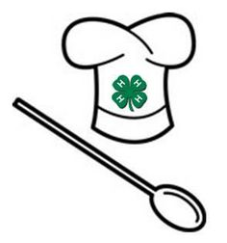
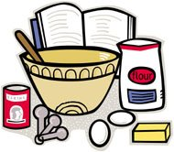

2018 Mendocino County 4-H Food Olympics
Part of Extravangza

Table of Contents

Favorite Foods Contest Page 3
Place Setting Contest 4
Cup Cake Decorating Contest 5
Recipe card example 6
Menu Example 7-8
Table Setting Hints 9-11
Evaluation Forms 12-13
__________________________________________________________

General Information
Food Olympics Contests
The Overall Theme for Extravaganza is Food Through The Years which includes the Food Olympics Contests.

The Food Olympics contests are open to all 4-H members. Pre-entry is required.

Age Divisions:

- Primary: 5-8 years old (may enter but will not be scored)
- Junior: 9-10 years old
- Intermediate: 11-13 years old
- Senior: 14-19 years old

For more information:

http://cemendocino.ucanr.edu/4H_Program/Fashion_Revue_and_Favorite_Foods

Favorite Foods Contest Guidelines
(no place setting)
General Rules:

Select a favorite food you would like to prepare—main dish, salad, vegetable, appetizer/snack or dessert. Plan a menu for the entire meal in which you would serve that dish. Keep in mind the USDA’s My Plate guidelines.

Prepare your dish for 4 people and bring it to the event ready to serve. To comply with food safety rules:
- Cold food must be kept at 40 degrees or colder.
- Hot foods must be kept at 140 degrees or hotter.
- The dish should not sit out longer than 2 hours.

The display should include:
- Menu card (explained on page 7)
- Recipe card (explained on page 6)
- Cost of ingredients to prepare Favorite Food (cost breakdown see page 6)
- Table covering (such as a cover or placemat)
- Prepared dish should be in an appropriate serving dish with the serving utensil.

You will be given a space approximately 22” wide x 29” deep to attractively display your prepared dish Remember: NO place setting is to be used in Favorite Foods contest.

Type your recipe on a separate paper in Times New Roman, size 12. The recipes will be collected after judging. Put your name and club on the recipe only, not on your display.

All entries must be made by the contestant. The contestant will set up their own display.
One entry per member per category.

Categories:

- Favorite Foods (see general rules above)
- Healthy Living (see general rules above)

Entry must include at least 2 out of the 4 requirements:**

- At least 1 fruit and/or vegetable
- A lean protein (legumes, beans, poultry, fish, etc.)
- A whole grain (oats, corn, whole wheat, brown rice, quinoa etc.)
- A low fat or fat-free dairy product

**No added sugar (honey, molasses and applesauce are acceptable)
**Ingredients used should be lower in sodium, where applicable (i.e. low sodium broth).

All other rules for an entry for Favorite Foods apply to the Healthy Living Category. There will be County Winners in the Favorite Foods Category as well as the Healthy Living Category. As long as there are 5 entries in each category each can award a County Winner. If there are less than 5 in each category the staff reserves the right to combine the two to determine a County Winner.
Encourage your friends to enter!
Place Setting Contest Guidelines
(no food)
General Rules: Theme is Food Through The Years

The Food Olympics contest for 4-H members. For Food Olympics, setup starts at 1:00 p.m., judging will start at 2:00 p.m. Select a theme for your place setting. This can be holiday, family celebration, BBQ anniversary, or any other occasion. Plan a menu for the entire meal, keeping in mind the USDA’s My Plate Guidelines.

Select a coordinated place setting for your entry. You will need dishes and silverware for everything on your menu.

- Tablecloth or placemat
- Dishes
- Silverware
- Centerpiece (low)
- Menu card (see page 7 for more information)

Place setting is only for one person.

Arrange your place setting attractively.

Do not put your name on the display.
One entry per member.

You will be given a space approximately 22” wide X 29” deep to display your place setting.
Participants must set up their own place setting. (Helpful hint: Take a picture of your place setting at home, print picture and bring it to the event so you have a reminder of how you want your place setting to look. Examples:

Cup Cake Decorating Contest Guidelines

General Rules: Theme: Food Through The Years

4-H members participating in the Cup Cake Decorating Contest will be given 2 cupcakes to decorate.

Participants have 30 minutes to decorate the 2 cupcakes.

The cupcakes must be decorated identically, or if incorporating a theme, the cupcakes may be decorated differently while still carrying out the theme.

Participants must bring all the equipment and ingredients to decorate the cupcakes. Include items to help keep your work space clean (paper towels, sponge, etc.) Please cover any brand names on frosting container, etc.

All decorations used for the cupcakes must be made during the 30 minutes allotted.

Cupcakes will be judged on originality and quality of decorating.

One entry per exhibitor.

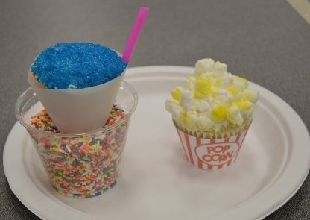
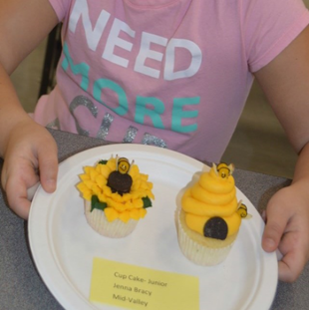
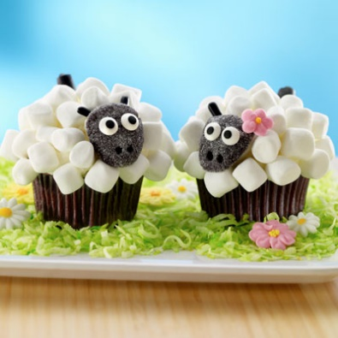
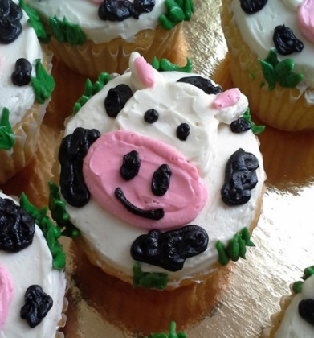

Encourage your club members to participate.
We could see which club is the overall winner of this contest.
Please spread the word.
Favorite Foods Contest Guidelines

Recipe Card Example

Type in font Times New Roman, size 12, on 8-1/2 x 11” white paper

Rice Cereal Treats

Ingredients:
3 tablespoons butter
1 package (10 oz., about 40) marshmallows
6 cups rice cereal

Directions:
1. In a large saucepan melt butter over low heat. Add marshmallows and stir until completely melted. Re-move from heat.
2. Add rice cereal. Stir until well coated.
3. Using a buttered spatula or wax paper, evenly press mixture into 13 x 9 x 2 inch pan coated with cooking spray. Cool. Cut into 2-inch squares. Best if served the same day.

Prepared by: (Name 4-H member) 4-H Club:

Cost Breakdown of Ingredients

Please include on paper with recipe. May use back of paper if more space is needed.

3 Tablespoons butter $________________
10 ounces marshmallows $________________
6 cups rice cereal $________________

TOTAL: $________________

Note: For most of the ingredients purchased, you may use only a portion of the package/contents.

For butter: Divide the price of the pound of butter by 4. This will give you the cost of 1 stick of butter. After you know the cost of 1 stick of butter, divide that by how many tablespoons are in a stick (8 tablespoons), then multiply by 3 since the recipe calls for 3 tablespoons of butter. This will be the cost of the butter used.

Menu Writing for Favorite Foods & Place Setting

The following guidelines are helpful in planning a menu.

- Use descriptive terms that give information about the temperature, texture, color, or other special characteristics of the food or the method of preparation.

Example: Chilled Apple Cider, Broiled Sirloin Steak, Cream of Asparagus Soup, etc.

2. Write menus in a symmetrical arrangement on the page, listing foods in the order they are served.

Example: Broiled Hamburgers
Baked Potatoes with Sour Cream
Broccoli and Glazed Carrots
Hot Rolls with Whipped Butter
Iced Tea

- Capitalize all words except articles and prepositions—words such as or, and, of, with, etc. are not capitalized.

Example: Cream of Mushroom Soup

4. Foods should be grouped by courses. The most important item should be listed first.

Example: Broiled Hamburgers

5. If foods are served with an accompaniment, list the food first.

Example: Baked Potatoes with Sour Cream
Cheddar Cheese Cubes with Rye Chip

6. If the main dish has two or more accompaniments, center the main dish and space the accompaniments on the same line on either side, or write them on the line below.

Example: Whole Grain Crackers- Chicken Soup - Soda Crackers

Chicken Soup
Whole Wheat Crackers and Soda Crackers

7. Items such as butter, cream, sugar, or salad dressing are not written on menus unless they are special in some way.

Example: Crusty Rolls with Whipped Butter
Wedge of Lettuce with Thousand Island dressing

- The beverage(s) appears as the last item(s).

Example: Iced Tea

- Allow extra spacing between courses. This is often omitted in menus printed in books, magazines, and newspapers in order to save space. The following menu is for a three course meal.

Example:**
Family Holiday Celebration

French Onion Soup
Whole Wheat Crackers
Celery Sticks, Assorted Olives

Prime Rib of Roast Beef au Jus
Potato Soufflé
Asparagus with Hollandaise Sauce
Mixed Green Salad
Hot Rolls with Whipped Butter

Lemon Ice
Coffee and Hot Tea

**For the Favorite Foods Contest the menu card is a decorative part of your display. Taken from: http://four-h.purdue/foods/Writing%20menus.htm

Table Setting Contest Helpful Hints

The purpose of a table setting is to make the act of eating easy.

Objects that are used in the right hand are placed to the right of the plate: knives, spoons and beverage containers. The fork is laid to the left of the plate because historically it was used only in the left hand.

The Cover
The cover consists of the dinnerware, beverage ware, flatware, and linens to be used by each person—it is the individual’s place at the table. The cover size for the place setting contest is approximately 22” wide (left to right) by 29” deep (front to back).

Linens: Linens consist of the tablecloths, placemats and other table covers and napkins used on the dining table, regardless of fiber content. Linens should be spotless and wrinkle-free. Plastic and paper tablecloths, placemats and napkins are permissible if they complement the theme of the place setting.

Napkins: The napkin is usually placed to the left of the fork(s). However, if the covers are close together, it can be placed in the center of the plate, in a glass, etc. A 12-inch size napkin is usually for breakfast and lunch. For the dinner meal, an 18-inch (or larger) napkin is preferred

Placemats: Lay placemats flush with the table edge or not more than approximately ½” from it. (If using a tablecloth, fold to the appropriate size designated for the cover.)

Table Decorations
Table decorations should be appropriate for viewing while dining. Resist the temptation to make the centerpiece too grand as it can be a distraction. Keep it low so your guests can easily see over it and feel comfortable talking with those across the table. Centerpieces should be in good taste.

Dinnerware

Bread-and-Butter Plate: Place the bread-and-butter plate to the left of the cover near the tip of the fork. In this position, it balances the glass or glasses on the right of the cover. In addition, the bread and butter plate can be used for celery, olives, and other relishes eaten with the fingers. The dinner or luncheon plate, if not overcrowded with food, is a suitable place for bread and butter, especially when the bread is served hot. The bread-and-butter plate is used when a table is large enough to accommodate it, but it is not a “must” in table setting

Salad Plate: Unless served at the table, the salad is placed at each cover shortly before serving time. It may be placed in any of several positions.

- If no bread-and-butter plate is at the cover, place the salad at or near the tip of the fork. This is a widely used position and one that allows good leverage in cutting salad vegetables.
- When a bread-and-butter plate is included in the cover, you may place the salad to the left and a little below the bread-and-butter plate. However, unless covers are spacious, this position is often not possible. Where covers are close together, you may move the bread-and-butter plate a little to the left and place the salad to the right of it. In this position, it is above the luncheon or dinner plate.

Flatware: Lay pieces of flatware (silverware) in the order of use from the outside toward the plate. This is done for convenience during dining. Pieces should be laid close together but not touching.

- Knife: Lay the dinner knife to the right of the plate with the cutting edge directed toward the plate. All knives are laid with the cutting edge toward the plate, a 0position that protects the fingers of the right hand as it grasps the knife. When no dinner knife is required for the eating of a simple family meal, it can be omitted from the setting. Butter Knife: You may place the butter knife on the bread-and-butter plate.

- Spoons: Lay spoons with the bowls facing up at the right of the knife. Spoons should be placed in the order they will be used—the spoon used first farthest from the plate.

- Forks: Always lay the fork(s) with the tines facing up at the left of the plate, with this exception- a fork for eating seafood is laid to the right of any spoons in the cover because this fork is used in the right hand only. Lay the salad fork nearest the plate and the dinner fork to the left of it if you intend that the salad be eaten with the main course or after it. Lay the dinner fork nearest the plate and the salad fork to the left of it if you intend that the salad be eaten before the main course. It is not necessary to provide a salad fork when the salad accompanies the main course.

Beverageware
Place the water glass at the tip of the knife, or a little to the right or left of the knife depending on the size of the table, the cover, etc. Glasses placed in addition to the water glass are positioned successively closer to the table edge but not so as to modify the position of the flatware on the right side of the cover. Generally no more than three glasses appear within a cover.

Miscellanous notes
- If your table is marred you may cover it with a tablecloth, and then use the placemat you would normally use. (Keep in mind your space allocation.)
- If using a formal table setting, the arrangement of the cover may look cramped, but the judge will understand.
- Breakfast and lunches are usually simpler meals with most food items on the same plate. Dinners may be served in courses with necessary dishes stacked in order of use with first item used on top.

Sample Place Settings

Breakfast/Lunch:
Dinnerware, flatware and beverageware may vary depending on your menu.

.
Formal Dinner:
Dinnerware, flatware and beverage ware may vary depending on your menu.

- Napkin
- Salad fork
- Dinner fork

- Dessert fork & spoon
- Bread & butter plate with spreader
- Dinner plate
- Dinner Knife
- Teaspoon
- Soup spoon
- Cocktail fork
- Water glass
- Beverage glass
- Beverage glass
- Coffee cup and saucer

Family Dinner:
Dinnerware, flatware and beverage ware may vary depending on your menu.

