Contents

- Reducing Fertilizer Input Costs
- R.O.U.S. – Rodents of Unusual Size
- Take The Time to Evaluate the Level of Stem Rot
- Hedgerows in Rice Update

Save-the-Dates!

Propanil Stewardship Meetings

March 17, 2025
Yolo County Farm Bureau
69 W Kentucky Ave, Woodland, CA 95695
March 18, 2025
UCCE Sutter-Yuba
142 Garden Hwy, Yuba City, CA 95991

An in-depth discussion that covers propanil stewardship and alternative watergrass management strategies. More details to come. For more information, contact your local Rice Farm Advisor.


Reducing Fertilizer Input Costs


Already this year I have had a couple of calls asking how to lower fertilizer costs. My guess is that these questions are largely related to the current low rice prices and growers wanting to reduce input costs in general. From a fertility perspective, here are a few strategies to help reduce input costs.

Bruce Linquist, UCCE Rice Specialist, UC Davis
If you routinely apply a top-dress nitrogen (N) application, consider applying all the N you would normally apply as a top-dress at planting using aqua-N. We have done a lot of research on this and have seen no benefit of splitting the total N rate. If the field remains flooded early in the season, this aqua-N is efficiently used. This saves cost for two reasons. First, aqua-N is a cheaper N source than ammonium sulfate (typical top-dress N source). Second, you avoid the airplane costs associated with topdressing. I am often asked about the benefits of the sulfur (S) fund in ammonium sulfate. I have never seen S deficient rice in CA; and in the testing that I have done, the soil and plant S concentrations have always been above critical levels.
Was your field fallow last year? For the past four years we have been doing research at the Rice Experiment Station on how to manage N fertilizer in rice fields where the previous year the field was fallowed. I have written about our findings more extensively in previous articles. The bottom line is that there is more soil N available from fields which were fallowed the previous year. Thus, if you have a field coming out of fallow (and it had been in rice prior to that for several years) you can reduce N fertility rates. Our research shows that rates can be reduced by 20-40 lb N/ac.
Importantly, for both the strategies mentioned above, it is important to keep a close eye on the crop around panicle initiation (40-45 days after planting) to see if it is displaying any signs of N deficiency. This can be done with a Leaf Color Chart, a Green Seeker, or plant analysis – all of which have been discussed in previous newsletters. If the crop is showing signs of deficiency at this time, apply the top-dress of N.
Finally, test your soil. You may not need to apply phosphorus (P) and potassium (K) fertilizer. I recommend applying a balanced fertility program that balances the P and K removed from the field in harvested grain (and maybe straw) with what is applied as fertilizer. This is especially the case when soil tests are not used as it ensures an adequate supply of these nutrients. However, a decision to fertilize with P and K can be based on a soil test. If your soil P levels are above 12 ppm (Olsen P/soil bicarbonate test), consider not applying P as these soil P levels are adequate. Similarly, if your soil K levels are above 120 ppm, you may not need to apply K fertilizer. In areas on the east side of valley – especially the red soils, higher soil K levels may be necessary.

Rodents of Unusual Size


Let’s talk about nutria. Nutria (Myocastor coypus) are large, semi-aquatic rodents that are native to South America. The species is invasive in the United States and currently established in 17 states, including California. Nutria inhabit both freshwater and brackish coastal water areas and can be found near permanent water sources, including rivers, streams, lakes, ponds, wetlands, and continual rice production. However, they can still thrive in urban conditions; in cities, they can be found under buildings, in overgrown lots, on golf courses, and in storm drains. Nutria thrive in warmer climates, such as the southeastern region of the U.S., and their reproductive success is reduced by severe winter conditions. They can grow in size up to 20 lbs and have partially webbed feet. Often mistaken for small beaver or large muskrats, nutria can be differentiated by large front teeth that are yellow to orange in color, a heavy, rat-like tail, and prominent white whiskers that protrude from either side of their nose.
Sarah Marsh Janish, UCCE Rice Farming Systems Advisor – Colusa & Yolo
Incidentally, nutria have actually been present in California for over a century. Introduced in 1899 to stoke the fur trade, the first members of the species were spectacularly unsuccessful. Subsequent introductions of nutria followed in the 1940s and 50s, but once again failed (as did the nascent nutria fur market), and the species was declared eradicated from California in the 1970s. This remained true until the spring of 2017, when CA Department of Fish and Wildlife (CDFW) trapped and necropsied a pregnant female nutria in Merced County (CDFW). This triggered monitoring and eradication efforts across the state, which have indicated that nutria is spreading further north every year.
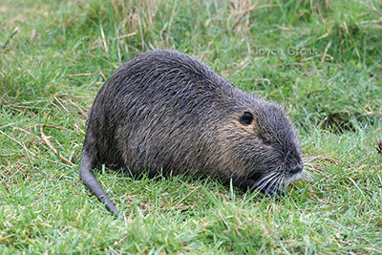
Photo courtesy of Joyce Gross, UC Berkeley
The Problem with Nutria
Nutria create havoc through 1) the damage they wreck and 2) the abundance of their offspring.
- Nutria cause various kinds of damage through burrowing, intense herbivory, and carrying pathogens and parasites.
  - Nutria do not construct dens; rather, they burrow, frequently causing water-retention or flood control levees to breach, weakening structural foundations, and eroding banks.
  - They can consume up to 25% of their body weight in above- and below-ground vegetation each day, but they waste and destroy up to 10 times as much, causing extensive damage to the native plant community and soil structure, as well as significant losses to nearby agricultural crops (CDFW). The loss of plant cover and soil organic matter results in severe erosion of soils, in some cases destroying marshlands. The destructive feeding habits of nutria threaten populations of rare, threatened, or endangered species that rely on critical wetland habitats.
  - Nutria also serve as hosts for tuberculosis and septicemia, which are threats to humans, livestock, and pets. Additionally, nutria carry tapeworms, a nematode that causes a rash known as “nutria itch”, and blood and liver flukes, which can contaminate swimming areas and drinking water supplies (CDFW).
- Nutria are such prolific breeders that one female can lead to 200 offspring in just a year.
  - Nutria reach sexual maturity at about four to six months. Females have anywhere from five to seven babies in a litter, and they have several litters every year.
  - Additionally, nutria have a high rate of migration and can move up to 50 miles from their original colonies.
The CDFW map image below shows the location and density of nutria taken in each area in red, with yellow circles indicating hot spots of habitation and blue halos indicating areas of likely infestation. As of January 8, 2025, a total of 5,448 nutria have been taken in California, with additional animals confirmed present, across Merced, Stanislaus, Fresno, Solano, San Joaquin, Fresno, Mariposa, Sacramento, Madera, Contra Costa, and Tuolumne Counties.

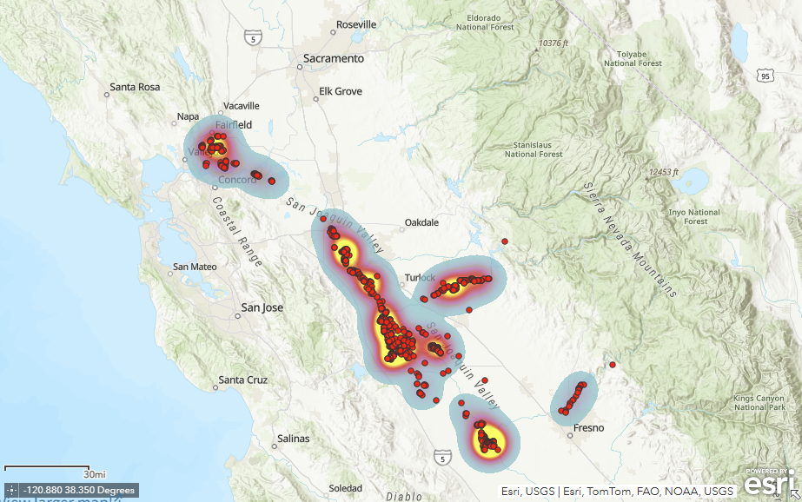

What Does This Mean for CA Rice?
So, why are we talking about this semi-aquatic mammal in the rice newsletter?

The current geographic distribution of nutria in California concerns those of us involved in rice production. As the preferred habitat of these rodents is identical to that of a rice field, the potential for damages is high. Additionally, identifying the rice damage caused specifically by nutria can be challenging, as it is easy to confuse it with damage caused by muskrats: both rodents clip the stems of the rice plants at the water line.

At high densities and under the right environmental conditions, the foraging of nutria can substantially impact plant communities. In the U.S., rice is one of the primary crops damaged by nutria, which can reduce yields through grazing and other crop destruction. However, nutria also favor crops and plants that can neighbor rice fields, including corn, grain sorghum, beets, alfalfa, wheat, barley, oats, peanuts, melons, and a variety of vegetables from home gardens and farms.

What is Being Done to Address Nutria
CDFW is collaborating with other agencies and local partners to develop the most effective strategy for eradicating nutria from California. The organization has created an “Invasion Curve” (below) that represents a hypothetical population increase from an invasive species infestation. The infestations typically experience a lag phase, while populations and area infested are relatively small and successful eradication has the most potential for success. As time progresses, the population size, area infested, and costs required for control increase exponentially, and the probability of successful eradication is lost. 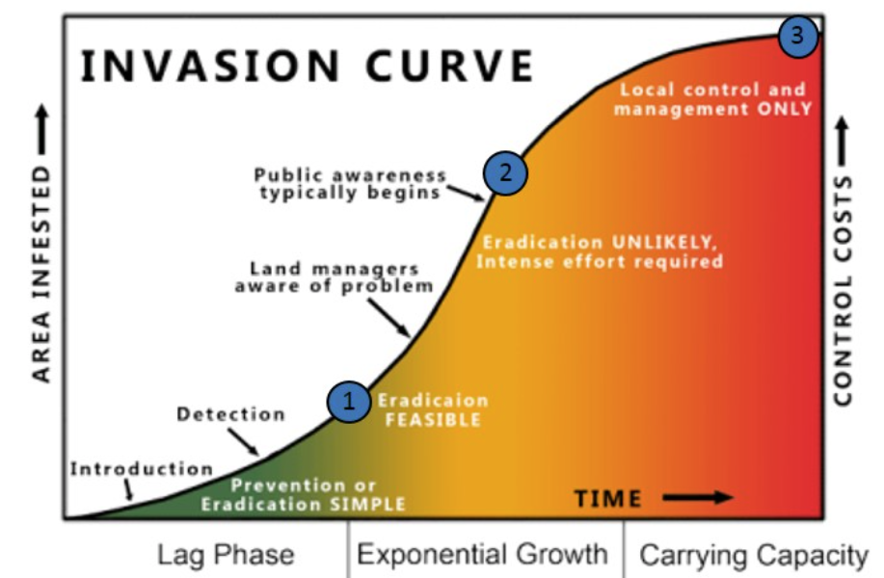 CDFW believes that Stage 1 represents the current state of the nutria population in California, indicating that eradication is possible if rapid response is taken. This is good news, especially compared to Stage 3, which is conceptually represented by the nutria population in Louisiana, where population control costs up to $2 million per year for bounty harvests alone.

In California, nutria are classified as a nongame mammal. Fish and Game Code §4152 specifies property owners or their agents (who possess written permission from the owner or tenant) may take nutria at any time by any legal means to address damage to crops or property. Restrictions apply to the use of traps and types of traps. Nutria are a Restricted Species in California under the California Code of Regulations, Title 14, Section 671, and cannot be imported, transported, or possessed live in the state of California.

In other states, bounty programs are underway to encourage taking of nutria. However, in California, it is illegal to offer a bounty for nutria. Under California Fish and Game Code, section 2019 clearly states: “It is unlawful for any person, including state, federal, county and city officials or their agents, to authorize, offer or pay a bounty for any bird or mammal.” State legislation changes would have to take place to alter the code and provide an exception for nutria.

Given their very similar appearances, particularly in overlapping size classes, citizens should take extra caution to distinguish nutria from other aquatic mammals. The majority of nutria reports received by CDFW have been muskrats, as have been some "nutria" featured in the media. Any nutria taken on private or public land should be reported to CDFW as soon as possible for purposes of delineating the extent of the infestation. At minimum, CDFW needs photos to confirm identification; preferably, CDFW needs the carcass to determine sex, age, and reproductive status. Suspected observations or potential signs of nutria in California should be photographed and immediately reported to CDFW ONLINE, by email to Invasives@wildlife.ca.gov, or by calling (866) 440-9530. Observations on state or federal lands should be immediately reported to local agency staff. If this species is captured, do not release it; immediately contact your local CDFW office or County Agricultural Commissioner.

Take the Time to Evaluate the Level of Stem Rot
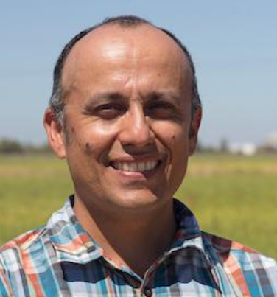
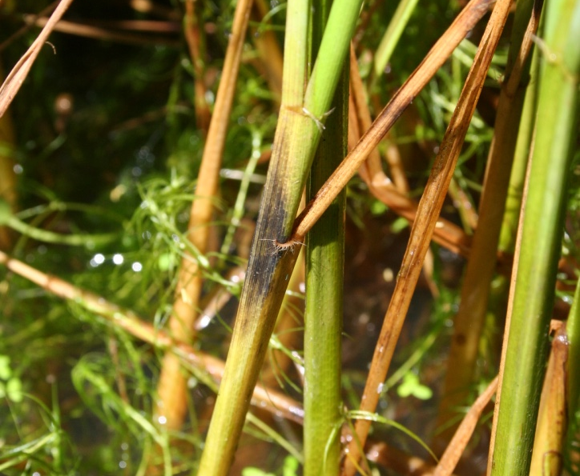

Last year was a pretty average year when it comes to rice diseases. The UC rice team did a disease survey to support the reauthorization of the allowance to burn rice straw, so we have a pretty good idea of what was out there.

Luis Espino, UCCE Rice Farming Systems Advisor – Butte & Glenn

Blast was not a problem. I did get several calls about fields with suspected blast, but after visiting them we were able to determine that they were not affected by blast. In the survey, we only found seven panicles with symptoms of blast out of 1600 samples. We did find some kernel smut, most of it on the north west area of the Valley (Glenn and northern Colusa counties) and in the easter side of Sutter and Yuba counties. I did not receive any reports of kernel smut being a serious problem.

As expected, the tiller diseases, stem rot and aggregate sheath spot, were found widely distributed in the survey. Of the two disease, stem rot is the most serious one. I view this disease as a “silent thief”. I say this because of how the disease develops. Stem rot lesions develop after the canopy has closed, and so it can be difficult to notice. Also, when the disease is not severe, there
is no effect on yield. But as time progresses, the disease starts to increase in severity and yield is affected. This process can be slow, so it may not be obvious that the disease is causing a loss.

The best way to determine if stem rot is becoming a problem is to take a tiller sample and look for stem rot lesions. The best time to do this is at drain time, because this is when the lesions are the most obvious. However, it can be difficult to take the time to do this then, when harvest is just around the corner.

You can also determine the level of stem rot at the late boot stage, right before heading. For the past two years I have conducted a project looking to develop some guidelines to evaluate stem rot at the boot stage. Take a handful of tillers and cut them at the soil level. Repeat this process two more times around you so you have three handfuls. Combine all tillers and select at least 30 and determine what percentage have stem rot lesions. Repeat this process in a few more areas of the field, avoiding nitrogen overlaps. If 50% or more tillers have stem rot lesions, the severity of stem rot is high and you should implement practices to address the disease (evaluate nitrogen use, address potassium deficiency, improve residue management, and use fungicide). In my trials, I have found that at this incidence level, yield losses can be as high as 6%. If you do your evaluation at drain time, stem rot severity will be considered high when 100% of your tillers show stem rot symptoms.

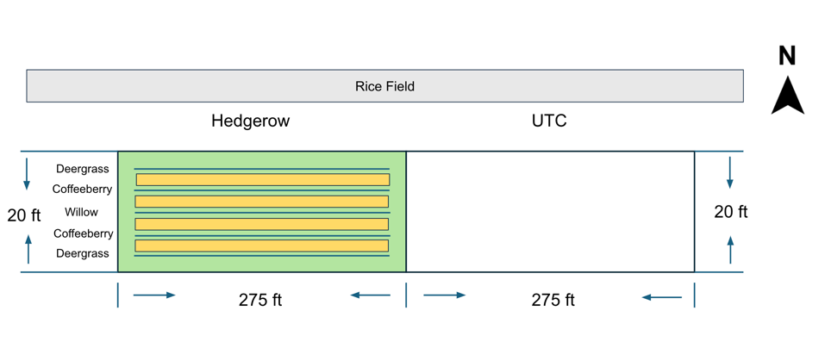

Hedgerows in Rice Update

Incorporating hedgerows in rice could provide growers with an alternative method for managing field margins without relying on pesticide applications to control the pests along the edges of rice fields. They may potentially improve soil health and lower costs for maintaining field edges and permanent levees. They may also increase beneficial insects found in rice fields. This study is the first of its kind in California rice, and provides the opportunity to learn about potential benefits to installing hedgerows along rice fields. In 2024, we established a hedgerow and collected data on soil health, weed control, insect populations, and success rates of hedgerow plants. The study is funded by the California Department of Food and Agriculture’s Healthy Soil Program, and will continue to through 2027.

Luis Espino, UCCE Rice Farming Systems Advisor – Butte & Glenn

Whitney Brim-Deforest, UCCE Rice Advisor – Sutter-Yuba, Placer, Sacramento

Taiyu Guan, UCCE Research Assistant Specialist

The study site is located on a permanent levee next to a rice field in Arbuckle, in Colusa County. The field is rotated with annual crops, with rice being the main crop. The hedgerow area and the unplanted control area are adjacent and share the same soil type. Both the hedgerow and control areas measure 275 feet in length and 20 feet in width (Fig. 1).

Sarah Light, UCCE Agronomy Advisor – Sutter-Yuba & Colusa

Figure 1. Demonstration setup and area. The yellow squares between the hedgerow plants represent the areas seeded with California poppies (Eschscholzia californica).
In April 2024, we established a hedgerow of native plant species suited to Colusa County, including:
- Arroyo willow (Salix lasiolepis)
- Coffeeberry (Rahmnus californica = Frangula californica)
- Deer grass (Muhlenbergia rigens)
- California poppy (Eschscholzia californica).

The species are adapted to the soil and climate conditions of the study site and are also recommended by Rachael Long (2010) (https://ucfoodsafety.ucdavis.edu/sites/g/files/dgvnsk7366/files/inline-files/26499.pdf).
All plants were purchased from a local nursery in Butte County and were transplanted from pots. The arroyo willows were spaced 15 feet apart, the coffeeberry 7.5 feet apart, and the deer grass 5 feet apart. Since the optimal seedling time for California poppy is late winter or early spring, we delayed seeding until November 2024. California poppy seeds were hand-sown in the spaces between the hedgerow plants at a seeding rate of 15–20 pounds per acre. In November 2024, we replaced the dead hedgerow plants to ensure the hedgerow’s continued effectiveness.
Irrigation is recommended during the first three years to ensure the survival of hedgerow species during California's dry season. Since the experiment began in April 2024, we irrigated the field twice weekly for approximately 4–6 hours through October 2024. When temperatures reached 110°F, we increased irrigation to three times per week. Additionally, we hand-irrigated individual plants that required extra water. In addition to irrigation, we fertilized the hedgerow species after transplantation in April 2024 to promote establishment and improve survivability. Urea was applied at a rate of 15 g to the deergrass and coffeeberry, and 30 g to the arroyo willow.
We studied the effects of implementing hedgerows in annual cropping systems across four key aspects: (1) soil health, (2) insects’ population, (3) weed pressure, and (4) establishment success rate for hedgerows.
Soil Health
To evaluate the benefits of hedgerows on soil health, we conducted baseline soil sampling on April 4th, 2024, in both the hedgerow and the unplanted control areas. Samples were sent to the lab and analyzed for carbon, nitrogen, organic matter, and micronutrients. We collected bulk density data on April 10th, 2024 and conducted soil water infiltration data collection on November 8th, 2024.

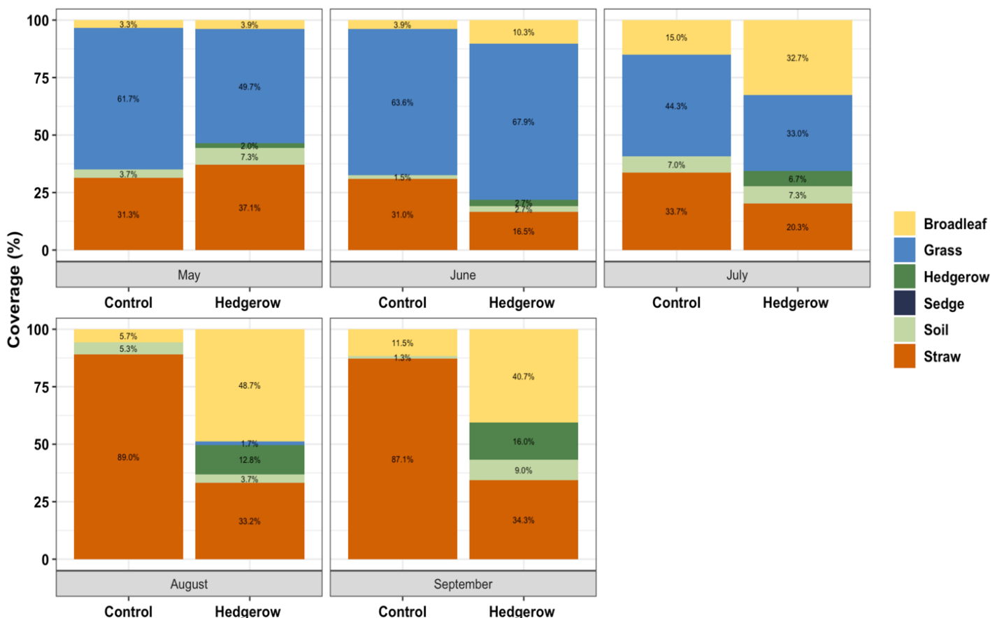
As this study only began last year, data collection on soil health is still ongoing, and analysis has not yet been completed.

Insect populations
To evaluate the benefits of hedgerows on insect populations, we used pit traps (in the ground) to collect the crawling insects and sticky traps to collect flying insects. We set up three pit traps and three sticky traps from the east, center, and west sections of the hedgerow area and unplanted control area and collected data monthly from May to September in 2024. In addition to traps, we used insect nets to sample insects from the tops of hedgerow plants, unplanted control areas, and adjacent rice fields. We conducted sweeps once each from the east, center, and west sections of both the hedgerow and unplanted control areas. We also conducted three sweeps at 40, 80, and 120 feet from the edge of both the hedgerow and unplanted control areas. Like the traps, insect sweeps were performed monthly from May to September in 2024.
Figure 2. Percent cover in the hedgerow and untreated control of broadleaves, grasses, soil, straw, and hedgerow plants. Measurements were taken in 15 random 1 m x 1 m quadrats monthly per area starting at 1 month after planting.

As this study only began last year, data collection on insect population is still ongoing, and analysis has not yet been completed. However, we noticed an increased presence of praying mantises in the hedgerow areas, suggesting potential benefits in attracting more beneficial insects.

Weed Pressure
To evaluate the benefits of hedgerows on weed control, we made a pre-emergent spray to control the weeds in the hedgerow area on April 2nd, 2024, before the experiment began. We used a tank mix of glyphosate + glufosinate + 2,4-D at their highest label rates and applied using a 10 ft handheld boom at 20 gallons of spray per acre. We assessed weed pressure in the hedgerow area and the unplanted control area monthly from May to September in 2024. Data collection included the percent cover of hedgerow plant species, weeds (grasses and broadleaf species), bare soil, and straw.
The first-year species composition data (Fig. 2) indicates significant differences between hedgerow plots and unplanted control areas. Specifically, we observed an increase in broadleaf weeds in the hedgerow plots over the summer, likely due to irrigation. The hedgerows also appeared to have much less residual straw, suggesting that irrigation may accelerate straw decomposition.
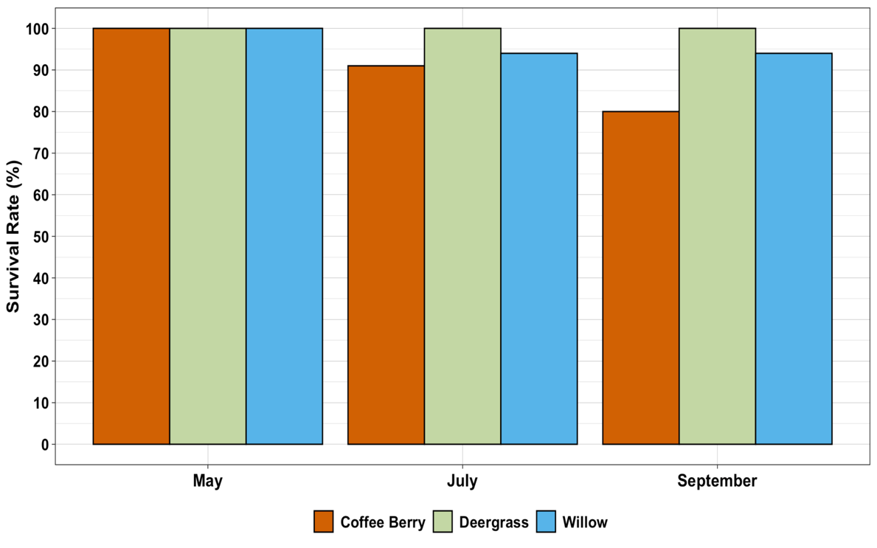
Establishment success rate for hedgerows
Figure 3. Percent survival of the transplanted coffee berry, deergrass, and willow at 1 month, 3 months, and 5 months after planting.

To evaluate the establishment success rate for hedgerow plants, we evaluated which plants survived the planting and established well. In May, July, and September 2024, we collected survivability data by counting the number of alive and dead plants for each hedgerow species. The survivability percentage = (the number of living plants/the total number of plants initially planted) * 100.

The first-year survivability data (Fig. 3) indicates coffeeberry appears less suitable as a hedgerow species in this particular location, potentially due to its intolerance to flooding. Willow and deer grass, however, may be better options. The hedgerow species' survival rate can be affected by the transplanting, so it is important to ensure the correct transplanting methods are used. Improper transplanting can lead to transplant shock, which may decrease plant survival. Hedgerow species could also be significantly affected by pesticide drift, particularly if pesticides are applied by air. This applies to both organic or conventional pesticides. To minimize pesticide exposure, it is important to maintain buffer zones between spray fields and hedgerows. Additionally, using larger spray droplets, applying pesticides during calm weather, and adjusting nozzle settings can help reduce drift. At this site, we collected phytotoxicity data, and found no phytotoxicity present after the adjacent rice field had an herbicide application.

It is the policy of the University of California (UC) and the UC Division of Agriculture & Natural Resources not to engage in discrimination against or harassment of any person in any of its programs or activities (Complete nondiscrimination policy statement can be found at http://ucanr.edu/sites/anrstaff/files/215244.pdf ). Inquiries regarding ANR’s nondiscrimination policies may be directed to John I. Sims, Affirmative Action Compliance Officer/Title IX Officer, University of California, Agriculture and Natural Resources, 2801 Second Street, Davis, CA 95618, (530) 750-1397

