Likely First Report of Powdery Mildew
Caused by the Fungus Erysiphe magnifica
on the Landscape Tree Magnolia grandiflora
DONALD R. HODEL, PAUL SANTOS, AND SUZANNE ROONEY-LATHAM
Magnolia grandiflora, commonly known as Southern magnolia or bull bay and one of our most noble and cherished American trees, is cultivated worldwide for its imposing, handsome habit, attractive, glossy green leaves, and large, showy, fragrant, white flowers. Unfortunately, its days as a preferred landscape subject in California are threatened as the ravages of climate change, including increasing temperatures and aridity and decreasing rainfall and water availability, sadly now make it an inappropriate choice to adorn our urban forests and landscapes.
Although considered mostly pest and disease free, climate change might be accelerating these maladies. Recently, tuliptree scale has become a resurgent and particularly nasty pest of Magnolia grandiflora (Hodel et al. 2018) and now, for the first time in California, a powdery mildew has been detected on this beloved species.
As the common name implies, Southern magnolia occurs from North Carolina south to Florida and west through the Gulf states to Texas and Arkansas. This natural range is generally moist and humid, perfect conditions for the development of powdery mildews. Nonetheless, powdery mildew was mostly unknown on Magnolia grandiflora in Southern California.
Thus, when co-author Paul Santos received damaged leaves of Magnolia grandiflora from Ray McGinty of C. G. Landscape, Inc., Anaheim, California in early 2023 from a site in nearby Orange, he was surprised to find powdery mildew as the culprit (Figs. 1–3). He sent samples to co-author Suzanne Latham at the California Department of Food and Agriculture Plant Diagnostics Center in Sacramento for confirmation. ITS sequencing data showed that the California isolate (GenBank OR461474) was 99.5% to 99.7% similar to other sequences of Erysiphe magnifica (U. Braun) U. Braun & S. Takamatsu (2000). Although E. magnifica is the most widespread powdery mildew on Magnolia species worldwide (Ondruŝková et al. 2014), we were unable to find a reliable reference to E. magnifica on M. grandiflora; thus, this detection might be the first confirmed record.
Here we provide an account of this novel pathogen/host interaction, including information about the pathogen, its relatives, host Magnolia species, and their ranges; symptoms and signs on M. grandiflora; and landscape management.

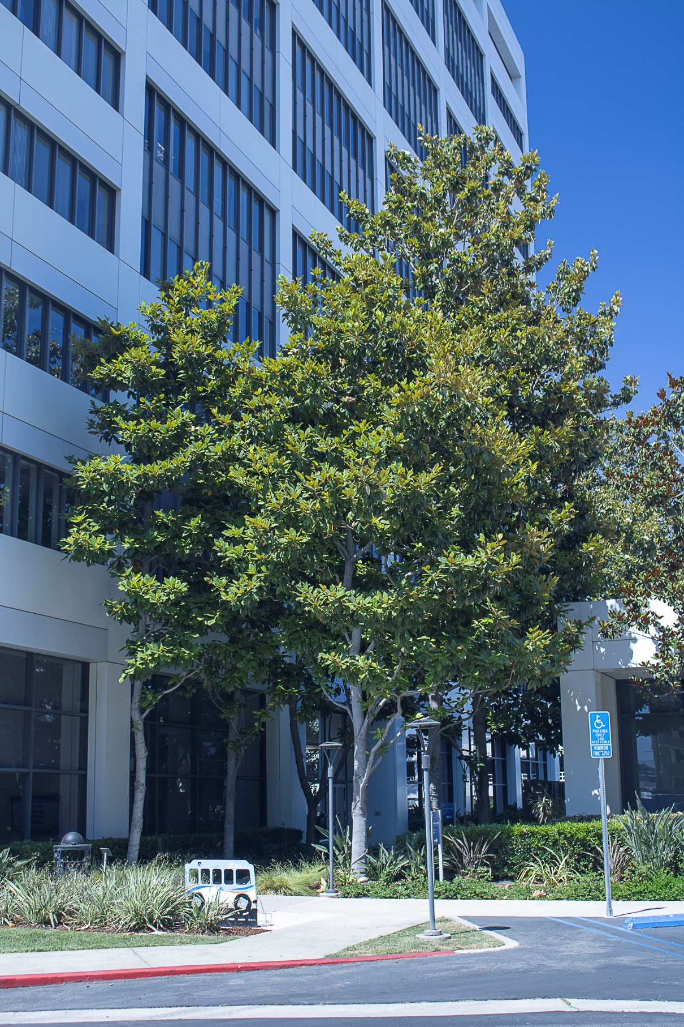
1. The grove of Magnolia grandiflora in Orange, California from which Ray McGinty brought spotted leaves to co-author Paul Santos who found powdery mildew (Erysiphe magnifica) on them. © 2023 D. R. Hodel.
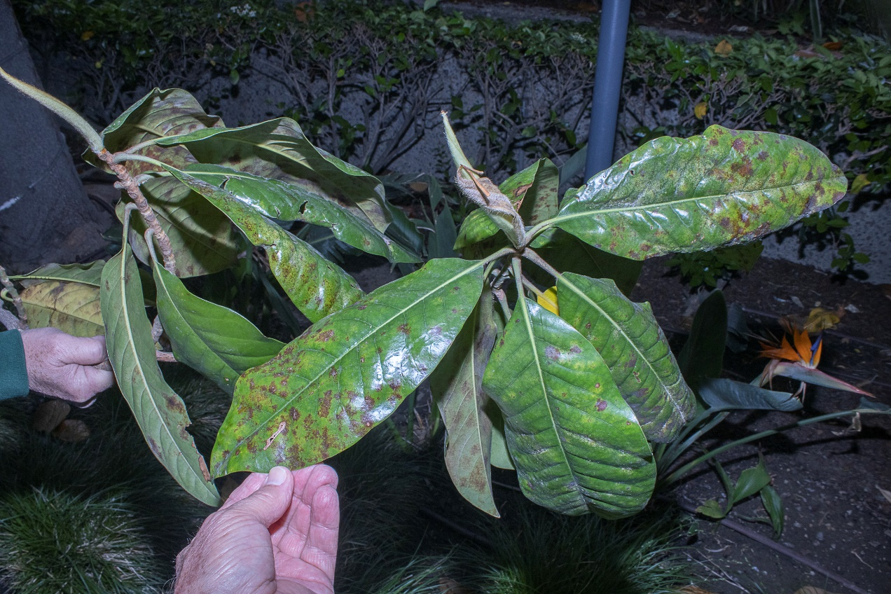
2. Adaxial leaf surface of Magnolia grandiflora infected with powdery mildew (Erysiphe magnifica) showing irregular, yellow to brown spots. © 2023 D. R. Hodel.

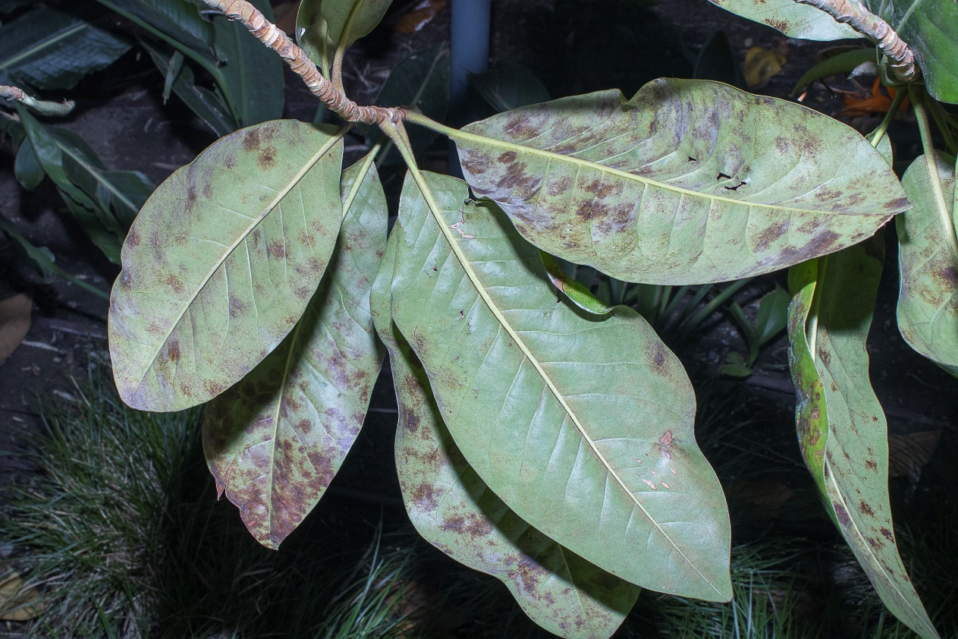
3. Abaxial leaf surface of Magnolia grandiflora infected with powdery mildew (Erysiphe magnifica) showing irregular, yellow to brown spots. © 2023 D. R. Hodel.
Erysiphe magnifica and Relatives on Magnolia Hosts
Erysiphe is a large genus of obligate plant pathogens that cause powdery mildew diseases on different plant hosts. Currently, five species of Erysiphe are known to cause powdery mildew on Magnolia spp., including E. aquilegiae, E. bulbosa, E. magnifica, E. magnoliae (Braun and Cook 2012), and E. magnoliicola (Cho et al. 2014).
Erysiphe magnifica is the most widespread of the five Erysiphe species attacking Magnolia spp. in terms of geographic range and host species. Braun (1983) originally described and named this fungal pathogen Microsphaera magnifica, from a specimen collected in 1920 on Magnolia acuminata from Harrisburg, Pennsylvania. Later, Braun and Takamatsu (2000) transferred it to Erysiphe, making E. magnifica.
When first named and described, Erysiphe magnifica was known to cause powdery mildew on various Magnolia spp. in eastern North America (Braun 1983). However, an earlier record might be present for eastern North America because Ondruŝková et al. (2014) suggested that what Ellett (1966) found on Magnolia liliiflora and M. stellata and reported as Microsphaera penicillata in Ohio was likely E. magnifica.
Since the late 1990s, Erysiphe magnifica has been on the move, spreading to western North America [Canada (Elmhirst 2013), Pacific Northwest, U.S.A. (Glawe 2003)]; South America [Argentina (Wolcan and Murace 2009)]; Europe [Germany and Switzerland (Braun et al. 2009), Netherlands (Pijpers 2009), United Kingdom (Cook et al. 201]), Ukraine (Chumak et al. 2012), Italy (Maspero and Tantardini 2011), Slovakia (Ondruŝková et al. 2014), Poland (Kimic 2012), Romania (Chinan and Dascălu 2023)]; Iran (Khodaparast et al. 2019); Japan (Nomura 1997); Korea (Shin 2000, Choi 2021); and Taiwan (Wang et al. 2020, 2022). It causes powdery mildew on 15 to 20 Magnolia spp. Ondruŝková et al. (2014) provided a concise summary of the geographic range and magnolia hosts of E. magnifica. Although always reported only on Magnolia spp., Kirschner (2010) found E. magnifica on Nelumbo nucifera (lotus), the first report on a non-magnoliaceous host.
Nearly all reports of Erysiphe magnifica are on various Magnolia spp. but other than M. grandiflora. A few earlier sources listed E. magnifica on M. grandiflora, but these might be in error because of misidentification of the pathogen or, due to the advent of molecular data, changes in phylogenetic interpretations and nomenclature. For example, Ondruŝková et al. (2014), listed E. magnifica on M. grandiflora and four other species in the U. S., including M. acuminata, M. liliiflora, M. × soulangeana, and M. stellata. They documented this finding with six references (Braun 1983, 1987; Amano 1986; Saenz and Taylor 1999; Shin 2000; Glawe 2003).
The only one of these six references that listed a powdery mildew on Magnolia grandiflora was Amano (1986), which listed Microsphaera alni (=Erysiphe alni); however, in the past, some authors considered E. alni to include E. magnifica (in Braun and Cook 2012, given as E. magnifica
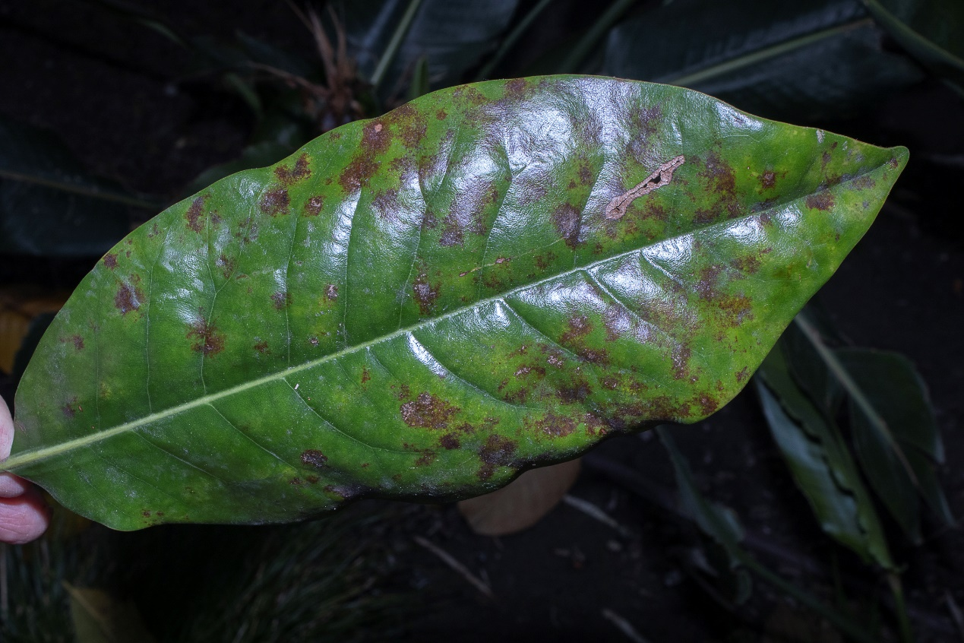
4. Symptoms of powdery mildew (Erysiphe magnifica) on Magnolia grandiflora include irregular, chlorotic and necrotic leaf spots on the adaxial leaf surface. © 2023 D. R. Hodel.

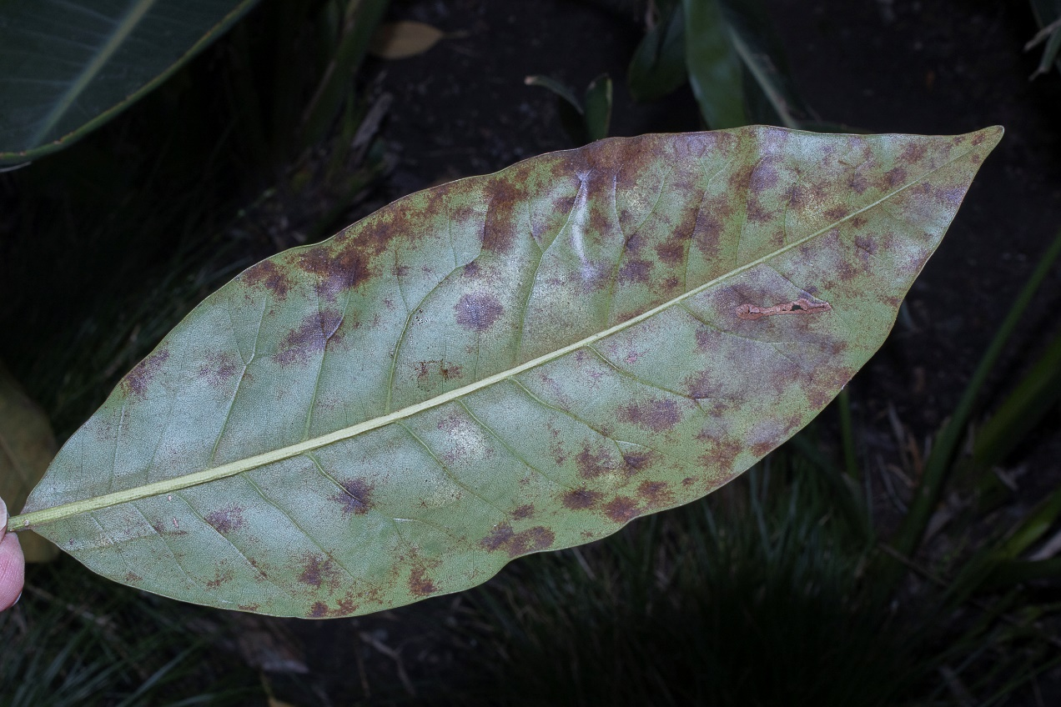
5. Symptoms of powdery mildew (Erysiphe magnifica) on Magnolia grandiflora include irregular, necrotic leaf spots on the abaxial leaf surface. © 2023 D. R. Hodel.
= E. alni auct. p.p.). Erysiphe alni is now a regarded as a synonym of Phyllactinia alnicola (MycoBank 2023). Amano (1986) likely based this finding on Wehlburg et al. (1975), who also listed Microsphaera alni on M. grandiflora but, because of how Wehlburg et al. (1975) presented the data, it is impossible to resolve. Thus, our finding of E. magnifica on M. grandiflora, which is based upon morphological measurements, molecular data, and accurate host identification, is likely the first confirmed record of this pathogen/host interaction.

Other fungal species can cause powdery mildew on Magnolia grandiflora. For example, Hagen (2001) reported that the fungi, Phyllactinia alnicola (formerly Microsphaera alni and E. alni) and P. guttata (formerly P. corlyea) (MycoBank 2023), cause powdery mildew on saucer (M. × soulangeana) and star (M. stellata) magnolias. However, work by U-Scout (2023), which appears to be based on Hagen (2001) because it uses the same fungal names, illustrated M. grandiflora with powdery mildew in a Florida nursery situation. Although Farr et al. (1995) listed Microsphaera penicillata (now Erysiphe penicillata) on M. grandiflora, this association is unlikely because E. penicillata in the modern sense only infects Alnus; thus, the reported presence of this fungus on Magnolia spp. is due to outdated taxonomic identifications (R. Kirschner, pers. comm.).

Symptoms and Signs of Powdery Mildew on Magnolia grandiflora
The symptoms of powdery mildew on the Magnolia grandiflora from Orange, California include irregular, yellowish chlorotic and brownish necrotic leaf spots on the adaxial leaf surface and irregular purplish brown necrotic spots on the abaxial surface (Figs. 2–5). Close inspection of these patches with magnification will reveal a network of white mycelia, the vegetative fungal strands of the pathogen (Fig. 6). Some stunting and deformation were seen but other symptoms typical of powdery mildews, such as leaf curling, seem uncommon because leaves of M. grandiflora tend to be durable, rigid, and stiff. Some light defoliation was seen although it is difficult to discern if it was due to the powdery mildew or natural, periodic leaf drop.
Sporulation of Erysiphe magnifica on Magnolia grandiflora occurs primarily on the abaxial leaf surface. Conidia are ellipsoid-ovoid to doliform and measure 28–44 x 14–20 µm (avg. 36 × 17 µm), similar to those described on other Magnolia species (Braun and Takamatsu 2000; Chinan and Dascălu 2023; Glawe 2003; Wang et al. 2020) (Figs. 7–8). Appressoria are lobed to nipple shaped and conidiophore foot cells measure up to 100µm in length, which is up to twice the length as some reports of E. magnifica. The variation in foot cell length between reports of E. magnifica may be due to different environmental conditions (Wang et al 2020). Reports of longer E. magnifica foot cells are more common in subtropical regions like Tawain, subtropical Iran, and this report in Orange, California.

6. Close inspection of brownish patches on the abaxial leaf surface of Magnolia grandiflora reveals white mycelia (Erysiphe magnifica). © 2023 D. R. Hodel.

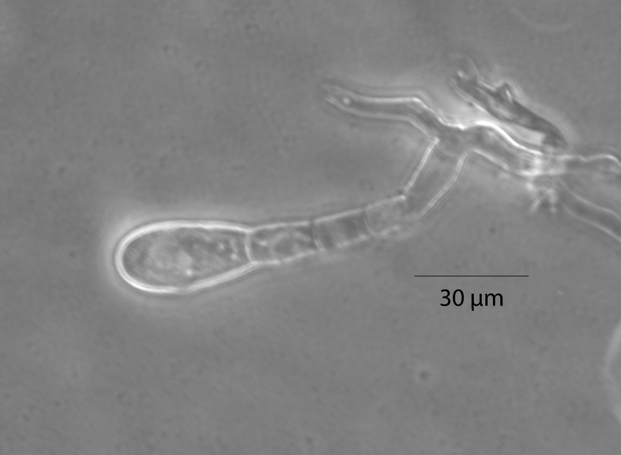
7. Conidiophore of Erysiphe magnifica with bent basal foot cell. © 2023 S. Rooney-Latham.
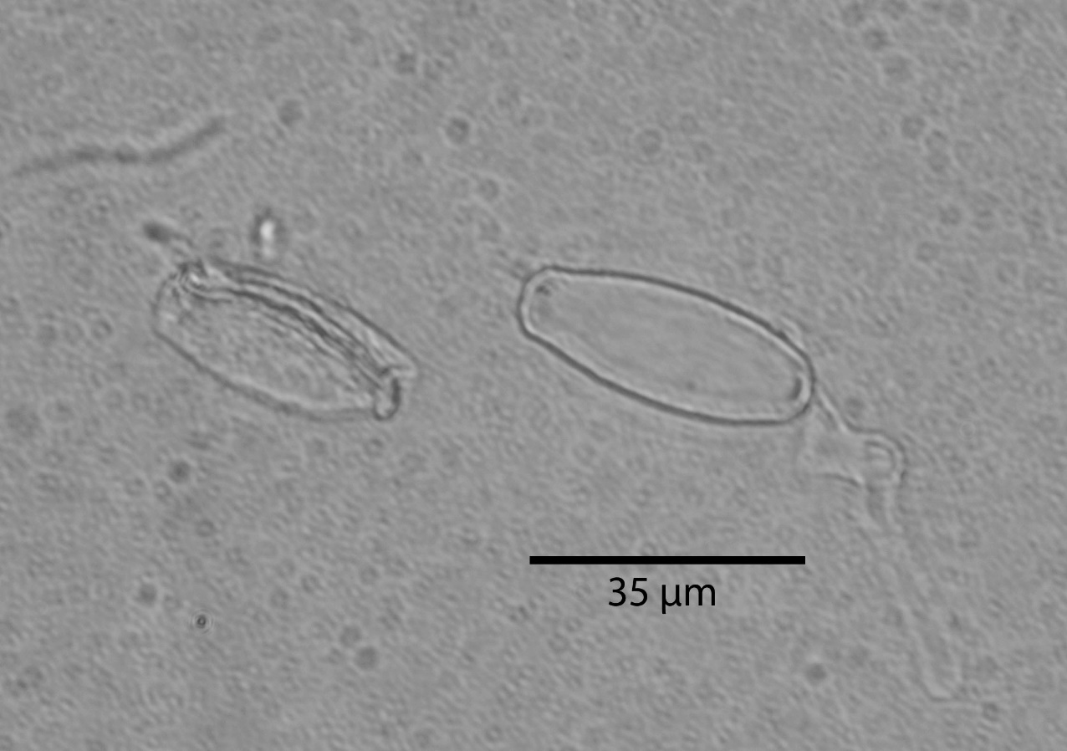
8. Doliform conidia of Erysiphe magnifica showing one of them germinating. © 2023 S. Rooney-Latham.
______________________________________________________________________________

Landscape Management of Powdery Mildew on Magnolia grandiflora
Understanding the life cycle and environmental conditions that favor powdery mildew disease development is critical to landscape management. Powdery mildews are obligate biotrophs, meaning they require living plant material for growth. Upon germination, the spores produce appressoria and haustoria, which allow them to penetrate epidermal cells and uptake nutrients from the plant. Powdery mildews primarily survive from season to season on leaves and in buds by their mycelia strands and asexual spores (conidia), or on leaves or bark of trunks and branches by spherical, sexual fruiting bodies (chasmothecia), which produce ascospores. Wind and splashing water carry and spread conidia and ascospores to new hosts (Gubler and Koike 2009, Knox et al. 2012).
Contrary to popular knowledge, powdery mildew spores can germinate and infect plant surfaces in the absence of free water. Free water inhibits germination and can kill spores. Although the presence of rain and irrigation water on plant surfaces might inhibit powdery mildew, they might promote other fungal pathogens. Shady conditions and temperatures in the range of 15° to 27°C (60° to 80 F) typically favor powdery mildew development. Spores and mycelium are sensitive to sunlight and extreme heat; leaf temperatures above 35°C (95°F) kill powdery mildew fungi (Gubler and Koike 2009, Knox et al. 2012).
The best management practice for powdery mildew is prevention. Avoid, correct, or mitigate conditions that favor the pathogen over the host, including excessive shade, poor air movement, and overcrowding (Fig. 9). In the case of the infected Magnolia grandiflora trees in Orange, California, they were densely planted on the north side of a tall building that provided ample shade, especially in the winter, decreased air movement, and a more humid environment. Avoid excessive fertilizer, which can promote lush, new growth that is especially susceptible to infection. Consider slow or time-release fertilizers that release a low, steady stream of nutrients over a longer period of time, making them less likely to cause lush growth spurts. Irrigate in the morning to allow plant surfaces to dry out before nightfall to avoid other foliar diseases (Gubler and Koike 2009).
Always provide optimal cultivation, including proper siting, irrigation, nutrition, mulch, and, if necessary, pruning to encourage and maintain a healthy, vigorous plant without excessive growth. If necessary, properly prune back adjacent, encroaching trees that provide excessive shade and increased humidity. Kimic et al. (2022) provided a review of a holistic approach to avoiding and managing fungal diseases, including powdery mildews, and optimizing urban landscape tree growth. They covered such topics and strategies as selecting the correct planting site, nutrient management, mulching, use of mycorrhizae, irrigation, cleaning tools, removal of diseased plant parts, and regular disease monitoring.
To manage the disease, prune out infected leaves and twigs and collect fallen, diseased leaves, securely bag them, and send them to a landfill. Diseased material that is properly composted is usually acceptable to reuse in the landscape in most cases because internal temperatures during the composting process are sufficiently high to kill the pathogen; however, proper composting requires judicious temperature monitoring and turning of the pile to ensure complete composting and death of most weeds, pests, and diseases (Downer et al. 2008). This process can be more labor intensive then simply removing and securing the diseased material for landfill disposal.
If necessary, numerous fungicides are available to help protect the plant from infection or eradicate powdery mildew. Protectants must be applied before infection or at the earliest stage of disease development. They must be applied thoroughly to cover all susceptible plant parts and when new growth emerges. Eradicants can be applied anytime but are most effective in the initial stages of infection. Start with the least toxic materials, such as horticultural oils, neem oil, jojoba oil, sulfur, potassium bicarbonate, and the biological fungicide Serenade (Bacillis subtilis). With the exception of the oils and Serenade, these materials are protectants although potassium bicarbonate has some eradicant activity (Gubler and Koike 2009).

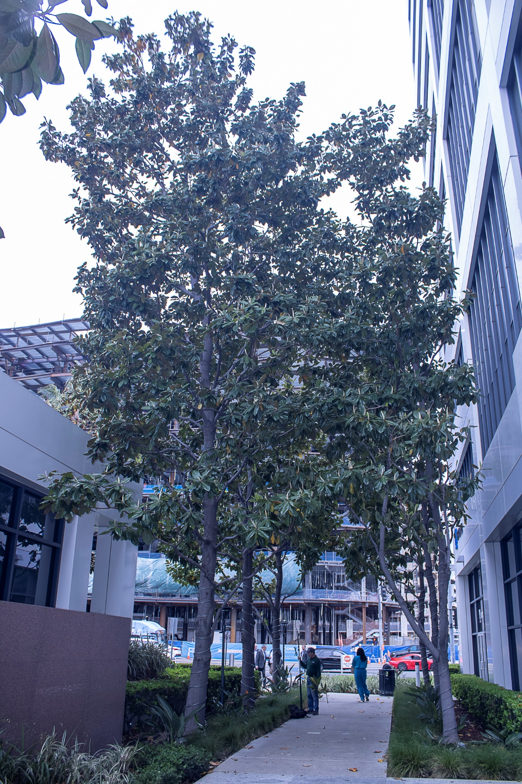
9. These crowded Magnolia grandiflora from which powdery mildew (Erysiphe magnifica) was first detected are on the north side of a tall building. This situation creates excessive shade, poor air movement, and damp conditions, all of which are conducive to powdery mildew. © 2023 D. R. Hodel.

Oils and sulfur can damage leaves, especially newly emerging leaves, when applied within two weeks of each other, or when temperatures exceed 32°C (90°F). Avoid applying oils to water-stressed plants. The best sulfur products are wettable powders formulated with surfactants or spreader/stickers (Gubler and Koike 2009).
If warranted, consider synthetic materials, including azoxystrobin, chlorothalonil, copper compounds, myclobutanil, metaconazole, propiconazole, pyriofenone, tebuconazole, thiophanate methyl, triadimephon, and trifloxystrobin (Gubler and Koike 2009, Knox et al. 2012, Pscheidt and Ocamb 2023). Remember, if plant health is not optimal and conditions that favor the pathogen over the host are present, the use of fungicides will likely not be effective. Always consult with a licensed pest control operator or advisor about applying fungicides. Carefully weigh the perceived benefits of using fungicides against potential damage to the environment.
Acknowledgements
We sincerely thank Katarina Pastirĉáková, Hyeon-Dong Shin, and Roland Kirschner who provided several, hard-to-find references. Kirschner also reviewed the manuscript and provided constructive suggestions to improve its quality.
Literature Cited
Amano, K. 1986. Host Range and Geographical Distribution of the Powdery Mildew Fungi. Japan Scientific Societies Press, Tokyo.
Braun, U. 1983. Descriptions of new species and combinations in Microsphaera and Erysiphe (III). Mycotaxon 16(2): 417–424.
Braun, U. 1987. A monograph of the Erysiphales (powdery mildews). Beih. Nova Hedwigia 89: 1–700.
Braun, U., N. Ale-Agha, A. Bolay, H. Boyle, U. Brielmaier-Liebetanz, D. Emgenbroich, J. Kruse, and V. Kummer. 2009. New records of powdery mildew fungi (Erysiphaceae). Schlechtendalia 19: 39–46.
Braun, U. and R. T. A. Cook. 2012. Taxonomic manual of the Erysiphales (powdery mildews). CBC Biodiversity Series 11: 1–707. CBS-KNAW Fungal Biodiversity Centre, Utrecht, Netherlands.
Braun, U. and S. Takamatsu. 2000. Phylogeny of Erysiphe, Microsphaera, Uncinula (Erysipheae) and Cystotheca, Podosphaera, Sphaerotheca (Cystotheceae) inferred from rDNA ITS sequences–some taxonomic consequences. Schlechtendalia 4: 1–33.
Chinan, V.-C. and M.-M. Dascălu. 2023. First report of Erysiphe magnifica on Magnolia trees in Romania. J. Plant Protect. 130: 657–661. https://doi.org/10.1007/s41348-023-00721z
Cho, S. E., S. Takamatsu, J. Meeboon, and H. D. Shin. 2014. Erysiphe magnoliicola, a new powdery mildew species on Magnolia. Mycotaxon 129(1): 153–161. https://doi.org/10.5248/129.153
Chumak, P., R. Palagecha, and V. Kovalchuk. 2010. Variability of the cleistothecia and distribution of Erysiphe magnifica (U. Braun) U. Braun & S. Takam. on Magnolia L. plants in O. V. Fomin Boitanical Garden. Mod. Phytomorphol. 2: 95–97.
Choi, Y.-J., B.-K. Choi, I.-Y. Choi, and H.-D. Shin. 2021. Erysiphe magnifica causes powdery mildew on Magnolia compressa. Forest Pathology 2021: 51:312706. doi: 10.1111/efp.12706
Cook, R. T. A., U. Braun, and P. A. Beales. 2011. Development of appressoria on conidial germ tubes of Erysiphe species. Mycoscience 52: 183–197.
https://doi.org/10.1007/S10267-0101-0099-7
Downer, A. J., D. Chron, B. Faber, O. Daugovish, J. O. Becker, J. A. Menge, and M. J. Mochizuki. 2008. Survival of plant pathogens in static piles of ground green waste. Phytopathology 98(5): 547–554. https://doi.org/10.1094/PHYTO-98-5-0547
Ellett, C. W. 1966. Host range of the Erysiphaceae of Ohio. Ohio J. Sci. 66(6): 570–581.
Elmhirst, J. 2013. Diseases diagnosed on commercial ornamental nursery crops in British Columbia in 2012. Can. Plant Dis. Surv. 93: 18–32.
Farr, D. F., G. F. Bills, G. P. Chamuris, and A. Y. Rossman. 1995. Fungi and Plants and Plant Products in the United States. American Phytopathological Society, St. Paul, MN.
Glawe, D. A. 2003. First report of powdery mildew of Magnolia caused by Microsphaera magnifica (Erysiphe magnifica) in the Pacific Northwest. Plant Health Progress. https://doi.org/10.1094/PHP-2003-5012-02-HN
Gubler, W. D. and S. T. Koike. 2009. Powdery Mildew and Ornamentals. UC ANR Pest Notes. Publ. 7493.
Hagen, A. K. 2001. Magnolia diseases. pp. 231–235 in: R. K. Jones and D. E. Benson (eds.), Diseases of Woody Ornamentals and Trees in Nurseries. SPS Press, St. Paul, MN.
Hodel, D. R., J. Rowland, E. Aguirre, and M. C. Wallich. 2018. The tuliptree scale, a particularly vile and nasty pest. PalmArbor 2018-01: 1–27. https://ucanr.edu/sites/HodelPalmsTrees/files/278630.pdf
Khodaparast, S., A. Ghobakhloo, B. Asgari, F. Aliabadi, and S. Sajedi. 2019. Notes on two powdery mildew fungi (Erysiphe magnifica and E. corylacearum) from Iran. Mycologia Iranica 6(1): 1–7. doi: 10.22043/mi.2019.120420
Kimic, K., E. Mirzwa-Mróz, and M. S. Szyndel. 2022. Diagnosis and recommendations for management of trees and shrubs in green squares in Warsaw based on research on fungal diseases. Trees: 1–15. https://doi.org/10.1007/s00468-022-02270-8
Kirschner, R. 2010. First record of Erysiphe magnifica on lotus, a host outside of Magnoliales. Mycol Progress 9: 417–424. https://doi.org/10.1007/s11557-009-0651-z
Knox, G. W., W. E. Klingeman, M. Paret, and A. Fulcher. 2012. Management of pests, plant diseases, and abiotic disorders of Magnolia species in the southeastern United States: a review. J. Environ. Hort. 30(4): 223–234. https://doi.org/10.24266/0738-2898.30.4.223
Maspero, M. and A. Tanterdini. 2011. Attivita di monitoraggio di tingidi e malattie fungine di nuova introduzione dannose per le pruduzioni tipiche di piante acidofile e ornamentali nella provincial di Como. Fondazione Miroprio Vertemate con Miniprio.
MycoBank. 2023. MycoBank fungal database. https://www.mycobank.org/
Nomura, Y. 1997. Taxonomic study of Erysiphaceae of Japan. Yokendo, Ltd., Tokyo.
Ondruŝková, E., G. Juhásová, and K. Pastirĉáková. 2014. The lily magnolia powdery mildew fungus Erysiphe magnifica found in Slovakia. Mycotaxon 127: 51–57. https://doi:org/105248/127.51
Pijpers, H. 2009. Echte meeldauw: een verdieping. De Boomkwekerij 5: 8.
Pscheidt, J. W. and C. M. Ocamb (eds.). 2023. Magnolia–Powdery Mildew. Pacific Northwest Plant Disease Management Handbook, Oregon State University, Corvallis, OR. https://pnwhandbooks.org/node/25156
Saenz, G. S. and J. W. Taylor. 1999. Phylogeny of the Erysiphales (powdery mildews) inferred from internal transcribed spacer ribosomal DNA sequences. Can. J. Bot. 77: 150–168. https://dx.doi.org/10.1139/cjb-77-1-150
Shin, H. D. 2000. Erysiphaceae of Korea. Nat. Inst. Agric. Sci. Tech, Suwon, South Korea.
U-Scout. 2023. Powdery mildews on Magnolia grandiflora. Powdery mildew (ufl.edu)
Wang, C. T., Y. W. Yeh, C. D. Lin, and R. Kirschner. 2020. First record of Erysiphe magnifica on the new host Magnolia × alba in Taiwan indicates high morphological plasticity of the anamorph under tropical conditions. Plat Path. Quart. 10(1) 59–65. doi: 10.5943/ppq/10/1/7
Wang, C.-T., Y.-W. Yeh, L.-D. Lin, W.-W. Hsiao, C. Wei, and R. Kirschner. 2022. Powdery mildews on ornamental trees: a new record of Podosphaera pruni-cerasoidis for Taiwan, a new host of Erysiphe magnifica for Taiwan and notes on E. liquidambaris. J. Exp. For. Nat. Taiwan Univ. 36(3): 183–192. doi: 10.6542/EFNTU.202209_36(3).0002

Wehlburg, C., S. A. Alfieri, Jr., K. R. Langdon, and J. W. Kimbrough. 1975. Index of Plant Diseases in Florida. Florida Dept. Agric. Consumer Serv. Bull. 11, Div. Plant Industry Contr. No. 390. https://palmm.digital.flvc.org/islandora/object/uf%3A104219#page/282/mode/1up
Wolcan, S. and M. Murace. 2009. Dos nuevos oídios en arbustos ornamentales en la Argentina. XI Jornades Nacionales de Floricuture. Montecarlo, Misiones, Argentina.
___________________________
Donald R. Hodel is the emeritus landscape horticulture advisor for the University of California Cooperative Extension in Los Angeles and specializes in the selection and management of palms and trees. drhodel@ucanr.edu Donald wrote the first draft of the manuscript and provided photographs of infected trees and leaves.
Paul Santos IS the plant pathologist and plant diagnostician at Plant Pulse Diagnostics in Anaheim, California. paul@plantpulsediagnostics.com Paul did the initial isolation and laboratory work on this disease and reviewed the manuscript.
Suzanne Rooney-Latham is a plant pathologist at the California Department of Food and Agriculture, Plant Pest Diagnostics Center (CDFA PPDC). Suzanne contributed morphological and molecular identification of Erysiphe magnifica on Magnolia grandiflora, provided photographs of the fungus, and reviewed the manuscript. suzanne.latham@cdfa.ca.gov Disclaimer: Disease management suggestions made in this article are not Latham’s or CDFA’s recommendations.
_________________________

Text © 2023 by Donald R. Hodel, Paul Santos, and Suzanne Rooney-Latham.
Photographs © 2023 by each photographer.
Publication Date: 14 October 2023.
PalmArbor: http://ucanr.edu/sites/HodelPalmsTrees/PalmArbor/
ISSN 2690-3245
Editor-In-Chief: Donald R. Hodel
Hodel Palms and Trees: http://ucanr.edu/sites/HodelPalmsTrees/

