Date Palm (Phoenix dactylifera) and Other Exotic Orchard Fruit Crops in Big Bend, Texas
DENNIS V. JOHNSON AND JANE C. MACKNIGHT
Among the dozens of new food plants introduced into the Americas after European contact, Dunmire (2004) described 20 orchard fruit crops, including date palm. As early as the 16th century, dried dates were among the food provisions imported from Spain in support of exploration and colonization in North America (Reitz and Scarry 1985). Exotic fruit crops were dispersed widely throughout Spanish America over succeeding centuries, becoming subsistence food where suitable environmental conditions existed. Before scientific studies determined the basic climatic requirements of individual fruit crops, in many locations experimental trials revealed that, for example, the date was unsuited to commercial production, yet the palms became part of the local landscape as dooryard gardens plants, ornamentals, and noninvasive naturalized species.
The date palms that visitors see at Hot Springs Village in Big Bend, Texas, U. S. A., hold a deep history and a distant origin. The date palm is one of the oldest tree fruit crops, domesticated some 7,000 years ago in the Middle East. By the time the Spanish reached the Americas, it was well established as a fruit crop in North Africa and Spain. Early dissemination of the date palm was by seed, although it can also be propagated by the excision of basal offshoots. Seed cultivation produces approximately equal numbers of staminate (pollen producing, male) and pistillate (seed or fruit bearing, female) plants, the gender only distinguishable when the palm reaches sexual maturity at four to eight years of age. A single staminate date palm can provide pollen for as many as 50 pistillate palms, therefore staminate palms in cultivation are appropriately reduced in numbers. Offshoot propagation is preferable because it carries forward the gender of the parent plant and its fruit quality. In addition to producing offshoots, spontaneous seedlings typically occur beneath pollinated female date palms.
The aim of this study is to examine the historical record behind the current presence of the date palm and other exotic orchard fruits in the Big Bend area of Texas and, in the case of the date palm, to attempt to determine how it disseminated and naturalized. Inspiration for this research was the discovery of a Big Bend National Park postcard showing the old trading post/post office at Hot Springs Village with a mature date palm (Fig. 1).
The Big Bend takes its name from the southward curve of the Rio Grande in western Texas as it works its way around Mariscal Mountain, the southern extremity of the Rocky Mountain geologic structure. This remote, thinly populated, triangular area lies on the Mexican Border, which is the river, and offers exceptional scenic views of rugged mountains, desert landscapes and deep canyons. The Big Bend is part of the northern reaches of the Chihuahuan Desert Ecoregion, which
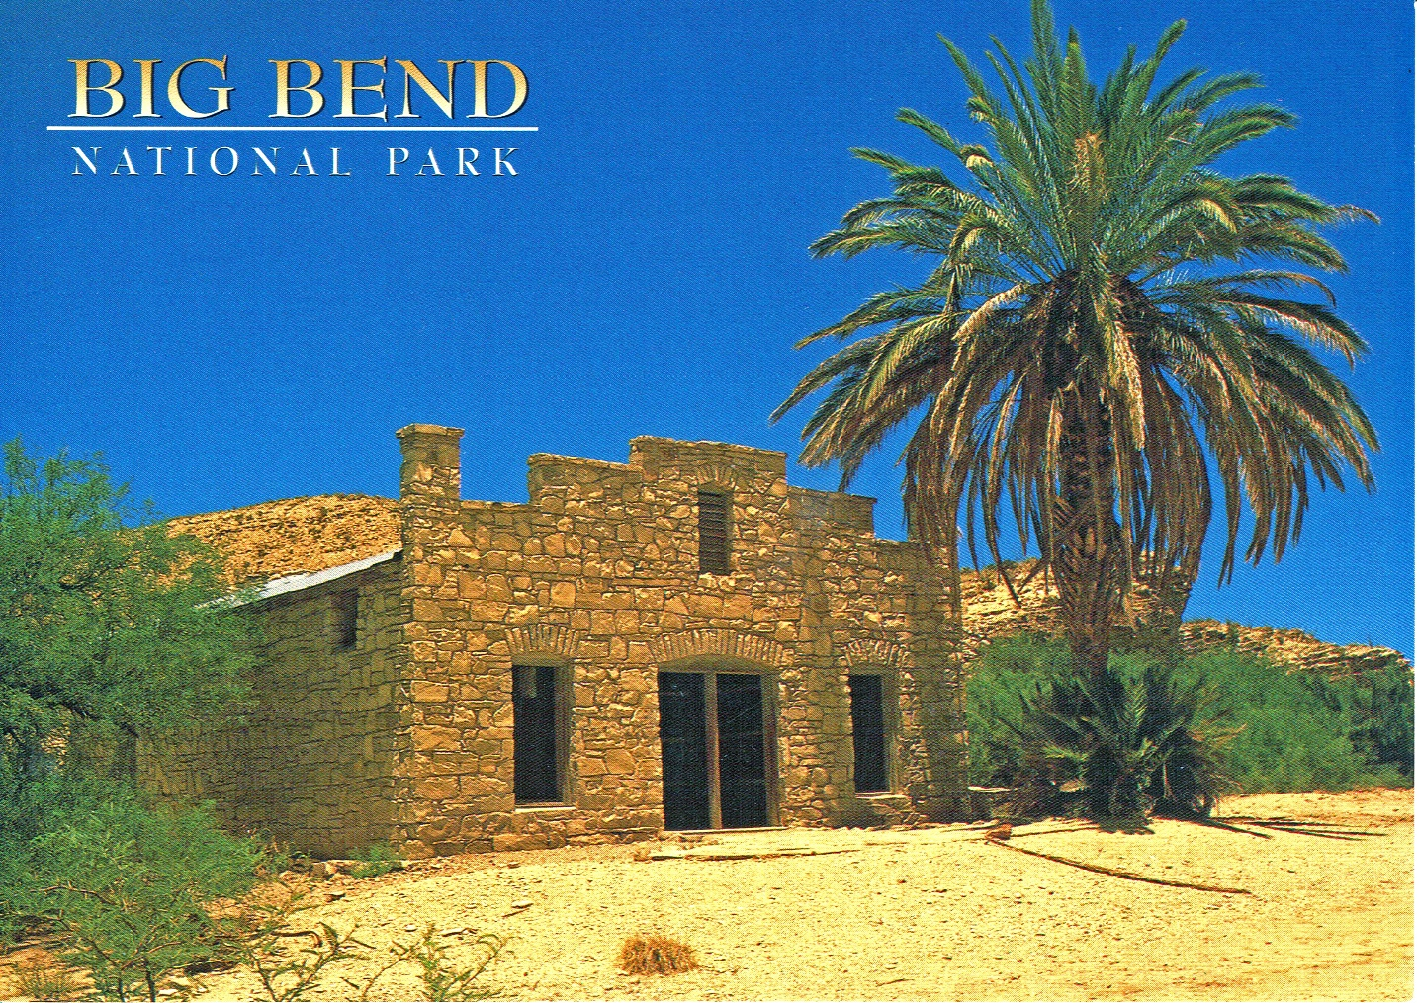
1. Big Bend National Park, the iconic trading post/post office. Unposted and undated postcard.
______________________________________________________________________________

has a northwest-southeast orientation, extending over 1,500 km (930 miles) from Albuquerque, New Mexico to the Mexican state of Nuevo León. Only 10 % of the Chihuahuan Desert is in the United States. No native palms currently exist in this desert, making historical references to palms within its limits much easier to interpret.
This study represents the seventh in a series of investigations documenting historic attempts at date growing for fruit production beyond the present locus of the United States date industry in Riverside and Imperial counties in California and Yuma County in Arizona. The initial study looked at noncommercial date growing in Arizona (Johnson et al. 2002), followed by Death Valley and Inyo County in California (Johnson et al. 2016), the Lower Colorado River Valley (Johnson and MacKnight 2019a), Borrego Springs in California (Johnson and MacKnight 2019b), Florida and Georgia (Johnson and MacKnight 2021), and South Texas (Johnson and MacKnight 2022).
Dried date imports from Arabia into the United States began in 1818 or earlier (Hopper 2014). Seeds from date fruit consumption were readily available north and south of Big Bend, providing chances to germinate and become orchard plants in suitable climatic areas. The history of the Big Bend from the Spanish, Mexican, Texas, and later American perspectives, lacks details about the
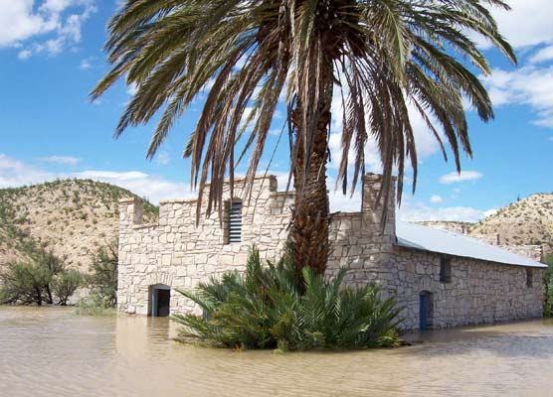
2. Big Bend National Park, trading post/post office. Record 2008 flood. Source: National Park Service.
______________________________________________________________________________

introduction of exotic orchard fruit crops, which is understandable given the minor dooryard garden role fruits such as dates played in the early settlement of Big Bend. As a general practice, the Spanish mission settlements actively promoted the growth of orchard fruit crops throughout New Spain. In attempting to understand the introduction process in Big Bend, it must be acknowledged that a series of unsuccessful introductions might well have taken place before success was achieved and the dates became established in gardens and, in some locations, naturalized. On the floodplain in Big Bend, where agriculture has been practiced for millennia, periodic floods have destroyed physical evidence of the crops (Fig. 2). General information on the early history and settlement of Big Bend provided context for orchard tree crops (Tyler 1975; Wauer 1966; Wright 1963), which was decidedly minimal.

Possible Sources of Date and Other Orchard Fruit Seeds
Without direct evidence, we can only suggest promising historical scenarios when orchard fruits, especially dates, may have first reached the Big Bend. Three such opportunities are described below.
Just west of Big Bend Ranch State Park, where the Río Conchos from Mexico joins the Rio Grande, is an extensive floodplain area called La Junta de los Ríos (The Joining of the Rivers). A cluster of centuries-old permanent agricultural villages exists on the higher portions of the floodplain. Today it is an important international river crossing between Presidio, Texas and Ojinaga, Mexico. In 1715, Juan Trasviñas Retes, lieutenant governor of Nuevo Viscayas, led an expedition from Durango to the site and during his visit distributed unspecified fruit tree seeds to farmers (Madrid 1996). This event represents an early chance for date palm introduction.
A second historic scenario for date palm introduction was the period 1772–1784. Along a minor byway just east of Dunmire’s (2004) Western Corridor of Spanish settlement, presidio-missions were built at San Vicente and San Carlos, Mexico. Located a few miles below the southern sweep of the Rio Grande, the intention was to gain military control of the remote area and to convert Indigenous people to the Catholic faith. These settlements were abandoned in the early 1780s (Casey 1969, Ivey 1990). Details of specific agricultural activities could not be found, but it is worth noting that concomitantly Spanish missions in Baja California (1770s) included the introduction of dates among the orchard crops of mission gardens. To the east, dates appear to have first reached the Lower Rio Grande Valley in the late 1700s to the early 1800s, along Dunmire’s Texas Corridor of colonization (Johnson and MacKnight 2022).
A third scenario comes from the mid-1850s, when the U. S. Army imported camels as pack animals for use in the southwestern desert areas ceded to the United States at the end of the Mexican-American War. About 75 camels were purchased in Turkey and shipped to Texas, accompanied by six Arab handlers, led by a Syrian named Hadji Ali. To assess the fitness of camels, trial expeditions were made from Fort Stockton to Hot Springs Village in 1859 and present Castolon in 1860. It is unknown what provisions the Arab camel drivers brought with them, but in their home countries dried dates were a common desert caravan food item for men and camels. They could have left behind date seeds. The outbreak of the U. S. Civil War in 1861 led the Army to transfer the animals to Fort Tejon, California where the camel experiment ceased in 1881. Hadji Ali remained in the USA continuing his employment with the Army and later as a drover of other pack animals (Brown 2021, Greenly 1952, Lammons 1958).
Date Palms Recorded in Big Bend
The earliest written reference found regarding date palms in the Big Bend is 1883, made by Waldemar G. Klee, a horticulturist at the University of California, Berkeley, who undertook a
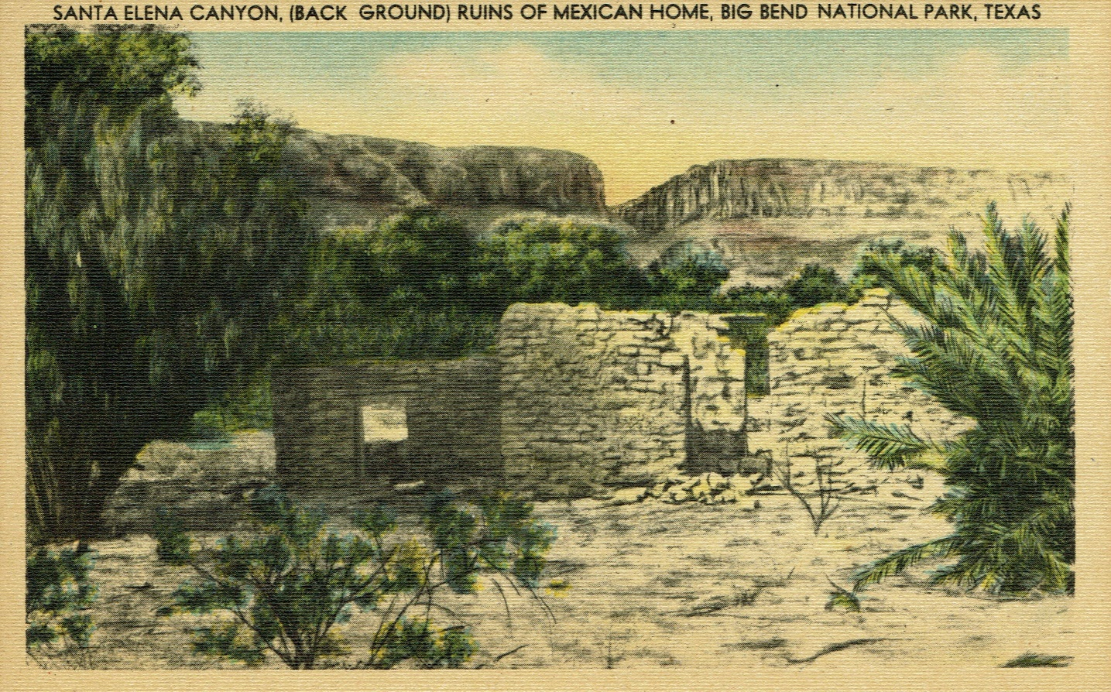
3. Big Bend National Park, ruins of Mexican house, La Coyota. Date palm visible at right margin. Unused postcard, c. 1930s.
______________________________________________________________________________

survey for the U. S. Department of Agriculture of the greater southwest in 1882 to identify promising areas for the commercial cultivation of dates. Klee observed dates, originating from seed, flourishing at locations in California, Arizona, New Mexico and the Big Bend of Texas (Colley 1983, Klee 1883). If “flourishing” means date palms in the Big Bend large enough to bear fruit, they would have had to be planted in the mid-1870s, at the latest. Details about Klee’s itinerary are unknown, but he may well have arrived in Marfa, West Texas by the newly opened Southern Pacific railroad, and from there made his way down to Big Bend by stagecoach to the mining town of Terlingua. From there it is only about 24 km (15 miles) to the Rio Grande; possibly Klee observed date palms near Castolon or the historic La Coyota village, the latter founded in 1884 on the floodplain (https://www.nps.gov/places/la-coyota.htm). An unused postcard (Fig. 3), c. 1930s, features an historic photograph of a ruined house at La Coyota, with a date palm discernable at the right margin, the oldest image found of a palm in Big Bend.
Dates and Other Orchard Crops
The past and recent occurrence of date palms and other orchard fruit crops in Big Bend can be considered by analyzing three separate geographic areas. Big Bend National Park, created in 1944 with an area of 323,750 ha (800,000 acres); Big Bend Ranch State Park, established in 1991 and
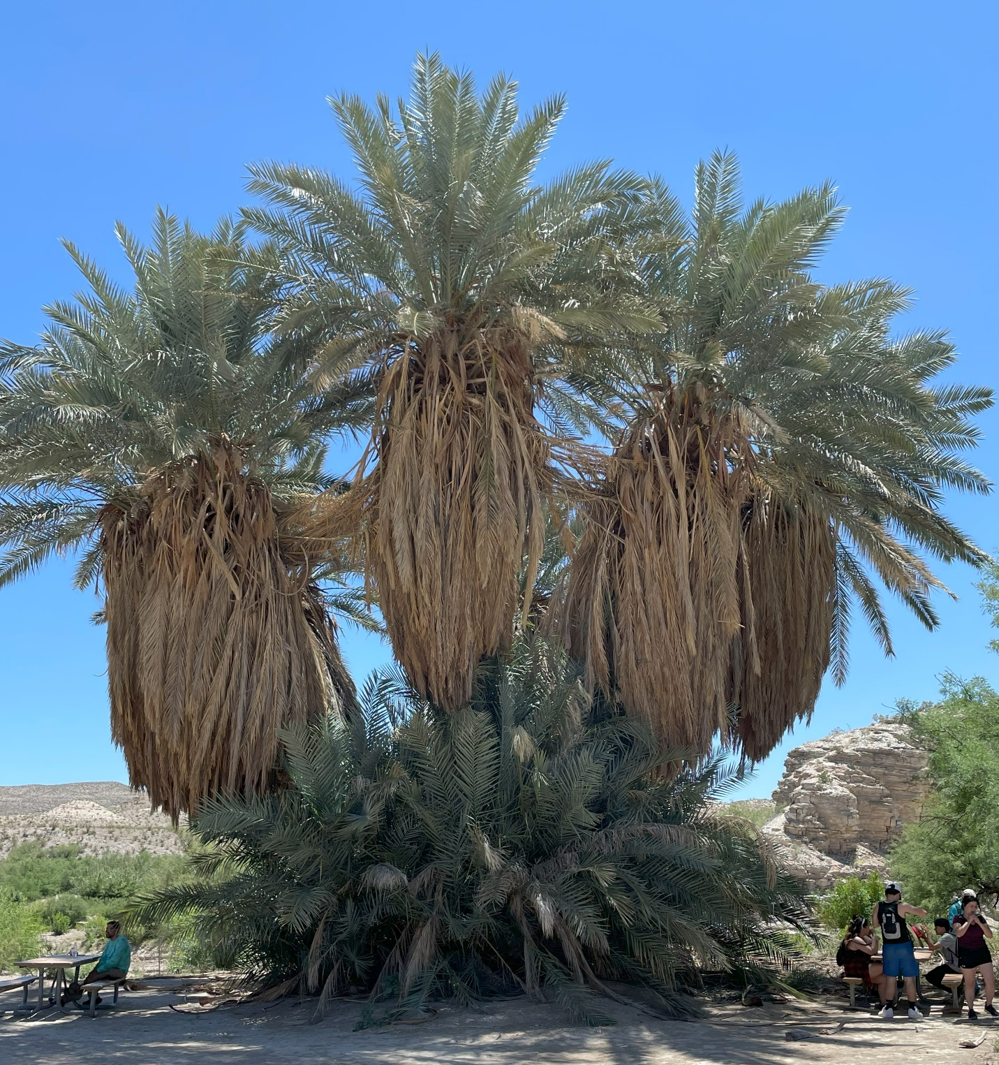
4. Big Bend National Park, Historic Hot Springs Village. Large cluster of mature staminate date palms with offshoots, at well site. Photographed April 2023 by Jane C. MacKnight.
______________________________________________________________________________

covering 121,400 ha (300,000 acres); and the inholdings and private lands close to these two protected areas.

Big Bend National Park
Within the National Park boundaries, historic Hot Springs Village is an early and well documented site of date palm planting, but apparently not for fruit production. J. O. Langford bought land there in 1909 and farmed, developed the hot springs into a health spa, and built a successful trading post. A new trading post/post office was constructed in 1927 and become the park’s iconic historic building. Photographs from the 1930s are devoid of a date palm. In 1940, Langford planted what turned out to be a staminate date palm at the site of the village well; today it has grown into a massive cluster of some ten large palms surrounded by a larger number of small ones (Fig. 4). Maggie and H. Baylor Smith took over the operations of the trading post/post office in 1942 and Maggie planted a date palm, which also turned out to be staminate, in front of the building for shade (Fig. 5). Without any evidence of pistillate palms, Hot Springs Village could not have been a seed source for subsequent date dissemination elsewhere in Big Bend. In the early 1940s, a large pear tree grew beside the building (Langford and Gibson 1952, Wright 2018). In 1955 an herbarium specimen was collected of a date palm from Hot Springs Village (SRSC 198907). Another herbarium specimen was obtained in 1996 from a solitary spontaneously occurring date palm in the Fresno Creek wash, east-northeast of Elephant Tusk (SRSC 19898), the only evidence of a palm from that remote location.
In the early 1900s, a spring at Dugout Wells, about 19 km (12 miles) northwest of Hot Springs Village, was settled by ranchers and farmers. The Green family constructed a wind pump at their homesite and created an oasis of trees and shrubs that included planting a pistillate date palm, which survives among the cottonwood trees (Fig. 6). The mother palm has a mature offshoot; both bear fruit, although without a staminate pollinator, fruits are stunted and seedless. Evidence of an old dead offshoot scar can be seen on the mother tree trunk. It is likely other fruit trees were planted at Dugout Wells, but no documentation or trees survive.
In 1910, Fred Frazier founded a ranch along the flowing Grapevine Spring in the Grapevine Hills, north of present Highway 118, which supported native willows, cottonwoods, and wild grapes. Frazier ranched and grew vegetables and had an orchard of fruit trees. Information about the ranch ruins and status of the spring could not be found. In the 1880s, just north of the Rosillos Mountains, the Buttrill Ranch was founded at the site of an active spring. In addition to ranching, the Buttrills constructed irrigated terraces for pecans (one survives) and unidentified fruit trees without survivors (Alex 2010). Pecans are native to eastern Texas, but not the Trans-Pecos Region, which includes Big Bend.
Orchard tree crops were grown at the Sam Nail Ranch on the Castolon Road. Fig, peach, and pecan trees survive at the site near Oak Springs Road. It is unknow if dates or other fruits were also grown. Farther south off the Castolon Road near the Cattail Canyon Trail into the Chisos Mountains, photographic evidence exists of spontaneously occurring date palms, one along the
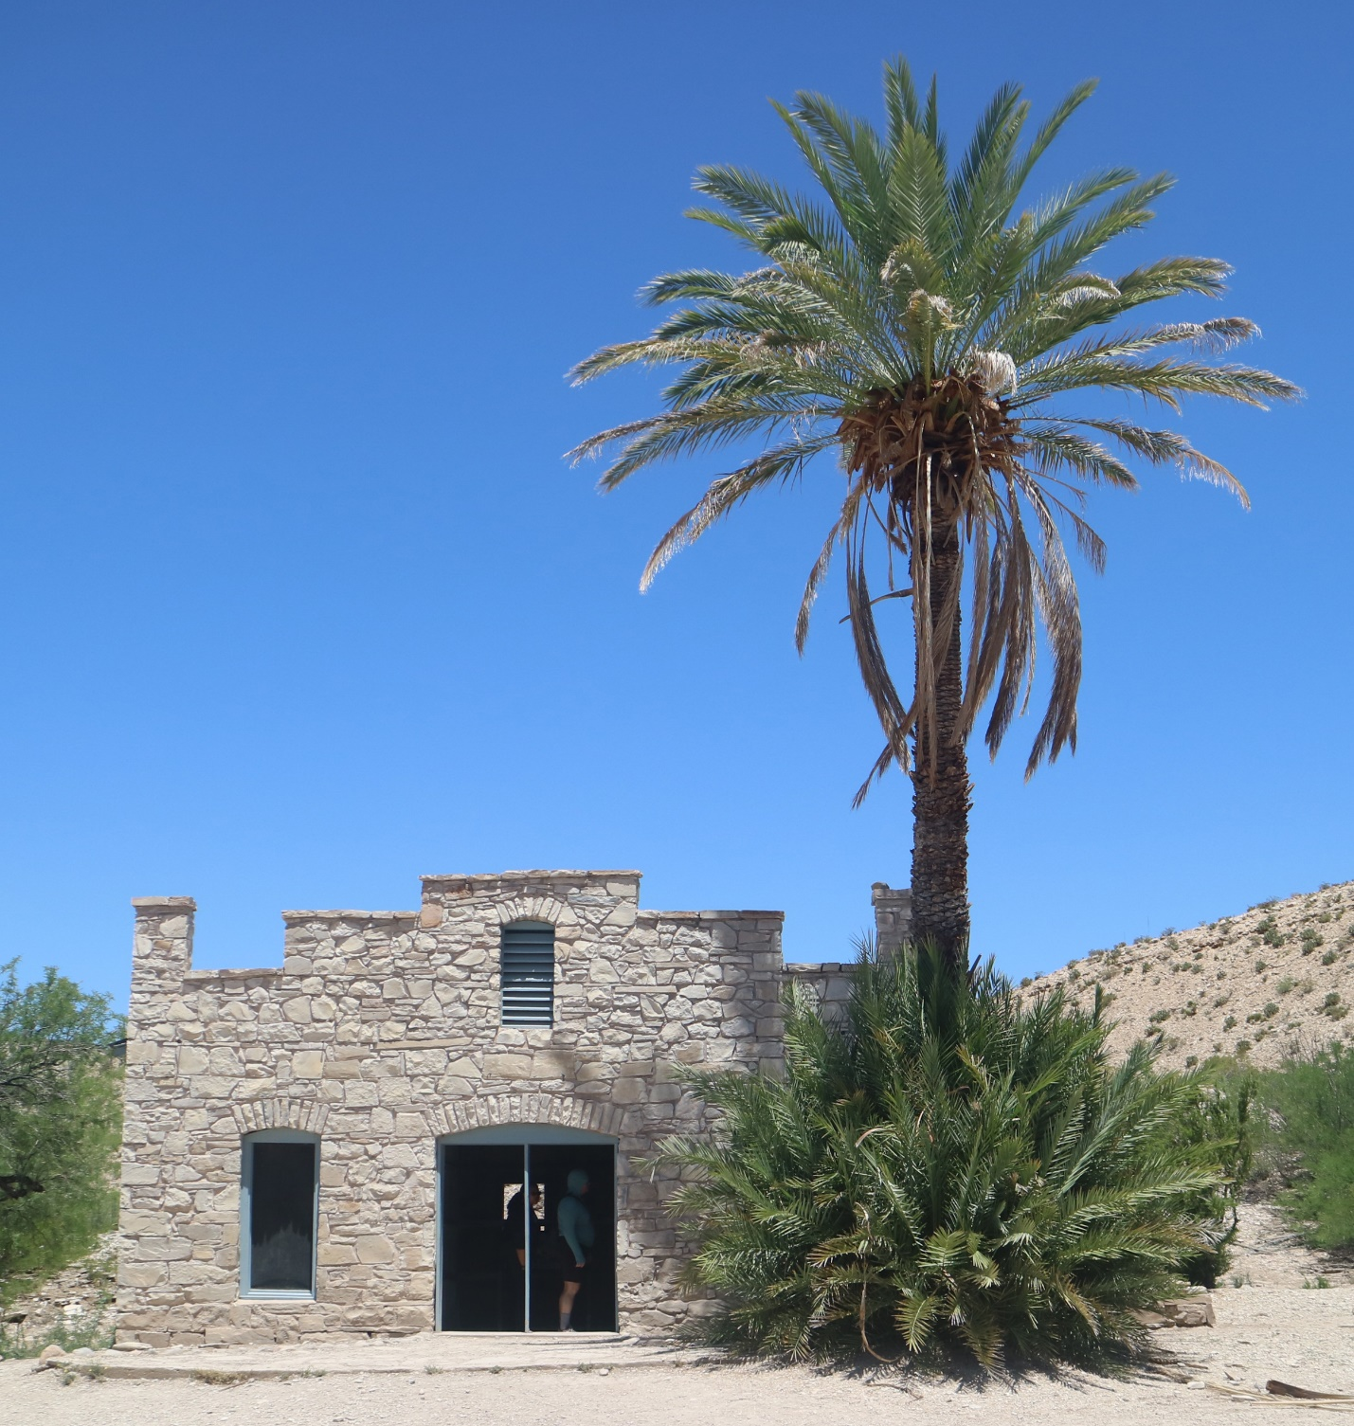
5. Big Bend National Park, Historic Hot Springs Village. Trading post/post office with mature staminate date palm with offshoots. Photographed April 2023 by Jane C. MacKnight.
______________________________________________________________________________

trail (Fig. 7) and a second at the waterfall (iNaturalist.org). Still farther south, date palms were found growing along the Mule Ears Spring Trail, but were extirpated by the Park Service (Skiles, pers. comm.).

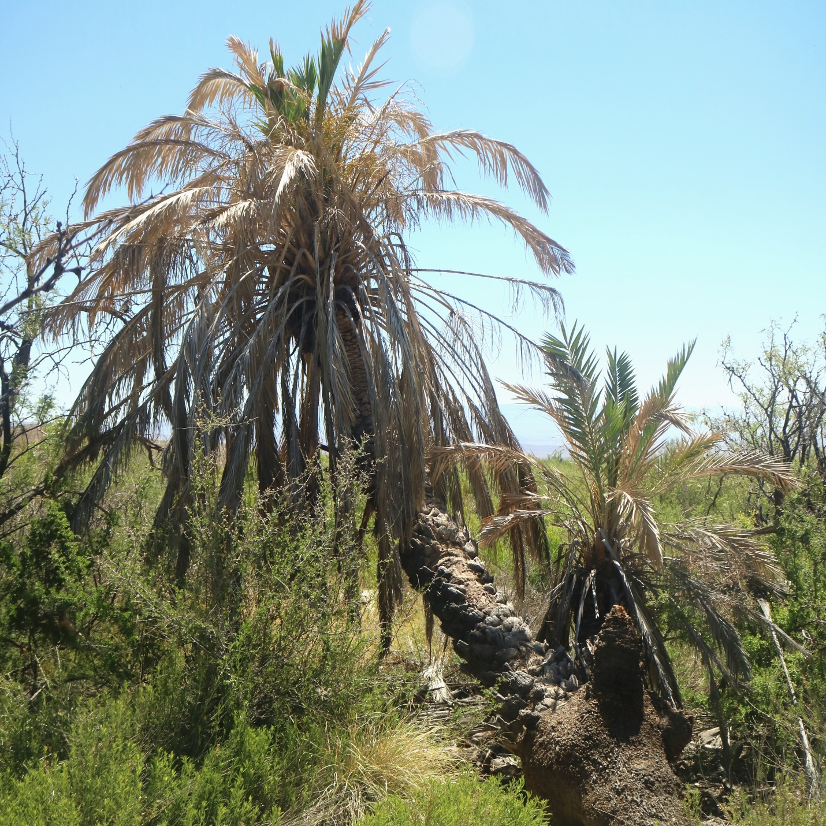
6. Big Bend National Park, Dugout Wells. Pistillate date palm with a single offshoot, both bearing fruit. Photographed April 2023 by Jane C. MacKnight.
______________________________________________________________________________

The Big Bend area now called Castolon, just downriver from Santa Elena Canyon, is an important locus of early American settlement and irrigated agriculture. Beginning in the 1880s corn, vegetables, wheat, alfalfa, cotton, and fruit crops were cultivated on the floodplain. Wayne Cartledge purchased land in Castolon in 1919 and planted pecans, peaches, and unspecified other orchard fruits, as well as cotton (Cartledge Collection 1922, 1924; Casey 1969). The photograph

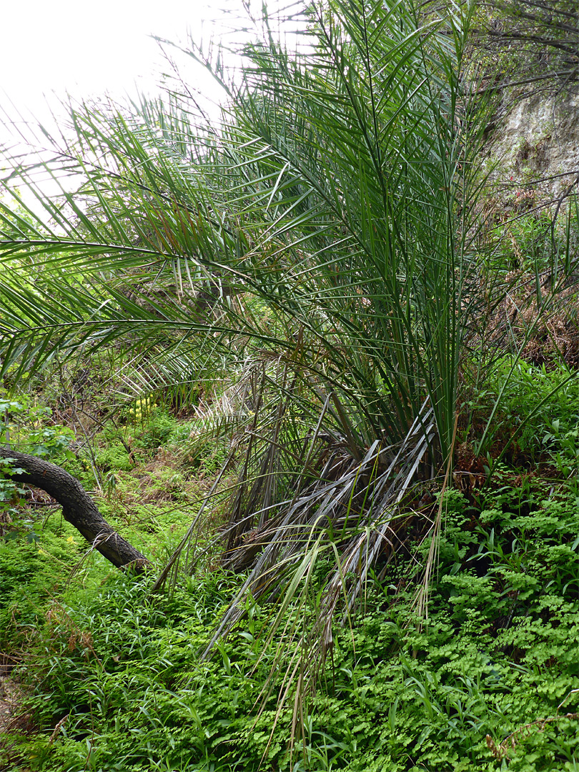
7. Big Bend National Park, Cattail Canyon. Spontaneous date palm along a hiking trail. Source: iNaturalist.org
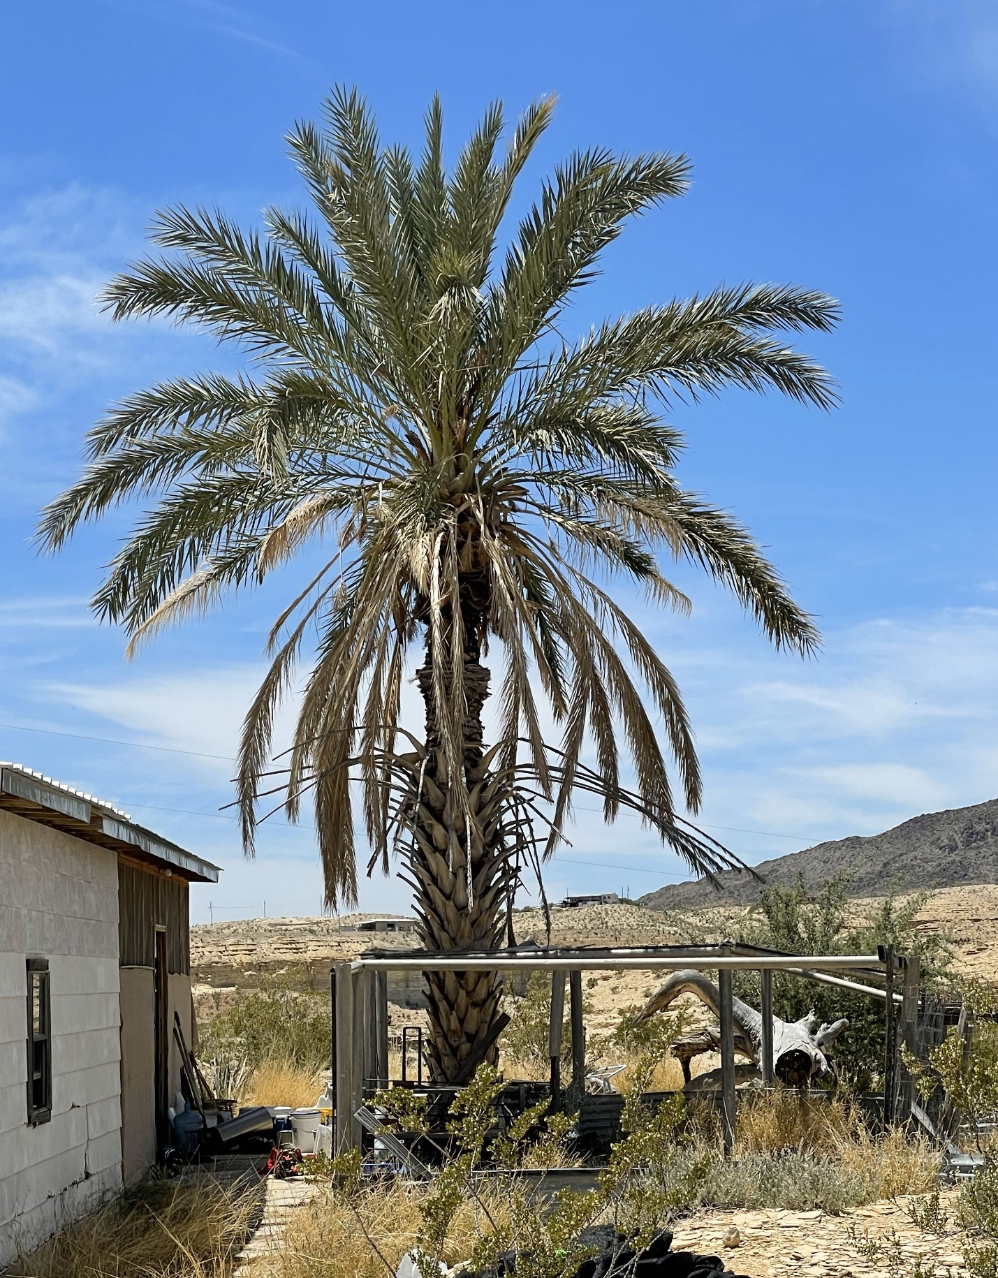
8. Mature staminate date palm in a private yard, Terlingua, TX. Photographed April 2023 by Jane C. MacKnight.

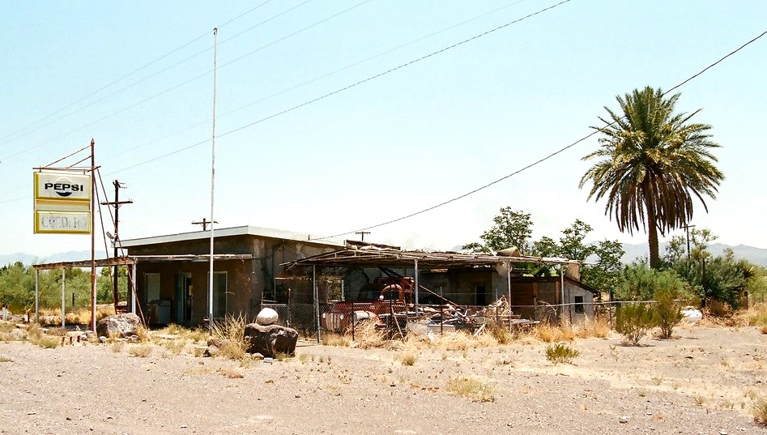
9. Mature staminate date palm behind a former roadside café, Redford, TX. Source: www.google.com/maps/place/18326+FM170,+Redford,+TX+79846/ Image capture July 2021.
______________________________________________________________________________

of a date palm at nearby La Coyota (Fig. 3), c. 1930s, suggests dates might have been cultivated in Castolon as well, but none survive.
Big Bend Ranch State Park
The sole evidence of date palm within this protected area is from a 2010 herbarium record. The collection consists of a date palm leaf segment, along with field images of the stemless plant and its staminate inflorescence, growing among boulders in the middle of the Lower Shutup Creek Canyon, Presidio County (SRSC 26363). No settlements in the canyon account for its presence, so it is presumed spontaneous. The Crawford-Smith Ranch of Fresno Canyon (not to be confused with the eponymous stream in the National Park) was founded in 1915 at the site of a natural spring. Besides goat ranching, an irrigated orchard of citrus, grapes, and figs, and a vegetable garden supplemented the ranch production.
(https://tpwd.texas.gov/publications/pwdpubs/media/pwd_br_p4501_152j.pdf).
Private Lands within and Proximal to the Parks
Inholdings and private lands near the two protected areas also provide current confirmation of date palm growth. Rancho de los Rios is an inholding in Big Bend Ranch Park to the west of Fresno Creek and part of its drainage. Two date palms reportedly are growing at a water source above the old ranch remains (Morey, pers. comm.). Redford is a very small community some 16 miles downstream from Presidio. It is on the Rio Grande, lying just south of the state park boundary. Along Highway 170, a mature male date palm (Fig. 8) is present behind the derelict Cordero Cafe and another ornamental date grows in a residential yard.
A stretch of private land extends from the Lajitas port of entry on the Rio Grande, northward to include the historic mining town of Terlingua and beyond. Terlingua has no historic record of fruit tree growing; farming was practiced to the south on the Lajitas floodplain, but nothing remains of it (https://visitbigbend.com/lajitas-history/agriculture). A few ornamental date palms grace Terlingua today; two male palms were observed along with two juvenile palms, at three private properties. The largest of these palms is shown in Fig. 9.
Discussion
We can confirm date palms in Big Bend area from five locations in the National Park, one in the State Park, and two near the parks. As stated, the exact historic time period, origin and place of the date palms’ introduction are unknown. It is without question that the Spanish missions promoted fruit tree orchards in their early settlements. The first successful introduction of dates to Big Bend likely took place in the early to middle 1800s; earlier attempts may well have failed before Klee reported date palms in Big Bend in 1882 (Colley 1983). Agricultural settlers along the Rio Grande and at inland ranch sites cultivated a few fruit crops; the only physical evidence today are the date, peach, fig, and pecan trees at a few ranch sites, an historic report of a pear tree at Hot Springs Village, and citrus and grapes from the Crawford-Smith Ranch in the present State Park.
Of the orchard crops documented to have been introduced in Big Bend—citrus, date, fig, grape, pecan, peach, pear— only grapes and pecans are now commercial crops in the Trans-Pecos Region. Meanwhile, the date palm has become naturalized, reproducing from seed and offshoots in the presence of ground water. The two date palm clusters at Hot Springs Village are the best example. The most plausible way dates spontaneously established themselves from seed in the protected areas is by human action, as exemplified in Fresno, Cattail, and Mule Ear’s canyons in the national park and in the state park in Lower Shutup Canyon. The four locations of fairly recent spontaneous date palms are along established park trails and may result from seeds of date fruit snacks discarded by hikers, near a water source. Likely other such unreported locations exist within the protected areas. Recent animal dispersal of fruit/seed by coyotes or birds is questionable because there is no apparent source of viable seeds from cultivated or feral palms in Big Bend. Spontaneous date palms do not pose a threat to Big Bend native plant communities because they cannot easily disperse. Ornamental date palms such as those found in Terlingua and Redford can also be observed farther up the Rio Grande to El Paso.
Acknowledgements
The authors thank Sul Ross University for the generous assistance of Victoria Contreras, Head Archivist of the Big Bend Archives and Dr. Mike Powell, Emeritus Director of the Michael Powell Herbarium. We were fortunate to meet National Park Service’s Ranger Bob Smith who shared his knowledge of the early settlements within the park.
Literature Cited
Alex, T. C. 2010. Big Bend National Park and vicinity. Arcadia Publishing, Charleston, South Carolina.
Brown, S. 2021. Hi Jolly – Uncle Sam’s camel captain. AramcoWorld 72(2):16–19.
Cartledge, Wayne R. Collections. 1922, 1924. Correspondence. Archives of the Big Bend, Sul Ross University, Alpine, Texas.
Casey, C. B. 1969. Soldiers, Ranchers and Miners in the Big Bend. Dept. of Interior, National Park Service, Washington, D. C.
Colley, C. C. 1983. The desert shall blossom: North African influence on the American Southwest. West. Hist. Quart. 14(3):277–290.
Dunmire, W. W. 2004. Gardens of New Spain. University of Texas Press, Austin, Texas.
Greenly, A. H. 1952. Camels in America. Papers Bibliog. Studies America 46(4):327–372.
Hopper, M. S. 2014. The globalization of dried fruit, pp. 158–182 In: J. L. Gelvin and N. Green (eds.), Global Muslims in the Age of Steam and Print. University of California Press, Berkeley, California.
Ivey, J. E. 1990. Big Bend Presidios. Southwest Cultural Resources Center, Prof. Paper 31, National Park Service, Dept. Interior, Santa Fe, New Mexico.
Johnson, D. V., E. Joyal, and R. K. Harris. 2002. Date palm varieties in Arizona. Fruit Gard. 34(5): 6–9; 26.
Johnson, D. V., J. C. MacKnight, and S. Zona. 2016. Date palms of Furnace Creek Ranch and China Ranch in Inyo County, California. Fruit Gard. 48(5): 6–15.
Johnson, D. V., and J. C. MacKnight. 2019a. A history of date palms in the Lower Colorado River Valley. J. Southwest 61(4): 863–879.
Johnson, D. V., and J. C. MacKnight. 2019b. Date palm in the Borrego Springs, California landscape. Palm J. 219: 44–47.
Johnson, D. V., and J. C. MacKnight. 2021. Historic cultivation of date palm (Phoenix dactylifera L.) in Florida and Georgia. Palms 65(3): 147–154.
Johnson, D. V. and J. C. MacKnight. 2022. Date growing in South Texas. PalmArbor 2022-04: 1–35.
Klee, W. G. 1883. Culture of the date. U.S. Dept. Agr., Washington, D C.
Lammons, F. B. 1958. Operation camel: an experiment in animal transportation in Texas, 1857–1860. Southwest. Hist. Quart. 61(1): 20–50.
Langford, J. O. and F. Gipson. 1952. Big Bend: a homesteader’s story. University of Texas Press, Austin, Texas.
Madrid, E. R. 1996. Native American and mestizo farming at La Junta de los Ríos. J. Big Bend Studies 8: 15–32.
Morey, Roy. Lajitas, TX. Personal communication, May 10, 2023.
Reitz, E. J. and C. M. Scarry. 1985. Reconstructing historic subsistence with an example from sixteenth century Spanish Florida. Soc. Hist. Arch., Special Publication Ser. #3, Ann Arbor, Michigan.
Skiles, Raymond, Aline, TX. Personal communication, February 23, 2023.
SRSC. Sul Ross State University, A. Michael Powell Herbarium, Alpine, Texas.
Tyler, R. C. 1975. The Big Bend: a history of the last Texas frontier. National Park Service, Dept. Interior, Washington, D. C.
Wauer, R. H. 1996. Naturalist’s Big Bend. Texas A & M Press, College Station, Texas.
Wright, B. 2018. The whole damn cheese. TCU Press, Fort Worth, Texas.
Wright, J. E. 1963. Early settling of the Big Bend. Sul Ross State Coll. Bull. 43(3):55–62.
___________________________
Dennis V. Johnson and Jane C. MacKnight are consultants specializing in plant sciences. djohn37@aol.com, janecmack@gmail.com
Text © 2023 by D. V. Johnson and J. C. MacKnight.
Photographs © 2023 by the authors unless noted otherwise.
Publication Date: 15 June 2023.
PalmArbor: http://ucanr.edu/sites/HodelPalmsTrees/PalmArbor/
ISSN 269083245
Editor-In-Chief: Donald R. Hodel
Hodel Palms and Trees: http://ucanr.edu/sites/HodelPalmsTrees/

