Effect of the Plant Growth Regulator
Paclobutrazol on the Growth of
Seven Species of Common Landscape Shrubs

DONALD R. HODEL, MARIANNE WAINDLE,
MAX F. ROTHSCHILD, AND JOSUE CHINCHILLA-VARGAS
Abstract
We conducted a three-year study at the University of California Research and Extension Center in Irvine, California on the effect of the plant growth regulator paclobutrazol on the growth of seven species of common landscape shrubs. The shrubs were in 3.8 l standard nursery containers. We randomly arranged and planted four plants each of Bougainvillea ‘Raspberry Ice’, Escallonia × exoniensis, Nerium oleander, Pittosporum tobira, and Rhaphiolepis indica and two plants each of Buxus japonica and Photinia × fraseri in a row. We included six replicate rows in the study. We placed the plants 2.1 meters apart in a row and spaced the six rows 3.7 meters apart. We randomly applied four treatments to the five species with four plants in each of the six rows: a control (no treatment) and low, medium, and high amounts of diluted ready-to-use (RTU) paclobutrazol (1 part Shortstop® 2SC concentrate to 11 parts water). We randomly applied two treatments to the two species with only two plants in each of the six rows: a control and medium amount of diluted RTU material. We determined the amount of diluted RTU material to apply to each plant by each plant’s crown volume and whether it was a low, medium, or high rate. Paclobutrazol tended to reduce growth across all seven shrub species at any rate 4 and 13 months after treatment. At the end of the study, 23 months after treatment, none of the treatments significantly reduced growth compared to the control. Paclobutrazol significantly reduced plant appearance across all seven species at any rate at 4, 13, and 23 months after treatment. The reported effects of paclobutrazol, including reduced shoot elongation, shorter internodes, more compact growth, and disease resistance tended to be true in our study. However, other reported effects, such as normal sized and darker green leaves, did not occur in most cases in our study; leaves tended to be smaller on treated plants while only Buxus japonica had greener leaves on treated plants. Suspected phytotoxic responses, mostly leaf discoloration, deformation, marginal chlorosis and necrosis, and defoliation leading to canopy thinning, were present in over half the species.
Introduction and Previous Work
Landscape shrubs and groundcovers generally need regular pruning to attain and maintain size, form, function, and esthetic quality. However, such pruning is labor intensive, time- and resource-consuming, and generates green waste material entering the waste stream going to landfills. Indeed, many municipalities in more than half the states now discourage, limit, or ban green waste material from entering the waste stream (Chen et al. 2012).
Various plant growth regulators (PGRs), which are organic, natural or synthetic hormones that regulate plant growth (Desta and Amare 2021, Kumari et al. 2018), have been used as a full or partial pruning substitute to reduce costs and production of green waste and enhance tolerance to the harsh conditions in urban landscapes (Chen et al. 2012, Chaney 2005, Desta and Amare 2021).
Interest in PGRs for use in woody landscape plants began in the 1950s, primarily to help limit growth of trees under overhead utility lines (Banko and Stefani 1988, Chaney 2005, Cregg 2019, EPRI 2000, Mann et al. 1995). At the time, the electric utility industry provided funding for chemical control of tree growth (Chaney 2005, EPRI 2000). Maleic hydrazide, a terminal bud inhibitor widely used at the time, was effective in retarding growth but was frequently phytotoxic and increased branching, which was not always desirable (Banko and Stefani 1988, Chaney 2005). Another PGR, napthaleneacetic acid, was applied to pruning wounds to retard sprouting and growth but the expenses and difficulty of painting wounds high up in the tree canopy limited its use (Chaney 2005).

By the 1970s, a newer class of PGRs, called triazoles, was being developed that retarded growth by inhibiting cell elongation. These compounds included paclobutrazol, uniconazole, and flurprimidol, which inhibit the production of gibberellins, in turn reducing cell elongation and subsequently shoot elongation (Banko and Stefani 1988, Chen et al. 2012, Chaney 2005, Cregg 2019, Desta and Amare 2021).

The triazoles also have other beneficial effects on woody landscape plants, including:
- Reducing plant growth, especially sprout growth after pruning to extend trim cycles and reduce green waste production (Banko and Stefani 1988, Cregg 2019, Davis et al. 1985, Early et al. 1988, Wang and Faust 1986, Watson 1996);
- Reducing the amount of wounding from repeated pruning. It is estimated that the average tree pruning produces 122 m² of cut surfaces, which is stress-inducing because of the energy needed to cover over wounds, which serve as entry sites for diseases and pests (Banko and Stefani 1988);
- Increasing stress resistance by reducing leaf surface area exposed to water loss and decreasing energy used for excessive growth (Banko and Stefani 1988, Herms and Mattson 1992, Percival and AlBalushi 2007, Ruter and Martin 1994, Swietlik and Miller 1983, Wample and Culver 1983, Warren et al. 1991, Zhu et al. 2004);
- Allowing larger plants to be used in smaller spaces (Banko and Stefani 1988);
- Improving plant appearance because of shorter internodes, more compact growth, and darker green color (Banko and Stefani 1988, Desta and Amare 2021);
- Increase the root-to-shoot ratio and production of fine roots (Watson 1996) and root initiation (Davis et al., 1985, Wang and Faust 1986), branching (Ashokan et al. 1995, Early et al. 1988), and thickening (Tagliavini et al. 1991);
- Morphologically modifying leaves (producing smaller stomatal pores, thicker leaves, and increasing the quantity and size of surface appendages like hairs) (Chaney 2005) and physiologically by increasing antioxidant enzymes and molecules (Fletcher et al. 2000, Jaleel et al. 2007) to increase protection against numerous abiotic stresses, such as heat, cold, flooding, and salinity, and biotic stresses like fungal and bacterial diseases and pest infestations (Chaney 2005, Cregg 2019, Desta and Amare 2021, Fletcher et al. 2000).

Triazoles are extremely active, a relatively small amount of the active ingredient is necessary for growth control, typically without phytotoxicity, and they are long lasting, up to three years (Banko and Stefani 1988, Cregg 2019) although 10 years has been reported in one instance (Burch et al. 1996). They were initially applied through trunk injections. However, trunk injections created problems, including cracks in the bark and cambium, weeping from injection holes, internal wood discoloration from alcohol carriers, and the limited internal movement of some products due to the recognized concept of compartmentalization of wounds, which blocks off wounds to slow decay (Chaney 2005). Bark banding with these compounds, also with an alcohol or petroleum distillate carrier, has been tried but damaged the bark.

Paclobutrazol is now the primary PGR used for growth retardation of woody landscape plants (Chaney 2005, Cregg 2019), and is best applied to the soil around the trunk or stem (Rademacher 2015), either injected or as a drench. Its soil half-life is six to 12 months depending on the soil type and environmental conditions (Norremark and Anderson 1990). Roots absorb the compound and translocate it to the branch tips via the xylem (Coutere 1982, Syngenta 2003). Photosynthesis is not reduced (DeJong and Doyle 1984, Rieger and Scalabrelli 1990). Soil drenches provide longer and more uniform height control (Franca et al. 2017, Rademacher 2015, Sharma and Awasthi 2005), especially in woody ornamentals (Gent and McAvoy 2000).

Paclobutrazol works by blocking the terpenoid pathway for biosynthesis of the plant growth-promoting hormone gibberellins by binding with and inhibiting enzymes that catalyze the metabolic reactions (Chaney 2005, Cregg 2019, Desta and Amare 2021, Rademacher 2000). Cells still divide but elongation is reduced (Chaney 2005, Early and Martin 1988, Wang and Faust 1986), resulting in shorter internodes but with the same quantity of leaves as untreated plants (Chaney 2005).

Paclobutrazol dramatically reduces plant growth for many species (Bai and Chaney 2005, Bai et al. 2004, Davis et al. 1985, Desta and Amare 2021, Tanis and Cregg 2015, Watson 1996). Average growth reduction is 40 to 60% while the range is 10 to 90% (Chaney 2005). Dosage depends on the plant species being treated and the size of the plant (Chaney 2005, Cregg 2019, Desta and Amare 2021).

Little previous work on the species in our study has been performed, and was mostly on containerized plants. Karagüzel (1999) found that in Bougainvillea spectabilis, paclobutrazol significantly reduced new shoot length, increased quantity of shoots per plant, and had longer suppression as a soil drench. Karagüzel and Ortacesme (2002) showed that paclobutrazol significantly reduced new branch length on B. glabra ‘Sanderiana’. Jain et al. (2016) found that paclobutrazol significantly reduced increases in plant height, spread, internodes, and shoot length of B. spectabilis ‘Shubra’. In contrast, Aldrich and Norcini (1995) found that paclobutrazol had no effect on suppression of growth of B. ‘Barbara Karst’.

In Nerium oleander, Syros and Economou (2000) showed that paclobutrazol significantly reduced new growth. Keever et al. (1990) and Owings and Newman (1993) had similar results with paclobutrazol applied to Photinia × fraseri. Rizzitelli et al. (2000) found that that paclobutrazol significantly reduced new growth on Pittosporum tobira.

Materials and Methods
We conducted this study at the University of California Research and Extension Center in Irvine, California (7601 Irvine Blvd., Irvine, CA, 92618, 33.688836°, -117.720348°, 125 m elevation). The site is classified as a maritime Mediterranean climate with cool, dry to moist winters and dry, warm summers, and is in Sunset Garden Zone 23 (Williamson 1988). Typical daily summer and winter maximum/minimum temperatures are 27/19 C and 19/9 C, respectively. Average annual precipitation is 300 mm. The soil is a San Emigdio sandy loam with a pH of seven, organic matter content of 0.84%, cation exchange capacity of 14.4 meq/100 g., and particle size distribution of 68% sand, 19% silt, and 13% clay.
On 1 November 2017, we planted seven species of common landscape shrubs out of 3.8 l containers. We randomly arranged four plants each of Bougainvillea ‘Raspberry Ice’, Escallonia ×
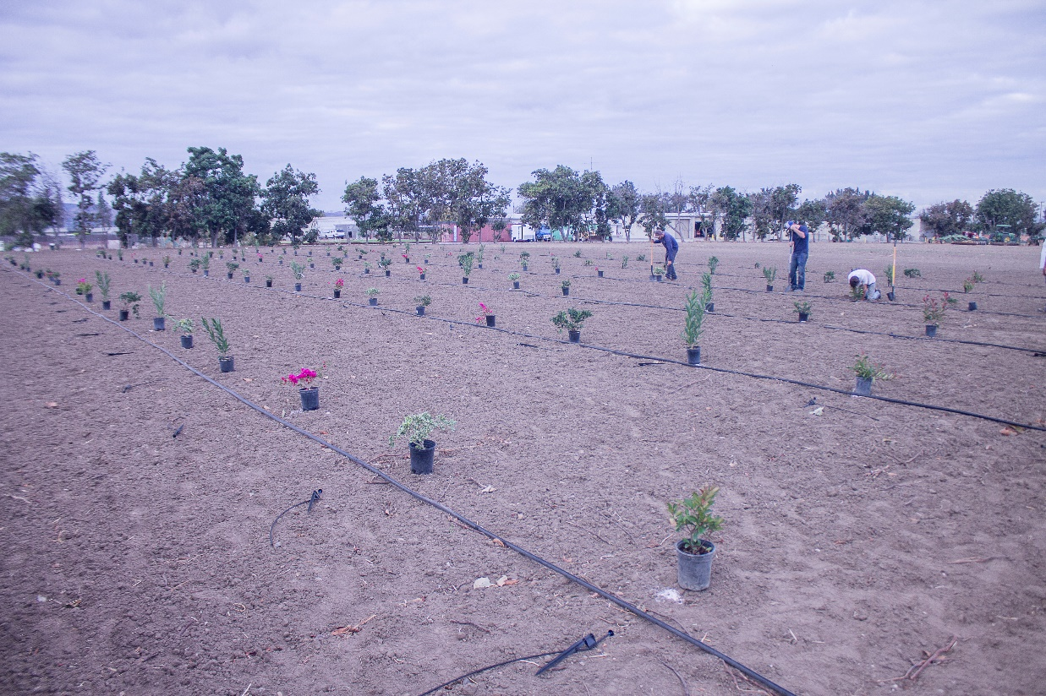
1. We randomly set out the shrubs in six rows, University of California Research and Extension Center, Irvine.

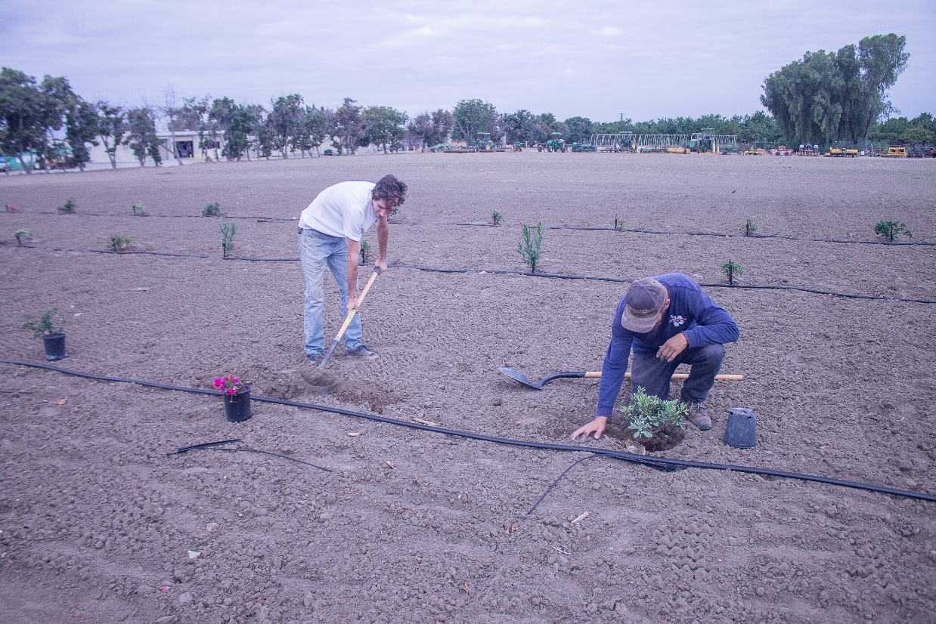
2. Center staff assisted with planting the shrubs.

exoniensis, Nerium oleander, Pittosporum tobira, and Rhaphiolepis indica and two plants of each Buxus japonica and Photinia × fraseri in a row, and had six replicate rows (Figs. 1–2). We placed the plants 2.1 meters apart in a row and the six rows were 3.7 meters apart. No fertilizer was added. Weeds were controlled by hand. Microsprayers provided water at about 80% of reference evapotranspiration for the site (ET_{o}) (Fig. 3); irrigations were scheduled when soil water loss accumulated to 50% in the upper 30 cm of soil root zone.
About a year later, on 14 November 2018, we pruned each plant with the objective to remove anomalous, rangy growth and to keep a tight, formal appearance for each species (Fig. 4). Then we determined the length, width, and height of the pruned crown of each plant to obtain a volumetric measurement.
On 3 December 2018, we applied the paclobutrazol treatments using the commercially available form Shortstop® 2SC (Arborjet, Inc., Woburn, MA.) (Fig. 5). We had four treatments randomly applied to five species with four plants in each of the six rows: a control and low, medium, and high amounts of diluted ready-to-use (RTU) paclobutrazol (1 part Shortstop® 2SC concentrate to 11 parts water). We had two treatments randomly applied to the species with only two plants in each of the six rows: a control and medium amount of diluted RTU material. The amount applied to each plant was determined by crown volume of each plant and whether it was a low, medium, or high rate.
Arborjet, Inc., the manufacturer of Shortstop® 2SC, created seven informal groupings of shrub species, each with its own recommended volume of RTU paclobutrazol. Because only two of our seven species (Buxus japonica and Photinia × fraseri) fell within these seven groupings, we communicated with the Arborjet, Inc., and they suggested using the following rates (Table 1).
Depending on the crown size of each plant, the corresponding amount of RTU paclobutrazol was applied as a soil drench to the root zone (Fig. 6).
On 30 April 2019, 29 January 2020, and 10 November 2020, we determined the length, width, and height of the crown of each plant to obtain a volumetric measurement and performance rated each plant on a scale of 1 to 5, where 1 is dead and 5 is optimal.
We compared the seven species and four treatments using two-way ANOVA and estimated mean differences for species and treatments for growth and appearance ratings that were significant (P<0.05). The model used included the fixed effects of block, treatment, and species.
Because for two species we had only two plants instead of four plants in each of the six rows and the loss of some plants occurred prior to the treatments or shortly thereafter, the experiment consisted of unbalanced data with some species not having all treatments. This development limited the statistical analyses we could perform and, therefore, specific treatment by species
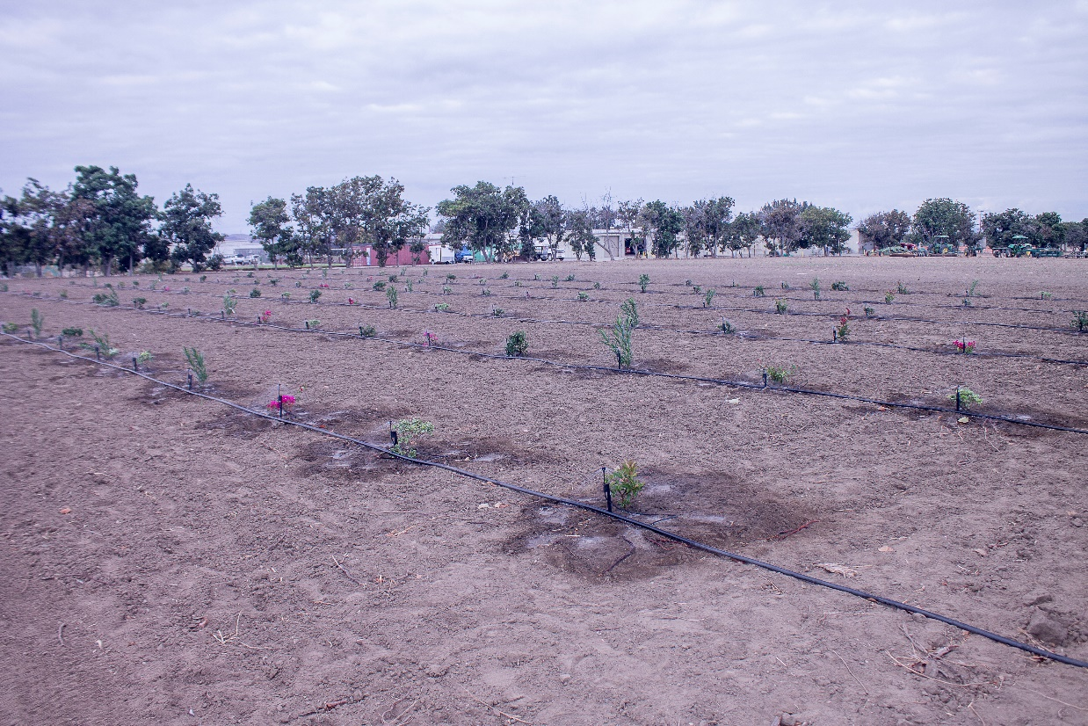
3. Microsprayers were used to irrigate the plot.

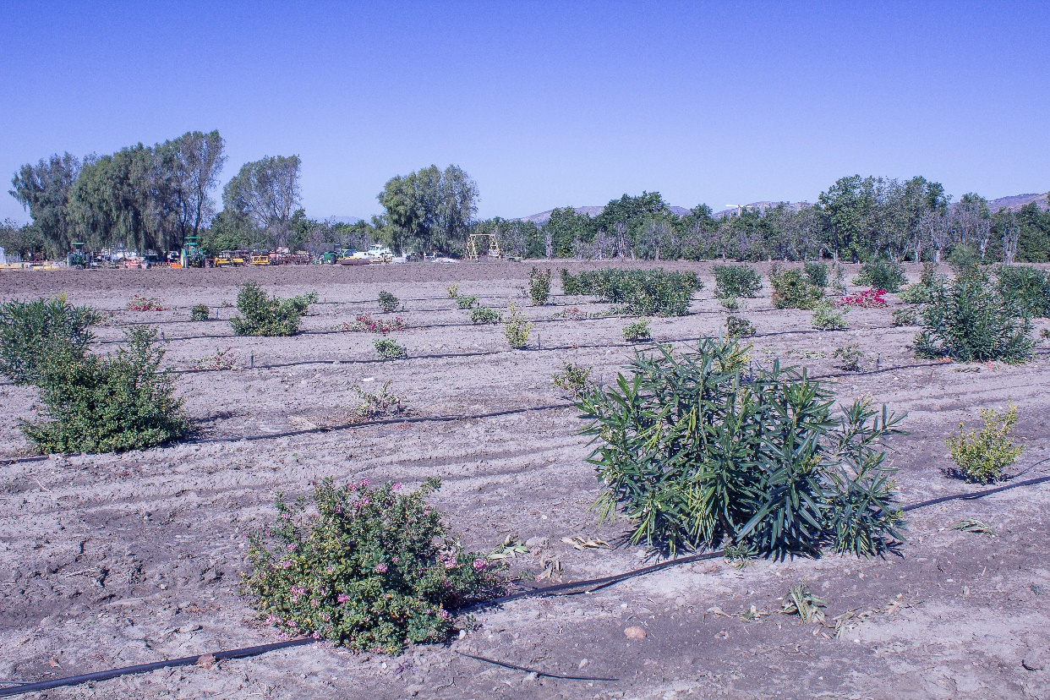
4. About a year after planting, we pruned each plant with the objective to remove anomalous, rangy growth and to keep a somewhat tight, formal appearance.
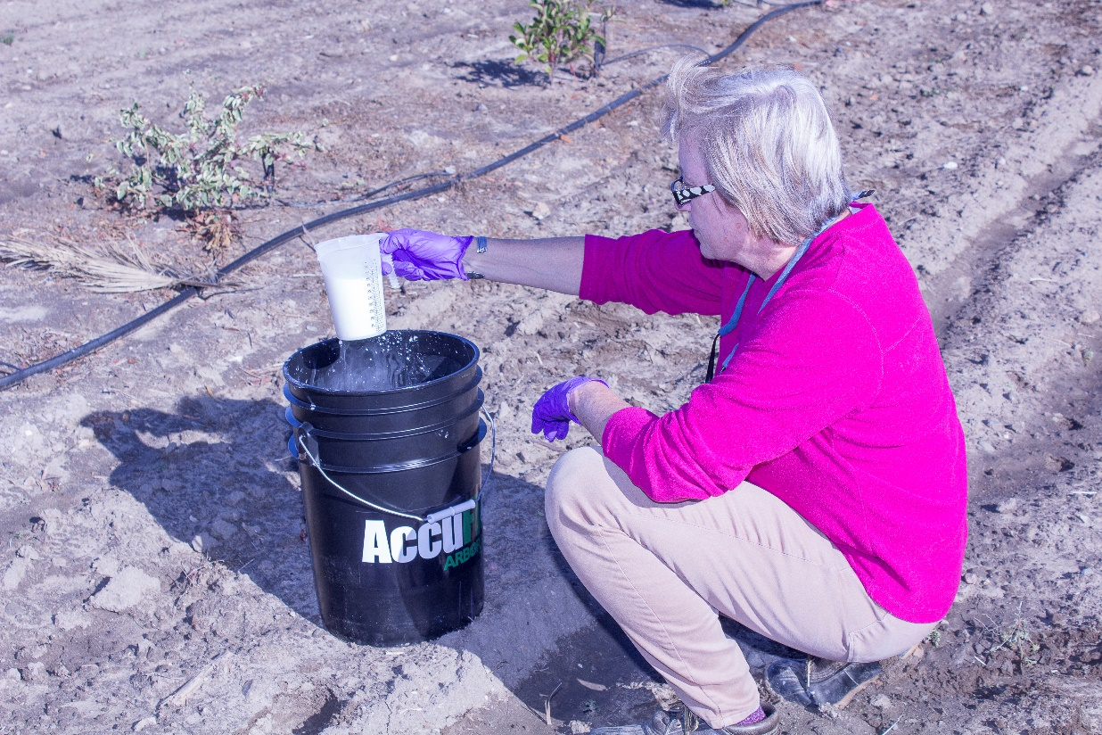
5. Co-author Marianne Waindle measures the amount of RTU material for application to a plant.

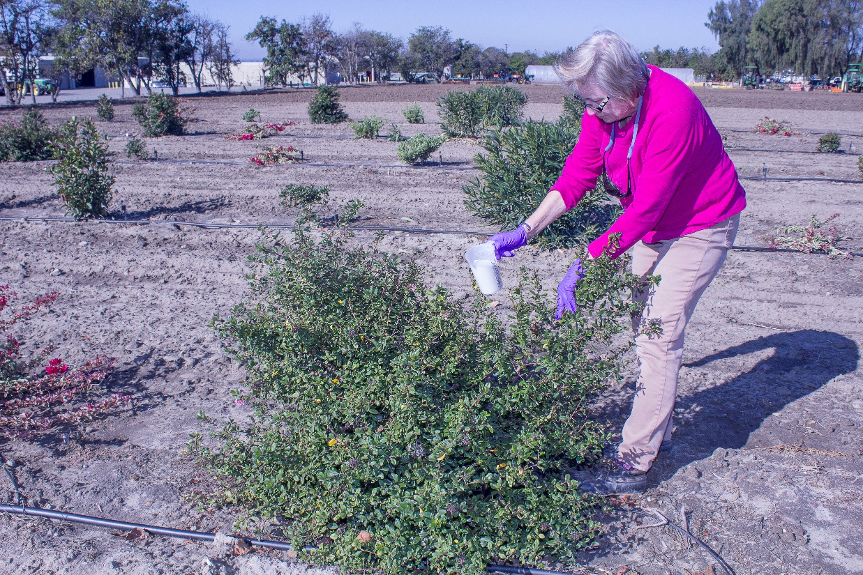
6. Co-author Marianne Waindle applies the measured amount of RTU material to an Escallonia × exoniensis.

Table 1. Amount of ready-to-use paclobutrazol (1 part Shortstop® 2SC to 11 parts water) per m³ of crown volume applied at four rates of none (control), low, medium, and high to seven species of common landscape shrubs. University of California South Coast Research and Extension Center, Irvine, CA. 3 December 2018.
Crown Volume m³ | Low (ml) | Medium (ml) | High (ml)
0.1 | 200 | 340 | 400
0.2 | 230 | 345 | 450
0.3 | 270 | 350 | 510
0.5 | 305 | 370 | 600
0.8 | 340 | 380 | 650
1.0 | 380 | 400 | 700
1.4 | 405 | 430 | 800
1.8 | 420 | 450 | 900
2.3 | 435 | 480 | 1000
2.8 | 455 | 510 | 1200
3.7 | 500 | 550 | 1300
______________________________________________________________________________
results are not presented. Results presented are for species differences averaged over the four treatments and treatment differences averaged over the seven species.
Results
Paclobutrazol tended to reduce growth across all seven shrub species at any rate four months after treatment (Table 2). However, while the high rate reduced growth significantly compared
______________________________________________________________________________

Table 2. Treatment level differences (control, low, medium, high) for mean growth and appearance averaged over seven common landscape shrubs at 4, 13, and 23 months after treatment with paclobutrazol (1 part Shortstop® 2SC to 11 parts water), 10 November 2020.
------------------------------------Months after Treatment------------------------------------
-----------------Plant Growth^{z}---------------- -------------Plant Appearance^{y}--------------
Treatment | 4 | 13 | 23 | 4 | 13 | 23
Control | 0.33² | 1.95² | 2.18¹ | 4.62² | 4.00² | 4.11²
Low | 0.11^{1,2} | 1.10¹ | 1.41¹ | 3.76¹ | 3.31¹ | 3.55¹
Medium | 0.10^{1,2} | 1.67¹ | 1.93¹ | 3.72¹ | 3.43^{1,2} | 3.57¹
High | 0.07¹ | 0.76¹ | 1.41¹ | 3.87¹ | 3.37¹ | 3.50¹
^{z}Plant growth measured in m³.
^{y}Plant appearance: 1 = dead, 5 = optimal.
Means in each column with different numerals are significantly different P<0.05
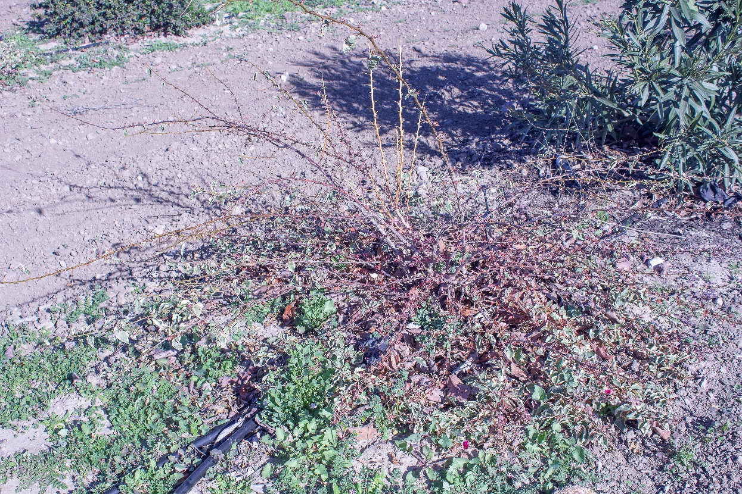
7. Bougainvillea ‘Raspberry Ice’, control, 13 months after treatment, January 2020.

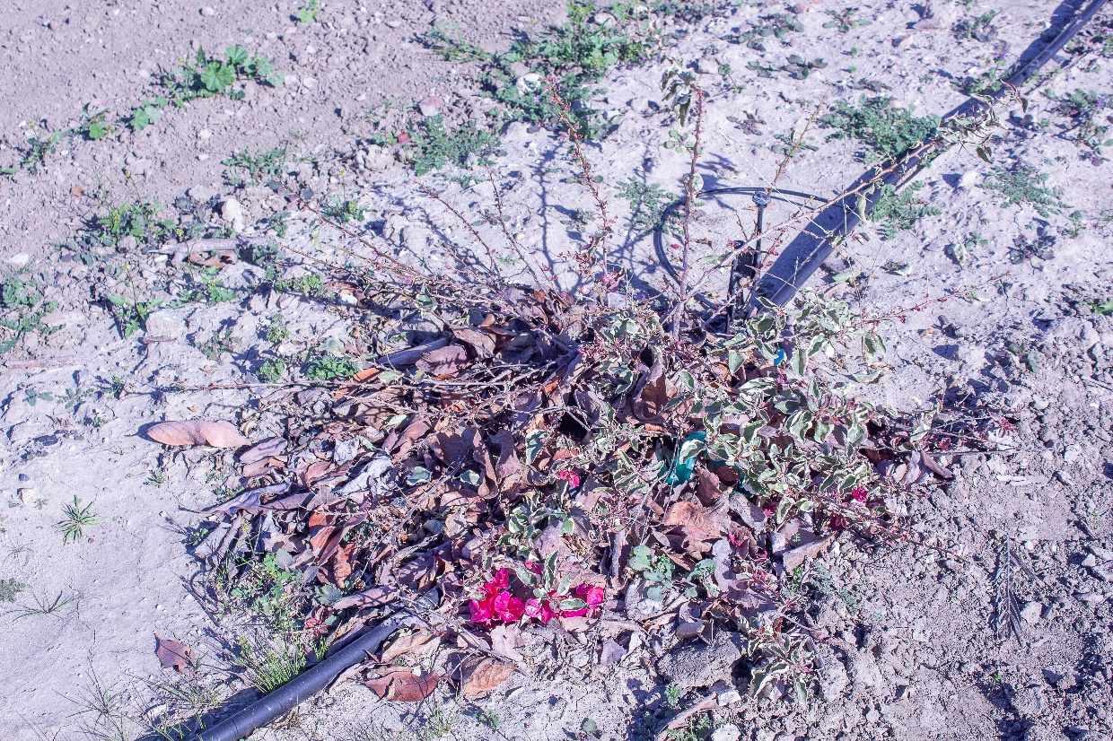
8. Bougainvillea ‘Raspberry Ice’, high rate, 13 months after treatment, January 2020.

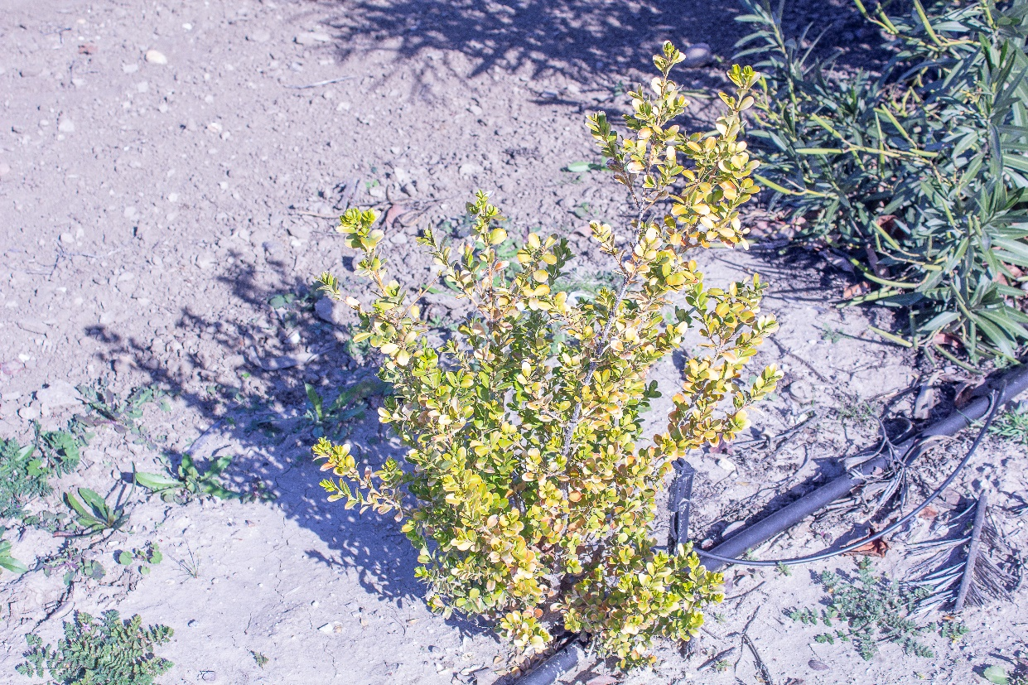
9. Buxus japonica, control, 13 months after treatment, January 2020.

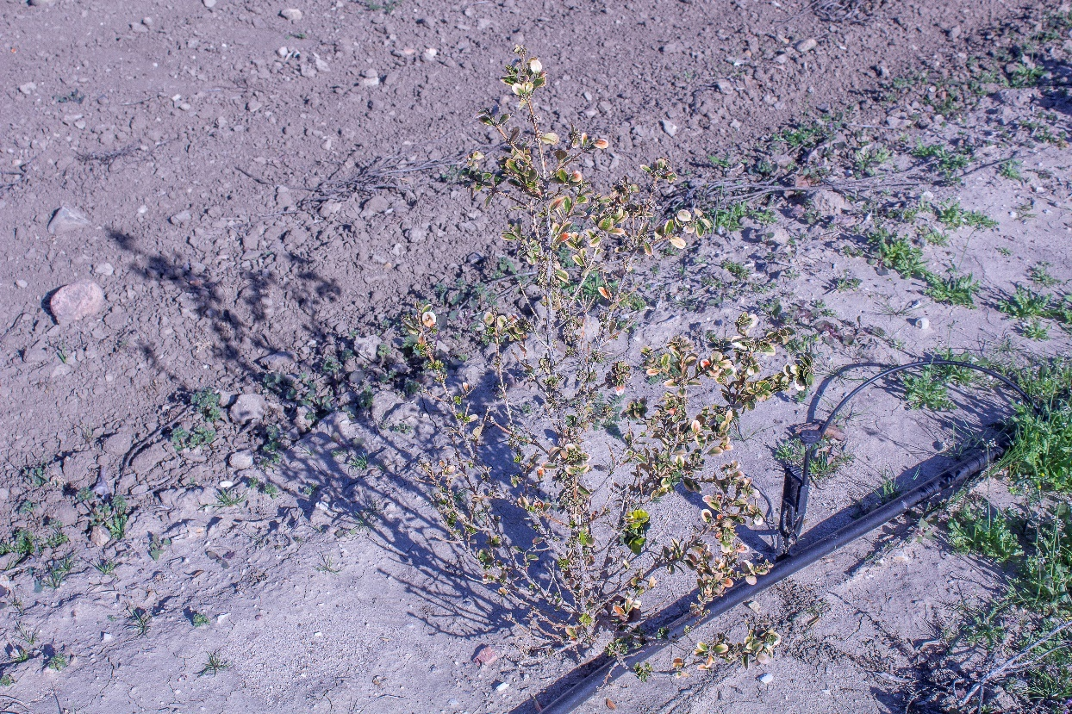
10. Buxus japonica, medium rate, 13 months after treatment, January 2020. Note the severe defoliation along sub-apical areas of shoots resulting in an open or thinned out canopy, a possible phytotoxic response.

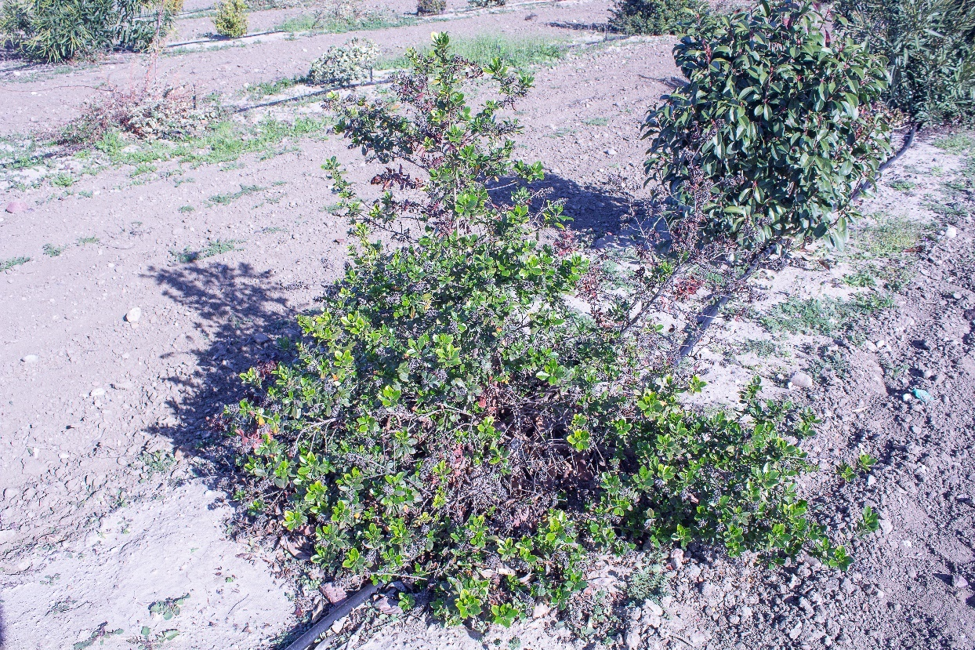
11. Escallonia × exoniensis, control, 13 months after treatment, January 2020.

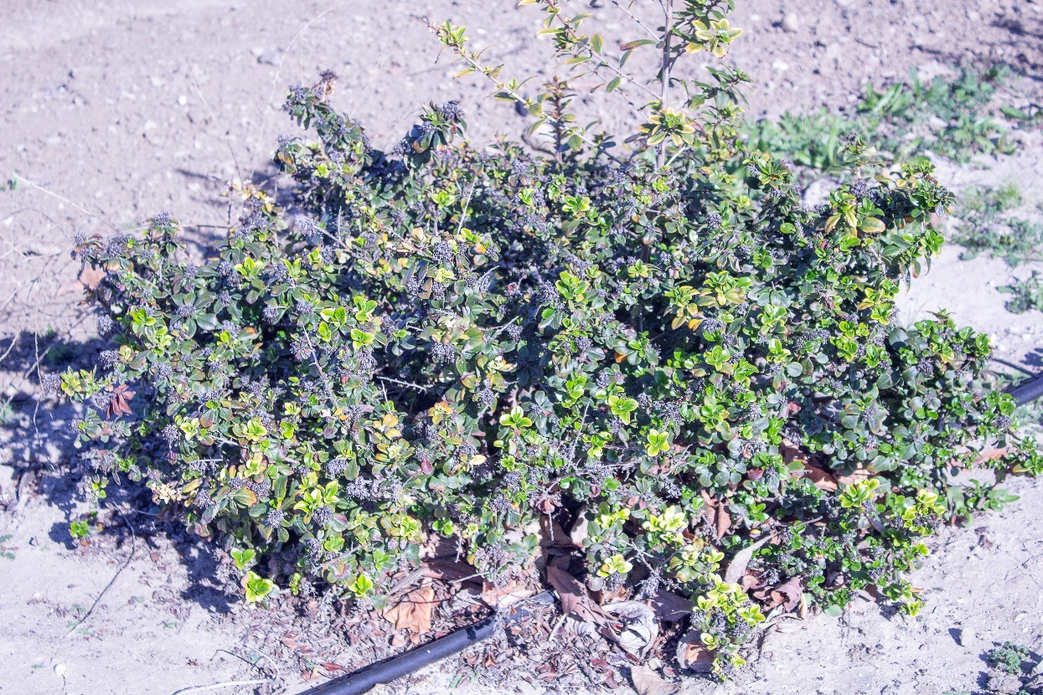
12. Escallonia × exoniensis, high rate, 13 months after treatment, January 2020.

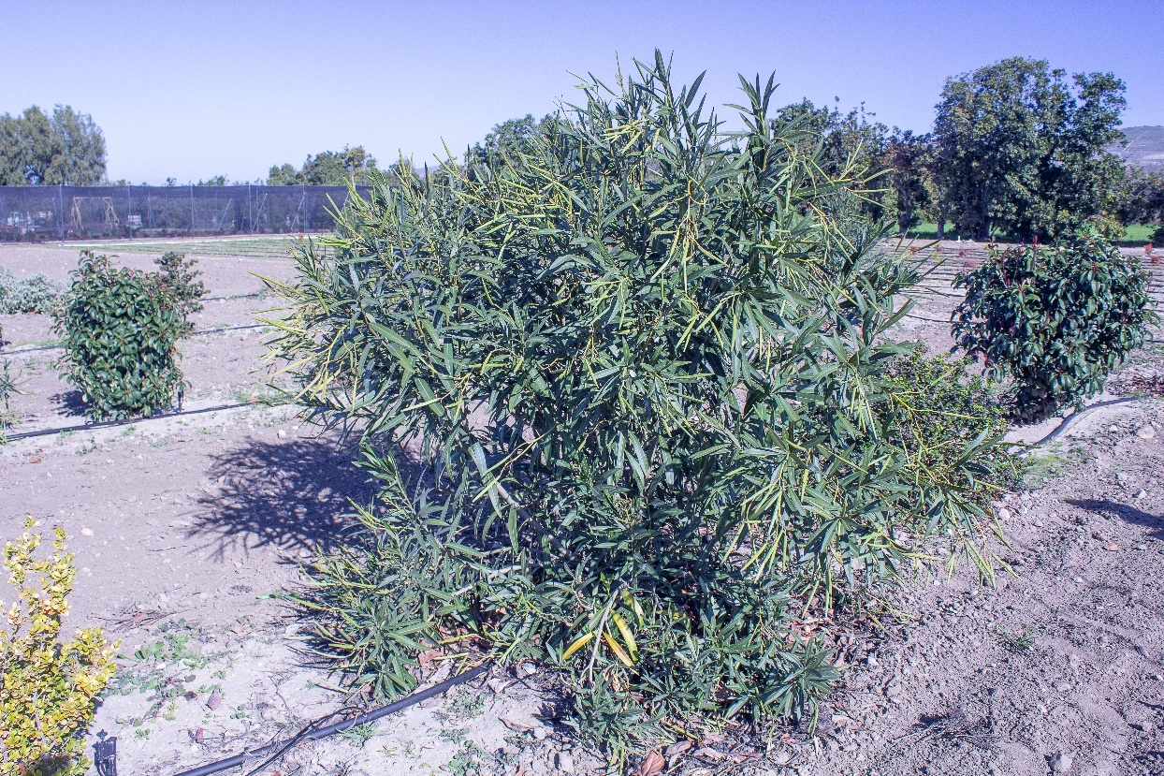
13. Nerium oleander, control, 13 months after treatment, January 2020.

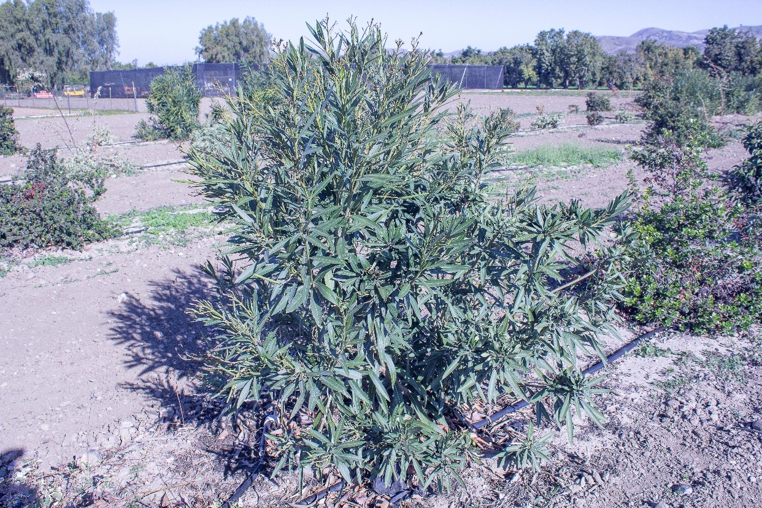
14. Nerium oleander, high rate, 13 months after treatment, January 2020.

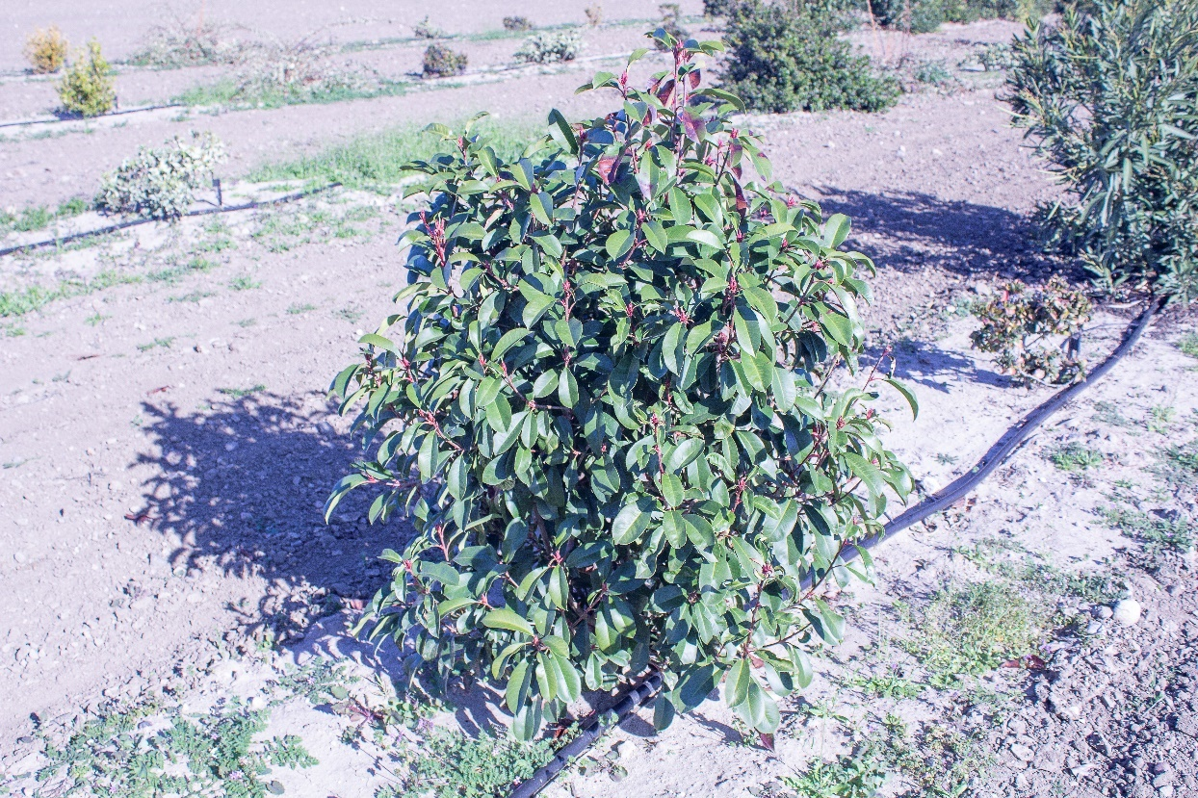
15. Photinia × fraseri, control, 13 months after treatment, January 2020.

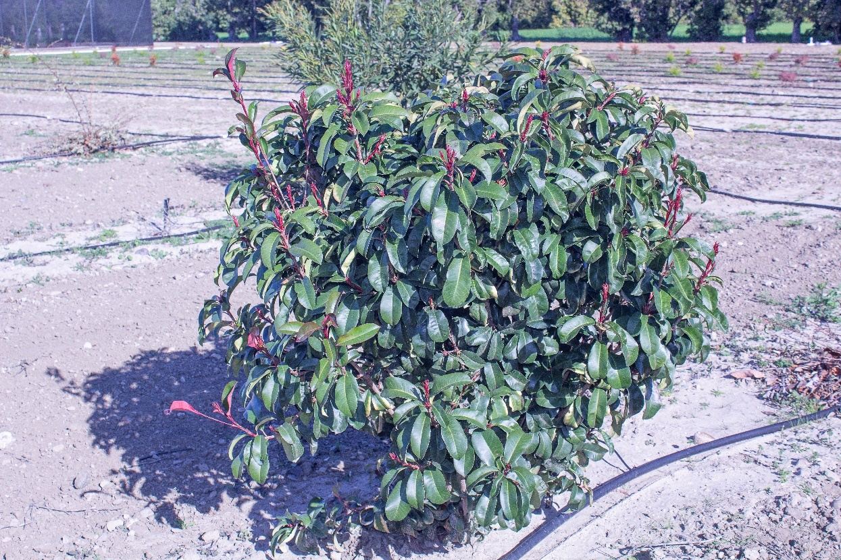
16. Photinia × fraseri, medium rate, 13 months after treatment, January 2020.

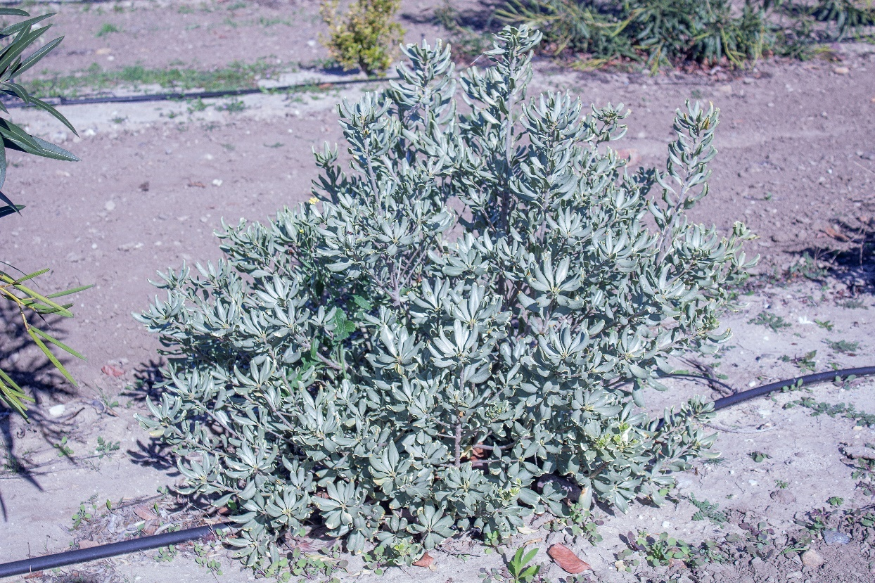
17. Pittosporum tobira, control, 13 months after treatment, January 2020.

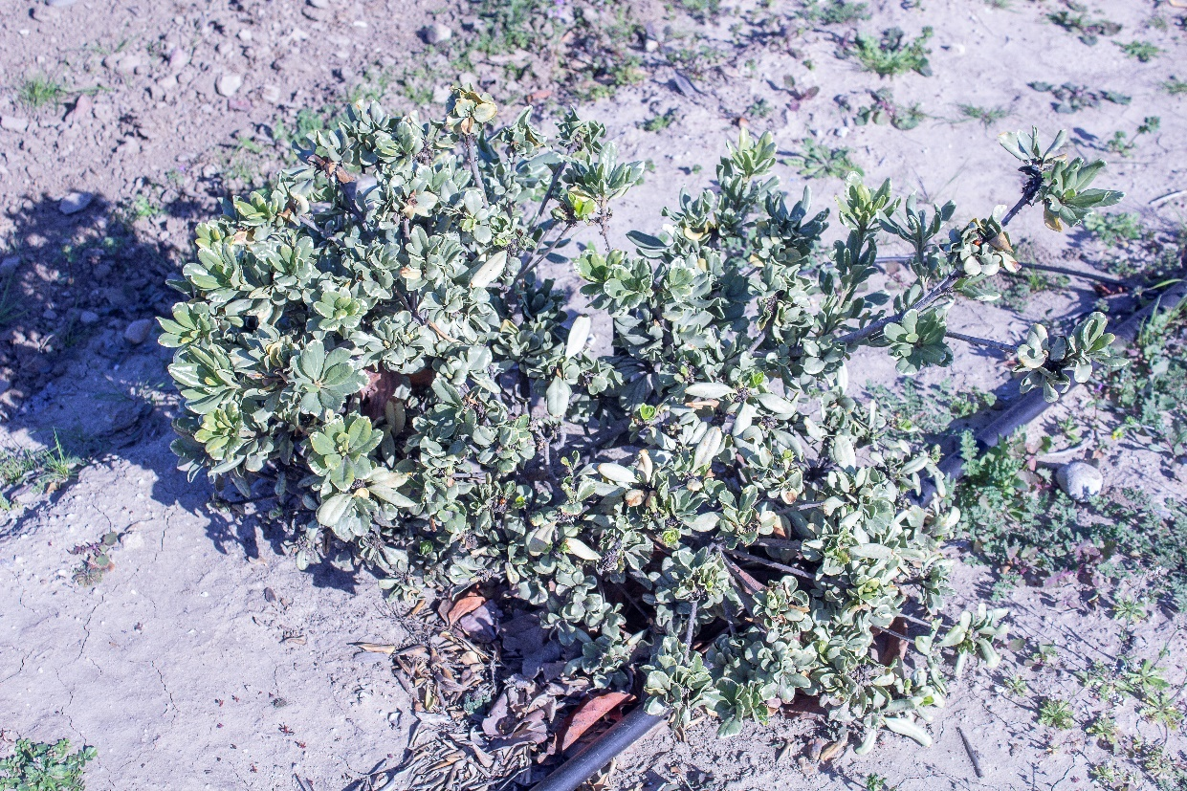
18. Pittosporum tobira, high rate, 13 months after treatment, January 2020.

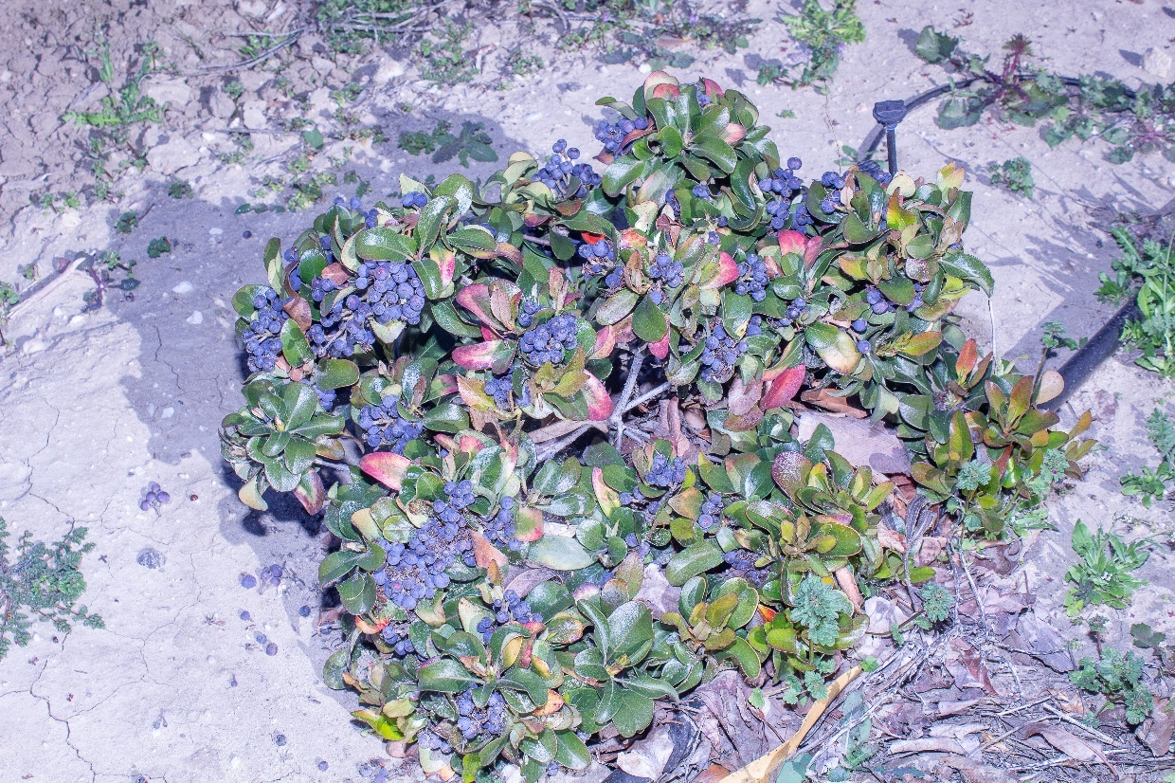
19. Rhaphiolepis indica, low rate, 13 months after treatment, January 2020.

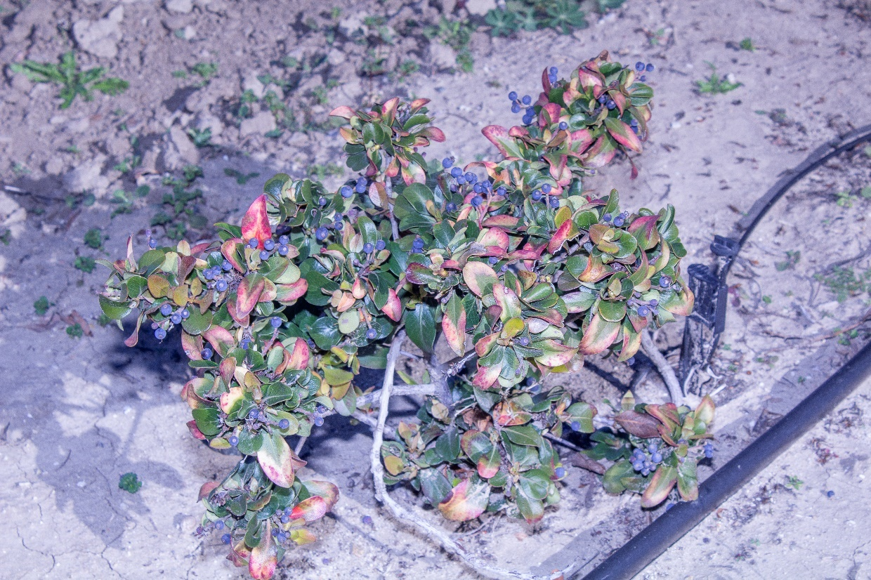
20. Rhaphiolepis indica, high rate, 13 months after treatment, January 2020.

to the control, the low and middle rates were intermediate and not significantly different from the high rate or the control. At 13 months after treatment, though, paclobutrazol significantly reduced plant growth across all seven species at any rate compared to the control (Figs. 7–20). At the end of the study, 23 months after treatment, none of the treatments significantly reduced growth compared to the control.
Paclobutrazol significantly reduced plant appearance across all seven species at any rate at 4, 13, and 23 months after treatment; however, at 13 months after treatment, the medium rate was intermediate and not significantly different compared to other treatments and the control.
Differences among species are in Table 3. At four months after treatment, Bougainvillea ‘Raspberry Ice’ had the least growth although it was not significantly different from Buxus japonica, Nerium oleander, Pittosporum tobira, and Rhaphiolepis indica; these latter four species were intermediate in their response, producing significantly less growth than Photinia× fraseri but not significantly different from Bougainvillea ‘Raspberry Ice’. Escallonia × exoniensis was also somewhat intermediate; it produced significantly more growth than Bougainvillea ‘Raspberry Ice’ but not significantly different from Buxus japonica, Nerium oleander, Pittosporum tobira, and Rhaphiolepis indica.
At 13 months after treatment, Buxus japonica, Escallonia × exoniensis, and Pittosporum tobira produced significantly less growth than Bougainvillea ‘Raspberry Ice’ and Nerium oleander but not significantly different from Photinia × fraseri and Rhaphiolepis indica. Nerium oleander had made a remarkable recovery and produced significantly more growth than all other species. Bougainvillea ‘Raspberry Ice’ also made a somewhat dramatic recovery.
At the end of the study, 23 months after treatment, Buxus japonica, Escallonia × exoniensis, and Rhaphiolepis indica produced significantly less growth than Nerium oleander and Photinia × fraseri while Bougainvillea ‘Raspberry Ice’ and Pittosporum tobira were somewhat intermediate.
At four months after treatment, Escallonia × exoniensis had the highest plant appearance rating and Buxus japonica and Pittosporum tobira significantly had the lowest rating, while Bougainvillea ‘Raspberry Ice’, Nerium oleander, Photinia × fraseri, and Rhaphiolepis indica were somewhat intermediate.
At 13 months after treatment, Nerium oleander had the highest and Buxus japonica the lowest plant appearance ratings. The other species were somewhat intermediate between the two.
At the end of the study, at 23 months after treatment, Nerium oleander (Fig. 21) and Photinia × fraseri (Fig. 22) significantly had the highest plant appearance ratings and Buxus japonica (Fig. 23) and Escallonia × exoniensis (Fig. 24) significantly had the lowest ratings while the other species were intermediate.
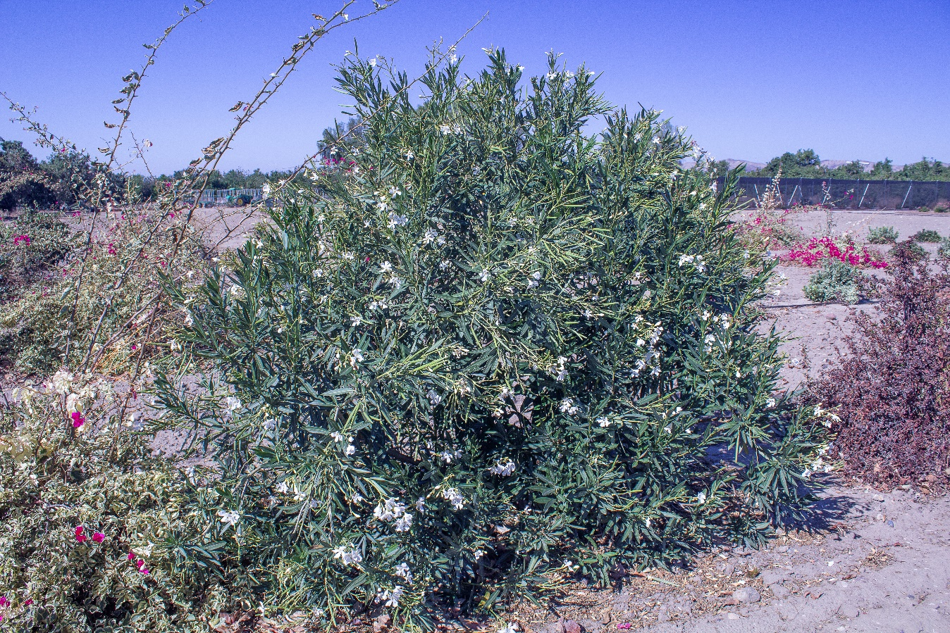
21. Nerium oleander was one of two species with the highest appearance rating at the end of the study, 23 months after treatment (high rate).

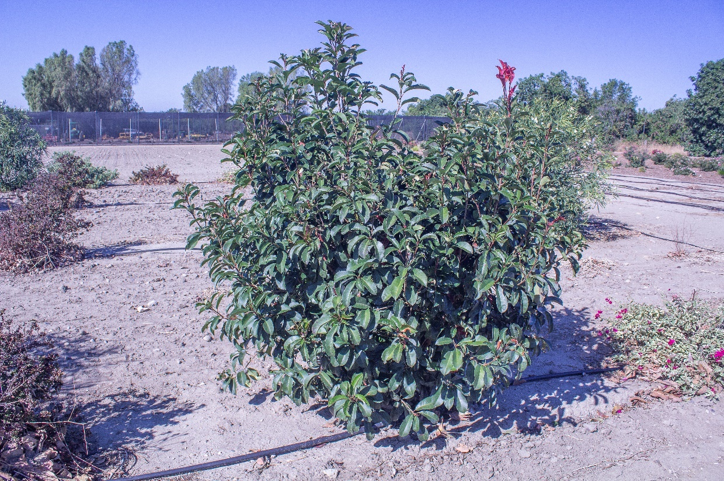
22. Photinia × fraseri was one of two species with the highest appearance rating at the end of the study, 23 months after treatment (medium rate).
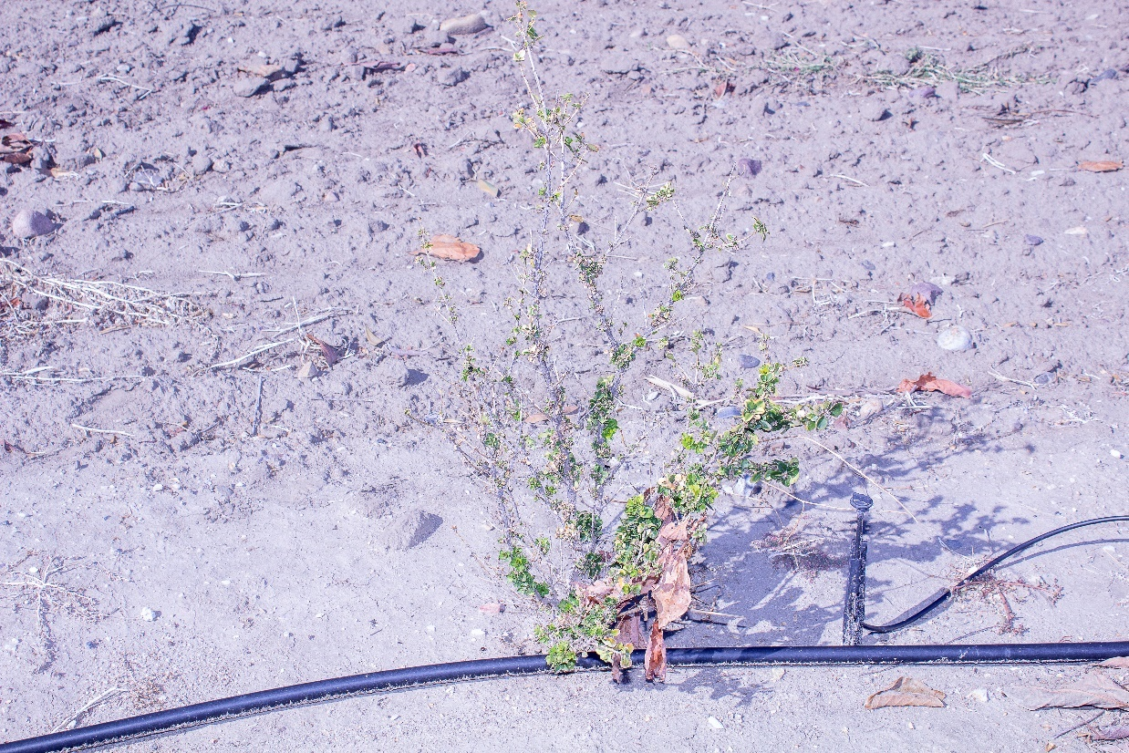
23. Buxus japonica was one of two species with the lowest appearance rating at the end of the study, 23 months after treatment (medium rate).

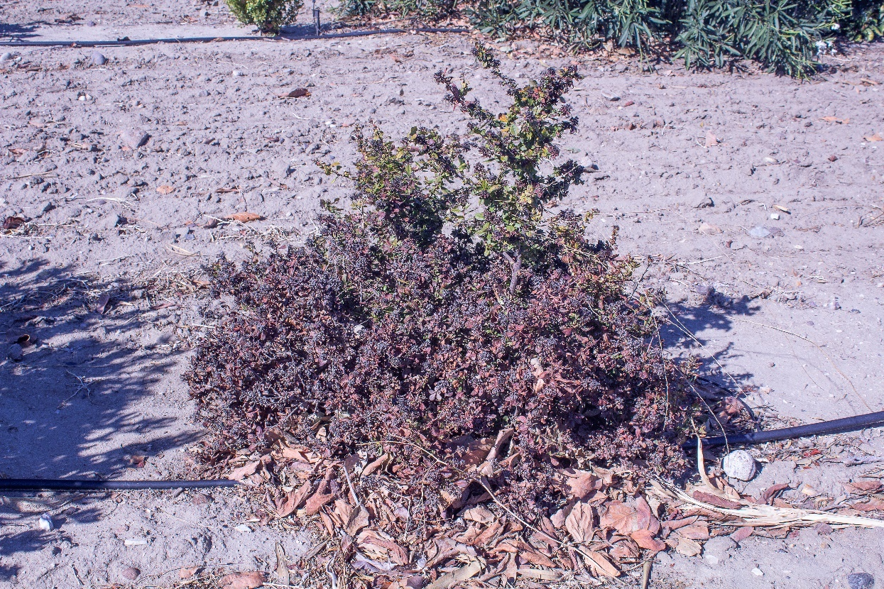
24. Escallonia × exoniensis was one of two species with the lowest appearance rating at the end of the study, 23 months after treatment (high rate). Note the abundance of dead leaves and limited green growth.
Table 3. Species differences for mean growth and appearance of seven common landscape shrubs averaged over four treatment levels (control, low, medium, high) of paclobutrazol (1 part Shortstop® 2SC to 11 parts water), at 4, 13, and 23 months after treatment, 10 November 2020.
---------------------------Months after Treatment------------------------
-------------Plant Growth^{z}--------- ---------Plant Appearance^{y}--------
Species | 4 | 13 | 23 | 4 | 13 | 23
Bougainvillea ‘Raspberry Ice’ | -0.04¹ | 1.28² | 1.25^{1,2} | 4.06² | 3.75^{3,4} | 3.96²
Buxus japonica | -0.02^{1,2} | -0.41¹ | -0.03¹ | 3.01¹ | 2.04¹ | 2.10¹
Escallonia × exoniensis | 0.30^{2,3} | 0.15¹ | 0.30¹ | 4.60³ | 3.62^{2,3} | 2.40¹
Nerium oleander | -0.01^{1,2} | 6.42³ | 6.56³ | 4.52^{2,3} | 4.46⁴ | 4.75³
Photinia × fraseri | 0.62³ | 0.21^{1,2} | 3.20² | 4.31^{2,3} | 4.35^{3,4} | 4.79³
Pittosporum tobira | 0.19^{1,2} | 0.05¹ | 0.72^{1,2} | 3.40¹ | 2.96^{1,2} | 3.83²
Rhaphiolepis indica | 0.03^{1,2} | 0.12^{1,2} | 0.12¹ | 4.03^{2,3} | 3.53^{2,3} | 3.94²
^{z}Plant growth measured in m³. Negative values mean plants lost crown volume.
^{y}Plant appearance: 1 = dead, 5 = optimal.
Means in each column with different numerals are significantly different P<0.05
______________________________________________________________________________

General Observations of Each Shrub Species
Bougainvillea ‘Raspberry Ice’
At 4 months through 23 months after treatment at any of the three levels of paclobutrazol, a conspicuous feature was the tendency for sub-apical lateral buds to form and break for up to 60 cm along shoots but these were unusually congested due to the short internodes and did not elongate much if at all (Fig. 25). We did not observe a phytotoxic response.
Buxus japonica
At 4 months through 23 months after treatment, a conspicuous feature was the tendency for sub-apical lateral buds to form and break for up to 30 cm along shoots but these were unusually congested due to the short internodes and did not elongate at all. Terminal leaves were so congested that they looked bud-like (Fig. 26). Chlorotic and orange-brown leaf margins were possible phytotoxic responses but even the untreated controls tended to show similar symptoms. These plants also tended to have numerous, unusually compact apical buds (Fig. 27).
At 13 through 23 months after treatment, sometimes severe defoliation along sub-apical areas of shoots resulted in an open or thinned out canopy, a possible phytotoxic response (Fig. 10). Remaining leaves were greener than the untreated control.
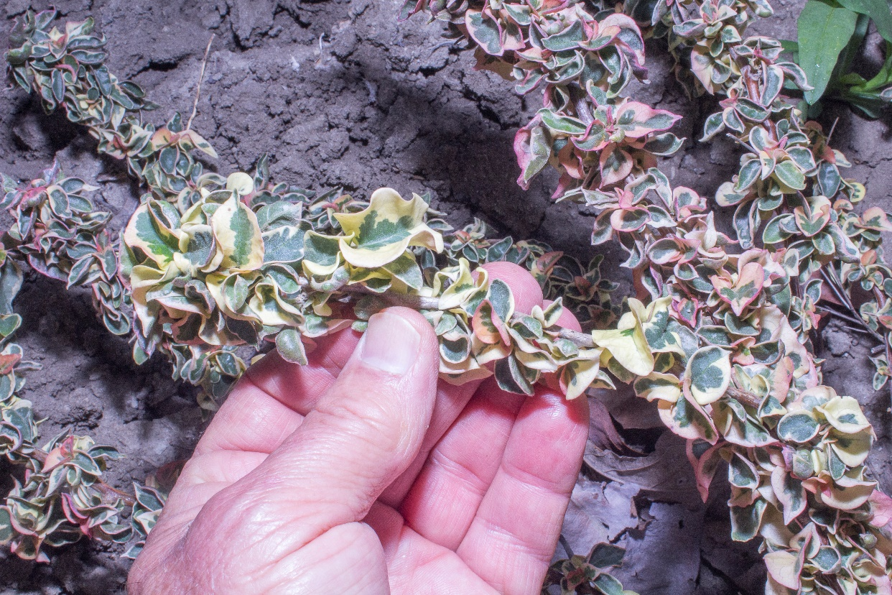
25. A conspicuous feature of Bougainvillea “Raspberry Ice’ was the tendency for treated plants to form sub-apical lateral buds and leaves along shoots but these were unusually congested due to the short internodes and did not elongate much (low rate).

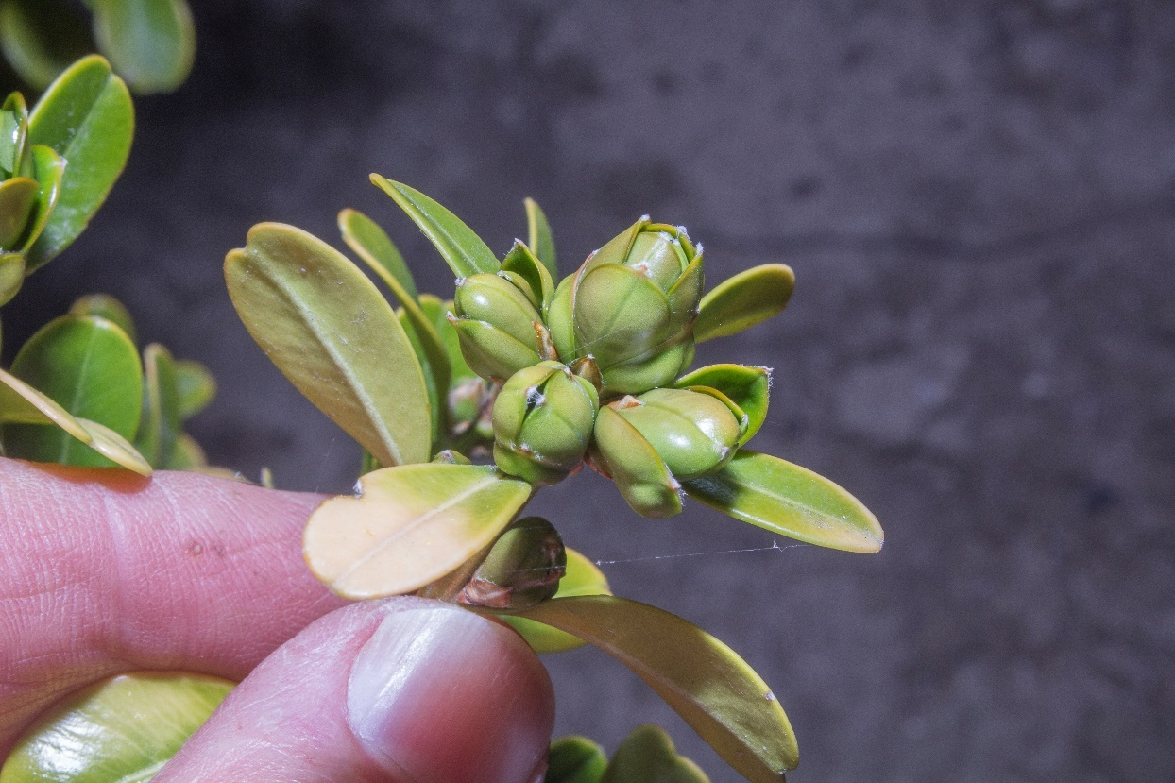
26. Terminal leaves of treated Buxus japonica were so congested that they looked bud-like (medium rate).
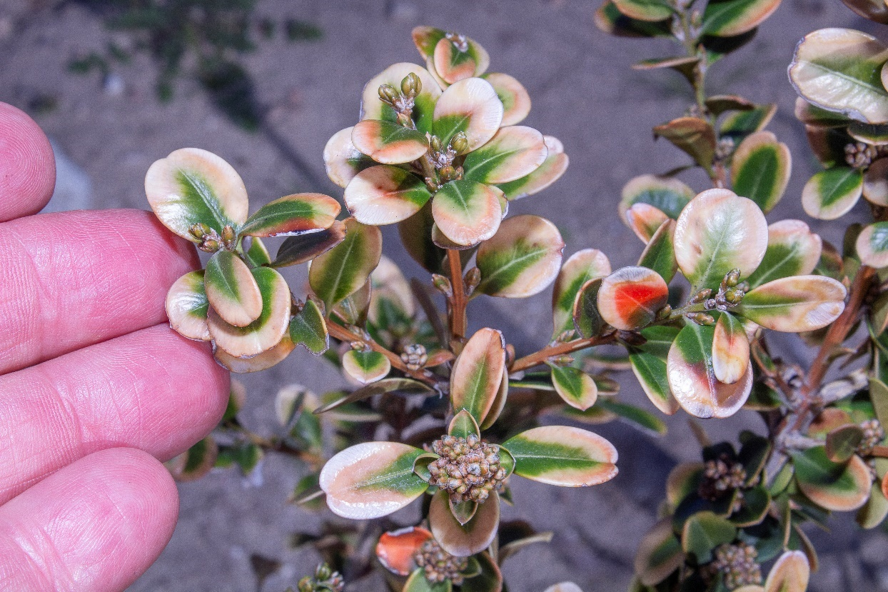
27. Chlorotic and orange-brown leaf margins of treated Buxus japonica were possible phytotoxic responses. These plants also tended to have numerous, unusually compact apical buds (medium rate).

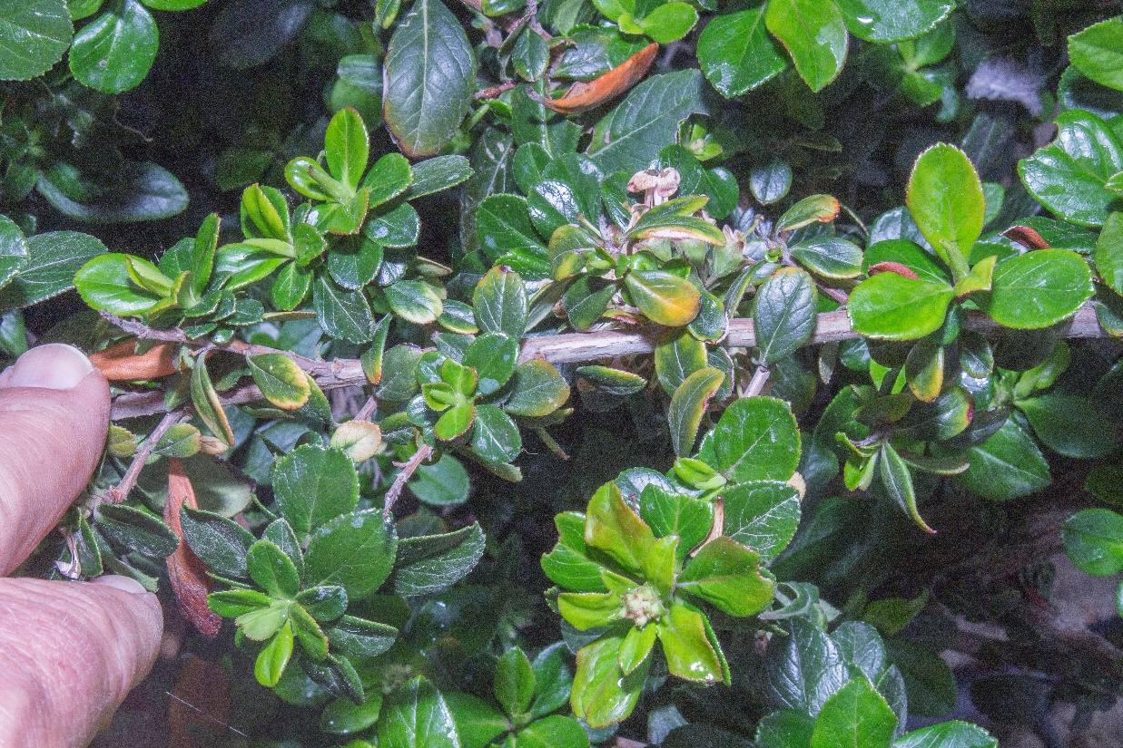
28. Escallonia × exoniensis had the tendency for treated plants to form sub-apical lateral buds and leaves along shoots but these were unusually congested due to the short internodes and did not elongate much (low rate).
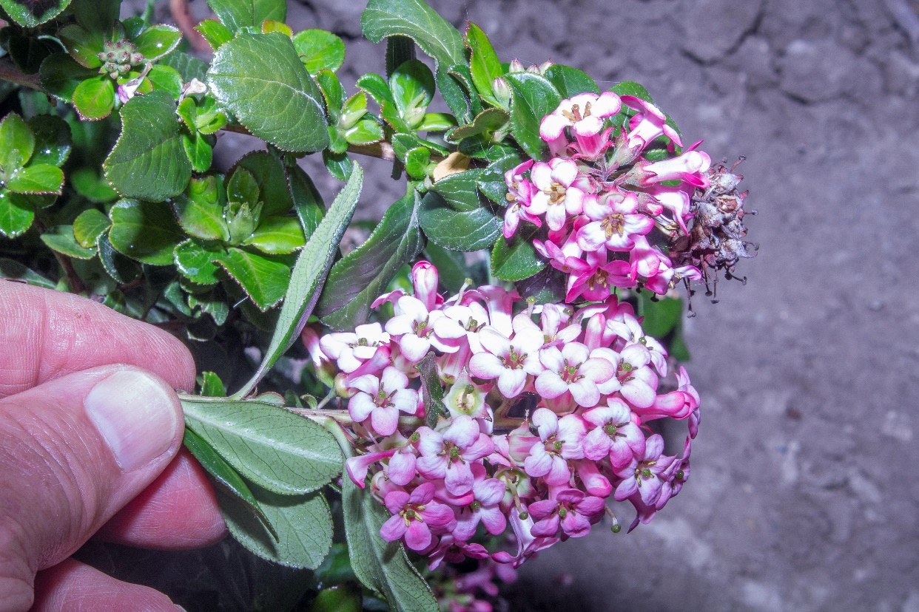
29. Treated Escallonia × exoniensis had inflorescences that seemed tighter or more congested than in the untreated control (high rate).

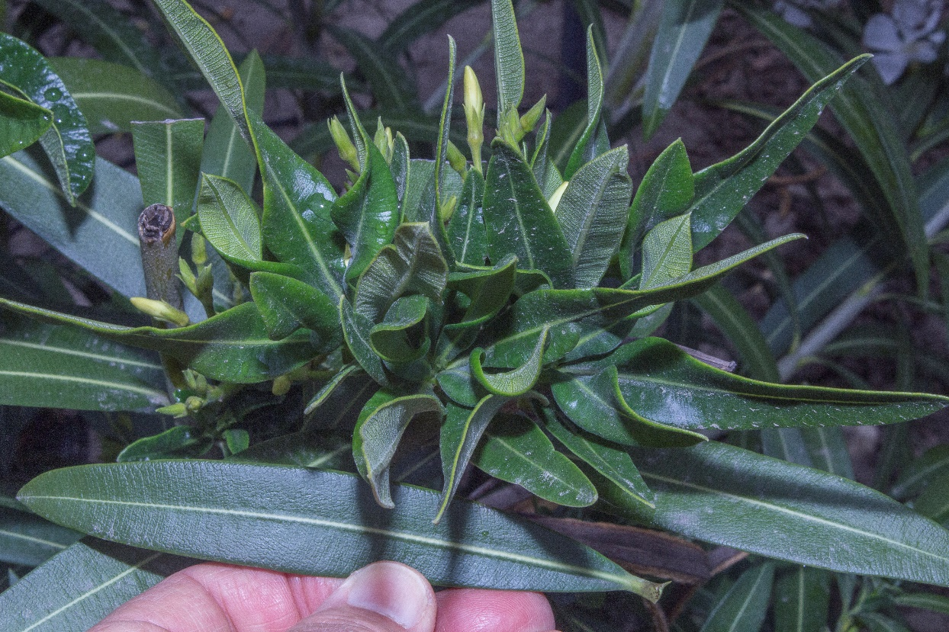
30. New shoot growth on treated Nerium oleander was initially “bunchy,” the result of short internodes (medium rate).
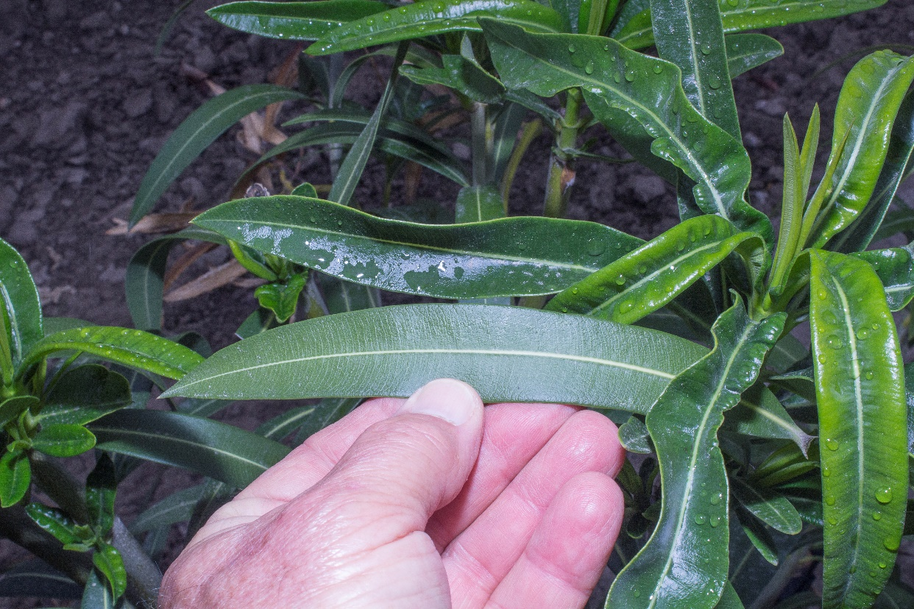
31. New leaves of treated Nerium oleander tended to be distorted and displayed a suite of symptoms, including thickened, v-shaped, trough-like leaf blades (low rate).

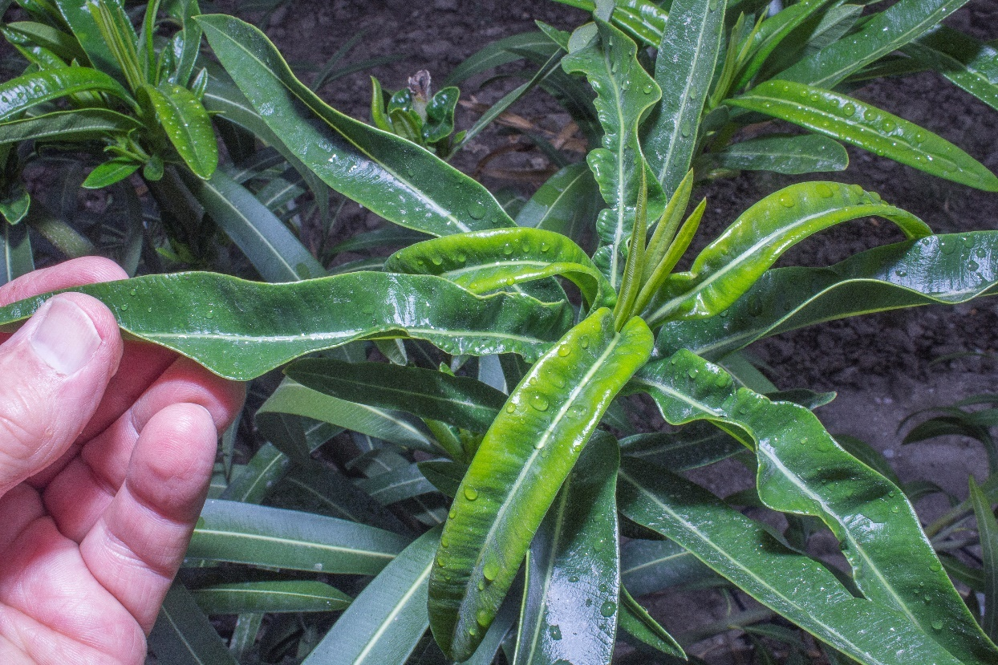
32. New leaves of treated Nerium oleander tended to be distorted and often had thickened, v-shaped, trough-like leaf blades (low rate).

Escallonia × exoniensis
At 4 months through 13 months after treatment at any of the three levels of paclobutrazol, a conspicuous feature was the tendency for sub-apical lateral buds to form and break for up to 50 cm along shoots but these were unusually congested due to the short internodes and did not elongate much if at all (Fig. 28). Inflorescences seemed tighter or more congested than in the untreated control (Fig. 29).
At 13 months after treatment, leaf margin chlorosis and necrosis appeared, possibly phytotoxic responses.
At 23 months after treatment none of the plants looked good, including the untreated control. They had an abundance of dead, persistent leaves and little or no new growth (Fig. 24).
Nerium oleander
At 4 months after treatment at any of the three levels of paclobutrazol, new shoot growth was “bunchy,” the result of short internodes (Fig. 30). New leaves tended to be distorted and displayed a suite of symptoms, including thickened, v-shaped, trough-like, spirally twisted blades with thickened, lighter green, wavy margins, likely a phytotoxic response (Figs. 31–33).
At 13 months after treatment, leaf distortion was still present on plants treated with paclobutrazol. Also, abundant, sub-apical lateral buds tended to form and break for up to 40 cm along shoots but these were unusually congested due to the short internodes and did not elongate much if at all (Fig 34).
At 23 months after treatment, little or no phytotoxic leaf deformation was present.
Photinia × fraseri
At 13 months after treatment, Entomosporium leaf spot and/or marginal leaf burn were present on some untreated plants while treated plants were “clean.”
Pittosporum tobira
A conspicuous feature at 4 months after treatment at any of the three levels of paclobutrazol was the sub-apical, short, densely placed, and compact inflorescences for up to 30 cm along shoots (Fig. 35). A phytotoxic response on treated plants but not the untreated control might have been the yellow-brown or enhanced gray color of some leaves while others on proximal portions of shoots seemed to defoliate prematurely (Fig. 36).
At 23 months after treatment, some leaves on treated plants had apical chlorosis and necrosis, likely a phytotoxic response.
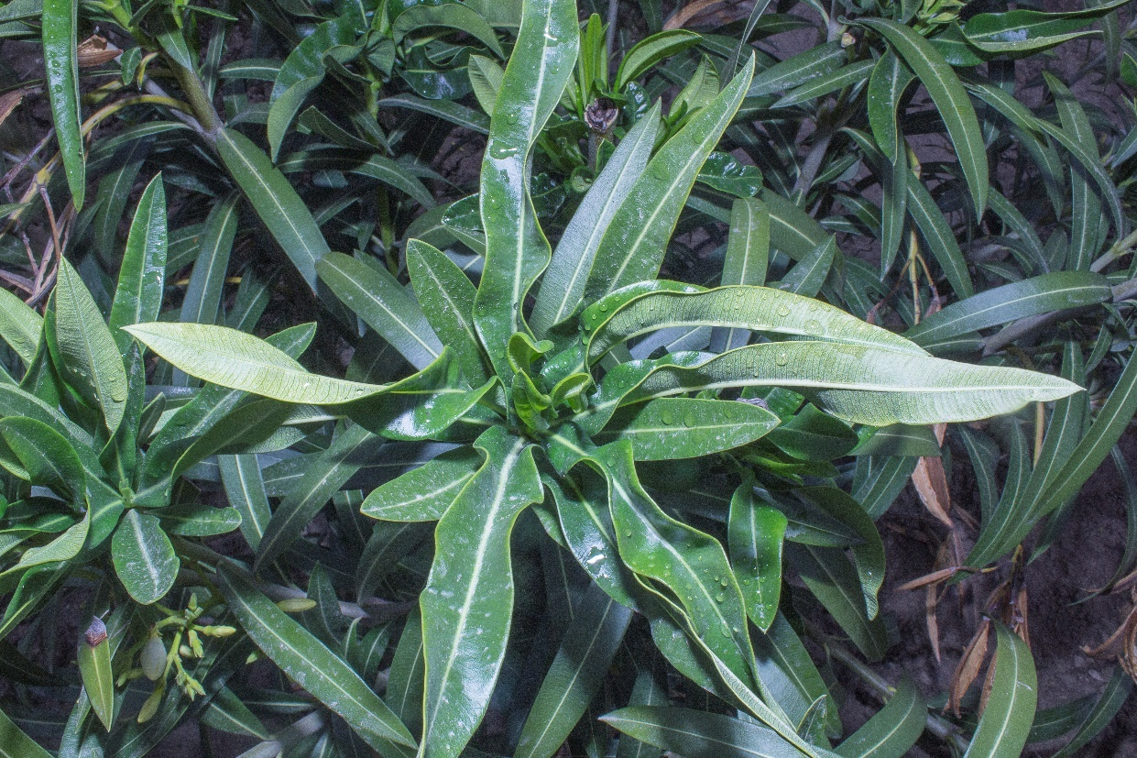
33. New leaves of treated Nerium oleander were often spirally twisted and had wavy margins (high rate).

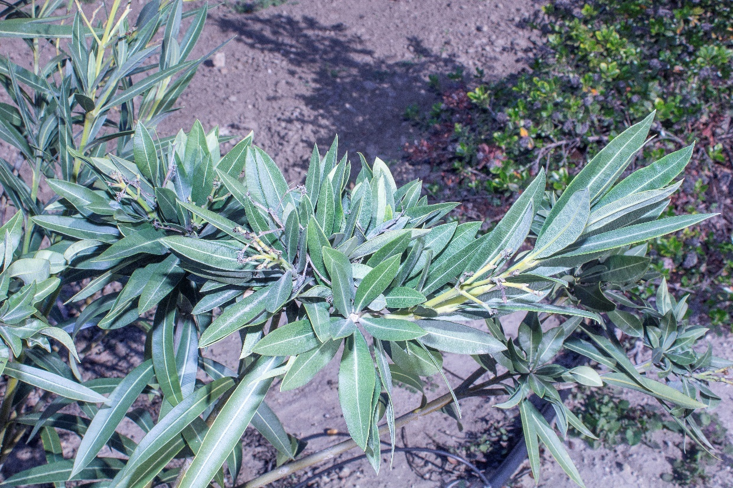
34. Nerium oleander had the tendency for treated plants to form sub-apical lateral buds and leaves along shoots but these were unusually congested due to the short internodes and did not elongate much (high rate).
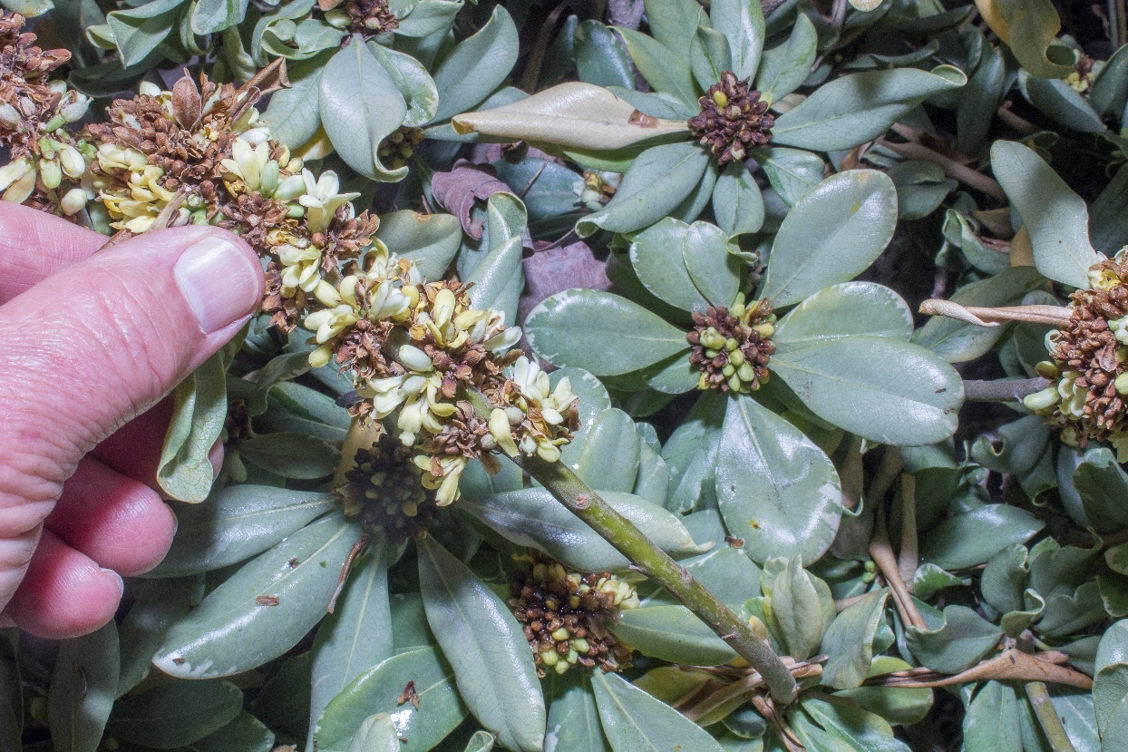
35. Treated Pittosporum tobira had sub-apical, short, densely placed, and compact inflorescences for up to 30 cm along shoots (low rate).

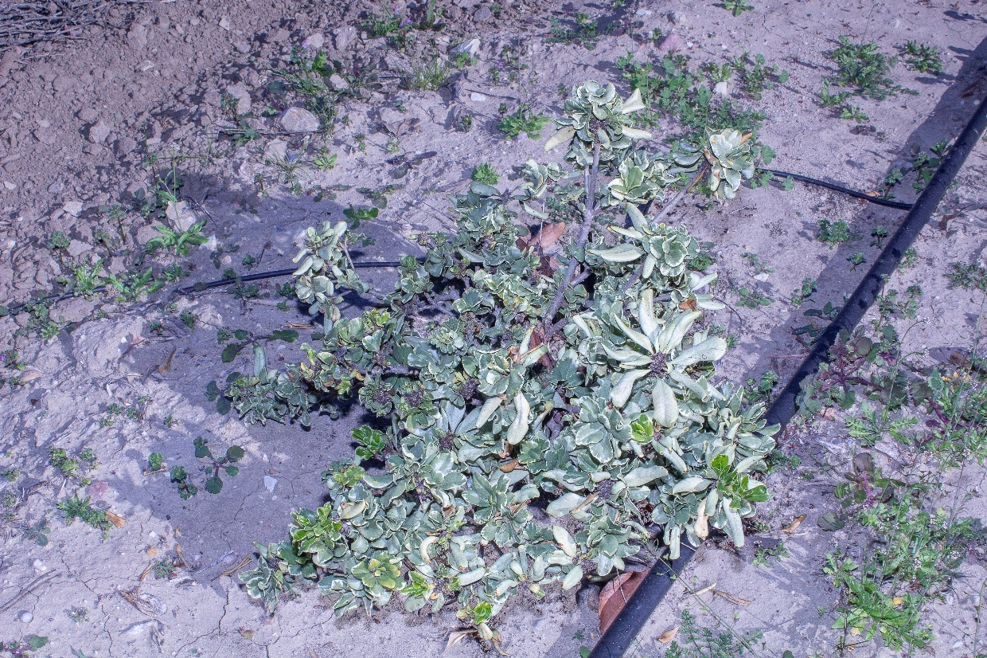
36. Some treated Pittosporum tobira had proximal portions of shoots defoliate prematurely (medium rate).

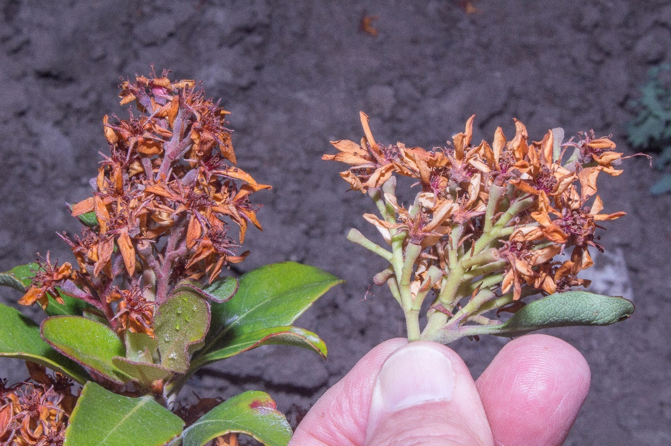
37. Treated plants of Rhaphiolepis indica had unusually compact inflorescences (low rate).

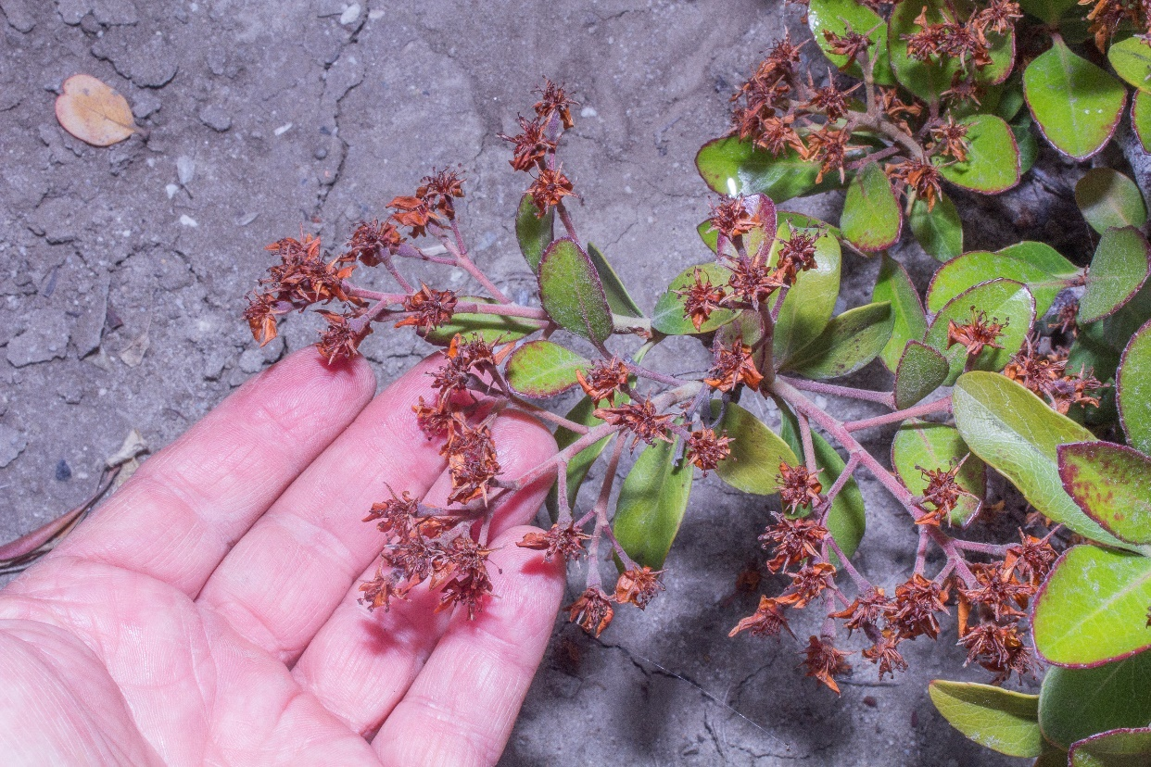
38. Untreated (control) plants of Rhaphiolepis indica had more expansive inflorescences than untreated plants.

Rhaphiolepis indica
At 4 months through 23 months after treatment at any of the three levels of paclobutrazol compared to the untreated control, a conspicuous feature was the tendency for sub-apical lateral buds to form and break for up to 20 cm along shoots but these were unusually congested due to the short internodes and did not elongate much if at all.
At four months after treatment with paclobutrazol, inflorescences were unusually compact and more densely placed than on the untreated control (Figs. 37–38).
Some leaf damage appeared at 23 months after medium and high treatments of paclobutrazol but not on low treatments and the untreated control.
Discussion and Conclusions
Soil applications of paclobutrazol at low, medium, or high levels reduced shoot elongation across all seven shrub species studied, generally for at least as long as nearly two years although with some species, including Escallonia × exoniensis, Nerium oleander, Photinia × fraseri, and Pittosporum tobira, the effects tended to wane somewhat by 23 months after treatment. The waning effects of paclobutrazol on some species after 23 months is not too surprising because most previous work noted that effects of soil-applied material typically last for up to three years although this amount of time is likely an average and surely the effects did not suddenly and dramatically stop at three years but started to fade a prior to that.
The reported effects of paclobutrazol, including reduced shoot elongation, shorter internodes, more compact growth, and disease resistance tended to be true in our study. However, other reported effects, such as normal sized and darker green leaves were not true in most cases in our study; leaves tended to be smaller on treated plants while only Buxus japonica had greener leaves on treated plants. We are unable to explain these phenomena.
Suspected phytotoxic responses, mostly leaf discoloration, deformation, marginal chlorosis and necrosis, and defoliation leading to canopy thinning, were present in four of the seven species (Buxus japonica, Escallonia × exoniensis, Nerium oleander, and Pittosporum tobira) at mostly all levels of paclobutrazol, which is contrary to most literature reports that note phytotoxic responses are rare with paclobutrazol. Only Bougainvillea ‘Raspberry Ice’, Photinia × fraseri, and Rhaphiolepis indica showed no suspected phytotoxic response. We are unsure why over half the species had suspected phytotoxic responses. Perhaps the dearth of information in the literature about the effects of paclobutrazol on the shrub species in our study made it difficult to determine the correct amount of material to apply without seeing a phytotoxic response. Or, perhaps we are not seeing a phytotoxic response but an unknown or unrecognized horticultural problem.
Acknowledgements
We thank Arborjet, Inc. for partially funding this study and the University of California South Coast research and Extension Center, Irvine, for hosting this study and providing basic care of the research plots.
Literature Cited
Aldrich, J. H. and J. G. Norcini. 1995. Effect of growth retardants on production of containerized ‘Barbara Karst’ Bougainvillea. HortScience 31(4): 679.

Ashokan, P. K., W. R. Chaney, and G. S. Premachandra. 1995. Soil applied paclobutrazol affects leaf water relations of American elm (Ulmus americana L.) seedlings. Plant Growth Regulator Society Quarterly 23: 1–12.

Bai, S., W. Chaney, and Y. Qi. 2004. Response of cambial and shoot growth in trees treated with paclobutrazol. Journal of Arboriculture 30(3): 137–145.

Bai, S., W. Chaney, and Y. Qi. 2005. Wound closure in trees affected by paclobutrazol. Journal of Arboriculture 31(6): 273–279.

Banko T. J. and M. Stefani. 1988. Growth regulators for trees and shrubs. Landscape Management 27(10): 52–58.

Burch, P. L., R. H. Wells, and W. N. Kline III. 1996. Red maple and silver maple evaluated 10 years after application of paclobutrazol tree growth regulator. Journal of Arboriculture 22(2): 61–66.

Chaney, W. R. 2005. A promising tool for managing urban trees. Purdue Extension FNR-252-W. Purdue University, West Lafayette, ID.

Chen, Y., R. P. Bracy, and A. D. Owings. 2012. Using plant growth regulators in the landscape. Louisiana Agriculture 55(1): 24–25.

Coutere, R. 1982. A new experimental growth regulator from ICI. Proceedings of the Plant Growth Regulator Society of America 9: 59.

Cregg, B. 2019. What can tree growth regulators do for you. Tree Care Industry Magazine 1 July: 1–8. https://tcimag.tcia.org/tree-care/what-can-tree-growth-regulators-do-for-you/

Davis, T. D., N. Sankhla, R. H. Wasler, and A. Upadhyaya. 1985. Promotion of adventitious root formation on cutting by paclobutrazol. HortSciense 20: 883–884.

DeJong, T. M. and J. F. Doyle. 1984. Leaf gas exchange and growth responses of mature ‘Fantasia’ nectarine tree to paclobutrazol. Journal of the American Society for Horticultural Science 109: 878–882.

Desta, B. and G. Amare. 2021. Paclobutrazol as a plant growth regulator. Chemical and Biological Technologies in Agriculture 8: 1–15. https://doi.org/10.1186/s40538-020-00199-z

Early, J. D., Jr. and G. C. Martin. 1988. Sensitivity of peach seedling vegetative growth to paclobutrazol. Journal of the American Society for Horticultural Science 113: 23–27.

EPRI. 2000. Tree Growth Regulators for Management of Trees in Electric Utility Rights-of-Way: A Literature and Current Status Review. Technical Report 1000317, 90 pp. Electric Power Research Institute, Palo Alto, CA.

Fletcher, R. A., A. Gilley, N. Sankhla, and T. D. Davis. 2000. Triazoles as plant growth regulators and stress protectants. Horticultural Reviews 24: 55–137. DOI:10.1002/9780470650776.ch3

Franca, C. F. M., L. C. Costa, W. S. Ribeiro, T. D. C. Mendes, M. N. S. Santos, and F. L. Finger. 2017. Evaluation of paclobutrazol application method on quality characteristics of ornamental peppers. Ornamental Horticulture 23(3): 821–829. DOI: http://dx.doi.org/10.14295/oh.v23i3.1074

Gent, M. P. N. and R. J. McAvoy. 2000. Plant growth retardants in ornamental horticulture, pp. 89–46 in: A. S. Bosra (ed.), Plant Growth Retardants in Agriculture and Horticulture: Their Role and Commercial Uses. Food Products Press, New York.

Herms, D. A. and W. J. Mattson. 1992. The dilemma of plants: to grow or defend. The Quarterly Review of Biology 67(3): 283–335.

Jain, R., T. Janakiram, and G. L. Kumawat. 2016. Effect of growth retardants on growth and flowering of bougainvillea (Bougainvillea spectabilis) cv. Shubra. Indian Journal of Agricultural Sciences 86(9): 1145–1150. DOI:10.56093/ijas.v86i9.61473

Jaleel, C. A., R. Gopi, P. Manivannan, and R. Panneerselvam. 2007. Responses of antioxidant defense systems of Catharanthus roseus (L.) to paclobutrazol under salinity. Acta Physiologiae Plantarum 29: 205–209.

Karagüzel, D. 1999. Effect of paclobutrazol on growth and flowering of Bougainvillea spectabilis Willd. Turkish Journal of Agriculture and Forestry 23(8): 527–532. https://journals.tubitak.gov.tr/agriculture/vol23/iss8/34

Karagüzel, D. and V. Ortacesme. 2002. Influence of paclobutrazol on the growth and flowering of Bougainvillea spectabilis ‘Sanderiana’. Akdeniz Üniversitesi Ziraat Fakültesi Dergisi 15(1): 79–84.

Keever, G. J., W. J. Foster, and J. C. Stephenson. 1990. Paclobutrazol inhibits growth of woody landscape plants. Journal of Environmental Horticulture 8(1): 41–47. https://doi.org/10.24266/0738-2898-8.1.41

Kumari, S., P. Bakshi, A. Sharma, V. K. Wali, A. Jasrotia, and S. Kour. 2018. Use of plant growth regulators for improving fruit production in sub tropical crops. International Journal of Current Microbiology and Applied Sciences 7(3): 659–669. DOI:10.20546/ijcmas.2018.703.077

Mann, M. P., H. A. Holt, W. R. Chaney, W. L. Mills, and R. L. Mackenzie. 1995. Tree growth regulators reduce line clearance trimming time. Journal of Arboriculture 21(4): 209–212.

Norremark, I. and A. Anderson. 1990. Effect of paclobutrazol on seed propagated Perlargonium × hortorum L. H. Bailey. Gartenbauwissenschafft 55: 1–8.

Owings, A. D. and S. E. Newman. 1993. Chemical modification of Photinia × fraseri plant size and lateral branching. Journal of Environmental Horticulture 11(1): 1–5. https://doi.org/10.24266/0738-2898-11.1.1

Percival, G. C. and A. M. S. AlBalushi. 2007. Paclobutrazol-induced drought tolerance in containerized English ivy and evergreen oak, Arboriculture and Urban Forestry 33(6): 397–409.

Rademacher, W. 2000. Growth retardants: effects on gibberellin biosynthesis and other metabolic pathways. Annual Review of Plant Physiology and Molecular Biology 51: 501–531.
Rademacher, W. 2015. Plant growth regulators: backgrounds and uses in plant production. Journal of Plant Growth Regulators 34(4): 845–872. DOI:10.1007/s00344-015-9541-6

Rieger, M. and G. Scalabrelli. 1990. Paclobutrazol, root growth, hydraulic conductivity and nutrient uptake of ‘Nemaguard’ peach. HortSciense 25: 95–98.

Rizzitelli, S., P. Vernieri, E. Malorgio, G. Serra, and F. Togoni. 2000. Effect of pinolene, paclobutrazol and water stress on ornamental shrubs. Colture Protette 29(10): 81–89.

Ruter, J. M. and C. A. Martin. 1994. Effects of contrasting climate and paclobutrazol on the growth and water use of two container-grown landscape plants. Journal of Environmental Horticulture 12: 27–32.

Sharma, D. and M. D. Awasthi. 2005. Uptake of Soil paclobutrazol in mango (Mangifera indica L.) and its persistence in fruit and soil. Chemosphere 60: 164–169. DOI: 10.1016/j.chemosphere.2004.12.069

Swietlik, D. and S. Miller. 1983. The effect of paclobutrazol on growth and response to water stress of apple seedlings. Journal of the American Society for Horticultural Science 108: 1076–1080.

Syngenta. 2003. Syngenta product details. Bonzi. 20 March 2003. http://www.syngentalprofessionalproducts.com/labels/Indexasp?nav=PrdLst&F=PrdDsp

Syros, T. D. and A. S. Economou. 2000. Plant height and flowering of Nerium oleander in pots as affected by paclobutrazol and supplementary lighting. Acta Horticulturae 515: 59–99. DOI: 10.17660/ActaHortic.2000.515.6

Tagliavini, M. and N. E. Looney. 1991. Response of peach seedlings to root-zone temperature and root-applied growth regulators. HortScience 26: 870–872.

Tanis, S. R., D. G. McCullough, and B. M. Cregg. 2015. Effects of paclobutrazol and fertilization on the physiology, growth and biomass allocation of three Fraxinus species. Urban Forestry and Urban Greening 14(3): 590–598. DOI:10.1016/j.ufug.2015.05.011

Wample, R. L. and E. B. Culver. 1983. The influence of paclobutrazol, a new growth regulator, on sunflowers. Journal of the American Society for Horticultural Science 108: 122–125.

Wang, R. L. and M. Faust. 1986. Effect of growth retardants and polyamine content in apple seedlings. Journal of the American Society for Horticultural Science 111: 912–917.

Warren, S. L., F. A. Blazich, and M. Thetford. 1991. Whole-pant response of selected woody landscape species to uniconazole. Journal of Environmental Horticulture 9: 163–167.

Watson, G. W. 1996. Tree root enhancement with paclobutrazol. Journal of Arboriculture 22(5): 211–217.

Williamson, J. F. (ed.). 1988. Sunset Western Garden Book. 5th edition. Lane Publishing Co., Menlo Park, CA.

Zhu, L. H., A. van de Peppel, X. Y. Li, and M. Welander. 2004. Changes of leaf water potential and endogenous cytokinins in young apple trees treated with or without paclobutrazol under drought conditions. Scientia Horticulturae 99(2): 133–141. 10.1016/S0304-4238(03)00089-X
_______________________
Donald R. Hodel is the Emeritus Landscape Horticulture Advisor for the University of California Cooperative Extension in Los Angeles and specializes in the taxonomy, selection, and management of palms and trees. drhodel@ucanr.edu

Marianne Waindle is a retired horticulturist. waindlemarianne@gmail.com

Max F. Rothschild is CF Curtiss Distinguished Professor Emeritus, Iowa State University, Ames, Iowa mfrothsc@iastate.edu

Josue Chinchilla-Vargas is the Animal Breeder Coordinator at Breeding Insight, Cornell University, Ithaca, New York. jc3635@cornell.edu

Text © 2024 by the authors.
Photographs © 2024 by D. R. Hodel.
Publication Date: 15 January 2024.
PalmArbor: http://ucanr.edu/sites/HodelPalmsTrees/PalmArbor/
ISSN 2690-3245
Editor-In-Chief: Donald R. Hodel
Hodel Palms and Trees: http://ucanr.edu/sites/HodelPalmsTrees/

