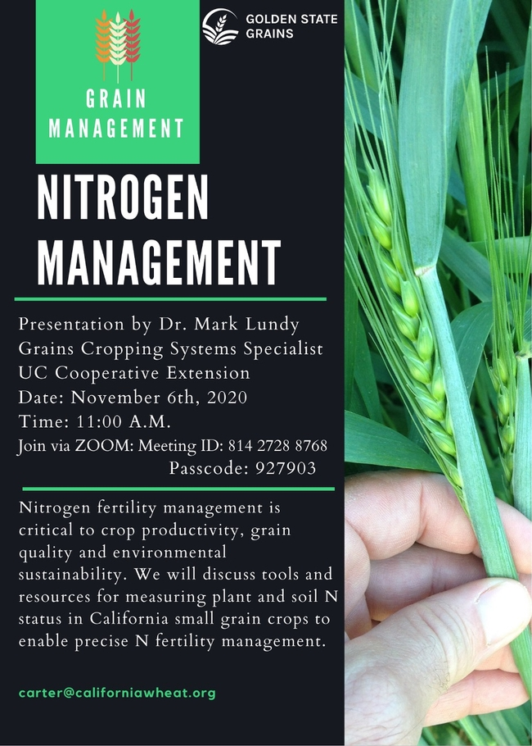

Join UCCE's Grain Cropping Systems Specialist, Mark Lundy next week (11 a.m. on November 6th, 2020) for a presentation on nitrogen management in California Small Grains (hosted by the California Wheat Commission and Golden State Grains).
Dr. Lundy will review methods of measuring soil and plant nitrogen status. This will include some of the decision-making tools being developed by UC agronomists, and discuss methods and strategies for nitrogen management/ monitoring in California small grain rotations. Registration is free.
Join Via Zoom,
Meeting ID: 814 2728 8768 (link below)
https://us02web.zoom.us/j/81427288768?pwd=dlU2ekZLS0JBM2c4MExNRG9SclRVdz09
Passcode: 927903
Additional crop management resources can be found through the UC Agronomy Research & Information Center. Decisions-making tools and nitrogen management resources for small grains can be found here: http://smallgrains.ucanr.edu/
Among other resources, the Small Grains website on the AgRIC contains information for growers on:
Variety Selection (Yield, Days to Maturity, Diseases Resistance...): http://smallgrains.ucanr.edu/Variety_Selection/
Nutrient Management (N-rich reference zones, soil nitrate quick tests, fertility guidelines...): http://smallgrains.ucanr.edu/Nutrient_Management/
General Production (Seeding Rate Calculator, Pest Management, Field Prepration): http://smallgrains.ucanr.edu/General_Production/

