

Ventura County Garden to Table Series – Winterizing the Garden
Below we will talk about winterizing the garden - be sure to check out the other Garden to Table Series handouts for additional information.

Reflection and Planning

A skill worth developing is accurate observation – however, it’s important to learn from your observations.

Weather - temperature, rainfall

Plants - successes and challenges

Plant Care - pest and disease incidents, water, fertilization

Soil - amendments, mulch

Maintenance - pruning and staking

Design - current and future plans

Tool Maintenance and Care

Proper tool care starts with cleaning

Remove soil, plant residue, and rust with brush (wire if needed). A good habit is to clean tools after each use.

Wash tools with warm, soapy water – some tools can be taken apart to clean.

Thoroughly dry tools.

Sanitize with rubbing alcohol - especially the blades - this will prevent disease transmission.

Lubricate, with household oil, any blades and moving parts.

Oil wooden handles with linseed oil.

Tool Maintenance

If needed, sharpen dull blades with sharpening tool -

Store tools where they can be hung, and out of the way to prevent damage to both the user and the tools.

Keep tools in a dry place to prevent rust.

Equipment Inventory – Assess – Inspect – Repair - Replace

Good site – including sharpening video - https://acmg.ucanr.edu/?blogpost=58665&blogasset=139346

Soil Renewal and Care
- Soil Readiness
  - Remove weeds and debris from previous crops to prevent competition for nutrients.
  - Improve Soil Structure - amend with organic matter, 6 to 12 inches, to enrich soil nutrients and feed beneficial microbes.
  - Fertilize, just before planting, using a balanced (13-13-13) fertilizer.
  - Remove plants showing signs of aging (slower growth, browning leaves) - compost remaining healthy plant material.
  - Inspect & correct any drainage or irrigation problems. Reduce irrigation during wet season.
  - New garden area, cover with moistened cardboard and mulch to be ready for spring.

Plant Protection and Maintenance

Identifying vulnerable plants – protect if frost warning.

Temporary protection methods:

Water plants 2-3 days before frost.

Remove mulch or leaves near trees – bare soil radiates heat.

At night - cover frost sensitive plants with burlap, sheets, or buckets.

Young trees – insulate trunks with blankets, cardboard, or pipe insulation.

Potted plants – move to protected area or cover as above.

Pruning – know your tree/shrub

Type - deciduous fruit/nut, citrus, avocado, or other.

Flowering – old wood, new wood, both.

When to prune - Understand growing and dormant seasons.

Make a pruning plan – based on plant health and overall goal.

Follow the 1/3 Rule – as a rule of thumb, at each pruning, remove no more than 1/3 of tree/shrub.

Pruning – basic guidelines - https://marinmg.ucanr.edu/CARE/HOWTOPRUNE/

3 D’s (Dead, Diseased, Damaged) – wood that can be removed any time of the year.

3 C’s (Competing, Crossing, Crowded) – best done during dormant season.

3 S’s (Safety, Sight Lines, Shape) – based on location and the plant in relation to the landscape.

Common Trees in Ventura County - https://homeorchard.ucanr.edu/Fruits_&_Nuts
Plant | Notes
Citrus | Little pruning needed, prune suckers, and older trees benefit from light pruning on top. Best early in spring.
Avocado | Grow irregularly and do better if not pruned – prune cautiously for control height, correct poor growth habits, prevent wind damage. Avoid pruning in the fall.
Apple | Remove 15-20% of last year’s growth (to let in light) in January.
Apricot | Remove 20% of last year’s growth in (fall (September) – before winter rains).
Fig | Winter pruning (January), reduce undesirable density by removing enter branches.
Peach | (and Nectarines) Remove 50% of last year’s growth in January.
Persimmon | Remove 30% of branches in December or January.
Plum | Remove 20% of last year’s growth in January.
Pomegranate | Light annual pruning of established trees encourages fruit production heavy pruning will reduce the crop. Prune in winter before spring blooms.


Seed Starting and Continuous Learning
- Growing Transplants
  - Soil – use seedling mix soil, or potting soil for large seeds (squash, cucumber, etc.).
  - Container – any container with drainage holes – fill 2/3 full using the soil mix.
  - Planting – according to package – general rule, plant 2 to 4 times the diameter of the seed.
  - Light and Temperature Requirements – depends on plant and whether stating indoor or outdoor.
  - Continuous Learning – classes, research (UCANR MG), new gardening techniques, layouts, designs.

Crop Rotation
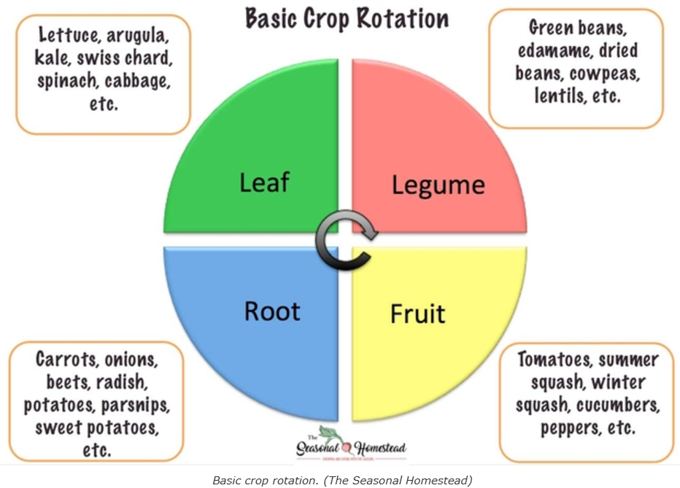
Square Foot Gardening
