What to Do with All Those Tomatoes!

Tomatoes are classified as a low-acid food because they have a pH of 4.6, which is very close to the dividing line between high and low-acid foods, home canned tomato products must be acidified by adding bottled lemon juice or citric acid before heat processing. To ensure safe results, do not substitute fresh lemon juice as its acidity varies. When home canning tomatoes, you need to use a boiling water canner, or a pressure canner. As a general rule, recipes that include other vegetables must be processed in a pressure canner. Any tomato recipe including meat or fish must be processed in a pressure canner.

Choosing Tomatoes

Both round and oblong tomatoes are suitable for canning. Oblong (plum or paste) tomatoes are meatier and less juicy than round tomatoes and often preferred by home canners as they create thicker sauces in a shorter period of time. The following chart shows the approximate yield by tomato type and preparation method.

Tomato Type | Purchase Unit | Purchase Weight | Preparation | Yield (Volume)
Round or Globe | 3 medium  3 medium | 1 pound  1 pound | Chopped  Peeled and crushed | 2-1/2 to 3 cups  1-1/2 cups
Oblong, Plum or Paste (Roma) | 5 medium  5 medium | 1 pound  1 pound | Chopped  Crushed or pureed | 2 cups  1-1/2 cups

Tomatoes Processed in a boiling-water canner

Tomatoes that do not have added vegetables can be safely home canned in boiling-water canner. The acidity of tomatoes is very important and have been scientifically tested to determine the safe amounts of acid to add each jar processed. Those acids include lemon juice, citric acid or vinegar. Follow the recipe for the correct amounts to add. Below are a few special tomato-basic recipes

Whole or Halved Tomatoes (packed in water) pint or quart jars

Tomatoes

Bottled lemon juice or citric acid

Salt/spices

Clean and heated jars

- Working in small batches. Wash tomatoes, cut a small X at the base, and dip in boiling water for 30 – 60 seconds or until skin splits. Then dip in cold water, slip off skins and remove core.
- Trim off skin and bruised or discolored portions and cut each tomato in half or quarters.
- Pint Jars: Add 1 tablespoon bottled lemon juice or 1/4 teaspoon citric acid to each jars. Add 1/2 teaspoon of salt or dried spices per pint jars, if desired.

Quart Jars: Add 2 tablespoons of bottled lemon juice, or 1/2 teaspoon citric acid to jars. Add 1 teaspoon of salt or dried spices per quart jars, if desired.
- Prepare tomatoes for packing:
Raw-pack method: Heat water, for packing tomatoes, to boiling. Fill hot jars with prepared raw tomatoes, leaving 1/2-inch headspace. Remove air bubbles. Wipe jar rim. Center lid on jar and apply band, adjust to fingertip tight. Place jar into canner. Repeat until all the jars are filled.
Hot pack: Put prepared tomatoes in a large saucepan and add enough water to completely cover them. Boil tomatoes gently for 5 minutes. Fill hot jars with hot tomatoes leaving 1/2-inch headspace. Add cooking liquid to jars to cover tomatoes, leaving 1/2-inch headspace. Remove air bubbles. Wipe jar rim. Center lid on jar and apply band, adjust to fingertip tight. Place jar into canner. Repeat until all the jars are filled.
- Process per your elevation.

Recommended process time for Whole or Halved Tomatoes in boiling-water bath (BW) canner

Style of pack | Jar Size | 0 – 1,000 ft  Use BW only | 1,001 – 3000 ft  Use BW only | 3,001 – 6000 ft  Use BW only | >6,0000 ft  Use BW only
Hot & Raw | Pints | 40 minutes * | 45 minutes * | 50 minutes * | 55 minutes *
Hot & Raw | Quarts | 45 minutes * | 50 minutes * | 55 minutes * | 60 minutes *

*Atmospheric steam canners cannot be used because the water well of the canner does not hold more than 45 minutes of water before running out of water. Cannot refill canner in the middle of processing.

- Turn off heat, remove lid from boiling-water canner, let jars stand 5 minutes. Remove jars and cool 12-24 hours. Check lids for seal, they should not flex when center is pressed.
Source: So Easy to Preserve 6th edition 2020

Tomatoes-Crushed (with no added liquid)
Quantity: An average of 22 pounds is needed per canner load of 7 quarts; an average of 14 pounds is needed per canner load of 9 pints. A bushel weighs 53 pounds and yields 17 to 20 quarts of crushed tomatoes – an average of 2-3/4 pounds per quart.

Procedure: Hot pack
- Wash tomatoes, cut an X at the bottom, and dip in boiling water for 30 to 60 seconds or until skins split. Then dip in cold water, slip off skins, and remove cores. Trim off any bruised or discolored portions and quarter.
- Heat one-sixth of the quarters quickly in a large pot, crushing them with a wooden mallet or spoon as they are added to the pot. This will exude juice. Continue heating the tomatoes, stirring to prevent burning.
- Once the tomatoes are boiling, gradually add remaining quartered tomatoes, stirring constantly. These remaining tomatoes do not need to be crushed. They will soften with heating and stirring. Continue until all tomatoes are added. Then boil gently 5 minutes.
- Before packing each jar of tomatoes, add 2 tablespoons of bottled lemon juice or 1/2-teaspoon of citric acid per quart of tomatoes. For pints, use 1 tablespoon bottled lemon juice or 1/4-teaspoon citric acid to hot jar. Add 1 teaspoon of salt per quart jar, if desired and 1/2 teaspoon for pint jars.
- Fill hot jars immediately with hot tomatoes, leaving 1/2-inch headspace. Remove air bubbles and adjust headspace if needed. Wipe rims of jars with a dampened clean paper towel. Adjust lids and process. Adjust for altitude.

Recommended process time for Crushed Tomatoes in a boiling-water (BW) canner

Style of pack | Jar Size | 0 – 1,000 feet  Use BW only | 1,001 – 3000 ft  Use BW only | 3,001 – 6000 ft  Use BW only | >6,0000 ft  Use BW only
Hot | Pints | 35 minutes * | 40 minutes * | 45 minutes * | 50 minutes *
Hot | Quarts | 45 minutes * | 50 minutes * | 55 minutes * | 60 minutes *

*Atmospheric steam canners cannot be used because the canner does not hold more than 45 minutes of water before running out. Cannot

refill canner in the middle of processing.

- For boiling-water canner, turn off heats after processing time, remove lid, let jars stand 5 minutes. Remove jars from canner. Let cool, undisturbed, 12-24 hours and check for seals. Remove rings, clean and label jars. Store sealed jars in a cool, dry, dark location. Use within 1 year for best quality.
Source: Source: So Easy to Preserve 6th edition 2020

Bruschetta in a Jar Yield: about 3 half-pints
This homemade bruschetta on a toasted baguette tastes out of this world. Your home-grown tomatoes will really enhance the flavor and make it enjoyable all year long!
Ingredients:
3 cloves garlic, minced
1/2 cup dry white wine
1/2 cup white wine vinegar (5% acid)
1/4 cup water
1 tablespoon sugar
1 tablespoon dried basil
1 tablespoon dried oregano
1 tablespoon balsamic vinegar
4‐1/2 cups chopped cored plum tomatoes (about 2 pounds or 6 medium)
Directions:
- Prepare boiling water canner or atmospheric steam canner. Heat jars in canner until ready for use. Wash two-piece metal lids and rings in warm soapy water and set aside.
- Combine garlic, wine, wine vinegar, water, sugar, basil, oregano and balsamic vinegar.
Bring to a full rolling boil over high heat, stirring occasionally.
- Reduce heat, cover and simmer 5 minutes or until garlic is heated through. Remove from
heat.
- Pack tomatoes into hot jars leaving 1/2‐inch headspace.
- Ladle hot vinegar mixture over tomatoes leaving 1/2‐inch head‐ space. Remove air bubbles.
- Wipe rims with a dampened clean paper towel; adjust two‐piece metal canning lids.
- Process in a boiling-water canner or atmospheric steam canner for 20 minutes at 0 ‐ 1,000 feet elevation,
25 minutes at 1,001 ‐ 3000 feet, 30 minutes at 3,001 ‐ 6,000 feet, 35 minutes at 6,001 ‐ 8,000 feet, and use a boiling water canner only when processing time is over 40 minutes, at 8,001 ‐ 10,000 feet process for 40 minutes. (ASC do not have enough water in them to boil for 40 minutes. No water can be added during the processing time.)

- For boiling-water canner, turn off heat after processing time, remove lid, let jars stand 5 minutes. For atmospheric steam canner, turn off heat after processing time and allow to sit for five minutes with the lid on. Remove lid after five minutes, taking care to release steam away from you.
- Remove jars from canner. Let cool, undisturbed, 12-24 hours and check for seals. Remove rings, clean and label jars. Store sealed jars in a cool, dry, dark location. Use within 1 year for best quality.
Source: Ball Complete Book of Home Preserving, 2020 page 223

Country Western Catsup Yield: about 6 or 7-pint jars
Ingredients:
24 pounds ripe tomatoes
5 Chile peppers
1/2 teaspoon ground red pepper (cayenne)
4 teaspoons paprika
4 teaspoons whole allspice
4 teaspoons dry mustard
1 tablespoon whole peppercorns
1 teaspoon mustard seeds
1 tablespoon bay leaves
2-2/3 cups vinegar (5% acidity)
1-1/4 cups sugar
1/4 cup salt
Directions:
To Prepare Chile Peppers (CAUTION: Wear rubber gloves while handling chilies or wash hands thoroughly with soap and water before touching your face.) Wash and dry chilies.
- Prepare boiling-water canner or atmospheric steam canner. Prepare jars and lids by washing them in warm soapy water. Set aside with bands.
- Oven or broiler method: Place peppers in oven (400 °F.) or broiler for 6 to 8 minutes until skins blister.
- Range-top method: Cover hot burner, either gas or electric, with heavy wire mesh. Place chilies on burner for several minutes until skins blister.
- Place on a cookie sheet under an inverted bowl and cover roasted peppers and allow to cool. This will make peeling the peppers easier. After several minutes, peel each pepper. Remove stem and seeds from peppers.
- Slice peppers. Wash tomatoes. Score an X in the tomato skin and dip in boiling water for 30 to 60 seconds or until skins split. Then dip in cold water, slip off skins and remove cores.
- Quarter tomatoes. Place in 4-gallon pot. Add peppers. Bring to boil and simmer 20 minutes, uncovered.
- Combine spices in a spice bag. Place spices and vinegar in a 2-quart saucepan. Bring to a boil. Turn off heat and let stand.
- When tomato mixture has cooked 20 minutes, remove spice bag from the vinegar and add the vinegar to the tomato mixture. Boil 30 minutes.
- Press boiled mixture through a food mill or sieve. Return to pot. Add sugar and salt. Boil gently, stirring frequently, until volume reduced by one-half or until mixture rounds up on spoon without separation.
- About 15 minutes before cooking time is complete heat jars in prepared boiling water or atmospheric canner.
- Ladle hot catsup into hot jars, leaving 1/8-inch headspace. Wipe rim. Apply lids fingertip-tight.
- Process in a boiling-water or atmospheric steam canner for 15 minutes at 0 - 1,000 feet elevation, 20 minutes at 1,001 - 6,000 feet, 25 minutes above 6,000 feet.
- For boiling-water canner, turn off heats after processing time, remove lid, let jars stand 5 minutes. For atmospheric steam canner, turn off heat after processing time and allow to sit for five minutes with the lid on. Remove lid after five minutes, taking care to release steam away from you.
Source: So Easy to Preserve, Sixth Edition, 2020

Two-in-One Barbecue Sauce Yield: 6 pint jars

Base for Sauces:
16 cups pureed seeded peeled plum tomatoes
2-1/4 cups pureed seeded green peppers
2 cups pureed onions
3 cloves garlic, finely chopped
2 tablespoon mustard seeds, crushed
1 tablespoon celery seeds
2 dried chili peppers, seeded and crushed
Stampede-Style Sauce:
3/4 cup mild-flavored or fancy molasses
3/4 cup malt vinegar (5% acidity)
1/3 cup Worcestershire sauce
2 tablespoon chili powder
2 teaspoons freshly ground black pepper
Sweet ‘n’ Sour Sauce:
1 tablespoon finely chopped ginger root
3/4 cup liquid honey
3/4 cup cider vinegar (5% acidity)
1/2 cup soy sauce
2 cups canned crushed pineapple, with juice

Directions:
- In a large pot, stirring frequently, bring half of the tomato puree to a full rolling boil. Maintain the boil and gradually add remaining puree. Cook over high heat, stirring frequently, until reduced by half, about 1 hour.
- Add peppers, onions, garlic, mustard seeds, celery seeds and chili peppers. Return to a boil. Reduce heat to medium and boil gently, stirring frequently, until peppers and onions are tender, about 10 minutes.
- Divide mixture equally between two stainless steel saucepans. Add ingredients for Stampede-Style Sauce to one pan; ingredients for Sweet ‘n’ Sour Sauce to the other. Bring both mixtures to a boil over high heat, stirring frequently.
- Reduce heat and boil gently, stirring frequently, until mixtures are thickened to the consistency of a thin commercial barbecue sauce, about 45 minutes.
- Wash lids and rings in warm soapy water; set aside. Wash canning jars and place in canner to heat.
- Ladle hot sauces into hot jars, leaving 1/2-inch headspace. Remove air bubbles and adjust headspace if necessary. Wipe rims. Apply lids and rings.
- Process in a boiling-water or atmospheric steam canner for 20 minutes between 0 - 1,000 feet elevation, 25 minutes between 1,001 – 3,000 feet, 30 minutes between 3,001 – 6,000 feet, 35 minutes between 6,001 – 8,000 feet. Use a boiling-water canner only for processing times over 40 minutes, 8,001 – 10,000 feet process for 40 minutes. (ASC do not have enough water in them to boil for 45 minutes. No water can be added during the processing time.)
- For boiling-water canner, turn off heats after processing time, remove lid, let jars stand 5 minutes. For atmospheric steam canner, turn off heat after processing time and allow to sit for five minutes with the lid on. Remove lid after five minutes, taking care to release steam away from you.
- Remove jars from canner. Let cool, undisturbed, 12-24 hours and check for seals. Remove rings, clean and label jars. Store sealed jars in a cool, dry, dark location. Use within 1 year for best quality.
Source: Ball Complete Book of Home Preserving. 2020, page 258

Adjustments to Salsa recipes that can be safely made
Some ingredients in salsa recipes can be adjusted to suit personal tastes. The changes are primarily limited to ingredient type. It is important not to change the amount of any ingredient, with the exception of dry spices. The table below summarizes the adjustments that can be made to the recipes in this handout without affecting the safety of your canned salsa.

Ingredients | Recipe Adjustments
Tomatoes | - As long as tomatoes are in good condition, any variety can be used. Paste tomatoes, such as Romas, have more solid tissue and will produce a salsa with a thicker texture. Slicing tomatoes will produce a runny, waterier salsa.  - Under ripe green tomatoes or tomatillos can be substituted for ripe tomatoes.  - Although salsas are traditionally made with red tomatoes, any color of tomato can be used.
Peppers | - One type of pepper can be substituted for another. Select any combination of hot and mild pepper to create a flavor you like, as long as you do not exceed the total amount specified. (For example, if the recipe calls for 2 cups of peppers, any mixture of hot and mild peppers can be used.)  - Bell peppers are an acceptable substitution for some or all of the long green chilies. Do not substitute the same number of whole peppers of a large size for the same number of peppers of a smaller size. (For example, do not use 6 bell peppers or long chilies in place of 6 jalapenos or serranoes)  - Canned chilies may be used in place of fresh.
Onions | - Red, yellow, or white onions can be substituted for each other. Do not increase the total amount of onions.  - Green onions cannot be used in place of bulb onions. Do not use green onions in a canned salsa recipe unless they are specified as an ingredient.

Zesty Salsa Yield: about twelve 8-ounce or six-pint jars

Ingredients:

10 cups chopped cored peeled tomatoes

5 cups chopped seeded green bell peppers

5 cups chopped onions

2 ½ cups chopped seeded chili peppers

1 ¼ cups cider vinegar (5% acidity)

3 cloves garlic, finely chopped

2 tablespoons finely chopped cilantro

1 tablespoons salt

1 teaspoon hot pepper sauce (optional)

Directions:
- Prepare canner, jars and lids.
- In a large stainless-steel sauce pan, combine tomatoes, green peppers, onions, chili peppers, vinegar, garlic, cilantro, salt and hot pepper sauce, if using. Bring to a boil over medium-high heat, stirring constantly. Reduce heat and boil gently, stirring frequently, until slightly thickened, about 10 minutes.
- Ladle hot salsa into hot jars, leaving ½-inch headspace. Wipe rim. Center lid on jar. Screw band down until resistance is met, then increase to fingertip-tight.
- Process 8-ounce or pint jars in a boiling water or atmospheric steam canner for 15 minutes at 0 - 1,000 feet elevation, 20 minutes at 1,001 - 3,000 feet, 25 minutes at 3,001 – 6,000 feet, 30 minutes above 6,000 feet elevation.
- For boiling-water canner, turn off heats after processing time, remove lid, let jars stand 5 minutes. For atmospheric steam canner, turn off heat after processing time and allow to sit for five minutes with the lid on. Remove lid after five minutes, taking care to release steam away from you.
- Remove jars from canner. Let cool, undisturbed, 12-24 hours and check for seals. Remove rings, clean and label jars. Store sealed jars in a cool, dry, dark location. Use within 1 year for best quality.
Source: Ball Complete Book of Home Preserving 2024

Fire Roasted Tomato and Peach Salsa Yield: about 4-pint jars
Ingredients:
2 pounds firm-ripe peaches (6 peaches), halved and pitted 2 cups prepared peaches
2 pounds ripe tomatoes, stem removed, halved, 6 large tomatoes, 2 cups prepared tomatoes
1 small red onion, peeled and halved
1 small red or yellow pepper, halved and seeded
2 tablespoons minced habanero, serrano or jalapeno
3/4 cup bottled lime juice (store bought)
2 teaspoon salt
2 tablespoons brown sugar
1 cup roughly chopped cilantro
Directions:
- Preheat grill to medium (or broiler to high). Place peaches, tomatoes, red pepper and onion halves skin side down on a grill pan and cook over medium flame until slightly charred, about 8 – 10 minutes. Remove from heat and let cool. If using a broiler, place fruits and vegetables on a baking sheet skin side up and broil until charred.
- Prepare boiling-water canner or atmospheric steam canner. Heat jars until ready to use, do not boil. Prepare jars and lids by washing them in warm soapy water. Set aside with bands.
- Dice peaches and tomatoes, leaving charred skin on. Dice red onion halves and red pepper. Combine everything up to the cilantro in a 4-quart saucepan. Bring to a simmer over medium heat, stirring frequently. Simmer until peaches have softened slightly and flavors have combined, about 10 minutes. Stir in cilantro.
- Ladle hot salsa into hot jars, leaving a 1/2-inch headspace. Remove air bubbles. Wipe jar rim. Center lid on jar and apply band, adjust to fingertip tight. Place jar in boiling-water canner or atmospheric steam canner. Repeat until all jars are filled
- Process jars 20 minutes, adjusting for altitude. 20 minutes at 0 – 1,000 feet elevation, 25 minutes at
1,001 – 3,000 feet, 30 minutes at 3,001 – 6,000 feet, 35 minutes at 6,001 – 8,000 feet, and use a boiling-water canner only when processing time is over 40 minutes, at 8,001‐ 10,000 feet process for 40 minutes.
(ASC do not have enough water in them to boil for 40 minutes. No water can be added during the processing time.) 40 minutes at 8,001 – 10,000 feet elevation.
- For boiling-water canner, turn off heats after processing time, remove lid, let jars stand 5 minutes. For atmospheric steam canner, turn off heat after processing time and allow to sit for five minutes with the lid on. Remove lid after five minutes, taking care to release steam away from you.
- Remove jars from canner. Let cool, undisturbed, 12-24 hours and check for seals. Remove rings, clean and label jars. Store sealed jars in a cool, dry, dark location. Use within 1 year for best quality.
Source: Ball Canning website: ballmasonjars.com 2024

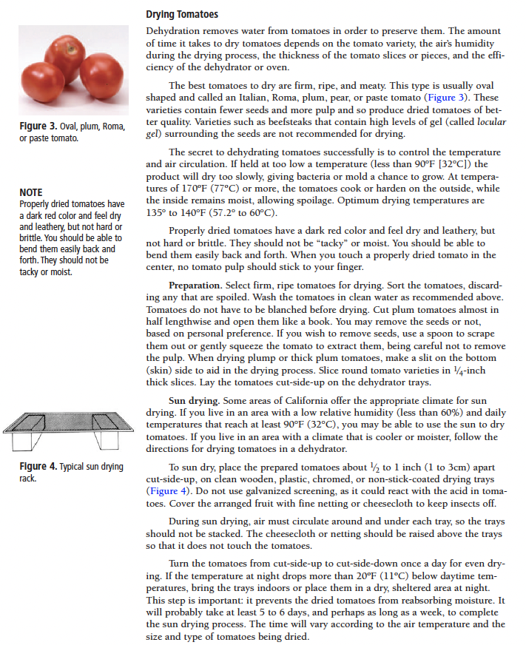
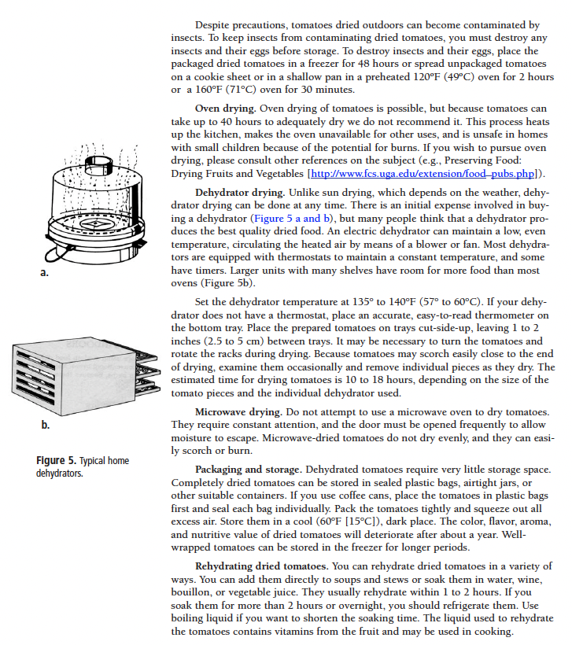
Source: UCANR Publication 8116. Tomatoes: Safe Methods to store, preserve and enjoy
http://anrcatalog.ucdavis.edu

Fundamentals in Preserving
Jars, Lids & Rings
Jelly Jar 4oz ½ cup
Half pint 8oz 1 cup
Three quarter 12 oz 1¼ cups
Pint 16 oz 2 cups
Quart 32 oz 4 cups

- Not any jar will do for canning. Canning jars are special and are made to withstand high heat and / or freezing and are designed for the lids to fit correctly.
- The lids are made specifically for canning jars in two different size jar openings, regular and wide mouth. Lids are self-sealing round metal disc that are held in place with a metal screw band (ring). The lids have a gasket that seals after processing. The lids are intended for one-time use. The rings are reusable.
- There are jars with clear glass lids and a replaceable rubber ring between it and the jar. These are not suitable for canning purposes.
- Wash lids and rings with warm soapy water. Do not use rusting or damaged lids or rings. Place lids seal down onto clean jar rim and follow with metal screw band. Tighten enough to hold the lid in place but loose enough to allow the air to vent from the jar, this enables the jar to have a tight vacuum seal when done.
- The rule of thumb is to tighten the screw band very gently until you feel a sight resistance. Then finger tight a little more. You do not want the bands too tight
or too loose.

Processing (length of canning time)
Process foods for which you have a researched-based processing time. The process time is unique to each food, based on the amount of time needed for the contents of the jar to reach a temperature required to destroy all dangerous microorganism. Processing times are specified for jar size. All recipes specify jar size needed. You can move down in size of jar (and be safe). Use the same processing time for the smaller jar as listed in the recipe. Never use a larger jar than the recipe recommends. If a larger jar is used, processing time has to be adjusted for that size jar and content. Don’t estimate on the processing time for larger jars; you need to be precise.

Canning Processes
- Use an atmospheric steam canner or a boiling water canner for high acid foods: fruits, pickled and fermented products, jams and jellies.
- Use a pressure canner for low acid foods: meats, vegetables, and seafood.

Why two different processes? Low acid foods must be pressure canned because Clostridium botulinum, the bacteria that causes botulism, is a spore former. When conditions are not favorable for the organism to grow (high heat, dryness, oxygen, high acidity), the bacterial cell forms a protective structure called a spore. It takes a higher temperature than boiling to destroy the spores: 240° - 250°F. If you do not destroy the spores in low acid foods they will germinate and produce fatal toxins in the food when it is stored on the shelf. High acid foods have enough acidity to destroy spores. The USDA does not recommend the open kettle method of canning because it does not prevent all risks of spoilage. (Open kettle canning is ladling hot foods into hot jars, applying the lids, and letting them seal without processing them in a canner.
Factors that affect growth of microorganism
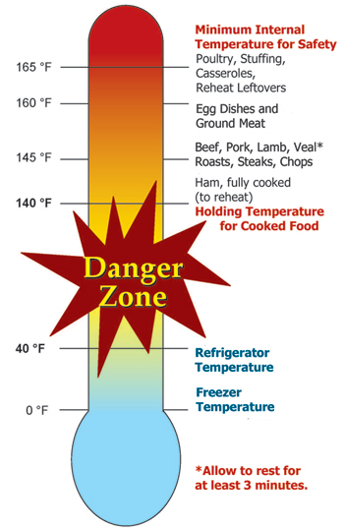
- Temperature: Foodborne pathogens grow best under the same conditions that allow people to thrive. Most foodborne bacteria grow fastest at temperatures from 90° to 110° F. However, foodborne bacteria will grow in the temperature range known as the Danger Zone, 40° to 140°F; some grow at temperatures below this range.
- Acidity or alkalinity (pH): Most organisms grow best under conditions that are not highly acid or alkaline; that is, a neutral pH. (Very few foods are highly alkaline.) High acid foods generally do not support bacterial growth.
- Moisture: Microorganisms require moisture for growth. Dehydration preserves foods by removing moisture.
- Oxygen: Most microorganisms require oxygen to grow; a few pathogens do not, or may require limited oxygen. However, controlling oxygen content is not useful for controlling bacterial growth for home food preservers.
- Time: It takes time for microorganisms to grow or multiply in foods. The time required is affected by temperature, acidity, moisture and oxygen levels. Under ideal conditions bacteria can double in number every 10 to 20 minutes.
- Food: Bacteria require nutrients to reproduce. Foods provide proteins and carbohydrates for growth.
- Inhibitors: Some natural compounds/food additives are bacterial inhibitors (sugar, acid).

Preventing Foodborne Illness


Clean
- Wash hands frequently and after using the toilet, changing a baby's soiled diaper, sneezing or coughing, touching animals, handling raw meat, fish and poultry and before handling food.
- 20-second rule: wash hands for 20-seconds or sing the Happy Birthday song twice.
- Bandage any cuts or burns on hands before handling food; use disposable gloves to protect food.
- Run sponges and dish scrapers through the dishwasher often. Change dish cloths daily.
- Use paper towels to mop up spilled juices from meat, fish or poultry.
- Use a disinfecting solution consisting of 1 tsp unscented chlorine bleach to 1 quart of water. Use a spray bottle to disinfect countertops, cutting surfaces, etc. Make a new solution every week.
Separate
- Avoid cross contamination. ALWAYS wash your hands, knives, cutting boards, and food preparation surfaces well with soapy water before and after any contact with raw meat or fish.
- Use a separate cutting board for fresh produce, raw meat and cooked meat.
- Rinse all fresh fruits and vegetables well under running water before preparing or eating them.
- When grilling or barbecuing, always use a clean plate for the cooked meat.
- Ice is food! Use clean ice to avoid contaminating food.
- Store raw meat, fish and poultry on the bottom shelf in the refrigerator or on a plate to prevent juices from dripping onto other food items.
Cook
- Must reach and maintain an internal temperature high enough to kill pathogens.
- Use a thermometer on meats; follow a reputable recipe when canning.
Chill
- Keep your refrigerator set at 40°F or below and refrigerate all perishable foods.
- Thaw frozen perishable foods in a refrigerator overnight, in a microwave oven, or under cold running water. Do not thaw frozen food on your counter.
- Do not prepare food more than 2 hours before serving without plans for proper storage in a refrigerator then reheating just before serving.
- Divide leftover hot food into shallow containers to accelerate cooling and refrigerate within 2 hours after preparation.
- Foods can spoil in as little as 1 hour in the hot sun. Discard any perishable foods from a picnic or potluck that have not been kept adequately chilled (40°F or below) or kept hot (140°F or above).

When in Doubt - Throw It Out! Never taste food that looks or smells strange to see if it can still be used. Just discard it. Generally, foods that contain bacteria will look, smell, and taste normal. Generally speaking most bacteria that cause foodborne illness are odorless, colorless and tasteless.

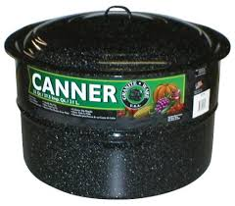
Boiling-Water Canning
- Preheat water to 140°F for raw-packed foods and to 180°F for hot-packed foods. Food preparation can begin while this water is preheating. Do not have the water boiling when you add the jars.
- Place jars on the rack in the canner. Add enough boiling water to cover the tops of the jar by at least 1" to 2".
- Place lid on canner. Bring the water to a rolling boil, then reduce heat to a gentle boil.
- Begin to count processing time when the water comes to a boil.
- Process for the time indicated in the recipe, maintaining a constant boil.
- All recipes are developed using sea level as the criteria for processing time. If you are at a higher altitude, adjust the processing times according to the following chart:

Altitude in feet | Increase processing time
1000 - 3000 | 5 minutes
3001 - 6000 | 10 minutes
6001 - 8000 | 15 minutes
8001 - 10000 | 20 minutes

- When the jars have boiled for the recommended time, turn off the heat and remove the canner lid. Wait no more than 5 minutes before removing jars
- Keep the jars upright when you remove them from the canner.
- Place the hot jars on a rack or folded towel away from drafts or cool surfaces. Keep the jars separated so they will cool evenly. Do not disturb the seal. Do not retighten the rings.
- Leave the ring bands on the jars until they have cooled (approximately 24 hours).
- Do NOT invert jars: Some canning books still recommend inverting the jars after removing them from the boiling water canner. The USDA does not recommend this method.
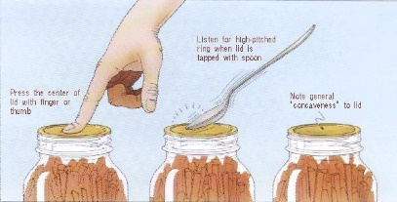
- After the jars have cooled, remove the ring bands. Look at the top of each jar. If the lid is slightly concave, it indicates a seal. Test the seal by pressing on the lid with your finger; the lid should not give. If you are not sure a jar is sealed, carefully lift the jar by the lid after removing the ring band. If not properly sealed, the lid will come off.
- Wash and dry bands. Clean the jars with a damp cloth. The ring bands may be replaced on the jars if desired. The ring bands must be thoroughly dry.
- Label and date the jars, and store in a cool, dark, dry area.
Reprocessing - If a jar did not seal, refrigerate and use within a few days, or reprocess it within 24 hours using a new lid. Check the jar for flaws. Process by the method originally advised and for the full length of time.

Atmospheric Steam Canner Processing
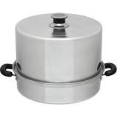
- Use a research tested recipe and processing time developed for a boiling water canner when using an atmospheric steam canner. An atmospheric steam canner may be used with recipes approved for half-pint, pint, or quart jars.
- Add enough water to the base of the canner to cover the rack. (Follow manufacturer recommendations.)
- Preheat water to 140°F for raw-packed foods and to 180°F for hot-packed foods. Food preparation can begin while this water is preheating. Do not have the water boiling when you add the jars.
- Heat jars prior to filling with hot liquid (raw or hot pack). Do not allow the jars to cool before filling.
- Load filled jars, fitted with lids, onto the canner rack and place the lid on the canner base.
- Turn heat to its highest position to boil the water until a steady column of steam (6-8 inches) appears from the vent hole(s) in the canner lid. Jars must be processed in pure steam environment.
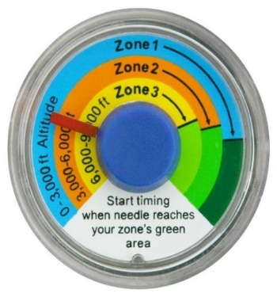
- If using a canner with a temperature sensor, begin processing time when
the temperature marker is in the green zone for your altitude. If using a canner without a temperature sensor, begin processing time when a steady stream of steam is visible from the vent hole(s).
- Set the timer for the total minutes required for processing the food, adjusting for altitude (see chart on page 5). Processing time must be limited to 45 minutes or less, including any modification for elevation. The processing time is limited by the amount of water in the canner base. When processing food, do not open the canner to add water
- Monitor the temperature sensor and/or steady stream of steam
throughout the entire timed process. Regulate heat so that the canner
maintains a temperature of 212°F. A canner that is boiling too vigorously can boil dry within 20 minutes. If a canner boils dry, the food is considered under-processed and therefore potentially unsafe.
- At the end of the processing time, turn off the heat, wait 2-3 minutes and remove the lid, lifting the lid away from you.
- Using a jar lifter, remove the jars without tipping and place them on a towel, leaving at least 1-inch spaces between the jars during cooling. Let jars sit undisturbed to cool at room temperature for 12 to 24 hours.
Sources
National Center for Home Food Preservation: http://nchfp.uga.edu/
USDA Complete Guide to Home Canning, 2015
So Easy to Preserve, Cooperative Extension, University of Georgia, 6th Edition, 2020
Ball Complete Book of Home Preserving, 2020
The All New Ball Book of Canning and Preserving, 2016, revised 2023.
UCANR Publication 8116. Tomatoes: Safe Methods to Store, Preserve and Enjoy Http://anrcatalog.ucdavis.edu
Cooperative Extension Offices (all 50 states)

It is the policy of the University of California (UC) and the UC Division of Agriculture & Natural Resources not to engage in discrimination against or harassment of any person in any of its programs or activities (Complete nondiscrimination policy statement can be found at http://ucanr.edu/sites/anrstaff/files/215244.pdf ) Inquiries regarding ANR’s nondiscrimination policies may be directed to John I. Sims, Affirmative Action Compliance Officer/Title IX Officer, University of California, Agriculture and Natural Resources, 2801 Second Street, Davis, CA 95618, (530) 750- 1397.

Should you need assistance or require special accommodations for any of our educational programs, please contact us at 530-621-5502.

