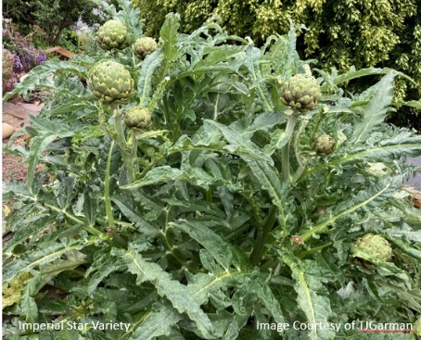

Ventura County Garden to Table Series - Artichoke

What is Artichoke? Artichokes are a variety of thistle in the Asteraceae family, which is often known as the sunflower family, and includes lettuce, daisy, artichoke, sunflowers, yarrow, tarragon, sage, and dandelion. Native to the Mediterranean, the artichoke is the edible flower bud of the plant. The edible portions of the bud (immature flower) are the tender bases of the leaves (bracts), and the fleshy base (heart).

When and Where to Plant

Plant from June through early August, In full sun, or part-shade in areas with hot, dry summers – they do best in areas having cool, foggy summers.

This perennial can be in either a vegetable garden or ornamental garden.

Give it lots of space - they get large – height of 3 to 4 feet and spread up to 6 feet in diameter.

What and How to Plant

Varieties to consider include – ‘Green Globe’ and ‘Green Globe Improved’ (most common and are considered the hardiest varieties, ‘Imperial Star’ buds are mostly large and spineless, or ‘Violetto di Romagna’ from Italy develops dark violet buds, sometimes considered the most flavorful.

Artichokes don't reproduce true from seed, so they're best planted by using root divisions available at nurseries or a healthy plant can be dug up, the root divided into two or more parts and replanted.

They should be set 6 to 8 inches deep in the soil, in either mounds or rows with irrigation furrows (ruts).

How to Keep Them Alive

During the growing season, irrigate about once weekly; more often in warm areas and less often if heavy soil.

Control aphids, snails & slugs that may appear by hand-picking or applying a shot of water.

Regular doses of nitrogen support growth – and MULCH…MULCH…MULCH.

Production starts about a year after planting.

When and How to Harvest

Coastal areas can enjoy two crops per year. After spring harvest (April – May), cut off the old stalks just below ground and withhold irrigation for several weeks. This allows for summer dormancy.

New shoots will develop and produce a fall crop (October – November). A plant can produce up to fifty buds per year.

Cut artichokes from their stems about 1 to 1-1/2 inches below the bud base.

Harvest buds, when they are tight and firm (usually at least 3 inches in diameter, with a sharp knife or pruners.

Buds allowed to become over mature will lose their tenderness and become fibrous and inedible.

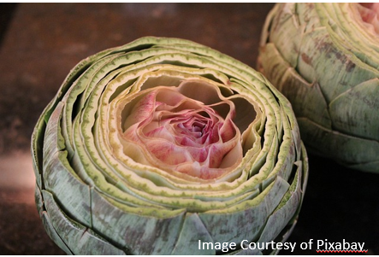
Cooking Tips and Recipe Ideas

The larger the artichoke, the longer the cooking time.

The length of the stem is also usually tender and edible.

Artichokes can be steamed, baked, broiled, grilled, roasted, sautéed, and marinated – don’t be afraid to explore the different ways to cook artichokes.

And once cooked - use them in pasta, salads, stuffed, and soups – explore the many ways to use artichokes.

Fun Facts

California, with its Mediterranean-like climate, produces virtually 100 percent of the U.S. crop.

Marilyn Monroe was the first official California Artichoke Queen in 1949.

March 16th is National Artichoke Day.

It is believed they were first cultivated at Naples around the middle of the 15th century.

Resources
- UC ANR - Master Gardeners of Ventura County - https://ucanr.edu/sites/VCMG/
- UC ANR Home Gardening- Home Page - https://ucanr.edu/sites/vric3/Home_gardening/

- UCANR Vegetable Gardening- https://rng.ucanr.edu/Gardening/Vegetable/UCDavis

