

Handbook

Preface
This Handbook contains information designed to standardize the work of the 4-H County Ambassador Program across California. It should guide the work of County Ambassadors and be used in conjunction with the County Ambassador Program Administration Manual.
A project of the University of California 4-H Youth Development Program Incentives and Recognition Advisory Committee
Chairs: Gemma Miner, Sarah Lloyd
Members: June Coleman, Barbara Butko, Sarah Berke, Jeff Randolph, Liliana Brown, Jordan Miner, Kate Lyn Sutherland, Sarah Gatie, Astoria Ho, Allison Keaney, Bailey Robinson-Burmester, Olivia Snodgrass
Suggested Citation:
Miner, G., Lloyd, S., Berke, S., Butko, B., Coleman, J. & Robinson-Burmester, B. (2024). County Ambassador Handbook. Davis, CA: University of California Agriculture and Natural Resources, 4-H Youth Development Program.
2024 Editors Acknowledgement:
Vera M. Bullard, Jenna Colburn, Addison Holbrook, Gemma Miner, Megna Nayar
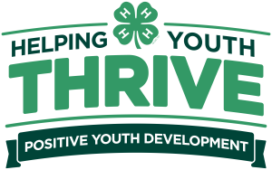

Table of Contents

Section 1: County Ambassador Overview Page 4
What is a County Ambassador 4
Guidelines for County Ambassadors 5

Section 2: Ambassador Team Interactions Page 6
Orientation 6
Tuckman’s Stages of Team Development 7
Formal Meetings 9
Youth-Adult Partnerships 10
Relationships with Other Groups 12
Team Information and Roster 13

Section 3: Yearly Planning Page 14
Plan of Action 14
Leadership Competencies 15
Service Learning 16
Plan of Action Worksheet 18
Example Plan of Action Worksheet 19
GPS Goal Management 20
GPS Goal Management Worksheet 21
Example GPS Goal Management Worksheet 22
GPS Goal Management Reflection 23
Example GPS Goal Management Reflection 24

Section 4: How-To Guides Page 25
How to Plan an Event 25
How to Plan a Workshop 29
How to Emcee an Event 31

Bibliography Page 34

Section 1: County Ambassador Overview

What is a County Ambassador?
A County Ambassador is the representative and champion of the county 4-H program. While no two County Ambassador programs are identical, they follow the same guidelines, provide similar opportunities, and have the same learning goals.
All County Ambassadors are highly encouraged to attend and participate in the California 4-H State Leadership Conference (at the beginning of their term), serve on statewide committees, and participate in other activities or events beyond the county level. These experiences help expand leadership skills and are beneficial for those wishing to become State Ambassadors.
The County Ambassador team plans their activities and learning goals within the established guidelines as described in this Handbook (see pages 14 – 16).
County Ambassadors act as visible 4-H members - role models for their fellow 4-H members, their county, their state, and their world.
Recognition
County Ambassadors stand out from other 4-Hers because of special attire such as:
- Lapel pin earned upon appointment and worn during years of service.
- County-specific County Ambassador uniform (usually a special jacket, polo shirt and/or name tag).
The attire for each county varies and often can be decided upon each year by the County Ambassador team.
*** Please use 4-H branding guidelines when designing County Ambassador uniforms. These guidelines are in the Branding Toolkit on the California 4-H website.

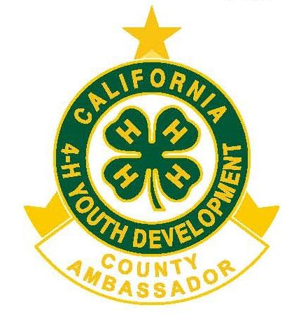
Guidelines for County Ambassadors
Being chosen as a County Ambassador is a working honor, and in fulfilling it, members are expected to behave with a degree of maturity, composure, and excellence. The following are general guidelines for succeeding as a County Ambassador.
As a County Ambassador, you are expected to:
- Follow the 4-H Code of Conduct always. Members sign this at the time of enrollment each year. It can also be referenced on the California 4-H website.
- Maintain a professional attitude as a representative of the 4-H Youth Development Program. Remember that both peer friendships and youth-adult partnerships are working, professional relationships.
- Follow the 4-H Dress Guidelines and dress appropriately for events attended or participated in as a County Ambassador. If the County Ambassador group has a uniform, this includes wearing Ambassador attire to an event when appropriate. The team should decide what the dress requirements will be at each event. Coaches should participate in the conversation and not determine this for the team.
- Serve as a role model for younger members. As a prominent senior member of the 4-H program, younger members will be watching County Ambassadors both on and off stage. Be mindful of this and aspire to set a good example always.
- Complete work on time. Whether it is an independent project or part of a group project, members should always complete the work that is agreed upon, whether determined by the group or individually volunteered. Members who are having trouble completing tasks on time must let the adult coach or County Ambassador team know so the adult coaches can help. This should be viewed as a learning experience. Things happen, and everyone needs to learn how to ask for help.
Consequences for not Fulfilling Responsibilities
Just as there are rewards for doing an outstanding job as a County Ambassador, there can also be consequences for not fulfilling the responsibilities of the position. These penalties will vary from county to county. Penalties might include loss of financial support to attend State Leadership Conference, or dismissal from the County Ambassador program, which includes forfeiture of the County Ambassador pin and county-specific uniform (jacket, polo, nametag, etc.). Be aware of the requirements of the County Ambassador position and follow through to completion to meet all the expectations to receive recognition.

Section 2: Ambassador Team Interactions

Orientation
The County Ambassador team’s initial meeting will set the tone for the rest of the term. It also serves to orient County Ambassadors, coaches, and program staff.
The team should accomplish the following:
Make Group Agreements
Establish group agreements and norms to which all members commit. These should be agreements that will apply for all team interactions for the entire term. At each meeting, reflect on the agreements. Add more if needed or revise or delete agreements as determined by the team. Each time a revision is made, all parties must obtain agreement about the new agreements.
Decisions, Decisions…
Set a standardized decision-making process. Will the team use a “majority rules” policy or aim for consensus on every decision? Coaches should be voting members of the team with an equal vote.
Set Up Communication
Find out what communication method works best for the group. These could include (but are not limited to) e-mail, text messages, instant messaging, phone, both virtual and in-person meetings.
Plan of Work
With your coaches your team will complete the activities from the County Ambassador Program Administration Manual on Leadership Competencies. Make sure you understand what each competency means well enough to explain it to others.
After orientation, you will meet again to pick three competencies the team will focus on. These are the big ideas guiding our learning for the year. Set specific goals for each of these, using the provided worksheet in Section 3: Yearly Planning.
Teambuilding and Personalities
Conduct team building and personality profile activities to understand how each member contributes to the team and works cooperatively with the team. Ideally, these activities should be led by a 4-H staff member or guest speaker so that the adult coaches participate as team members.

Tuckman’s Stages of Team Development
Your County Ambassador team, just like any other group, will go through phases of team development. Psychologist Bruce Tuckman described how teams move through stages known as forming, storming, norming, performing, and adjourning. You can use Tuckman's model to help your team to move through the five stages necessary and inevitable for your team to grow.
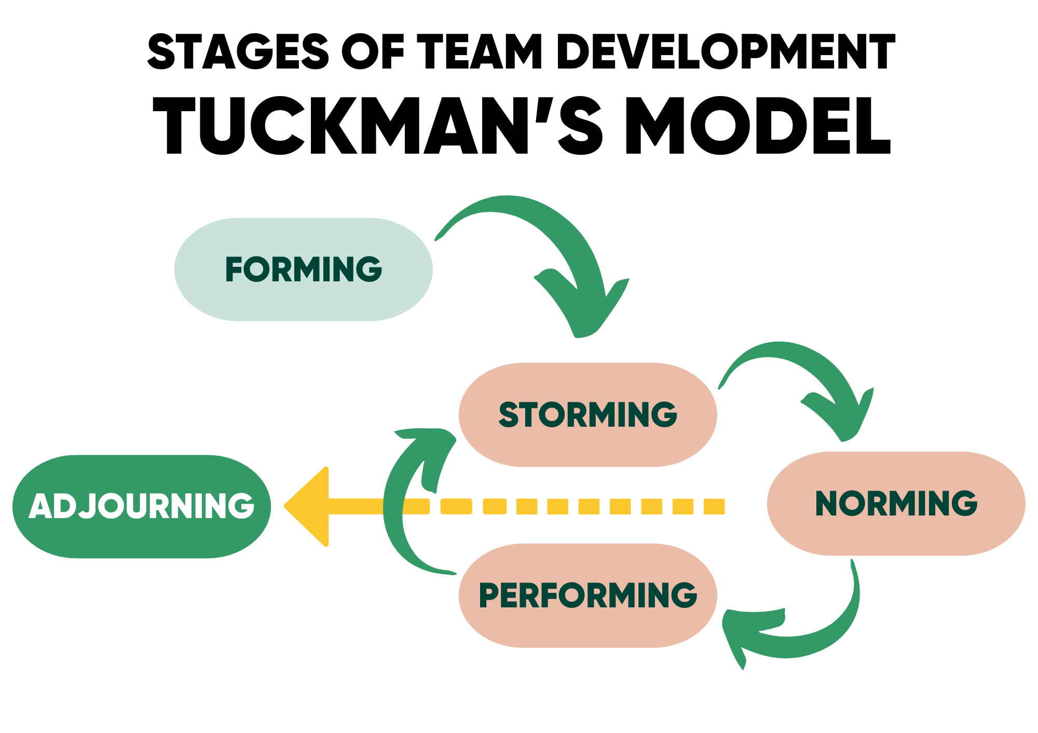
Stages
Forming: Members behave mostly independently and are generally polite to each other. To grow from this, members must learn to work together and risk the possibility of conflict.
Storming: Disagreements and personality clashes come out at this stage. Tolerance and patience must be emphasized here.
Norming: The team becomes aware of competition or shares a common goal. They accept each other and make efforts to move forward.
Performing: Team is motivated, focused, and knowledgeable. They can make decisions without supervision.
Adjourning: This final stage is when the group's work ends and can happen at any stage. There can be celebration and happiness for a job well done in addition to feelings of sadness and distress, especially if the group has worked together for a long period and developed strong relationships.
Please contact the California 4-H Office at ca4h@ucanr.edu for more information on activities that help teams understand and practice Tuckman’s theory of team development.
There are many resources on the internet related to Tuckman’s theory if you want to learn more.



Formal Meetings
Formal meetings of the entire County Ambassador team (including coaches) should be held regularly. A suggested frequency would be to meet once a month for the entire term (usually 12-18 months). Before the first meeting, perhaps during orientation, determine the meeting calendar for the year. Pre-assign one person who will act as the Leader of the Day, and another who will act as a Recorder for each meeting on the calendar. There is a sample schedule of meeting options in the Administration Guide.
Before Each Meeting:
- The Leader of the Day prepares the agenda in consultation with others, outlining all items to be addressed at the meeting.
At Each Meeting:
- The Leader of the Day leads the group through the agenda, keeps the meeting moving and ensures that the meeting objectives are met.
- Review group agreements that were developed during orientation. How is the team doing with these group agreements? Are there items to add? Delete?
- The Recorder notes what was discussed and any decisions the group made.
After Each Meeting:
- The Recorder distributes the meeting notes via an agreed-upon platform by an agreed-upon deadline (ex: via email, within one week of the meeting).
Extra Meetings
The team may need to have meetings more frequently when planning events – or hold separate meetings solely for planning a large event or activity. For example, if the County Ambassador team hosts a county-wide conference, extra meetings may be needed to plan that conference.
Adding extra meetings is fine, especially if they're necessary, as long as everyone on the team, including coaches, is informed with enough notice to attend. When scheduling additional meetings, make sure to assign a Leader of the Day and a Recorder beforehand.
Some of the skill-building activities such as Youth- Adult Partnership, Goal Setting, Introduction to Plan of Action, and Service Learning may be offered by the California 4-H State Ambassadors as a virtual workshop. You could attend these workshop offerings as part of your team’s meetings. Look for these workshops on the calendar of events on the California 4-H website.

Youth-Adult Partnerships
In 4-H, we believe in strong partnerships between youth and adults. When working together, we aim for partnerships that align with the higher rungs of Hart’s Ladder of Participation, as explained on page 11.
It's important for both youth and adults, including Ambassador coaches, club leaders, and community members, to aim for partnerships in the Rung 6 to 8 range. We should avoid activities or situations that feel tokenistic or superficial (Rungs 1 to 3). If we encounter these, let's discuss how to elevate our involvement through dialogue with the organizers.
Throughout the year, strategize on how to maintain these partnerships with adults.
Tips on how to get started:
- Youth and adults see each other as equals.
- Put aside any stereotypes or assumptions as we learn and grow together.
- Work towards goals that benefit from both youth and adult perspectives, creating outcomes that wouldn't be possible without both groups.


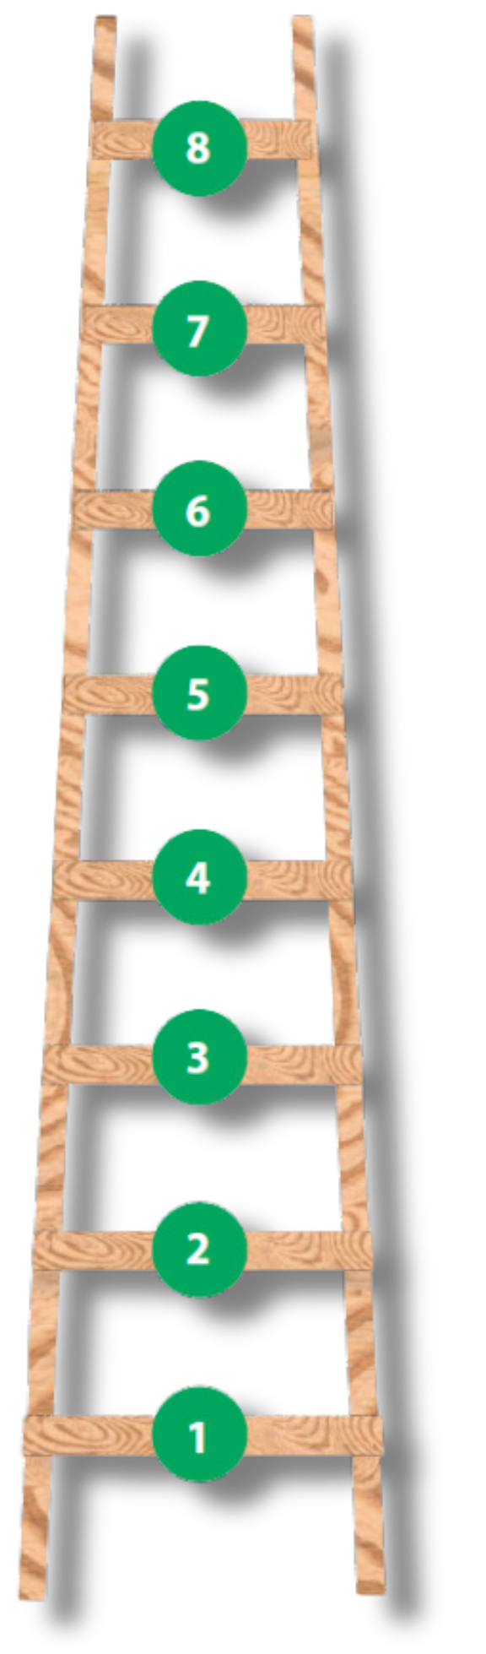
Roger Hart’s Ladder of Participation

8. Youth-initiated, shared decisions with adults: Activities are led by youth. The planning and decision-making are shared in equal partnership between youth and adults.

7. Youth-initiated and directed: Activities are led by youth. The activities planning and decision-making are mainly made by youth, with some adult input.

6. Adult-initiated, shared decisions with youth: Activities are led by adults. The activities' planning and decision-making are shared with youth.

5. Consulted and informed: Activities are led by adults. The activities include youth input and youth understand how their input will be used to inform the outcomes of adult decisions.

4. Assigned but informed: Activities are led by adults. The activities have some youth planning and decision-making. Youth also understand the purpose.

3. Tokenism: Activities are led by adults. The activities may have minimal youth input, but youth are not consulted for additional feedback.

2. Decoration: Activities are led by adults. The activities' purpose is understood by youth, but youth have no input into the planning and decision-making.

1. Manipulation: Activities are led by adults. The activities' purpose is not understood by youth and youth do as they are directed.
Source: Hart, R.A. 1992. Children’s participation: From tokenism to citizenship. Florence, Italy: UNICEF.

Relationships with Other Groups
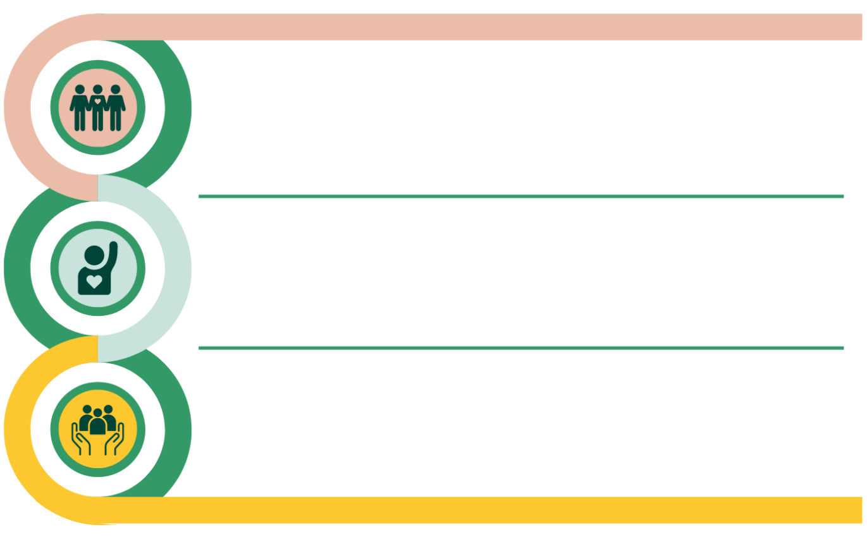
County Ambassadors will interact with various groups during their term. The list below outlines typical County Ambassador interactions. It may help to view each relationship as a partnership, just like the youth-adult partnerships formed within 4-H.
Community Organizations
- Participate in outreach and represent 4-H in the community to increase the visibility of the 4-H program.
- Service learning activities typically require collaboration with other organizations in the community.
Volunteer Management Organization
- Participate in county 4-H council/management board meetings and/or coordinate committees to help plan county events.
- Provide updates on the County Ambassador plans.
4-H Club, Units, and Program
- Encourage younger members to increase their participation.
- Visit county clubs, units, and programs to introduce the team to members and inform them of events and activities within 4-H.

Team Information and Roster
Name:_______________________________________________________________________________________________
Term Start Date: _______________________________ Term End Date: _______________________________

County Ambassadors
Name | Club | Phone Number/Text? | Email
Coaches and Helpers
Name | Club | Phone Number/Text? | Email
University of California Agriculture & Natural Resources (UC ANR) is an equal opportunity provider.

Section 3: Yearly Planning

Plan of Action

County Ambassador teams will develop a Plan of Action for their term. This plan will help the team stay focused on a shared goal throughout the year. For teams that have two-year terms, it is recommended that a new plan is developed for each year.
The "Plan of Action" should be drafted early in the term, using the provided Plan of Action worksheet (page 16) and GPS Goal Management worksheet (page 19) in this Handbook. Blank forms may also be found on the California 4-H Resource website. Completed examples of each worksheet can also be found on the page immediately following the worksheets.
Follow these steps:
- Learn about Leadership Competencies through activities led by your coach.

- With your team select three Leadership Competencies to work on during your term.
- Develop and complete a Service Learning Project that incorporates all three chosen Leadership Competencies.
- Set and manage team goals for the selected Leadership Competencies. Ensure that goals are both realistic and achievable, while also encouraging the team to aim high and challenge their skills and strengths.
- Reflect on the goals and achievements for the year.

Leadership Competencies
Focus on boosting leadership skills by tackling tasks and goals that really build those competencies. Imagine each skill as a bucket waiting to be filled with activities, events, and strategies. Try to pick activities that cover more than one bucket at a time; it's like multitasking for your growth! Choose strategies that hit multiple goals together. Remember, it's not just about getting things done, but about growing as a leader along the way!


Advise
Participate and be involved in decision-making at county level for 4-H.
Examples: County 4-H Council or Management Board, county level committee, Youth Council or Advisory Board
Avocate
Select a community issue of importance to the team and a plan to improve that specific situation in the community.
Examples: County Service Learning Project, County Ambassador Platform, National Youth Science Day
Mentor
Encourage members in the county to grow as a person and 4-Her.
Examples: County activity or event requiring mentorship of younger members, county-wide project support, special interest group or activity support
Plan
Improve 4-H in the county by working with others to carry out events for 4-H members.
Examples: Achievement Night, Officer Training, Presentation Events, Field Day, clinics
Promote
Present a positive image of 4-H in the county.
Examples: Farm Bureau, outreach event (health fair, parade, farmers’ market, etc.), civic event, fair, National 4-H Week
Teach
Lead workshops or lessons on a specific subject (team or individual choice).
Examples: Officer Training, multi-county conference, State Leadership Conference, Youth Experiences in Science (YES!), countywide project lessons.

Service Learning
The opportunity to serve, make a difference, and contribute to the community has always been a core value in 4-H. Service learning integrates meaningful community actions with learning, personal growth, and civic responsibility.
Each County Ambassador team is tasked with planning and executing at least one Service Learning project per term. The Service Learning project, activity, or event is designed to assist in development of the three Leadership Competencies selected by the team.
As County Ambassadors, you're not just doing regular community service anymore. You're moving into something deeper called 'service learning.' It means you'll learn about a problem, what causes it, and how you can make things better. And while you're helping, you're also learning and teaching others all at once!
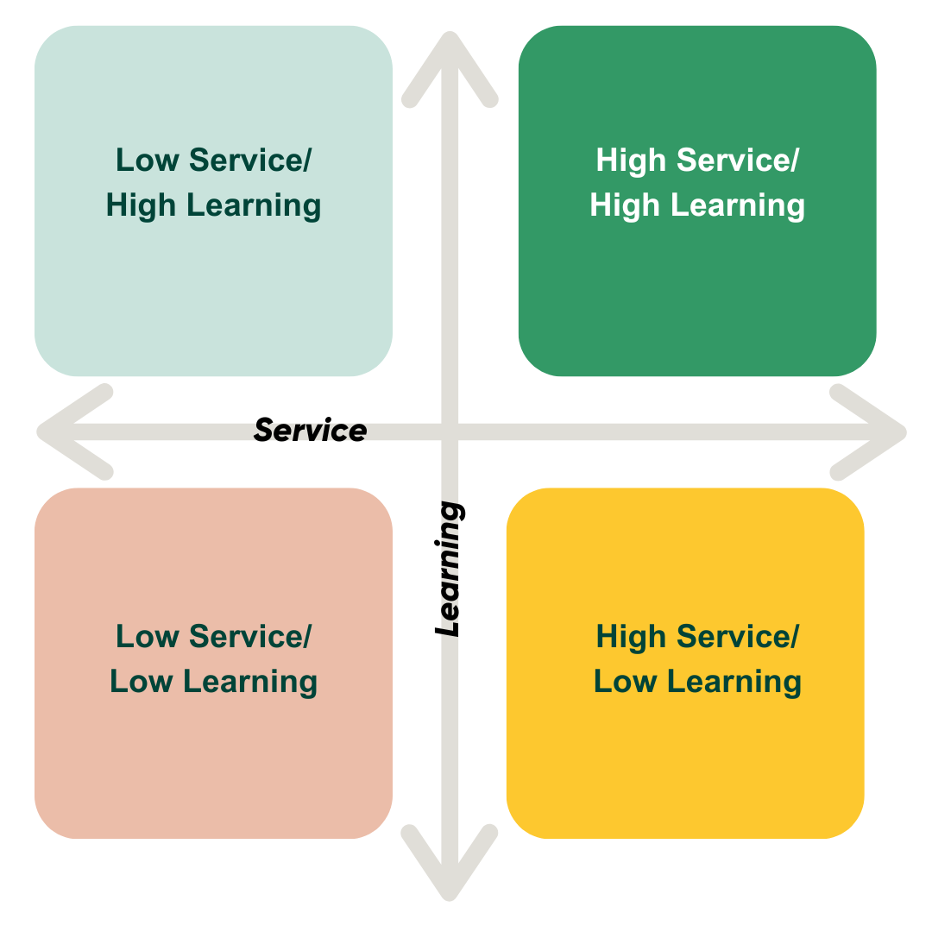
For more information on Service Learning and to access the Service Learning Toolkit go to the California 4-H website.
Service Learning Project Relationship to Impact Stars
Once your County Ambassador team has launched a service learning project, you might want to earn extra recognition for your efforts by working towards an Impact Star, achievement programs for senior 4-H members centered around service learning projects.
You can use the same project to fulfill the requirements for both County Ambassador and an Impact Star. While you'll need to complete paperwork for both, the good news is that they're quite similar. If you haven't earned Emerald Star I and II as an intermediate member, you'll need to start with those. Information on the achievement program can be found on the California 4-H Resource Site.

Plan of Action Worksheet
Complete one Plan of Action as a team or sub-team at the beginning of the term. Every team member should have access to a copy of this worksheet. It can be stored digitally on a cloud storage platform or file sharing platform, which ensures easy access for all team members.
County: |  |  | Coach(es):
Term Start Date: |  |  | Term End Date:
Selected Leadership Competencies (check 3):
☐ ADVISE  ☐ ADVOCATE |  | ☐ MENTOR  ☐ PLAN |  | ☐ PROMOTE  ☐ TEACH
For each competency selected, set one main goal. This can be broad and overarching; more specific goals will be set using the GPS Goal Management worksheet.
Leadership Competency |  |  | Main Goal
Decide on a Service Learning Project that will help you achieve one or more of the big goals you set above. For now, focus on the basics of the service learning – you can figure out specifics later.
What issue will you address?
What will you do to address it (using each of the Leadership Competencies)?
What will you learn? What will you teach the community?
What will be the outcome of the project?


Tip: Members can use these documents to help write the Leadership Development Report
in the 4-H Record Book.

University of California Agriculture & Natural Resources (UC ANR) is an equal opportunity provider.

Example Plan of Action Worksheet
Complete one Plan of Action as a team or sub-team at the beginning of the term. Every team member should have access to a copy of this worksheet. It can be stored digitally on a cloud storage platform or file sharing platform, which ensures easy access for all team members.
County: | Los Angeles |  | Coach(es): |  | Charlie Hansen, Suz Zamora
Term Start Date: | May 1, 2024 |  | Term End Date: |  | June 30, 2025
Selected Leadership Competencies (check 3):
☐ ADVISE  ☐ ADVOCATE |  | ☐ MENTOR  ☐ PLAN |  | ☐ PROMOTE  ☐ TEACH
For each competency selected, set one main goal. This can be broad and overarching; more specific goals will be set using the GPS Goal Management worksheet.
Leadership Competency |  |  | Main Goal
ADVOCATE |  |  | Divert waste from landfills, increase access to recycling and composting.
MENTOR |  |  | Create and lead a countywide project for upcoming leaders (11-13 years old).
PROMOTE |  |  | Spread the word about 4-H in LA county!
Decide on a Service Learning Project that will help you achieve one or more of the big goals you set above. For now, focus on the basics of the service learning – you can figure out specifics later.
What issue will you address?
LA county produces a lot of trash, which builds up in landfills. A lot of that trash can be recycled or composted.
What will you do to address it (using each of the Leadership Competencies)?
To Advocate: Talk to local businesses about putting a recycling and compost bin next to their garbage bins, encouraging customers to think about what they are throwing away and where it should go.
To Mentor: We work with other 4-H members to help them make choices about if an item is really trash, can be reused or recycled?
To Promote: When working in the community on this issue, we will bring flyers and posters that show people we are in 4-H. We will wear 4-H clothing.
What will you learn? What will you teach the community?
We will research what the LA Dept. of Public Works is already doing to manage waste. We will teach others how to reduce, reuse, recycle, and compost.
What will be the outcome of the project?
Less trash going to landfills, more blue recycling bins and compost bins in public places!
University of California Agriculture & Natural Resources (UC ANR) is an equal opportunity provider.

GPS Goal Management
Goal management involves more than just setting goals. It's a process that includes setting a goal, figuring out specific strategies to achieve it, and identifying potential obstacles that might hinder progress. The acronym GPS (Goal Selection, Pursuit of Strategies, Shifting Gears) is helpful to remember the steps involved in goal management that lead to success.
This process is a key part of your Plan of Action. You will start early in the year to build these skills before diving into activities and projects.
- Using the GPS Goal Management worksheet, we determine the Goals, Strategies, and Shifts for the leadership competencies selected and the Service Learning Project. You'll need to complete a total of four worksheets.
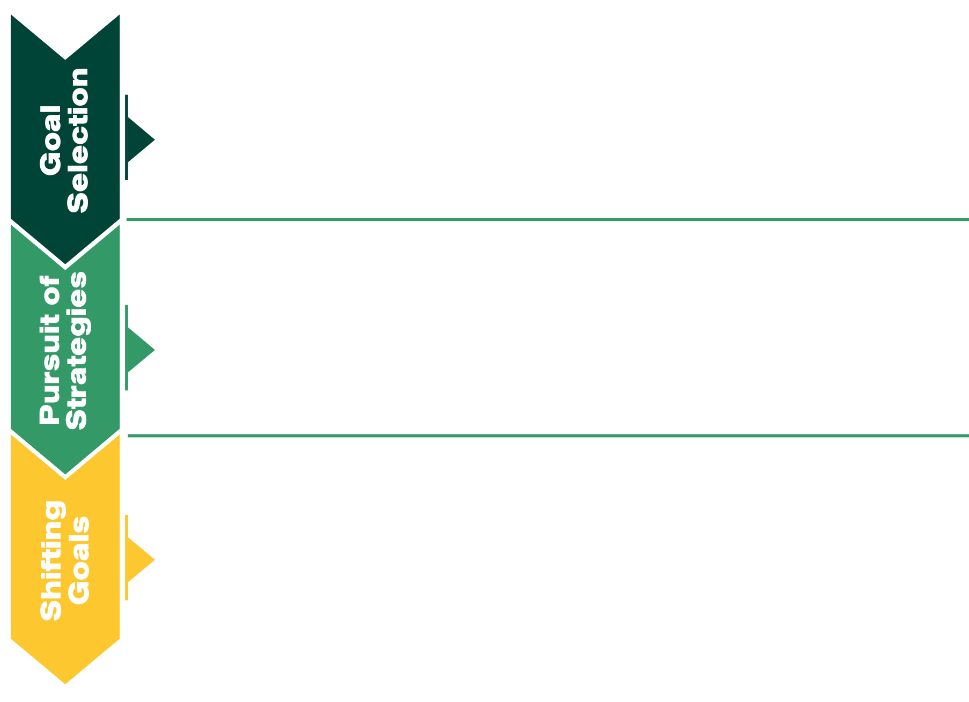
- At each meeting, we'll check back on our progress. Are we on track? Do we need to shift gears because something's blocking our progress? Do we need to adjust our goals or strategies? Achieving goals is an ongoing process, and we'll need to check in often to stay on course.
- What do you want to do?
- Goals should be specific and measurable.
- Think of each goal as a destination--what will be accomplished when the goal is reached?
- How and when will the goal be achieved?
- Write specific tasks and deadlines for each step or strategy.
- Think of this as a checklist of everything that needs to be done to reach the goal.
- What are some things that could happen that will get in the way of completing a strategy or reaching a goal?
- What can be done if this happens?
- Who can be asked for help?

GPS Goal Management Worksheet
Complete one worksheet for each leadership competency selected and the Service Learning project at the beginning of the County Ambassador term. Every team member should have a copy and/or it should be stored in either cloud storage or a file sharing platform, where team members can have access to it.
Goals should be realistic and measurable, stretch the group's skills, and encourage collaboration to help achieve other goals.
Pursue Strategies should be VERY specific. They should state what exactly will be done, by whom and by when. This will be the longest part of the worksheet. This section will also be added to over time as you think of other things you need to do to accomplish the goal.
Shift Gears and think of the things or circumstances that could be roadblocks—things that get in the way of achieving the goals. Record the roadblocks and the strategies you will use to adjust your strategies or your goal if that happens.
Leadership Competency Selected OR Service Learning Project Title
Select Goals
Record the goals you have for this leadership competency.
Pursue Strategies
What are the steps you will take to reach your goals? Include by when, by whom, and the specific actions you or your team members will take.
Shift Gears
What are some things that may get in the way of achieving your goals? What can you do to overcome those challenges or obstacles?

Tip: Members can use these documents to help write the Leadership Development Report
in the 4-H Record Book
University of California Agriculture & Natural Resources (UC ANR) is an equal opportunity provide

Example GPS Goal Management Worksheet

Note: This example does not include all the strategies needed to achieve each goal. This should be used as an example to start thinking about the things that go in each section and your team GPS goals will be more than one page long for each competency.
Leadership Competency Selected OR Service Learning Project Title
PROMOTE
Select Goals
Record the goals you have for this leadership competency.
1) Apply for and set up a 4-H outreach booth at the farmer’s market.
2) Attend at least two meetings of outside organizations like the Farm Bureau and City Council meeting and make a presentation about 4-H and how they can support it.
3) Host a county-wide 4-H “Meet & Greet” where the community can come and learn what 4-H is all about!
Pursue Strategies
What are the steps you will take to reach your goals? Include by when, by whom, and the specific actions you or your team members will take.
1a) Margo will collect information on what is needed to apply for a booth at the farmer’s market by October 3.
1b) Our coach, Charlie, will help us fill out the application and turn it into the city by October 20.
2a) Before December, Micah will contact the Farm Bureau to find out when their meetings are and ask if we can send a couple ambassadors to their next meeting. Jose will do the same for the City Council.
2b) Micah and Jose will plan a presentation to talk about our Service Learning Project and seek financial support from each of those organizations to fund our project.
3a) Justine will contact the department of Parks and Recreation to find out if/when we can host a public event at Sycamore Park. If we can host an event, she will complete the paperwork by January 15th.
3b) Using the same materials and ideas from the farmer’s market, we will all participate in the day.
Shift Gears
What are some things that may get in the way of achieving your goals? What can you do to overcome those challenges or obstacles?
1) We may need to pay a fee to reserve a booth at the farmer’s market. If this is the case, we will hold a snack booth fundraiser at Achievement Night to raise the funds for this.
2) The Farm Bureau and City Council may not allow visitors at their meetings. If so, we will seek out two other community organizations to build a relationship with.
3) The Parks and Rec department is known for being a little slow with paperwork, which means we might not get this done by the deadline. If this happens, we will send polite follow-up emails or make phone calls reminding them of our plans.
University of California Agriculture & Natural Resources (UC ANR) is an equal opportunity provider.

GPS Goal Management Reflection
Reflection is where learning happens. Be sure to include time in your plans for the team to talk about what happened, what you learned, and why it matters that you learned that. Think about how what you learned can be applied to other situations in your life.
Because everyone learns different things, even though the same experience, the GPS Reflection worksheets will be completed individually. After everyone has completed their reflection, the team members should set a meeting time to share and discuss what each member learned.
Complete one reflection per competency and the Service Learning project after achieving your goals, or at the end of your County Ambassador term.
GPS Reflection
Discuss how you did or did not reach your goals for this project, program, or experience. What did you do to reach your goals? Discuss how your strategies did or didn’t work. Discuss situations that made you shift gears. How did you handle having to shift gears? Give examples and explain what you learned through the project, program, or experience.
University of California Agriculture & Natural Resources (UC ANR) is an equal opportunity provider.

Example GPS Reflection Worksheet
GPS Reflection
Discuss how you did or did not reach your goals for this project, program, or experience. What did you do to reach your goals? Discuss how your strategies did or didn’t work. Discuss situations that made you shift gears. How did you handle having to shift gears? Give examples and explain what you learned through the project, program, or experience
What a year! The farmer’s market booth was successful – we did end up having to pay a fee to apply for a booth, but the county council was nice enough to grant us the funds, so we didn’t have to raise the money in a fundraiser. We had at least two County Ambassadors and two club members present at the booth every Saturday. I noticed that we attracted the most attention when we brought animals to pet or activities to demonstrate. Our hands-on learning approach certainly made us stand out and drew attention to our booth.
The Farm Bureau was happy to have us as guests! We established a tradition of sending at least one ambassador to each FB meeting to give an update on what our county 4-H program was up to. Partnering with them has definitely increased our confidence in reaching out to other community groups! City council meetings were less successful… they let us come and watch but there was rarely time for us to speak about the 4-H stuff we’ve been doing. It was still good to show up in 4-H shirts and sweatshirts just to let our city council members know that 4-H exists and is important to young people in our community.
Surprisingly, we were able to actually get an event planned at Sycamore Park! We learned (the hard way) that parks are really popular venues for events, especially in the springtime. So, we ended up having to push our Meet & Greet back to next Fall (set for September 4th). I think this will work out better, though, because it will line up with when clubs are recruiting new members and families are signing up for extra-curricular activities. Charlie helped us learn to be patient with the Parks and Rec dept. and taught us how to draft polite, professional emails. In the end, all that hard work paid off!
University of California Agriculture & Natural Resources (UC ANR) is an equal opportunity provider.

Section 4: How-To Guides

How to Plan an Event
County Ambassadors may be called upon to plan an event for the county. If the team decides that planning an event helps develop a skill of one or more of their selected Leadership Competencies, use these questions to help get started. Events come in all shapes and sizes, but there are common steps to planning them. Early in the planning process, fill out this table for the event. These are all important details to include in advertising, too!
What
What is the event? If it is an annual event, does it need a theme? If it is a new event, what will the topic and theme be? What is the goal for this event?
Who
Who attends? Who is in charge? Who can help with tasks? The bigger the event, the more help needed. If this is a new event, it is a good idea to find someone with experience to learn from.
When
What other schedules need to be considered? The county 4-H office? Other 4-H clubs/units/programs? The schools or city or county? The fairgrounds? Pick a date far enough ahead that gives plenty of time to plan and publicize.
Where
If there is not already a customary location, one will need to be found. Some questions to think about are: Is it the right size? How much will it cost? Is it available? Is it accessible and not too far away from attendees? Are decorations allowed? How is it obtained/rented? What about cleaning up afterwards?

Event Information
Early in the planning process, fill out this table for the event. These are all important details to include in advertising, too!
Name of Event: _____________________________________________________________________________________
Date and Time: _____________________________________________________________________________________
Location: ___________________________________________________________________________________________
Audience or Purpose: ______________________________________________________________________________
_____________________________________________________________________________________________________
Example:
Name of Event: _____________________________________________________________________________________
Date and Time: _____________________________________________________________________________________
Location: ___________________________________________________________________________________________
Audience or Purpose: ______________________________________________________________________________
_____________________________________________________________________________________________________

Los Angeles County 4-H Awards Banquet
Saturday, October 7th, 2017
Alhambra High School Gymnasium
All 4-H members and families are invited to help us celebrate those who have earned awards for the 2016-2017 program year!

Other considerations in event planning
Budget
Is there an existing budget? Who is responsible for the finances?
Permits
Is a food permit needed from the city or county? If it is a fundraising event, fill out the 4-H fundraising form and get it approved. Check out if there are any other permits or applications needed.
Food
Will refreshments or a meal be offered? Who will take the 4-H food safety training? What food? How much food? Is there a contract to have processed for catering? Remember the healthy living requirements.
Decorations
Are decorations needed? Are they allowed? Who will bring them?
Attendees
Do people need to apply or RSVP for the event? Is there a deadline to register? Is there an application process or fee? How will that be handled?
Schedule
Are speakers needed? Does the event include workshops? Are there different workshops going on at the same time? Who will MC? Are games or other activities needed? Is a printed schedule needed for everyone?

Overnight
If the event is overnight, what accommodations will there be and who will be chaperones? Is a contract needed? Who will send the contract to the county office for processing?
Advertising
How will you get the word out? How will you make sure that as many as possible of your intended audience will be informed? Newsletters, postcards, posters, announcements? Include: time, place, purpose, etc.
Setup and Cleanup
Who will be available for these duties? Can they get in early or stay late?
Risk and Safety Management
Are there hazards to be aware of? Are safety and first aid equipment and supplies available? Do participants need to be aware of any safety issues or requirements? Is specialized safety gear needed by participants? How will you inform participants? Is a health professional always needed on site?

The Day of the Event
- Does everyone involved have all the information they need?
  - Schedule
  - Numbers of other team members
  - Addresses
  - Paperwork
  - Equipment
  - Can attendees find the coordinators easily?
- Keep a few runners nearby so the person in charge is not running everywhere when something goes wrong and can delegate tasks to them.

After the Event
- Follow-up – Thank those who worked behind the scenes and up front. Send thank you notes or give a small gift to special speakers or those who put a lot of work into making the event a success. Make sure people are reimbursed for expenses.
- Evaluate – A written evaluation is helpful for those who may do this next time. Even if this is a one-time event, some kind of report should be given to the club/unit/program/county. Include budget information, number of people who attended, any results, and the coordinators’ opinions and ideas of how things went and what could be improved.
A basic event evaluation should answer these questions:
- How many people attended? Who were they?
- What was the cost of the event? Was there a profit made?
- What aspects of the event went well?
- What aspects didn’t go so well?
- How can this event be improved?

How to Plan a Workshop
County Ambassadors will likely lead educational sessions and workshops on a wide range of topics. Presentations will be made at club/unit/program, county, regional, and state levels. They may be given as an individual, small group, or whole team. Audiences will range in age and interests. Planning is the key to leading a successful workshop.

Getting Started
Key questions to ask when planning a workshop:
- Who is the audience?
- What topic is going to be presented?
- Where is the presentation?
- How is the information going to be presented?

Know Your Audience
The audience will most often influence what the topic of the presentation should be. There are a variety of conferences that are held each year throughout the state.
To better understand the audience, ask the event coordinator these questions:
- What is the age of the attendees? What is presented to teens could be different than what is presented to adult leaders or younger 4-H members.
- Is the audience made up primarily of junior members who do not have the same level of experience as senior members?
- Is it a mixed audience of adults and youth?
These are important pieces of information that must be answered before starting work on the presentation or workshop.

Topic
Deciding what to present in a workshop can be tricky. It's important to think about who will be attending and what they're interested in. Also, consider the main theme of the conference. Sometimes, the organizers might ask you to cover a specific topic. Make sure to check if there's something specific they want you to talk about. Asking questions can help you figure out what topic to choose, which makes planning a lot easier. If you need help with structuring your presentation, check out sections 1 and 5 of the UC 4-H Presentation Manual.

Location
Events and conferences offer plenty of chances to present workshops. Start by checking out events in your county, then regional ones, and finally state-level activities. Sometimes, there are even national opportunities for workshops. If you're new to workshops, starting at the county level is a great way to gain practice and confidence. Plus, it gives your team a chance to refine both your presentation and your skills.

Facilitating vs Presenting
Running a workshop involves more than just presenting to people. It's about guiding them through an interactive and interesting learning experience. But the basics of presenting are still super important. Check out section 1 of the UC 4-H Presentation Manual for tips on how to get your message across effectively.

How to Emcee an Event
If asked to be the Master of Ceremonies (M.C., also emcee) at an event, think about what should happen before, during and after the event. The primary job of an emcee is to keep the event flowing in order and on time – the audience will expect it.

Before the Event
- Appearance should reflect your respect for the audience and the event. Wear County Ambassador attire, or at least the same level of dress or a notch higher than the audience.
- If possible, meet with the coordinator(s) to find out their goals for the event and what they expect.
- Read through the script/program. Think through the flow of things—be prepared.
- Practice pronouncing names. Find help if needed. There’s no shame in double-checking!
- Check that all audio/stage equipment is in working condition and in the right place.
- Make sure that all awards are in order and placed efficiently.
- Coordinate with any others who may be sharing the emcee responsibilities.

During the Event
- Welcome the audience, if you are first: “Welcome to … [state the name of the event].” Thank them for coming, if appropriate. Identify and thank the organizers and dignitaries, if any.
- Introduce yourself by giving your name, your position, and your county (if appropriate).
- Introduce others, if that is your responsibility, the same way, or allow them to introduce themselves.
- Take care of any practical matters such as the schedule, how awards will be handed out, applause, photos, and sometimes the restrooms or exits need to be pointed out at the beginning of an event.
- Ensure that the stage is never empty. There should always be someone or something happening on the stage. Learn how to pass the podium on to someone else.

Exploring More About the Event
Keeping the audience's attention:
- Speak clearly and slowly; talk in your normal tone if using a microphone.
- Smile!
- Don’t rush.
- Look at the audience.
- Be engaged and excited.
- Face the audience.
Control the Mic
Sometimes you must wait for the noise to quiet down. Don’t try to yell over them. You can always ask, “May I have your attention, please?” Don’t hesitate to apologize for any delays. Keep the audience informed. Nobody likes to sit and wait. Depending on the event, have some time-fillers in mind that can be used. Ensure the filler does not require people to move out of their chairs so the regular program can resume quickly.
Introducing a Speaker
Give their name, position and where they are from. It is usually appropriate to give a little biographical information about them. If that hasn’t been given to you, contact the speaker before the event and ask what information they would like to include.
Say: “Let’s welcome (name of speaker) to the stage!” Lead the audience in the applause.
Handing Out Awards
Choreograph who will be announcing, who will be handing out awards, who will shake hands, how applause and photos will be handled. It is a bit of a dance, so plan ahead! Practice ahead of time can be useful and help this feel natural.
Closing an Event
Thank the speaker. Thank everyone (again) for coming. Thank the organizers. Let everyone know that the event is finished and any other instructions, like how soon they have to leave, or which way they have to exit, who picks up unclaimed awards, etc.

After the Event
- Thank the coordinator for asking you to emcee and thank the speaker for their presentation, if possible. Shake their hands.
- Ask the coordinator if there is anything else you can do.
- If you are in charge of any equipment, ensure it gets to the right place.
- Take care of any unclaimed awards, or get them to the correct person if this is your responsibility.
- Be available for photos if anyone wants them.
- Help with any cleanup if this is expected.

Bibliography
Benson, P.L. (2008) Sparks: How parents can help ignite the hidden strengths of teenagers. California, CA: Jossey-Bass.
Bouillion Diaz, L., McGlaughlin, P., Oberle, D., Stocker, D. (2015). Teen Leadership Competencies: A framework for advancing teen leadership. Urbana, Illinois: University of Illinois Extension.
Cain, J, Cummings, M., Staunchfield, J. (2008). A teachable moment: A facilitator's guide to activities for processing, debriefing, reviewing and reflection. Dubuque, Iowa: Kendall Hunt.
Chen, M. (2007, Mar. 16) Smart talking: Tell students to feed their brains. Edutopia: http://www.edutopia.org/tell-students-feed-their-brains
Damon, W. (2008) The path to purpose: How young people find their calling in life. New York: Simon & Schuster
Dweck, C.S. (2006) Mindset: The new psychology of success. New York: Ballantine Books.
Dweck, C.S. (2007, Nov. 28) The secret to raising smart kids. Scientific American Mind: http://www.scientificamerican.com/article.cfm?id=the-secret-to-raising-smart-kids
Hart, R. (1992). Children’s participation from tokenism to citizenship. Florence: UNICEF Innocenti Research Centre, as cited in www.freechild.org/ladder.htm
Lerner, R.M. (2007) The good teen: Rescuing adolescence from the myths of the storm and stress years. New York: The Stonesong Press.
Miner, G., & Dogan, S. (2012). iChampion 2 adult volunteer leader guide. Davis, CA: University of California Agriculture and Natural Resources, 4-H Youth Development Program.
Murdock, S. (2002) Youth-adult partnerships: http://ucanr.org/sites/UC4-H/About/Mission/YAP/
Pfeiffer, J.W., & Ballew, A.C. (1988). Using structured experiences in human resource development (UATT Series, Vol. 1). San Diego, CA: University Associates.
Rae-Dupree, J. (2008, July 6) Unboxed: If you’re open to growth, you tend to grow. The New York Times: http://www.nytimes.com/2008/07/06/business
Sankey, A., Worker, S., et. Al. (2016). UC 4-H presentation manual. Davis, CA: University of California Agriculture and Natural Resources, 4-H Youth Development Program.
Tuckman, B.W., Jensen, M.A. (1977). Stages of Small-Group Development Revisited. Group & Organization Studies, 2(4), 419-427.
UNIVERSITY OF CALIFORNIA AGRICULTURE AND NATURAL RESOURCES (UC ANR)
NONDISCRIMINATION STATEMENT FOR
UC ANR PUBLICATIONS REGARDING PROGRAM PRACTICES
Full text of USDA’s nondiscrimination statement can be found at Non-Discrimination Statement | USDA
April 2023
In accordance with Federal law and U.S. Department of Agriculture (USDA) civil rights regulations and policies, University of California Agriculture and Natural Resources (UC ANR) is prohibited from discriminating on the basis of race, color, national origin, religion, sex, gender identity (including gender expression), sexual orientation, age, disability, income derived from a public assistance program, or reprisal or retaliation for prior civil rights activity. Remedies and complaint filing deadlines vary by program or incident.
Program information may be made available in languages other than English. Persons with disabilities who require alternative means of communication to obtain program information (e.g., Braille, large print, audiotape, American Sign Language) should contact the UC ANR Office of Diversity & Inclusion, phone: 530-786-0206, email: dewhite@ucanr.edu or USDA’s TARGET Center at (202) 720- 2600 (voice and TTY) or contact USDA through the Federal Relay Service at (800) 877-8339.
To file a program discrimination complaint, complete the USDA Program Discrimination Complaint Form, AD-3027, found online at How to File a Program Discrimination Complaint and at any USDA office or write a letter addressed to USDA and provide in the letter all of the information requested in the form. To request a copy of the complaint form, call (866) 632-9992. Submit your completed form or letter to USDA by: (1) mail: U.S. Department of Agriculture, Office of the Assistant Secretary for Civil Rights, 1400 Independence Avenue, SW, Washington, D.C. 20250-9410; (2) fax: (202) 690-7442; or (3) email: program.intake@usda.gov.
Alternatively, a program discrimination complaint may be filed with the UC Harassment & Discrimination Assistance and Prevention Program (HDAPP) by email hdapp@ucdavis.edu or phone: 530-304-3864; or contact the UC ANR Title IX Coordinator at (530) 752-9466.
University of California Agriculture and Natural Resources (UC ANR) is an equal opportunity provider.
Inquiries regarding the University’s nondiscrimination policies may be directed to: UC ANR, Interim Affirmative Action Compliance Officer, University of California, Agriculture and Natural Resources, 2801 Second Street, Davis, CA 95618, (530) 750-1280. Email: tljordan@ucanr.edu. Website: http://ucanr.edu/sites/anrstaff/Diversity/Affirmative_Action/.

