DO NOT DIRECTLY COPY FROM THIS EXAMPLE DOCUMENT
COPYING IS OBVIOUS AND PROHIBITED

Earning Your Impact Stars

Member Name: | Jane Doe | 4-H Club/Unit: | Clover City Club
Collaborators: | John Smith, Andrew Jones, Ashley Jones
Mentor Name: | Amelia Williams | County: | Clover County
Current Star Rank: | Bronze | Rank Applying For: | Sliver

Preliminary Information

If you are applying for a Silver, Gold, or Platinum Star: (Skip this box if you are working toward your Bronze Star.)
Personal Development Goal:  What was your Personal Development Goal for your previous Impact Star? This is a goal for self improvement inspired by your Spark. This goal should have been specific to you. | Impact Goal:  What was your Impact Goal for your previous Impact Star? This goal uses your spark to make a difference in your community. Your group, if you have one, could have shared this goal.
Learn about the needs of refugees who are new to our community. | Help 25 refugee children and their families feel welcome in our city.

Part A. Setting Goals and Identifying Your Service Learning Activity
Service Learning Activities have two components:
- Personal Development Goal - something you want to improve about yourself
- Impact Goal - something you want to improve in your community
Your Spark (what you are passionate about) should guide you in setting these goals.

What is your spark? | Helping refugees feel welcome in our communities.
Personal Development Goal:  What is your Personal Development Goal? This is a goal for self improvement inspired by your Spark. This goal is specific to you. |  | Impact Goal:  What is your Impact Goal? This goal uses your spark to make a difference in your community. Your group, if you have one, could have the same shared goal.
Improve my ability to network and speak to others about the needs of local refugees. |  | Help 100 refugee children and their families feel welcome in our country.
What community partner will you collaborate with to achieve your Impact Goal? |  | The International Rescue Committee
After meeting with your community partner to determine possible needs, define at least 3 strategies to help you achieve each goal.
Personal Development Strategies:  These strategies should be specific to you, not shared with your group mates. |  | Impact Goal Strategies:  You and your teammates can have the same impact goal strategies.
- Present to local clubs about my project and the refugee community.  - Reach out to my county 4-H Community Outreach staff and enlist their help with our project.  - Network with the International Rescue Committee office in my town, so that we can use their resources for our project. |  | - Add child activity sheets to the welcome packets distributed by the International Rescue Committee.  - Organize a clothing and food drive in the 4-H county community, specifically for refugee families.  - Organize a refugee fun day/festival to be held in April. Each 4-H club in the county will be asked to host a booth for the event.  - Share what we learned about refugees and how our community can help at an educational day at the county agriculture center.  - Host a 4-H booth at the IRC World Refugee day.
Your Service Learning Activity will connect your Personal Development Goal with your Impact Goal. This activity MUST make a difference in your community, affect the community outside of 4-H, and involve your community partner. You must answer all the questions below in a response between 2-5 sentences. Use the skills learned from your Emerald Stars and the Service Learning Planning Guide.
What issue will you address? What data or research shows that this issue is significant? Why should your community care about this issue?
I will address the lack of inclusion of refugee youth in my county 4-H program. From 2014 to 2017, around 1,200 refugees arrived in my county, mostly from Iran, Iraq, and Afghanistan. However, despite this significant population of refugees, there are no refugee youth involved in our county 4-H program. We should work to make our program more accessible and inclusive to these youth because 4-H can provide positive opportunities for youth, like Spark discovery, leadership, community service, and public speaking, and these opportunities should be available to all youth. The entire 4-H community could benefit from a more diverse 4-H program.
What is needed to solve the issue you chose? What actions can you take to address it? How will your Service Learning Activity help address this issue?
After meeting with the IRC, I know that they need positive messages of welcome for new families. My strategies start with helping refugee families feel welcome. In order to feel comfortable enrolling in 4-H will take a lot of time. To partner the 4-H and IRC programs, we will need to hold outreach events and introduce the two communities. To address this, we will host a 4-H booth at the IRC World Refugee Day event ‌to introduce 4-H to the refugee community, and we will host an educational day at the county agriculture center to introduce the 4-H community to refugee issues.
What community partner will you work with? Why did you choose this community partner? What are they currently doing to address the issue, and how will your Service Learning Activity supplement their work?
We will work with the International Rescue Committee, which is an international organization that provides aid to refugees worldwide. The local office in my town resettles new families, helps them find jobs and homes, and provides citizenship and English classes. I chose this community partner because they are very active with the refugee community and they can provide language and cultural knowledge to help our project be effective. My Service Learning Activity will supplement their work by forming new connections with the 4-H program and expanding youth educational programming.
What will you learn? What will you teach the community?
I will learn about the refugee community in my hometown and what they need to succeed. I will teach my community about what it means to be a refugee, what struggles they go through, and what we can do to include them in our 4-H program.
What will be the outcome of the activity?
There will be an established partnership between my county 4-H program and our local IRC office, and local refugee youth will have the opportunity to enroll and feel welcome in 4-H.
What will you title this Service Learning Activity?
Refugees in our community
Mentor Comments/Recommendations:
The space below is for the Mentor only.
Please give the member feedback on their goals and ideas for this activity.
Excited to see what you do with this project! When you meet with the IRC, remember to talk to them about the things they are already doing for refugees and ask them how 4-H can help use this information to guide you. Remember to split apart the workload evenly between all group members. Consider meeting every week to work on tasks.

Member Response:
How will you respond to your mentor’s comments? What will you change or keep in your activity ideas?
Thank you for your comments. Great idea about meeting more often to work on tasks. We will definitely do that!

Part B. Create an Action Plan/Timeline
Using your goals and strategies, write down specific, manageable tasks to accomplish your goal. Collaborate with your community partner and your mentor to develop your Action Plan. Then assign start dates, end dates, and the person/people responsible for each task. Note where your community partner is responsible for a task. Star Ranks should take about one year.

Does this reoccur? How often? | Date Scheduled/Due | Actual Date Completed | Task/Tactic | Person/People Responsible
No | 1/3/21 | 1/3/21 | Have a zoom call with the local IRC | Everyone
Monthly | 1/20  2/25  3/37  4/23  5/2 |  | Write a newsletter article about the project to the county | Ashley
Monthly every first Monday | 1/4  2/1  3/1  4/5  5/3 |  | Start collecting supplies to be donated to the IRC | Everyone
Every Other week |  |  | Start a weekly instagram Advertising campaign for Refugee Awareness Day. | John and James
Monthly last sunday of the month | 1/31  2/28  3/28  4/25 |  | Meet as a group to go over what we have been working on and what is left to do | Everyone
No | 5/30 | 5/30 | 4-H Refugee education day | Everyone
Mentor Comments/Recommendations:
The space below is for the Mentor only.
Please give the member feedback on their action plan for this activity. What should the members change in their plan? What works well?
The Instragam campaign every other week may be too much to manage, maybe consider once a month and then weekly once it is closer to your event? Consider taking turns writing newsletter articles thats alot of writing for one person! Double check that your date for the event won't conflict with any state field day events. As previously mentioned, you may want to meet more often.
I don’t see any steps here about collecting or creating the activity sheets or the clothing and food drive. Maybe re-look at your strategies and make them match up a bit more.

Member Response:
Based on your mentors' recommendations and comments, how will you revise your activity action plan?
That's a really good idea. Every other week is alot for us! We have discussed it with the group and we will be taking turns writing for the county Newsletter. These dates should not conflict with State Field Day events. We will work on our tasks and timelines a bit more and see where our gaps are.

Part C. Teach Your Community
This is an opportunity for you to display the work you did on sharing and communicating about your Service Learning Activity at the county level or above. You must include 3 examples of communicating your activity, and 2 of them must be at the county level or above. Include evidence for each communication method - see the manual for specifics.

Communication Method #1
Type: | Newsletter Article | Date: | 3/5/21
Title: | Refugees in our Community
Level (club, county, area, state, national, global?) | County
Who was your audience? What group/people are you reaching? | 4-H Members and Volunteers
Summarize the content you discussed in the communication method above. What exactly did you talk or write about? What do you hope your audience learned?
I wrote about the refugees in my local community. I provided information to 4-H members about how many refugees are in the community and how the 4-H community could better communicate and reach out to them. The article introduced the refugee community and asked 4-H’ers for help in our welcome letter writing campaign. Hopefully the 4-H community will better understand the difficulties refugees face and involve them in 4-H programs and activities.
How is this connected to your goals and/or strategies of your Service Learning Activity ?
This is to kick off our project and spread awareness about the refugee community. It’s related to the strategy of creating a letter writing campaign to welcome refugees to the community.
Insert or embed the evidence for this communication method
https://url.url

Communication Method #2
Type: | Social Media Post | Date: | 1/15/21
Title: | Welcome to 4-H!
Level (club, county, area, state, national, global?) | County
Who was your audience? What group/people are you reaching? | Followers on the county IRC social media sites and those new to the area.
Summarize the content you discussed in the communication method above. What exactly did you talk or write about? What do you hope your audience learned?
The posting was an invite to refugees and those new to the area to attend the fun day/festival where we could also recruit new members. Besides being an introduction to 4-H, those attending would hear how you can build skills, participate in 4-H programs and meet new people.
The key message, we hope those new to the area learned is that through 4-H you can meet people, get involved and build skills.

How is this connected to your goals and/or strategies of your Service Learning Activity ?
Social Media will be used to invite refugees to the monthly welcome events at the County Agriculture Center and to connect refugee youth with 4-H clubs.
Insert or embed the evidence for this communication method
https://url.url

Communication Method #3
Type: | Presentation | Date: | 10/2020
Title: | 4-H Refugee Education Day
Level (club, county, area, state, national, global?) | Club
Who was your audience? What group/people are you reaching? | Every 4-H club
Summarize the content you discussed in the communication method above. What exactly did you talk or write about? What do you hope your audience learned?
We went to every club in the county to talk about our 4-H refugee fun day. We created a google slides presentation outlining the event activities and how the clubs could be involved. We emphasized that the purpose of the event was to connect 4-H with refugees and get people excited about working together. We hope everyone will see the benefit of a more diverse 4-H program.

How is this connected to your goals and/or strategies of your Service Learning Activity ?
This is a way to market our event and get members excited to sign up and be involved.
Insert or embed the evidence for this communication method
https://url.url

Part D. Showcase Your 4-H Work
Your 4-H Showcase is a creative opportunity to reflect on your 4-H experiences and other activities that relate to your Service Learning Activity. This is a space for you to be creative and document your experience in a way that makes sense for you.

See page 57 of the Manual for more information on how to upload media.

Insert a link or embed an image/screenshot/video for your showcase.
Here’s what an example of a scrapbooking page could look like

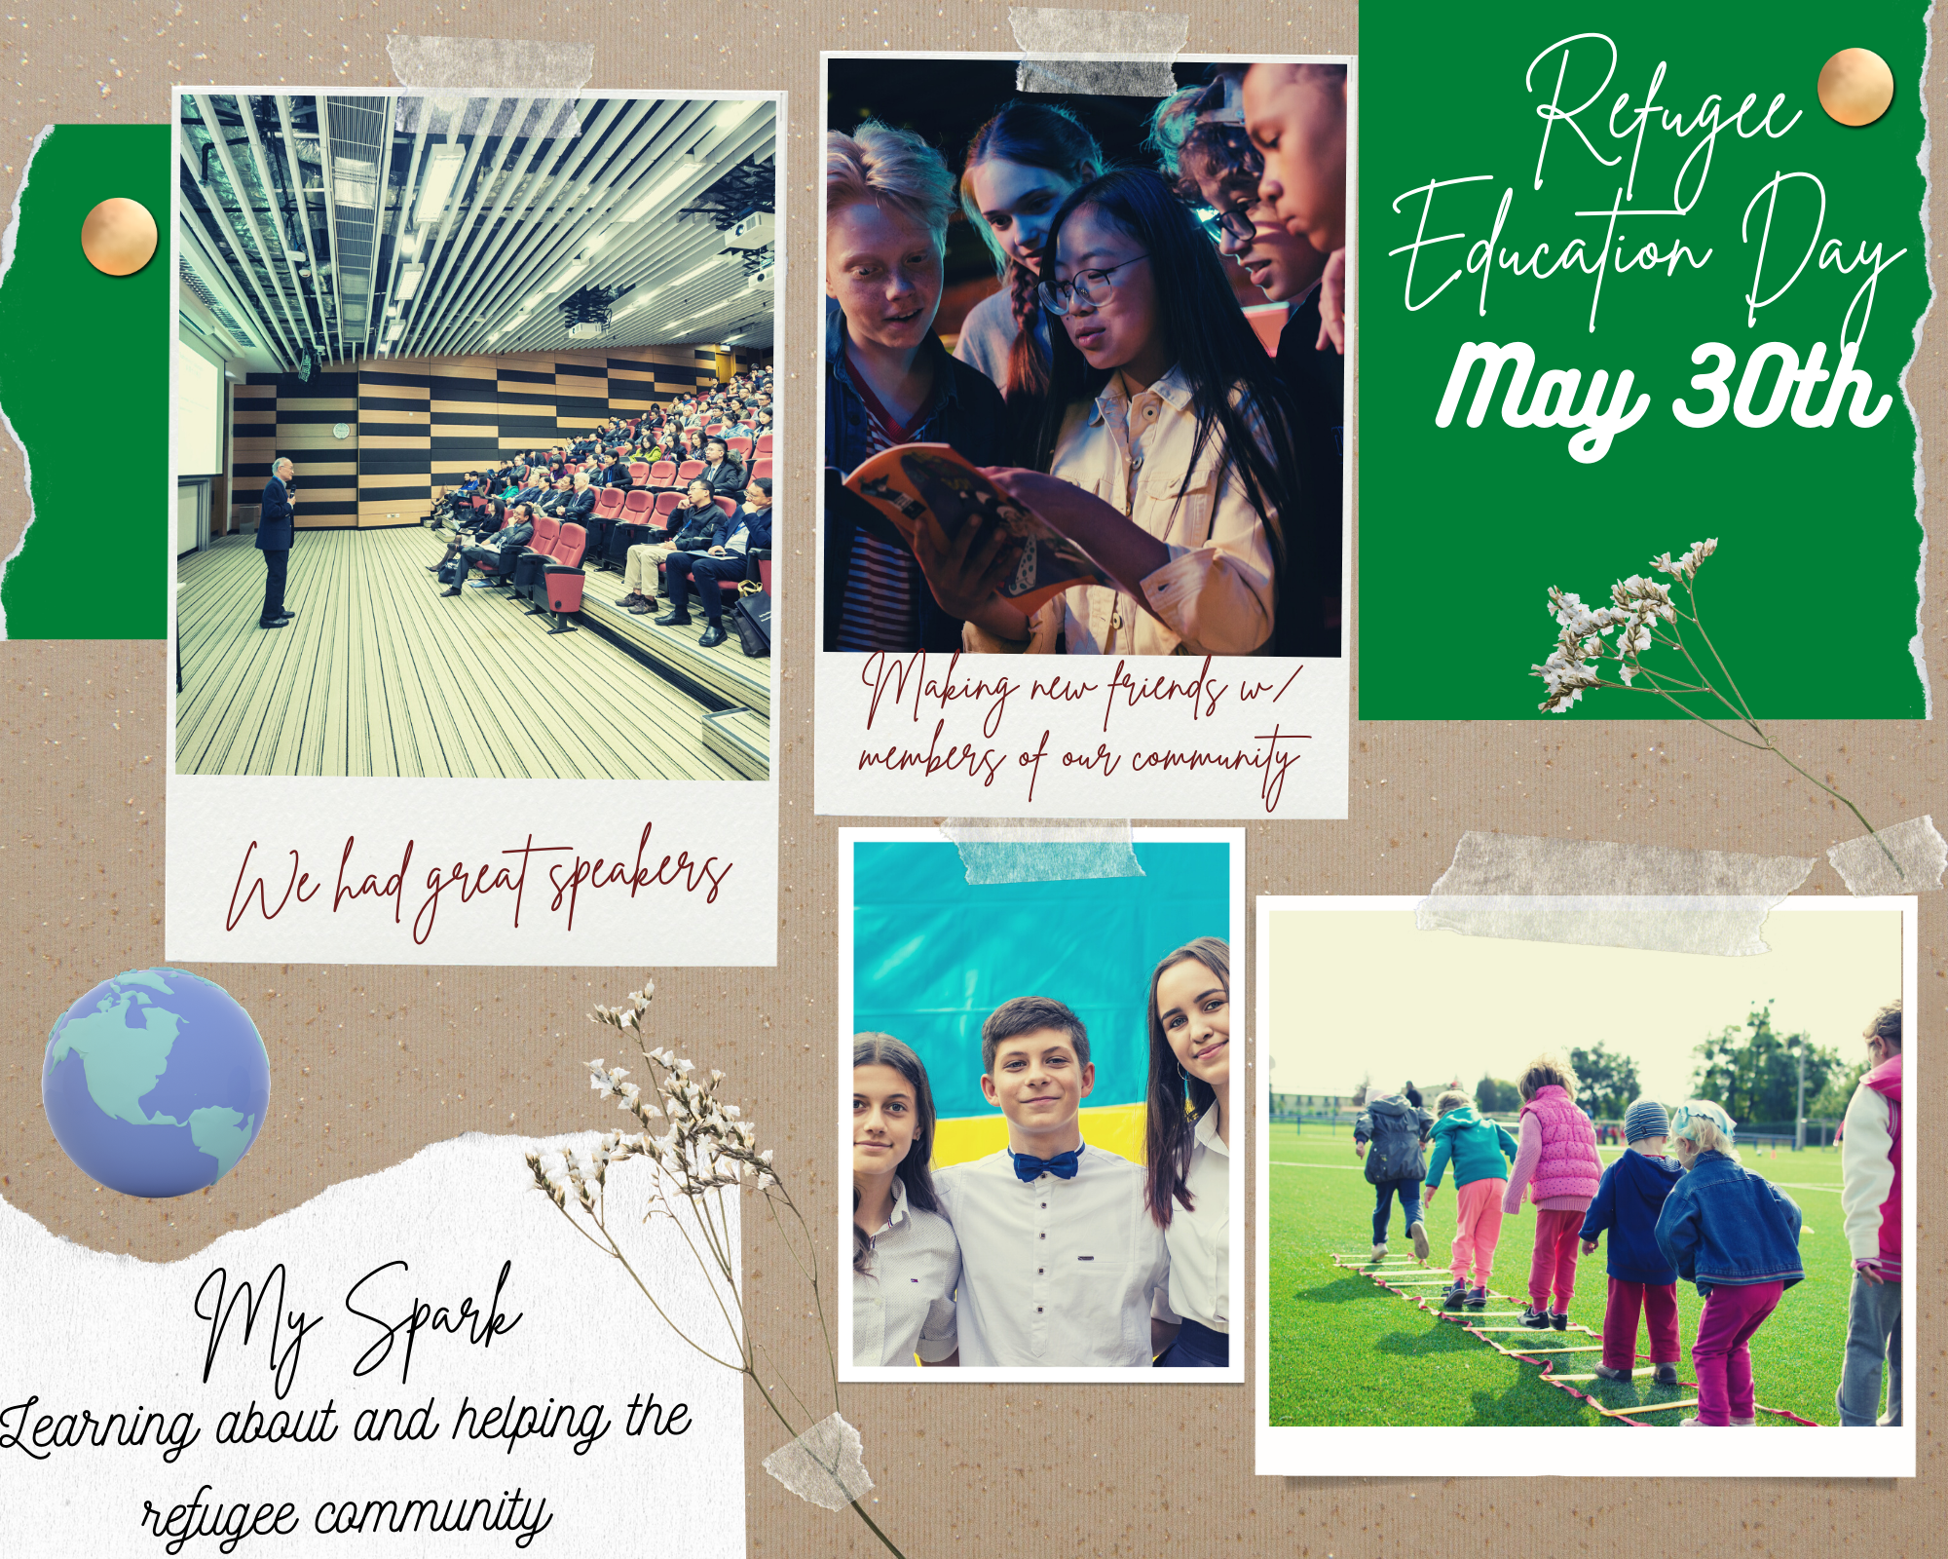


Part E. Reflection
The answers to each question below should be between 3-6 sentences.
1)If you are applying for a Silver, Gold, or Platinum Star: How was this Star different from your previous Star? How did you build on what you learned in the previous Star?
This project expanded on the refugee project I did last year. This star is different because I focused on what I learned about the refugee community, it's a community underserved through 4-H. Last year, I focused on volunteering with the IRC, meeting people in the refugee community, and connecting the IRC with the 4-H library of youth development resources. This year, I expanded the project by focusing more on awareness within the 4-H community and making my 4-H program more inclusive. The success of this project involved talking to refugees and experts in my community to understand language and cultural differences.
2) Discuss how you met (or did not meet) your Personal Development Goal. Discuss which strategies worked and which did not, and how you shifted gears.
I was able to improve my ability to network and speak to others about topics I am passionate about.

Through newsletters, google presentations and social media, I was able to communicate to local clubs about my project and the refugee community. This created excitement and got people to sign up for a welcome letter writing campaign. There was some challenge with this strategy, because I was intimidated to speak about a potentially political issue in my rural area. But with the help of my mentor I learned how to answer questions well and direct people back to the issues at hand. I actually found more support than I expected!

I reached out to my county 4-H Community Outreach staff and got their assistance in setting up a booth at IRC World Refugee Day and hosting an educational day at the county agriculture center. We were able to introduce 4-H to the refugee community and the 4-H community to the refugee issues.

I met with the International Rescue Committee office in my town to use their resources for this project and realized they need positive messages of welcome for new families. So our first action was to start a welcome letter writing campaign.

3) Discuss how you met (or did not meet) your Impact Goal. Look back at your Action Plan, discuss which strategies worked and which did not, and how you shifted gears.
My Impact Goal was to welcome local refugee youth into my county 4-H program, which has no refugees enrolled. I did not recruit as many new members as I had hoped. But I did succeed in introducing them to the 4-H program and getting them excited to eventually enroll or at least participate in some of the activities.

Although I initially was very excited to meet and welcome new refugee families, I realized that welcoming these families when they first arrive in our town from the airport was not possible because they usually arrived very late at night on weekdays at a location about 30 minutes away from my 4-H club. It was just not feasible for our youth club to meet at this time and place, so we focused on our other strategies.

We initiated a coat and food drive to welcome families and got many 4-H members to participate. This was very accessible to our 4-H program because it was an understandable and easy task, and it was a good action task for people to engage with after we told them about our refugee project.

We organized a fun festival for the refugee community to learn more about 4-H. Members ran their fun activity booths and presented ways that the refugees could participate and also what resources are available to help them in their new life. We also provided activities for parents to learn about other community organizations and we provided snacks. I wish we had brought more healthy snacks!

We set up a booth at World Refugee Day to tell the refugee community about 4-H. This was one of the first strategies we completed! It was intimidating because it was our first major outreach event, but it actually went well. We had speakers from the IRC, activities, Q&A sessions, and we received feedback that people have a better understanding about refugees and obstacles they face. If we were to hold this event again, I would want to have more audience interaction and small group discussions to foster more community.

4) What did you learn about yourself from working towards your goals?
I learned that I can take on more than I realize and that when I network with the appropriate groups I learn where the real needs are and can make adjustments to accomplish my goals. I learned a lot from my Bronze Star and I really wanted to make a bigger impact with my Silver Star, but I wasn’t sure what exactly I could do to help. But I learned that working with a team and asking for help from my mentor and from the experts at the IRC can help me better accomplish my goals. I may not know everything, but that’s why I need to reach out and learn from others.
5) Explain why you chose the Service Learning Activity that you completed. How does it relate your Personal Development Goal with your Impact Goal?
Learning about the refugee community and making positive spaces like 4-H more accessible to refugee youth is my spark/passion. I first had to learn about the refugees’ situations then educate others so that we could develop ways to get them involved. This took a lot of networking and discovering resources which are personal goals of mine. Accomplishing my Personal Development Goal was an essential part of working towards my Impact Goal.
6) What was the result of your project? What impact did it have on your community? Did it have the impact that you expected? If not, what impact were you expecting?
We completed our Refugee day event and had 74 refugee youth whose ages range from 7-14 show up. We got them interested in 4-H and one family I spoke to said they were going to join my club next year! This impacted my community because it showed these refugee families that they are welcome in our community. One thing that I did not expect was how much our 4-H members would learn from the refugee community. I thought our communities were going to be so different but I learned we have so much in common. All the kids loved the games we played and everyone was so happy to meet new friends.
7) What would you do differently on your next Service Learning Activity? What new Impact or Personal Development goals do you want to focus on in the future?
On my next Service Learning Activity I want to start the planning process a little earlier. It was really hard to do everything we wanted within 4 months. I also want to do my next project on a bigger scale at the regional or state level. I want to focus on an Impact Goal of creating statewide programming for refugee youth within 4-H, and potentially using existing community organizations like the IRC to investigate how alternative modes of 4-H outreach, like SPIN clubs, might be more accessible to refugee youth than community clubs.
Mentor Comments/Reflections:
The space below is for the Mentor only.
Please give the member feedback on their work in this Impact Star. What did they do well? What could they do differently on their next Impact Star?
You all worked so hard on this Service Learning Activity and it shows! I do agree that one thing to improve upon is to start earlier in the year. As for what you did well, everyone worked so well as a group! You all did a great job splitting up the workload evenly amongst everyone, a great example of teamwork. On your next star work on expanding to a larger audience it would be great to see all of you work on this activity at the regional or state level. Maybe next year you can create a manual for working with refugees that others can use and learn from. (alternative suggestion) Maybe next year you can involve some of your new refugee friends or other refugee teens in the community in the leadership of your project and get their insight and ownership in the program.
Member Response:
How do you respond to your mentor’s comments? Did they mention something you hadn’t thought of before? How might you use their comments in a future Impact Star?
I definitely need to put more thought into my timeline in the future. I think starting next year’s activity in the early fall might be alot better than starting in January. Creating a manual is a great idea! I think that is something I will be focusing on in my activity next year.

I wrote this report and did the work described here. I have completed the requirements for this achievement rank: Silver

Member Signature: | Jane Doe | Date: | June 5, 2021
Adult 4-H Mentor Signature: | Amelia Jones | Date: | June 10, 2021
Club/Unit Leader Signature: | Thomas Smith | Date: | June 25, 2021

