Photo Resources for Master Gardeners

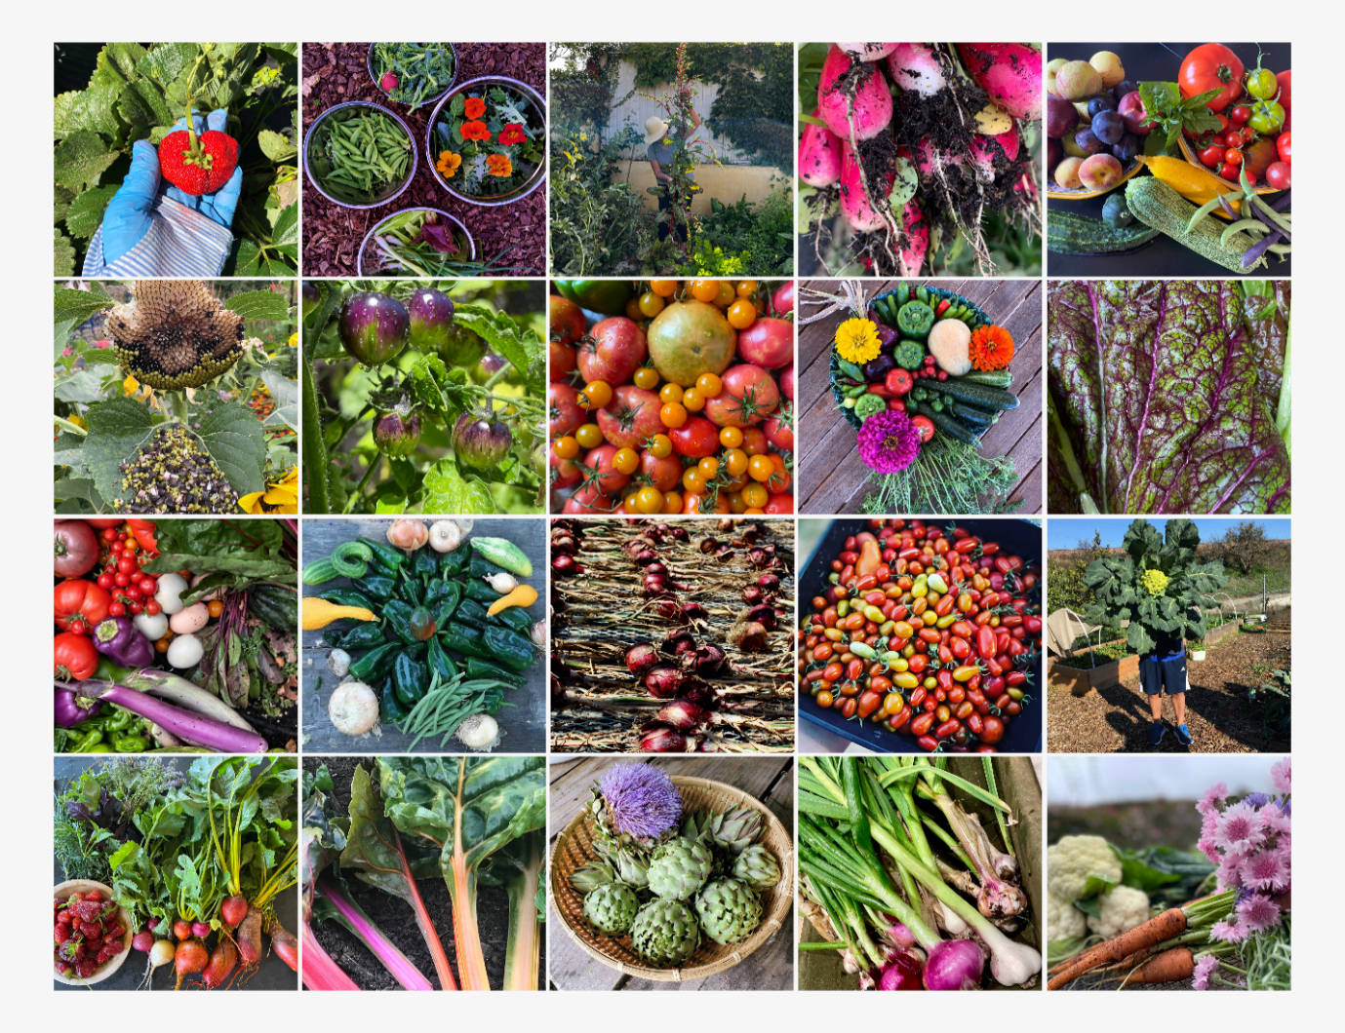

Beautiful, relevant photos enhance and complement your educational message. The following approved resources are available to use in your materials. Always give credit to the photographer!
- Your own photos are encouraged.
- PCMG VMS Photo Albums (PCMG member photos)
- See Links to NEW MGPC Photo Albums on VMS (PCMG member photos).
- UCANR Repository: https://ucanr.edu/repository/
- UC IPM: https://ipm.ucanr.edu/index.html
- UC Arboretum at UC Davis: https://arboretum.ucdavis.edu/plant-database
- Calscape for California native plants: https://calscape.org/
- The California Garden Web: https://cagardenweb.ucanr.edu/
- Creative Commons image website: https://search.creativecommons.org/
- CalPhotos: https://calphotos.berkeley.edu/
Always check the terms of use!

