Fall ‘23 Pomegranate and Citrus HLB Extension Meeting
When: October 31st, 2023
Where: University of California, Davis campus, PES 3001
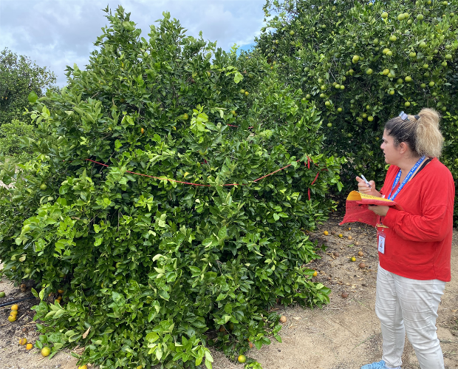
You are invited to attend the Pomegranate and HLB Tolerant Citrus Extension Meeting that will take place at UC Davis on October 31st, 2023 at 8 AM Pacific Standard Time.
Pomegranate and Citrus research findings will be disseminated
Schedule: 8 AM until 12:15 PM
8 AM: Coffee
Introductions and Welcome
Dr. John Chater: HLB tolerant citrus accessions from UF/IFAS
Dr. Themis Michailides: Black Heart research update
Dr. Zhanao Deng: Fruit rot research
-Break-
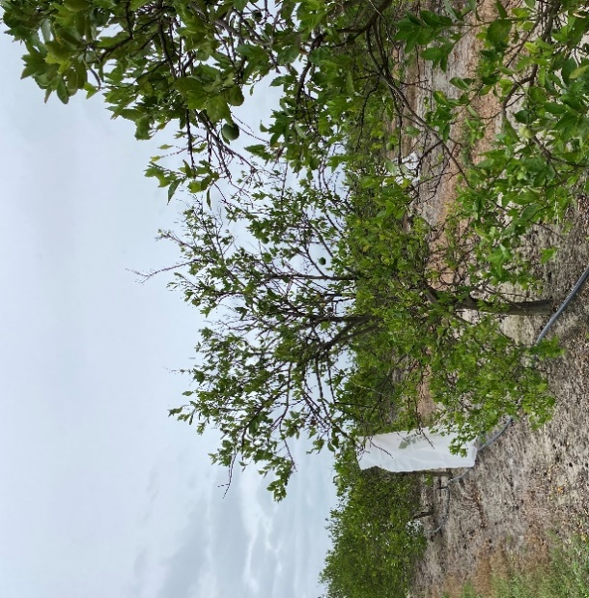
Dr. Giuseppe Lana: Update on ‘Wonderful’ genome assembly
Dr. Muhammad Shahid: Citrus in cold climates
Dr. Ali Sarkhosh: Growing pomegranate in Florida
Dr. Jonathan Kaplan: Pomegranate economics
12:15: Lunch: on your own
After lunch, there will be a visit to the pomegranate germplasm
block at the USDA-ARS National Clonal Germplasm Repository
in Winters, CA. Space will be limited, so register soon!
Register here by 10/27/23:
https://registration.ucdavis.edu/Item/Details/1069
Questions? Contact:
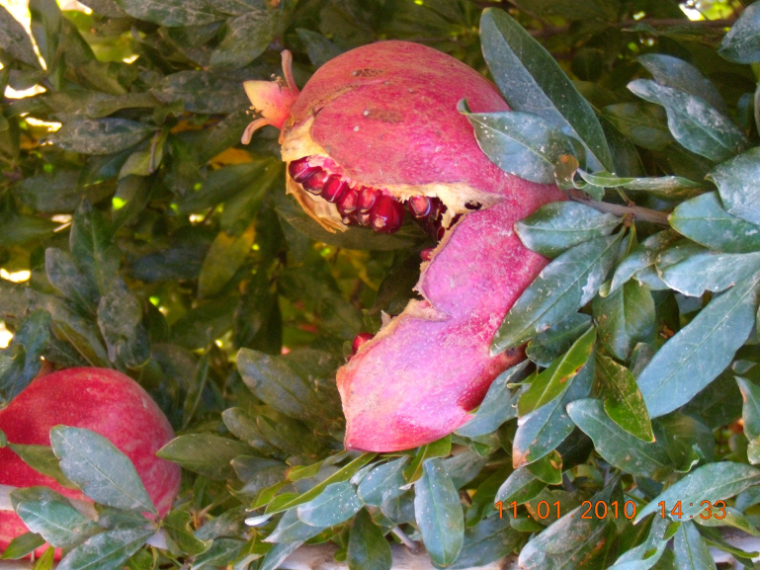
Dr. Themis Michailides; email: tjmichailides@ucanr.edu
Dr. John Chater; email: jchater@ufl.edu
