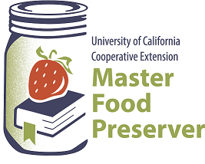
UCCE Master Food Preservers of El Dorado County
311 Fair Lane, Placerville CA 95667
Helpline (530) 621-5506 • Email: edmfp@ucanr.edu • Visit us on Facebook!

“Preserve today, Relish tomorrow”

CHRISTMAS IN JULY

Saturday, July 15, 2023
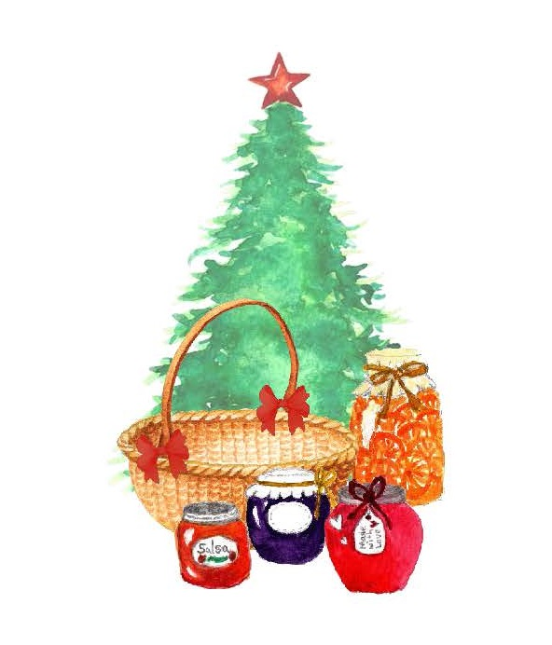
9:30 a.m. – 11:30 a.m.

Seasonal preserving with the holidays in mind!

In this fun class, we will offer creative ideas for each month leading up to the December holidays, as well as a special presentation on how to make attractive gift baskets.

UC ANR is an equal opportunity provider and employer.
Should you need assistance or require special accommodations for any of our educational programs, please contact us at 530-621-5502.
Food Safety / Canning Basics
The first step when preparing food for preservation is food safety. Cleanliness is essential in preventing food-borne illness. Proper cleaning and sanitizing, avoiding cross-contamination, and washing produce are all part of the canning process. Remember:

Clean Work Area Wash Hands No Cross-Contamination Prepare Food Properly

To ensure safety when canning, it’s critical to follow a current, research-based recipe and to use the correct canning method and processing steps.

For further details, please review our publication, Core Canning Techniques (free to download from our website here: https://ucanr.edu/sites/mfp_of_cs/files/380380.pdf), which covers basic food safety information and the essentials of home canning, including the types of canners and which types of foods they are appropriate for; preparing jars and lids; step-by-step processing instructions; and helpful tips for canning success.

Cleaning Gift Baskets
FOR NEW BASKETS: If you purchased a new wicker basket and just want to make sure it is clean before using, follow the instructions below. For cleaning, you’ll need microfiber cloths, mild liquid dish detergent, and a bucket or large bowl.

- Wipe down the basket with a dry microfiber cloth.
- Mix one to two drops of dishwashing liquid in a large container of warm water.
- Lightly dampen a clean microfiber cloth in your soapy water. Take care not to over saturate the cloth, as too much water can make cleaning ineffective and could damage the wicker.
- Clean the wicker basket with the damp microfiber cloth, taking care to get into the weave and tackle the base of the basket.
- Wipe the basket down with a fresh microfiber cloth or let it air dry.
- Make sure the basket is completely dry before placing any items back inside.

For information on how to clean microfiber cloths, see: https://www.merrymaids.com/cleaning-tips/diy/how-to-clean-microfiber-cloth/

FOR USED/DIRTY BASKETS: If you have a dirty basket, one purchased from a location such as a hospice or thrift store, or are simply unsure how the wicker basket was used in the past or how it was stored, it is best to do a thorough cleaning before using it.

Since it's a natural material that's often only lightly stained or sealed, it's fairly common to have mold growth on wicker baskets. One of the most effective ways to deal with it is to spray or scrub down the fibers with a solution of bleach.
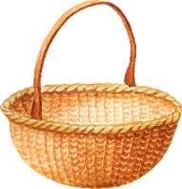

Cleaning Gift Baskets (cont.)
To clean a dirty basket, follow these steps:
- Vacuum or wipe away loose dirt and mold.
- Prepare a 1:1 solution of cool water and bleach.
- Put on rubber gloves.
- Use a soft-bristle brush, sponge, or microfiber cloth to scrub away mold.
- Use a clean toothbrush to get into tight spaces, such as in between the weave.
- Rinse with a hose or wet cloth.
- Let the basket dry in the sun.

Gift Basket Ideas
Baskets with a “theme” are a great idea. Choose items that match your chosen theme. Don’t forget to use color also.

THEMES. Here are some fun themes to get you started.
- For the Mustard Gourmet: A copy of a book about Mustards, yellow mustard seeds, brown mustard seeds, a selection of vinegars, a collection of four-ounce glass jars and jar labels.
- Chillin’ with Chili: Use a stew pot or pottery casserole dish as a basket and fill with assorted dried beans, kidney, black, white, navy, pinto, etc., dried chili peppers, chili powder, cayenne pepper, cumin, cilantro, chili recipes, cornbread mix, pepper jelly and pot holders.
- The Heat is On: Use a chili pot as a basket and fill it with spices, hot sauces, spicy chili vinegar and Mexican style oil.
- Lotsa Pasta: Use a large pasta bowl or colander as a basket and fill it with dried pasta, tongs, sun-dried tomatoes, extra-virgin olive oil, spices, oregano, basil and garlic powder. A collection of pasta recipes, hand-printed on recipe cards, a pasta cookbook, pasta sauce and breadsticks.
- Tea, Coffee, or Cappuccino Time: Use a teapot as a basket and fill it with assorted teas, flavored sugar, spiced honey and tea cookies. Or fill a tin with a coffee or cappuccino mix or both, add cups and scone mix.
- Kooky for Cookies: Use a cookie tin as a basket and fill it with your favorite cookie recipes or a cookbook, cookie cutters, chocolate chips, assorted nuts, decorator icing set and assorted sprinkles.
- Ice Cream Parlor: Fill a basket with your favorite sauces and some cookies. Include sundae glasses, ice cream scoop, toppings, nuts, sprinkles and a bottle of cherries.
- Death by Chocolate: Fill a basket with chocolate cookies, chocolate candies, chocolate sauces and syrups, hot chocolate mix, chocolate flavored coffee beans.

SUPPLIES. Once you’ve decided on your theme, you’ll need to gather some basic supplies for putting your gift basket creations together.
- Baskets: Choose the size of your basket carefully. The larger the basket the more it takes to fill it up and the more expensive the cost of the total basket. It is better to have a smaller basket and pack it full. Triangle shaped baskets give the illusion of being a larger gift.

Gift Basket Ideas (cont.)
- Other Containers: Tins, gift boxes, tin pails, gift bags, airtight bottles, glass canning jars…be creative!
- Gift Tags and Labels: Tie-on and self-adhesive tags and labels, for showing recipients names and providing instructions on keeping times and how to serve or cook edible gifts.
- Ribbon, Strings, Yarns and Cords: Pick an assortment for securing or decoratively securing gift containers, including tying cellophane and making any style of bow. Ribbon types acetate, paper, Mylar, curling, satin, etc. Use Raffia in natural or colors.
- Stamps and Stamp Pads: Inexpensive way to add festive, personalized decorations to gift cards and wrapping paper. For an especially dazzling effect, seek out stamp pads saturated with metallic gold or silver ink.
- Seals and Sealing Wax: A traditional way to seal gifts with a personal touch. Light the wick of the candlestick of wax and let the wax drip onto the knot or the seam of the package to be sealed. Then press the metal seal into the cooling wax to leave an impression.
- Paper Doilies: Inexpensive, lacey paper doilies attractively line gift containers and separate layers of cookies or candies.
- Foam/Popcorn: Use these items to fill the very bottom of your basket. It will help you cut costs so not as much tissue paper or filler will be needed.
- Tissue Paper: This is used above the foam or popcorn to give a cushion to your items. By using the tissue you will be able to place your items at an angle or stabilize heavier items. Also used for lining gift boxes and baskets and for wrapping bottles, jars and canisters.
- Cellophane Roll: Cellophane comes in clear, colored, and printed, and there are many different lengths and widths.
- Tape: Use transparent tape only.

GIFT BASKET ADDITIONS. After you have assembled your basket you can enhance the presentation by tucking in:
Candy canes
Foil wrapped chocolate
Small pine cones
Cinnamon sticks tied together with ribbon
Wrapped taffy or other candies
Christmas greenery such as the tips of spruce or pine branches
Christmas ornaments
Small scented candles
Use your imagination

SPECIAL INSTRUCTIONS. Before you present your gift, did you remember to include storage directions? They are included at the end of most recipes, and it’s a good idea to include them with your gifts. Storage directions are an absolute must for perishable items and those that must be held in the refrigerator.

DIY Beer Bread Mix
Yield: 1 loaf

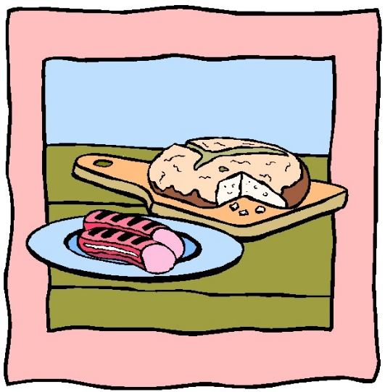
3 cups sifted self-rising flour
1 tbsp sugar
½ tsp salt
1 tsp Italian seasoning (optional)
½ tsp garlic powder (optional)
12-oz can of beer

- Combine the flour, sugar, salt, and seasonings (if using) and whisk well. Be sure you have sifted the flour to prevent an overly hard, crunchy crust. Place in a large mason jar.

- To Bake the Bread: Preheat oven to 375°F. Prepare a bread pan by greasing or coating with cooking spray. Combine bread mix with 1 can of beer. Stir until combined. Pour into prepared pan and bake for 55 minutes. Let cool in pan for 10 minutes, then remove.

Source: https://tastythin.com/diy-beer-bread-mix

Italian Seasoning

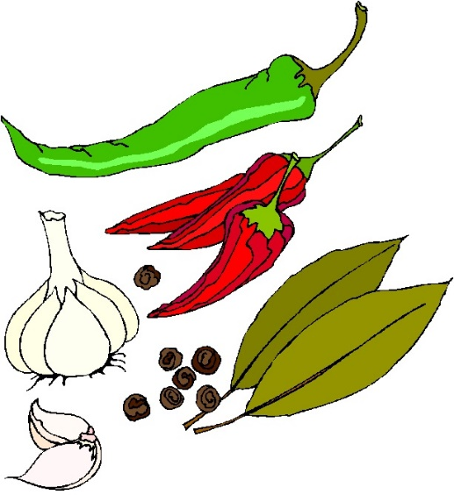
1 tbsp oregano
1 tbsp parsley
1 tbsp thyme
2 tsp basil
2 tsp sage
1 tsp garlic powder
1 tsp sea salt
1 tsp ground pepper

Combine all ingredients and mix. Store in an airtight container and mix again before using.

Source: realsimplegood.com

Singapore Chili Sauce
Yield: about 6 half-pint jars

4 cups (from about 1 lb.) chopped fresh hot red peppers (Dutch or red Thai)
2 ½ cups white vinegar, 5% acidity
2 ½ cups sugar
1 ½ cups sultana raisins, rinsed
¼ cup chopped garlic
1 tbsp grated fresh gingerroot
2 tsp salt

- Using gloves, prepare red peppers by discarding stems and chopping. (For a much milder sauce, remove seeds and white membranes before chopping.)

- In a large stainless steel saucepan, combine vinegar and sugar. Bring to a boil over high heat, stirring occasionally. Reduce heat and simmer 3 minutes.

- Add the red peppers, sultana raisins, garlic, gingerroot and salt. Bring to a boil, then reduce heat and simmer 5 minutes. Remove from heat.

- Ladle hot mixture into a hot jar, leaving ½-inch headspace. Remove air bubbles and adjust headspace, if needed, by adding more of the mixture. Wipe jar rims clean with a dampened clean paper towel or cloth. Place lid and rings on jar. Tighten ring only finger-tip tight, or follow the directions of the lid manufacturer. Repeat for remaining jars.

- Process half-pint jars in a boiling water or atmospheric steam canner as follows:
10 minutes at 0-1,000 feet elevation
15 minutes at 1,001-3,000 feet elevation
20 minutes at 3,001-6,000 feet elevation
25 minutes at 6,001-8,000 feet elevation

- For boiling water canning, turn off heat, remove canner lid and wait 5 minutes. For atmospheric steam canning, turn off heat, leave canner lid on and wait 2-3 minutes. Remove jars to a rack or towel and let cool, undisturbed, for 12-24 hours and then check seals. Store unsealed jars in the refrigerator or reprocess. Clean and label sealed jars and store in a cool, dry dark location.

Source: Adapted from Bernardin.ca

Caramelized Pineapple Habanero Salsa
Yield: about 4 pint jars

2 – 2 lb. ripe pineapples
TIP
Use rubber gloves when seeding or chopping peppers. Don’t touch your face or eyes to avoid burning.
Vegetable cooking spray
6 tbsp sugar, divided
2 cups chopped red onion
½ cup bottled lime juice
1 habanero pepper, seeded and minced
½ cup chopped fresh cilantro
1 ½ tsp salt

- Preheat oven to 400°F. Peel, quarter lengthwise, and core the pineapples. Slice each quarter into 1” pieces. Place slices in a single layer on 2 baking sheets coated with cooking spray. Sprinkle with ¼ cup of the sugar.

- Bake for 15 minutes. Turn slices over and bake for 10 to 15 minutes more, or beginning to caramelize. Remove from oven and allow to cool. Coarsely chop the baked pineapple slices to measure 6 ½ cups.

- Combine the chopped pineapple, onion, lime juice, and habanero pepper in a large stainless steel or enameled saucepan. Bring to a boil over medium heat. Cook 5 minutes, stirring occasionally. Stir in the cilantro, salt, and remaining 2 tbsp sugar.

- Transfer half of the mixture to a food processor and process until chopped (do not purée). Return the chopped mixture from the food processor to the remaining mixture in the pan.

- Cook over medium heat for 5 minutes or until thoroughly heated, stirring occasionally.

- Ladle hot mixture into a hot jar, leaving ½-inch headspace. Remove air bubbles and adjust headspace, if needed, by adding more of the mixture. Wipe jar rims clean with a dampened clean paper towel or cloth. Place lid and rings on jar. Tighten ring only finger-tip tight, or follow the directions of the lid manufacturer. Repeat for remaining jars.

- Process pint jars in a boiling water or atmospheric steam canner as follows:
15 minutes at 0-1,000 feet elevation
20 minutes at 1,001-3,000 feet elevation
25 minutes at 3,001-6,000 feet elevation
30 minutes at 6,001-8,000 feet elevation

- For boiling water canning, turn off heat, remove canner lid and wait 5 minutes. For atmospheric steam canning, turn off heat, leave canner lid on and wait 2-3 minutes. Remove jars to a rack or towel and let cool, undisturbed, for 12-24 hours and then check seals. Store unsealed jars in the refrigerator or reprocess. Clean and label sealed jars and store in a cool, dry dark location.

Source: Adapted from Ballmasonjar.com
Lemon Sage Wine Mustard
Yield: about 5 4-ounce jars

1 bunch of fresh sage
¾ cup dry white wine
¾ cup yellow mustard seeds
grated zest and juice from 2 large lemons
½ cup liquid honey
¼ tsp salt
1 cup white wine vinegar

- Finely chop enough sage leaves to measure ⅓ cup, and set aside.

- Coarsely chop the remaining leaves and stems to measure ½ cup and place in a small non-reactive saucepan with the white wine. Bring to a boil over medium heat, stirring and pressing sage to release flavor. Remove from heat, cover tightly, and let steep 5 minutes.

- Transfer sage infusion to a sieve placed over a glass or non-reactive metal bowl and press leaves with the back of a spoon to extract all the liquid. Discard solids and return liquid to saucepan. Add mustard seeds. Cover and let stand at room temperature until the seeds have absorbed most of the moisture, about 2 hours.

- In blender or a food processor fitted with a metal blade, combine marinated mustard seeds (with liquid) and vinegar. Process until blended and most seeds are well chopped (you want to retain a slightly grainy texture). Transfer to a nonreactive pan.

- Add the lemon zest and juice, honey, salt, and reserved finely chopped sage leaves. Bring to a boil over high heat, stirring constantly. Reduce heat to low and boil gently, stirring frequently, until volume is reduced by a third, about 20 minutes.

- Ladle hot mixture into a hot jar, leaving ¼-inch headspace. Remove air bubbles and adjust headspace, if needed, by adding more of the mixture. Wipe jar rims clean with a dampened clean paper towel or cloth. Place lid and ring on jar. Tighten ring only finger-tip tight, or follow the directions of the lid manufacturer. Repeat for remaining jars.

- Process 4-ounce jars in a boiling water or atmospheric steam canner as follows:
10 minutes at 0-1,000 feet elevation
15 minutes at 1,001-3,000 feet elevation
20 minutes at 3,001-6,000 feet elevation
25 minutes at 6,001-8,000 feet elevation

- For boiling water canning, turn off heat, remove canner lid and wait 5 minutes. For atmospheric steam canning, turn off heat, leave canner lid on and wait 2-3 minutes. Remove jars to a rack or towel and let cool, undisturbed, for 12-24 hours and then check seals. Store unsealed jars in the refrigerator or reprocess. Clean and label sealed jars and store in a cool, dry dark location.

Source: Adapted from Ball Complete Book of Home Preservation (2016)
Bloody Mary Mix
Yield: about 5 pint jars

2 quarts tomato juice (see next recipe)
TIP
This recipe can be frozen instead of canned.
½ cup finely minced celery hearts (light green leafy centers)
6 tbsp Worcestershire sauce
6 tbsp dill pickle juice
¼ cup prepared horseradish
2 tbsp hot sauce
2 tsp garlic powder
1 tsp black pepper
1 tsp celery seed
1 tsp smoked paprika
1 cup bottled lemon juice

- Combine all ingredients except lemon juice. Bring to a boil, reduce heat, and simmer for 5 minutes. Remove from heat and stir in lemon juice.

- Ladle hot mixture into a hot jar, leaving ½-inch headspace. Remove air bubbles and adjust headspace, if needed, by adding more of the mixture. Wipe jar rims clean with a dampened clean paper towel or cloth. Place lid and ring on jars. Tighten ring only finger-tip tight, or follow the directions of the lid manufacturer. Repeat for remaining jars.

- Process pint jars in a boiling water or atmospheric steam canner as follows:
40 minutes at 0-1,000 feet elevation
45 minutes at 1,001-3,000 feet elevation
50 minutes* at 3,001-6,000 feet elevation
55 minutes* at 6,001-8,000 feet elevation
*Note that processing times in steam canners are limited to 45 minutes or less.

- For boiling water canning, turn off heat, remove canner lid and wait 5 minutes. For atmospheric steam canning, turn off heat, leave canner lid on and wait 2-3 minutes. Remove jars to a rack or towel and let cool, undisturbed, for 12-24 hours and then check seals. Store unsealed jars in the refrigerator or reprocess. Clean and label sealed jars and store in a cool, dry dark location.

Source: Adapted from Ballmasonjars.com


Tomato Juice
Yield: about 4 quart jars
TIP
Tomatoes that are very ripe and bursting with juice can be used for this recipe. (However, never can overripe tomatoes.)

14 lbs. tomatoes, cored and quartered
1 large red beet, peeled and cut into ¼-inch cubes
1 tbsp salt or celery salt
2 tsp citric acid ~or~ ½ cup bottled lemon juice

- Core tomatoes and cut into quarters. Bring tomatoes, any accumulated juice, and diced beet to a boil in a large non-reactive stockpot, stirring often. Reduce heat and simmer, uncovered, 15 minutes or until vegetables are very tender, stirring often.

- Press tomato mixture, in batches, through a food mill into a large bowl; discard skins and seeds. Return tomato juice to stockpot. Cook over medium heat, stirring often, until a thermometer registers 190°F; remove from heat. Stir in salt and citric acid or lemon juice.

- Ladle hot mixture into a hot jar, leaving 1-inch headspace. Remove air bubbles and adjust headspace, if needed, by adding more of the mixture. Wipe jar rims clean with a dampened clean paper towel or cloth. Place lid and ring on jars. Tighten rings only finger-tip tight, or follow the directions of the lid manufacturer. Repeat for remaining jars.

- Process quart jars in a boiling water or atmospheric steam canner as follows:
40 minutes at 0-1,000 feet elevation
45 minutes at 1,001-3,000 feet elevation
50 minutes* at 3,001-6,000 feet elevation
55 minutes* at 6,001-8,000 feet elevation
*Note that processing times in steam canners are limited to 45 minutes or less.

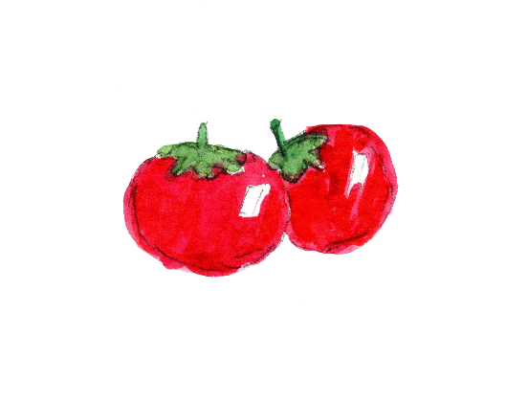
- For boiling water canning, turn off heat, remove canner lid and wait 5 minutes. For atmospheric steam canning, turn off heat, leave canner lid on and wait 2-3 minutes. Remove jars to a rack or towel and let cool, undisturbed, for 12-24 hours and then check seals. Store unsealed jars in the refrigerator or reprocess. Clean and label sealed jars and store in a cool, dry dark location.

Source: Adapted from Ballmasonjars.com

Basil Garlic Tomato Sauce
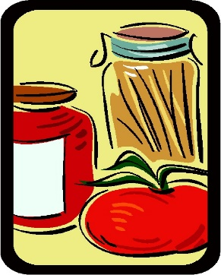
Yield: about 7 pint or 3 quart jars

20 lbs. tomatoes (from about 60 medium tomatoes)
1 cup chopped onion (about 1 large)
8 cloves garlic, minced
1 tbsp olive oil
¼ cup finely minced, fresh basil
citric acid ~or~ bottled lemon juice for each jar

- Wash tomatoes and drain. Remove core and blossom ends. Cut into quarters. Set aside.

- Sauté onion and garlic in olive oil until transparent. Add tomatoes. Bring to a boil. Reduce heat and simmer 20 minutes, stirring occasionally. Purée tomato mixture in a food processor or blender, working in batches. Strain purée to remove seeds and peel.

- Combine tomato purée and basil in large saucepot. Bring to a boil. Reduce heat and simmer until volume is reduced by half, stirring to prevent sticking.

- For each hot pint jar: Add ¼ tsp citric acid or 1 tbsp bottled lemon juice to jar.
For each hot quart jar: Add ½ tsp citric acid or 2 tbsp bottled lemon juice to jar.

- Ladle hot mixture into a hot jar, leaving ½-inch headspace. Remove air bubbles and adjust headspace, if needed, by adding more of the mixture. Wipe jar rims clean with a dampened clean paper towel or cloth. Place lid and ring on jar. Tighten ring only finger-tip tight, or follow the directions of the lid manufacturer. Repeat for remaining jars.

- Process pint jars in a boiling water or atmospheric steam canner as follows:
35 minutes at 0-1,000 feet elevation
40 minutes at 1,001-3,000 feet elevation
45 minutes at 3,001-6,000 feet elevation
50 minutes* above 6,000 feet elevation
Process quart jars in a boiling water or atmospheric steam canner as follows:
40 minutes at 0-1,000 feet elevation
45 minutes at 1,001-3,000 feet elevation
50 minutes* at 3,001-6,000 feet elevation
55 minutes* at 6,001-8,000 feet elevation
*Note that processing times in steam canners are limited to 45 minutes or less.

- For boiling water canning, turn off heat, remove canner lid and wait 5 minutes. For atmospheric steam canning, turn off heat, leave canner lid on and wait 2-3 minutes. Remove jars to a rack or towel and let cool, undisturbed, for 12-24 hours and then check seals. Store unsealed jars in the refrigerator or reprocess. Clean and label sealed jars and store in a cool, dry dark location.

Source: Adapted from Ballmasonjars.com
Applesauce
Yield: about 8 pint jars

12 lbs. (about 36 medium) apples, peeled, cored, quartered, and treated for browning*
water
3 cups sugar (optional)
4 tbsp bottled lemon juice

*Treat apples to prevent browning by placing the prepared quarters in a solution of 1 tsp of pure ascorbic acid powder in 1 gallon of water, or ¼ cup of lemon juice in 4 cups of water. If using a commercial product, follow the manufacturer’s instructions.

- Combine drained apples with just enough fresh water to prevent sticking in a large non-reactive saucepot. Bring to a boil over medium-high heat. Reduce heat and boil gently, stirring occasionally, for 5 to 20 minutes, until the apples are tender (time will depend on the variety of apply and their maturity). Remove from heat and let cool slightly, about 5 minutes.

- Transfer apples in batches to a food mill or a food processor fitted with a metal blade and purée until smooth.

- Return apple purée to the saucepot. Add sugar, if using, and lemon juice. Bring to a boil over medium-high heat, stirring frequently to prevent sticking. Maintain a gentle boil over low heat while filling jar.

- Ladle hot mixture into a hot jar, leaving ½-inch headspace. Remove air bubbles and adjust headspace, if needed, by adding more of the mixture. Wipe jar rims clean with a dampened clean paper towel or cloth. Place lid and rings on jar. Tighten ring only finger-tip tight, or follow the directions of the lid manufacturer. Repeat for remaining jars.

- Process pint jars in a boiling water or atmospheric steam canner as follows:
20 minutes at 0-1,000 feet elevation
25 minutes at 1,001-3,000 feet elevation
30 minutes at 3,001-6,000 feet elevation
35 minutes at 6,001-8,000 feet elevation

- For boiling water canning, turn off heat, remove canner lid and wait 5 minutes. For atmospheric steam canning, turn off heat, leave canner lid on and wait 2-3 minutes. Remove jars to a rack or towel and let cool, undisturbed, for 12-24 hours and then check seals. Store unsealed jars in the refrigerator or reprocess. Clean and label sealed jars and store in a cool, dry dark location.

VARIATIONS: For spiced applesauce, in Step 3 add 4 tsp of ground spices, such as cinnamon, nutmeg or allspice. For chunky applesauce, in Step 3 coarsely crush half of the cooked apples and purée the remainder. Combine before adding the sugar.

Source: Adapted from Ball Complete Book of Home Preserving (2012)

Orange Marmalade
Yield: about 7 half-pint jars

2 cups thinly sliced orange peel (from about 10 medium oranges)
1 quart chopped orange pulp (from about 8 to 10 medium oranges)
1 cup thinly sliced lemon (from about 2 medium lemons)
½ quart water
sugar

- Wash oranges and lemons under cold running water; drain. Cut oranges in half crosswise and remove seeds. Remove pulp from each orange half, reserving peel. Chop orange pulp; measure 1 quart of chopped orange pulp. Remove white pith from orange peel. Thinly slice orange peel; measure 2 cups sliced peel. Thinly slice lemons crosswise; remove seeds and discard ends. Measure 1 cup sliced lemons.

- Combine all ingredients, except sugar, in a large saucepan. Boil gently for 5 minutes; remove from heat. Cover and let stand in refrigerator for 12 to 18 hours.

- Cook rapidly until peel is tender. Measure the fruit and liquid mixture. Add 1 cup sugar for each cup of fruit mixture, stirring until sugar dissolves. Bring mixture to a boil over medium-high heat, stirring constantly. Cook rapidly over high-medium heat almost to the gelling point (220°F), stirring constantly. Remove from heat. Skim off foam if necessary.

- Ladle hot mixture into a hot jar, leaving ½-inch headspace. Remove air bubbles and adjust headspace, if needed, by adding more of the mixture. Wipe jar rims clean with a dampened clean paper towel or cloth. Place lid and rings on jar. Tighten ring only finger-tip tight, or follow the directions of the lid manufacturer. Repeat for remaining jars.

- Process half-pint jars in a boiling water or atmospheric steam canner as follows:
10 minutes at 0-1,000 feet elevation
15 minutes at 1,001-3,000 feet elevation
20 minutes at 3,001-6,000 feet elevation
25 minutes at 6,001-8,000 feet elevation

- For boiling water canning, turn off heat, remove canner lid and wait 5 minutes. For atmospheric steam canning, turn off heat, leave canner lid on and wait 2-3 minutes. Remove jars to a rack or towel and let cool, undisturbed, for 12-24 hours and then check seals. Store unsealed jars in the refrigerator or reprocess. Clean and label sealed jars and store in a cool, dry dark location.
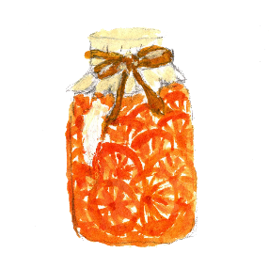
Source: Adapted from Ball Blue Book (2020)

Low Sugar / No Sugar Fruit Jams

Jams with lower amounts of sugar – or no sugar at all – are a great way to reduce sugar intake. These jams are less firm than full-sugar jams, but burst with fresh fruit flavor. The following charts use Ball Low or No-Sugar Needed Pectin, which is sold in flexible multi-batch containers, or Bernardin Low Sugar Pectin or Bernardin No Sugar Pectin. If using another manufacturer’s pectin, follow their instructions.

For every 4 half-pint (8 oz/250 ml) jars, you will need: | Low Sugar | No Sugar
Prepared fruit (see table below) | 2 2/3 cups (650 mL) | 4 cups (1 L)
Unsweetened fruit juice or thawed fruit juice concentrate | 2/3 cup (150 mL) | 2/3 cup (150 mL)
Bottled lemon juice (use only with blueberries, peaches or sweet cherries) | 2 tbsp (30 mL) | 2 tbsp (30 mL)
Ball Low or No-Sugar Needed Pectin or Bernardin No-Sugar Needed Pectin | 3 tbsp (45 mL) or 1 pkg (49 g) | 3 tbsp (45 mL) or 1 pkg (49 g)
Butter or margarine* (optional) | ¼ tsp (1 mL) | ¼ tsp (1 mL)
Granulated sugar, sugar substitute or liquid honey | Up to 1 cup (250 mL) | None
Quick tip: Adding up to ¼ tsp. butter or margarine will reduce foaming.

TO PREPARE FRUIT:
Apples | Peel, core and chop
Apricots | Pit, peel and finely chop
Blackberries | Crush, one layer at a time, using a potato masher
Blueberries | Crush, one layer at a time, using a potato masher
Boysenberries | Crush, one layer at a time, using a potato masher
Cherries (Sweet) | Remove stems and pits and finely chop
Cherries (Tart) | Remove stems and pits and finely chop
Peaches | Peel, pit and finely chop
Pears | Peel, pit and finely chop
Plums | Pit and finely chop
Raspberries | Crush, one layer at a time, using a potato masher
Strawberries | Hull and crush, one layer at a time, using a potato masher


Continued on next page.

Low Sugar / No Sugar Fruit Jams (cont.)

Method
Step | Description
1 | Prepare canner, jars and lids.
2 | Combine prepared fruit with fruit juice and lemon juice, if using, in a large saucepan. Gradually stir in pectin. Add butter, if using. Bring mixture to a full rolling boil that cannot be stirred down, stirring constantly.
3 | Add sugar, if using. Return mixture to a full rolling boil. Boil hard for 1 minute, stirring constantly. Remove from heat. Skim foam if necessary.
4 | Ladle hot jam into hot jars, leaving ¼ inch (.5 cm) headspace. Remove air bubbles and adjust headspace, if necessary, by adding hot jam. Wipe rim. Center lid on jar. Screw band down until resistance is met, then increase to fingertip-tight.
5 | Place jars in canner, ensuring they are completely covered with water. Bring to a boil and process for 10 minutes. Remove canner lid. Wait 5 minutes, then remove jars, cool and store

Source: Adapted from Ball Complete Book of Home Canning (2020)

Citrus Lemon and Lime Salt
Yield: about 1 cup

zest from 1 lemon
zest from 1 lime
1 cup coarse sea salt or Maldon salt (Maldon is a flakier salt)

- Use your hands to blend the salt and lemon and lime zests in a mixing bowl. (The oils in your hands help mix things up.)

- Spread the mixture over a dehydrator sheet and dehydrate at 125°F for about 6-8 hours, or until the zest is completely dried through. Alternatively, spread the mixture over a baking sheet and dry in the oven at 125°F for about 6-8 hours, or until the zest is completely dried through. If your oven doesn’t go to that low of a temperature, crack open the oven door a bit to let in some air flow.

- Grind down the larger zest into the salt with a mortar and pestle (a spice grinder works well also, but try not to over-process). Note: if using DRIED citrus zest, simply grind down the zest into the salt with a mortar and pestle or a spice grinder; just don’t over-process.
Source: https://www.chilipeppermadness.com/recipes/citrus-lemon-lime-salt/

Always follow research-based recipes from reliable resources that follow the recommendations of the National Center for Home Food Processing.

For more information on food safety and preserving, see our series of Educational Posters at:

https://ucanr.edu/sites/mfp_of_cs/Food_Safety/

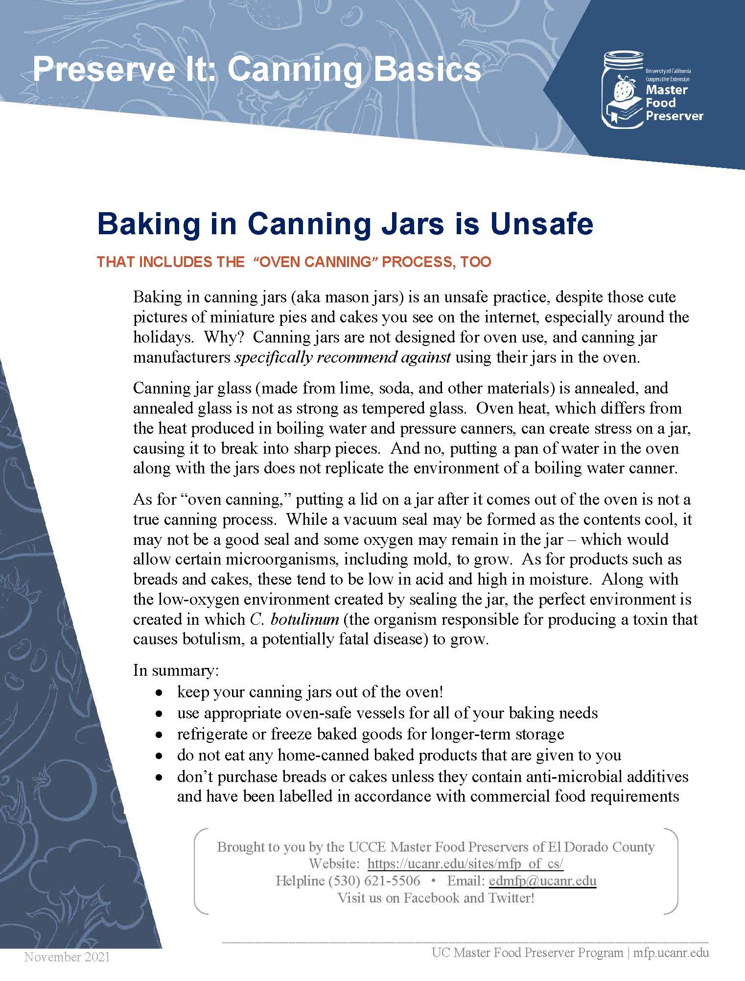

Other Resources:
UC Master Food Preservers of Central Sierra https://ucanr.edu/sites/mfp_of_cs/
National Center for Home Food Processing https://nchfp.uga.edu/
USDA Complete Guide to Home Canning https://nchfp.uga.edu/publications/publications_usda.html#gsc.tab=0

The information in this handout is provided as a courtesy to the reader. No endorsements of commercial products or services are made or implied, nor is criticism implied of similar products or information from organizations not listed.

It is the policy of the University of California (UC) and the UC Division of Agriculture & Natural Resources not to engage in discrimination against or harassment of any person in any of its programs or activities (Complete nondiscrimination policy statement can be found at http://ucanr.edu/sites/anrstaff/files/215244.pdf

