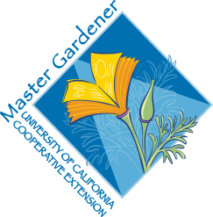
UC Master Gardeners of Placer County
University of California, Placer County Cooperative Extension

Spice It Up: Growing Herbs

Public Website: http://pcmg.ucanr.org

Questions: Hotline (530) 889-7388

ROT Line (530) 889-7399

RESOURCE LINKS

Landscaping with Herbs – covers planning and planting an herb garden. (EHN15)
https://ucanr.edu/sites/sacmg/files/116769.pdf

Culinaary Herb Profiles – shows a plant by plant profile of commonly used culinary herbs. (EHN70)
https://ucanr.edu/sites/sacmg/files/116768.pdf

Integrating Culinary Herbs into the Garden
https://ucanr.edu/sites/ucmgplacer/files/158599.pdf

The Multi-Purpose Herb Garden
https://ucanr.edu/sites/ucmgplacer/files/290859.pdf

