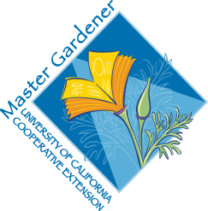
UC Master Gardeners of Placer County
University of California, Placer County Cooperative Extension

Lawn Replacement Resources

Public Website: http://pcmg.ucanr.org

Questions: Hotline (530) 889-7388

ROT Line (530) 889-7399

HANDOUTS
This handout.

RESOURCE LINKS
Sheet Mulching article from Butte County Master Gardeners
https://ucanr.edu/sites/bcmg/files/216158.pdf
Sheet Mulching from the Sacramento Suburban Water District
https://www.sswd.org/departments/conservation/water-efficient-landscape-gardens/creating-a-water-wise-garden-garden-on-eden/sheet-mulching

BOOKS

MORE

