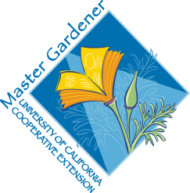
UC Master Gardeners of Placer County
University of California, Placer County Cooperative Extension

Irrigation: Basics, Tips and Tricks for the Home Gardener

Resource Sheet

Public Website: http://pcmg.ucanr.org

Questions: Hotline (530) 889-7388

ROT Line (530) 889-7399

HANDOUTS
Resource Sheet: Irrigation: Basics, Tips and Tricks for the Home Gardener

RESOURCE LINKS
Hunter Irrigation Design Guide
https://www.hunterindustries.com/sites/default/files/design_guide_Residential_System_LIT-226-US.pdf
UCANR Irrigation and Soils Homepage. https://ucanr.edu/sites/Irrigation_and_Soils_/
UCANR Sacramento MG Irrigation Links. https://sacmg.ucanr.edu/Irrigation/
Rainbird Irrigation Design Manual
https://www.rainbird.com/sites/default/files/media/documents/2018-02/IrrigationDesignManual.pdf
Sprinkler School Resources. https://school.sprinklerwarehouse.com/
University of Florida – Basic Tips for Designing Irrigation Systems
https://edis.ifas.ufl.edu/publication/AE539
Colorado State Small Acreage Irrigation Guide
https://sam.extension.colostate.edu/wp-content/uploads/sites/2/2017/04/sam-irr-guide.pdf

BOOKS
David Sauter. Landscape Construction. (2011).

MORE
Arizona University Irrigation Components Guide
https://cals.arizona.edu/extension/ornamentalhort/waterquality/dripirrigation_basic.pdf
University of Vermont Getting Started with Drip Irrigation
https://www.uvm.edu/~pass/grubinger/Pubs/UVM_dripirrigation.pdf

