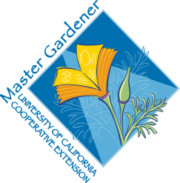

UC Master Gardeners of Placer County

Cool Season Vegetables
Public Website: pcmg.ucanr.org

Questions?: Hotline 889-7388

HANDOUTS
Resources
Placer CountyVegetable Planting Guide (paper)
Vegetable Families Chart (for crop rotation)

RESOURCE LINKS
Vegetable Gardening Basics http://anrcatalog.ucanr.edu/pdf/8059.pdf
California Garden Web: Vegetables http://cagardenweb.ucanr.edu/Vegetables/
Climate Zone Information http://cagardenweb.ucanr.edu/Your_Climate_Zone/
UC Integrated Pest Management www.ipm.ucdavis.edu
All About Cover Crops http://ucce.ucdavis.edu/files/filelibrary/5842/25997.pdf

BOOKS
Coleman, Eliot. Four-Season Harvest. Vermont: Chelsea Green Publishing, 1999

MORE
Day Length Chart https://www.timeanddate.com/sun/
Frost Dates http://ucanr.edu/blogs/mbmg/blogfiles/40600.pdf

UC Master Gardeners of Placer County are University of California Cooperative Extension (UCCE) ambassadors to the Placer County home gardening community. Master Gardeners promote environmental awareness and sustainable landscape practices, and extend research-based gardening and composting information to the public through educational outreach. UCCE is part of the Division of Agriculture and Natural Resources (ANR) of the University of California. UCCE Placer County: 11477 E Avenue, Auburn, CA 95603, (530) 889-7385
UC Master Gardeners of Placer County Hotline: (530) 889-7388; Website: http://pcmg.ucanr.org/ 6/18

