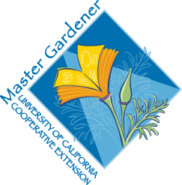
UC Master Gardeners of Placer County
University of California, Placer County Cooperative Extension

The Backyard Orchard: Top 10

Public Website: http://pcmg.ucanr.org

Questions: Hotline (530) 889-7388

ROT Line (530) 889-7399

HANDOUTS
Resource Sheet

RESOURCE LINKS
Tree Ring Irrigation Contraption https://ccuh.ucdavis.edu/tric
NRCS web soil survey https://websoilsurvey.sc.egov.usda.gov/App/HomePage.htm
UC Home Orchard http://homeorchard.ucanr.edu/
UC IPM site http://ipm.ucanr.edu/
Placer Co Master Gardeners http://pcmg.ucanr.org/
Nevada Co Master Gardeners http://ncmg.ucanr.org/
Kevin Marini Krmarini@ucdavis.edu

BOOKS
Ingels, Chuck. The Home Orchard. (2007).

MORE
Dave Wilson Nursery https://www.davewilson.com/
Four Winds Growers (Citrus) https://www.fourwindsgrowers.com/

