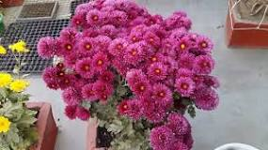
www.youtube.com
In a pot, a chrysanthemum plant lasts for a few weeks inside. Keep it in a brightly lit position and water when dry. Pick off any dead flowers or discoloured leaves. When flowering has finished, take it outside, cut it back to 15cm and plant it out in your garden. The plant may look dead, but don’t discard it because they will come back and continue to bloom for a number of years.
Chrysanthemums love full sun but need moisture, so keep soil moist but not soggy. Mums do not like wet feet like many other flowering plants. The minimum direct sunlight should be at least three hours for plants to flower but more is better. Make sure soil does not dry out.

Deadhead {removing all dead and decaying branches} from mums in late spring to mid summer to encourage flowering and any wilted or crisp blooms. You can do this with your finger but use pruning tools if you are clipping bunches of dead flowers; shear at the bottom of the stem for major deadheading.

- ↑ http://farmersalmanac.com/home-garden/2015/09/28/keep-your-potted-mums-thriving-this-fall/
- https://www.sunset.com/garden/new-sunset-western-garden-book
- http://www.extension.umn.edu/garden/yard-garden/flowers/garden-chrysanthemums/
- www.mums.org/chrysanthemum-classes

