An area-wide PSE covers a geographic area of land and is not confined to a physical address. An example would be active transportation policies or capital improvements for a city’s sidewalk system that affect large parts of a city, rather than the occupants of a single building.
Before beginning this survey, the PSE activity must already be entered into PEARS. If you have been entering area-wide PSEs into PEARS in previous fiscal years, continue to use the site you used in previous years. If entering in a new area-wide PSE, select an administrative site to represent the PSE, for example, city halls, or county public health departments. If a site is not available in PEARS, please contact evaluateSNAPEd@ucanr.edu.
Beginning with FFY 22, you can now choose the setting that is most relevant to the area-wide PSE work, same as the instructions for how to select a PSE setting in any PSE activity report. In the example given above, the closest PSE setting would be “bicycle and walking paths”. This marks a change from previous years when we did not have the ability to systematically capture area-wide PSEs, and PEARS users were instructed to use the “other live” setting text field to describe area-wide PSE work.
Gathering the relevant PSE information
1. Before you begin the area-wide PSE survey, you will need the PSE activity ID, site name, and the project name.
When you are entering your PSE information into the General Information page, make note of the PSE activity ID, site name, and project name. The PSE activity can be taken from the URL by copying the 5-digit number after “…track/pse/”. The rest of the information can be retrieved as you fill out the General Information page.
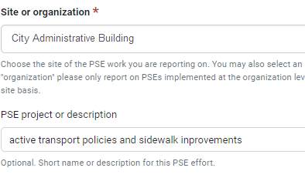
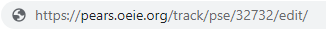

If you have already entered the PSE information into PEARS, go to the end of this document to see where to find the PSE Activity ID, Site Name, and PSE Project Name.

Entering data into the survey

2. Once you have the PSE information, enter the survey using this link: https://arcg.is/1yP9aO.
When you enter the survey, you will see 3 fields to enter the PSE activity ID, site name, and project name, pictured below.
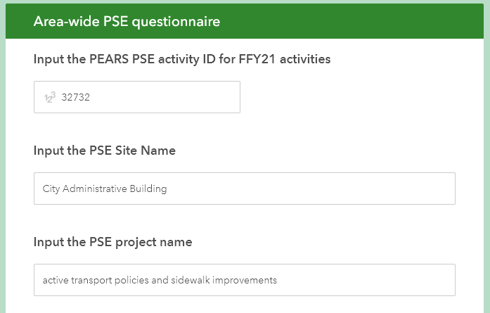

3. Next, you will capture the PSE coverage using the map. Search for the general location using the map's search bar or using Ctrl+scroll to zoom. To mark the PSE area, click on the insert area button; the second button down on the right-hand side.
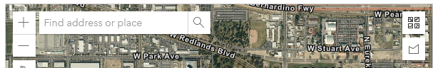
Location of search bar and insert area button

4. On the map, click on the boundary of the PSE to set the first marker, then continue to click around the PSE area until you have completed the shape of the area. Once you complete marking the area it will turn blue. If you do not see the blue area, you must complete the polygon. Double click the polygon to auto-complete the area.
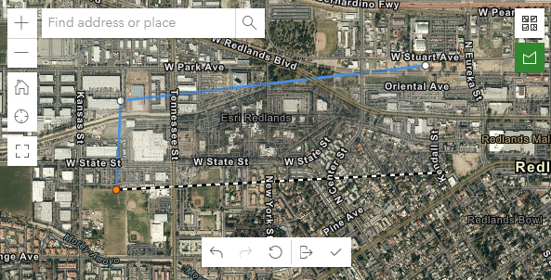
Example of an area in-progress
When you start to mark the PSE area, each segment will turn blue when you connect 2 nodes. Nodes, or the points representing the beginning or ending of a line, are the white and orange dots at the end of each line. An area can have as many sides and nodes as needed, as long as it has at least 3 nodes.

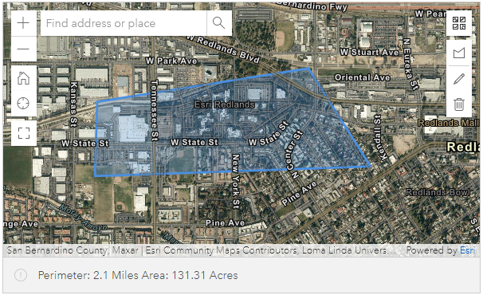
Example of completed area, highlighted by a blue polygon

5. If you need to edit the area, the pencil button on the right will allow you to edit the nodes. Click on the green pencil button to save the edits. If you need to start over, click on the trash can button to the right. An example can be seen below.

6. The next question asks about the type of area or administrative boundary that the PSE covers. Choose the type of area that best corresponds to the PSE coverage. For example, if the PSE covers most of the county except for a small, unpopulated portion, choose “County”. If the PSE is limited to CalFresh Healthy Living eligible tracts, choose “Census Tract”. If the PSE does not follow administrative boundaries, choose other.
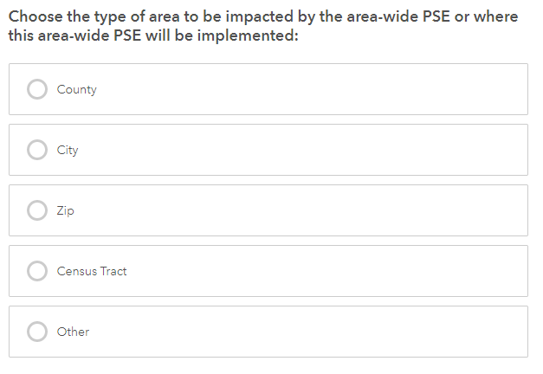

7. The following question will allow you to name the area and/or describe the specific boundaries in detail. Using the next text box, describe the area of impact. If using a custom area, describe the boundaries, e.g. sidewalks between Main st and 2nd St, and between Park Ave and Lakeview Ave; if using a defined area, list that here, e.g. Sacramento County.
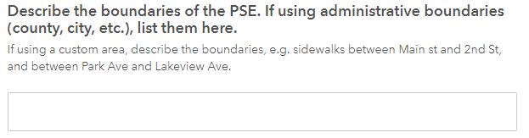
8. The last questions ask whether work was done towards informing, improving, or adopting area-wide policies during this federal fiscal year. For example, these may be zoning policies, city-wide healthy procurement policies, and other multi-sectoral changes described in the SNAP-Ed evaluation framework under MT7 and MT10. If yes, please select all the types of policies that you worked on this year for the geographic area described above, whether or not the policy change has been adopted yet.
Here is a list of the types of policies to choose from. If you choose other, please specify what the policy is.
- Local Food Production/Distribution
- Healthy Food Procurement/Vending
- Physical Activity Policies and Supports
- Nutrition/Health Element in General Plan
- Access/safety to parks/open space
- Complete Streets and/or active living
- Community design and/or safety
Gather information from a previously entered PSE
- Go to the Analyze PSE section of PEARS and find the area-wide PSE that you will be filling out information for. Click on the Site/Org Name to enter the PSE summary.
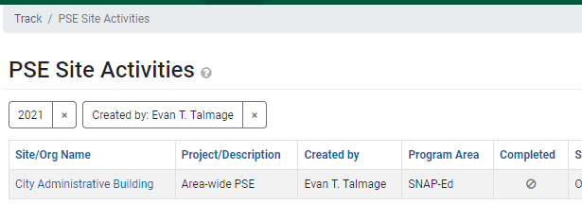
- On the PSE summary page, you will find the PSE Activity ID, Site Name, and PSE Project Name.