Fungicide Application in Young Vineyards Protect Pruning Wounds from Grapevine Trunk Diseases and Provides Long-Term Economic Benefit
Carmen Gispert, UCCE Viticulture Farm Advisor Riverside County
Jonathan Kaplan, Department of Economics, Sacramento State University
Philippe E. Rolshausen, UCCE Specialist, Department of Botany and Plant Sciences, UC Riverside
Grapevine trunk diseases (GTDs) including eutypa dieback, bot canker, blackfoot disease, young vine decline, and esca (also known as grape measles), limit the profitable lifetime expectancy of vineyards. Growers are well aware of the negative impact of GTD on vineyard productivity and have consistently ranked them as a research priority for the industry. Fungicide application on the pruning wounds of young vines is recognized as an efficient practice to minimize GTDs incidence and is most beneficial when implemented in the first years after the vineyard has been established (Figure 1).
A

B
Figure 1. Expected annual production of 19 lbs. boxes/acre from table grape vineyards with different rates of disease control efficacy (DCE), with preventative practices starting in (A) year 3 or (B) year 5 (from Norton et al., 2020).
However, stakeholder surveys suggest that few growers follow these guidelines. Further these surveys have shown that the first fungicide applications often coincide with the initial spur or cordon dieback when vineyards turn 8-10 years of age. The long incubation period between the initial infection and the first symptom appearance often gives growers a false sense of security, leading to an excessive delay in the use of GTD-protective fungicides. Delayed application of GTD fungicides provides short-term production cost savings but results in long term yield reduction and shortens a vineyard’s productive life.
In 2012, we started a survey in the area following several farm calls from growers that experienced a high incidence of GTD in young vineyards with typical wood dieback, declining vigor, and apoplexy (Image 1). These observations were at first unexpected because the pathogens causing these diseases require rainwater to sporulate and become airborne and the arid conditions of the Coachella desert are not conducive to the spread of these pathogens. However, local growers use overhead sprinkler irrigation during the winter months to help satisfy chilling requirements. This process overlaps with vine pruning, creating suitable conditions for new GTD infections. In addition, when establishing a new vineyard, growers used to interplant the new vines between the old stumps left from the previous vineyard (Image 2). This allows the old wood to act as a reservoir for pathogens. The stumps coupled with the overhead sprinkler irrigation creates the perfect environment for fungal spores to become airborne and infect the exposed pruning wounds on young vines.
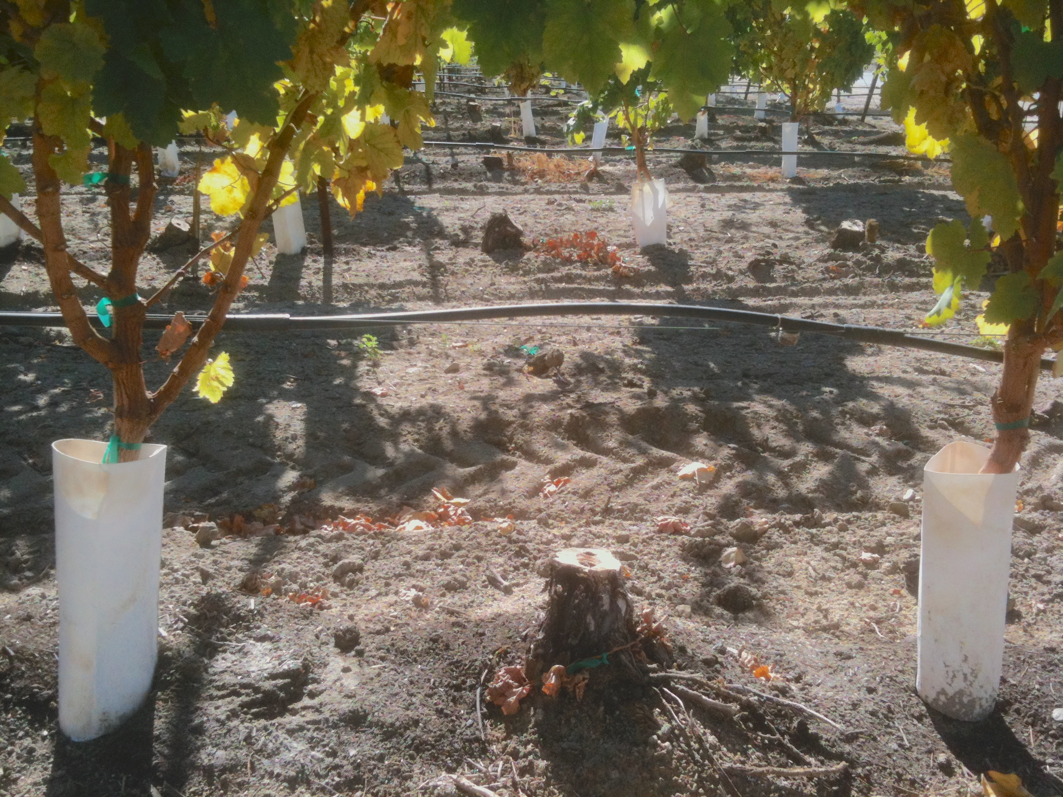Image 2. New vineyard inter-planted between old vine stumps.

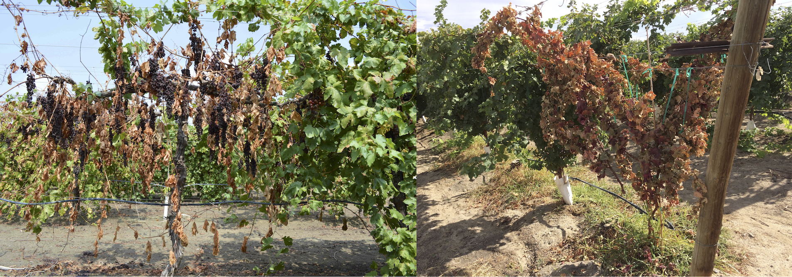Image 1. Young vines collapse (aploplexia) caused by Grapevine Trunk Diseases
To combat this issue, we conducted a long-term study to evaluate the effect of applying pruning wound fungicide application in young vineyards under high disease pressure (with vine stumps) on GTD incidence and productivity. The field experiment started in 2014 in a commercial two-year-old vineyard of Sugraone located in the desert of Coachella Valley. Each winter, vines were manually pruned, and one half of the vineyard was tractor sprayed on the second day after pruning with the California industry standard Topsin-M® (AI thiophanate methyl) at the recommended label rate for six consecutive years. The other half of the vineyard remained unsprayed for GTD across all 6 years.
After 6 years, we randomly pruned the cordons and spurs of 150 vines (10 vines per row in a total of 15 rows in both control and treated blocks) and inspected them for symptoms of GTD and scored the number of vines with symptoms (i.e., wood discoloration, streaking or necrosis; as seen in Image 3). We also recorded the yield of 25 individual vines selected randomly within those 15 rows in both the treated and untreated blocks. Finally, we estimated the economic benefits of post-pruning fungicide application.
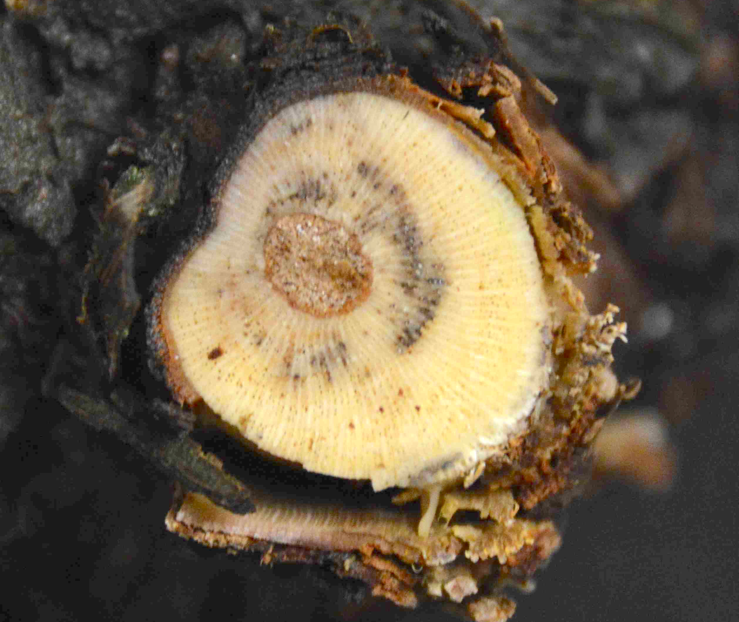Image 3. Symptoms caused by GTDs (black streaks of esca) in a grapevine cordon.

Thiophanate-methyl pruning wound treatments reduced disease incidence and increased yield (Figure 2). After six years of post-pruning fungicide applications GTD incidence was reduced by half (from 40% to 20%) and yields were increased by 40% (from 19 to 27 lbs. per vine). According to our economic analysis, the benefit from spraying in year 2 and beyond was calculated at just over $85,000 per acre over a 25 year vineyard lifespan for the 50% disease control scenario, which is equivalent to a benefit of more than $3,400 per acre and per year.
This study has helped table grape growers in the Coachella desert with decision making to effectively manage GTDs. Over the course of this trial, growers were more diligent about removing old vine stumps before planting new vineyards. In addition, many more applied Topsin M® on vines soon after pruning. In view of the economic benefit, this study provides wine, table, and raisin grape growers convincing evidence in support of early adoption of post-pruning fungicide application to manage GTDs.
Figure 2: Disease incidence and crop after 6 years in block treated with Topsin M® and non-treated control block.

Acknowledgments: This project was funded by the California Desert Grape Administrative Committee and in part by the USDA-NIFA Specialty Crop Research Initiative Grant#2012-51181-19954 awarded to K. Baumgartner (USDA-ARS, UC Davis). We would like to thank ‘Anthony Vineyards’ for providing a commercial vineyard to conduct the research and for the assistance with the tractor application of fungicide and crop harvest.

References
Baumgartner K. et al. Managing Grapevine Trunk Diseases in California's Southern San Joaquin Valley. American Journal of Enology and Viticulture, 2019. 70(3): p. 267-276.
Hillis V. et al., Preventative Disease Management and Grower Decision Making: A Case Study of California Wine-Grape Growers. Phytopathology, 2017. 107(6): p. 704-710.
Kaplan J. et al. Identifying Economic Hurdles to Early Adoption of Preventative Practices: The Case of Trunk Diseases in California Winegrape Vineyards. Wine Economics and Policy, 2016. 5: p. 127-141.
Norton M. et al. An Economic Analysis of Preventative Practices for Managing Trunk Disease in Table Grape Vineyards. SCRI Trunk Disease Project Research Brief. http://treeandvinetrunkdiseases.org/wp-content/uploads/2017/06/170612_CTGC.pdf. October 2020.
Rolshausen P.E. et al. Evaluation of Pruning Wound Susceptibility and Protection Against Fungi Associated with Grapevine Trunk Diseases. American Journal of Enology and Viticulture, 2010. 61(1): p. 113-119.

Effect of Smoke on Grape Production in the San Joaquin Valley
George Zhuang, UCCE Viticulture Advisor Fresno
Matthew Fidelibus, Department of Viticulture and Enology, UC Davis
Karl Lund, UCCE Viticulture Advisor Madera, Merced, and Mariposa Counties
2020 is a year that many would like to forget. A global pandemic and extreme heat waves in California have caused disruption and damage to agricultural operations. Moreover, some of the largest and most destructive wildfires in California history developed at the end of the summer, many in close proximity to vineyards. Wineries and other structures have been destroyed and the wine grape crop in some areas was exposed to heavy smoke, potentially tainting the grapes. Effects of smoke on grape and wine is a relatively new research topic, pioneered by Australians whose industry has also had to contend with devastating wildfires. Increasingly frequent and severe wildfires in California have prompted local industries and universities to undertake research towards the effects that smoke may have on grape and wine quality.
Dr. Anita Oberholster, a UC Davis extension specialist in Enology, spoke on the subject of smoke taint in grape and wine at the recent San Joaquin Valley Virtual Grape Symposium in December of 2020. She went into the mechanisms of how burning wood releases volatile phenols, such as free guaiacol and 4-methylguaiacol, along with o, p, m-cresol, syringol, and 4-methylsyringol. These chemicals can be absorbed through the skin of the grape and lead to wines that have an ashy, bonfire, or smoky flavor. The ability for these chemicals to absorb through the skin of the grape does increase after veraison; however, even very young berries can still be affected by smoke taint. As these chemicals do need to be absorbed by grape, their effect is only felt during the current season. Once these volatile phenolics are inside the grape they become glycosylated, chemically bound to sugar molecules inside the grape. This bond makes the volatile phenolics harder to detect and harder to remove from the wine. Enzymes in human sylvia are able to dissolve these bonds, releasing the smoke flavored volatile phenols directly to your taste buds.
As these chemicals are hard to deal with once inside the grape. It would be helpful to understand how damaging a specific exposure event was to your grapes, and if there is a way to prevent this exposure. Dr. Oberholster also touched on these subjects. She went into how smoke density does not always equate to volatile phenolic exposure and smoke taint. The ash particulates in smoke do not always represent the amount of volatile phenolics in that same smoke especially as that smoke ages. However, the presence of fresh (<24 hours old) thick smoke is highly likely to contain both ash and volatile phenolics. In a similar manner, washing ash from grapes does not affect the volatile phenolics already absorbed into the berry. However, ash that is fresh (less than 1 week old) does release small amounts of volatile phenolics that can be absorbed by the grapes, especially if they are in direct contact. Therefore, removing this ash can be beneficial to prevent additional smoke taint.
The ability to protect grapes from smoke exposure has had variable results, Dr. Oberholster explained. The first problem when trying to protect grapes is that protectants applied to the berries can normally only cover 30% - 40% of the berries surface. This leaves most of the berry’s skin free to still absorb the volatile phenolics from the atmosphere. Timing of protectant application is also a problem. If a protectant is applied too early, it can be worn off prior to the berry’s exposure. More interestingly, Dr. Oberholster talked about an application event that led to an increase in the effects of smoke taint. In this case the protectant was applied the day before a smoke event. It is believed that when the volatile phenolics from the smoke entered the vineyard after this application the berries were still wet from the previous day’s application. This water was a double-edged sword as it both increased the surface area of the grape from which absorption can happen; as well as present a surface which is more absorbent for the volatile phenolics. When asked about the ramifications of this work, Dr. Oberholster remarked that at this time it is probably best to avoid all spray applications when there is a worry about smoke exposure. Any liquid sprayed on the surface of a grape during a smoke event will increase the surface area for absorption and can possibly lead to higher levels of exposure.

Image 1. Smoke over the vineyard near Los Banos in early September.
In addition to the effect that volatile phenolics can have on grape and wine chemistry, the smoke can also affect additional components of grape production. These affects were felt across the San Joaquin Valley (SJV) during 2020, and in the remainder of this article, we will review how the smoke may affect:
- Grapevine Physiology
- Vine Water Status and Irrigation Management
- Berry Ripening, Yield Formation, and Raisin Drying
- Mitigation Strategy
Grapevine Physiology
Figure 1. A. Maximum daily air temperature in comparison of 2020 and last 10 years’ average during months of August, September, and October. B. Solar radiation in comparison of 2020 and last 10 years’ average during months of August, September, and October. Data points were extracted from CIMIS station #56 at Los Banos. The red arrows indicate the first smoke event from lightning ignited fires in August and the second smoke event from Creek Fire in September.
Smoke in the SJV reduced sunlight and, in turn, also reduced ambient temperature (Image 1). Solar radiation has been significantly reduced during the middle of August and the beginning of September in comparison of ten years’ average in the Valley (Figure 1 B), and maximum daily temperature was also affected by smoke, although the influence was relatively mild (Figure 1 A). Changes in solar radiation have been well correlated to the recent smoke events. There were mainly two smoke events in the southern San Joaquin Valley: a series of lightning strike fires started on August 16 in Santa Clara, Santa Cruz and Monterey counties; and the early-mid September Creek Fire, near Huntington Lake. Among the two fires, the Creek Fire seemed to have more significant influence on grape production and there have been several reports on delayed wine grape ripening and poor raisin drying. During periods of heavy smoke, it was cloudy, hazy, and cooler than it had been before the smoke arrived. As a result, growers reported having a difficult time achieving the targeted Brix and get the raisin dried on time.
George Zhuang, the Viticulture Advisor for Fresno County, monitored the effect of smoke on vine physiology, water stress and berry ripening in SJV vineyards during the smoke events of 2020 (Picture 2). Heavy smoke decreased sunlight and, in turn, photosynthesis, and transpiration of grapes. During these smoke events, the photosynthetic active radiation (PAR) dropped from 1900-2000 µmol· s⁻¹ ·cm⁻², on pre-smoke days, to 300-400 µmol · s⁻¹ · cm⁻². Therefore, depending on the thickness of smoke, the decrease of sunlight on grapevine canopy could be as much as 80%. Grapevine leaves need approximately 1500 µmol · s⁻¹ · cm⁻² to achieve a maximal photosynthetic rate. At veraison, grape berries begin to rapidly accumulate sugar, anthocyanins, and other flavor compounds, and all these berry chemical components need carbon produced from photosynthesis to be produced. The severe reduction in sunlight limited grapevine photosynthesis for approximately two weeks. This period of suboptimal photosynthesis likely affected berry ripening, raisin drying and harvest yield.
Vine Water Status and Irrigation Management
The main driving force for vineyard water use is sunlight. According to last 10 years’ average in the SJV plant water use, as tracked by crop reference evapotranspiration (ET_{o}), is highly correlated with solar radiation and max daily air temperature (Figure 2). Other environmental factors influencing grape water usage include wind speed and vapor pressure deficit. With vapor pressure deficit also being highly dependent on ambient temperature. As a result, the reduced solar radiation and lowered ambient temperature resulting from smoke could reduce the grapevine water usage significantly.
Figure 2. Solar radiation was correlated to max daily air temperature and daily ET_{o} from last 10 years’ average during months of August, September, and October. However, solar radiation had much stronger influence on daily ET_{o} than max daily air temperature. Data points were extracted from CIMIS station #56 at Los Banos.

As a general rule, grape growers intend to impose mild water stress on the vines after veraison to promote the sugar accumulation, anthocyanin biosynthesis, and manage other flavor compounds. The most common irrigation scheduling tool is crop evapotranspiration (ET_{c}). A certain fraction of ET_{c} is used to purposely stress the vines to achieve certain grapevine stress target. During smoke events, historical ET_{c}, reference ET_{o} from CIMIS station, and ET from satellite images are all impacted and did not provide the most reliable ET_{c} information.
In short, the smoke might have reduced grapevine water demand, and the use of ET based on pre-smoke or clear days could have led growers to over irrigate the vines, which may have delayed berry ripening further. The combined effects of reduced sunlight and over irrigation might help explain why fruit ripened slowly in some vineyards. As such it is advised that growers use soil moisture, pressure chamber, visual assessment to adjust the irrigation during smoke events.
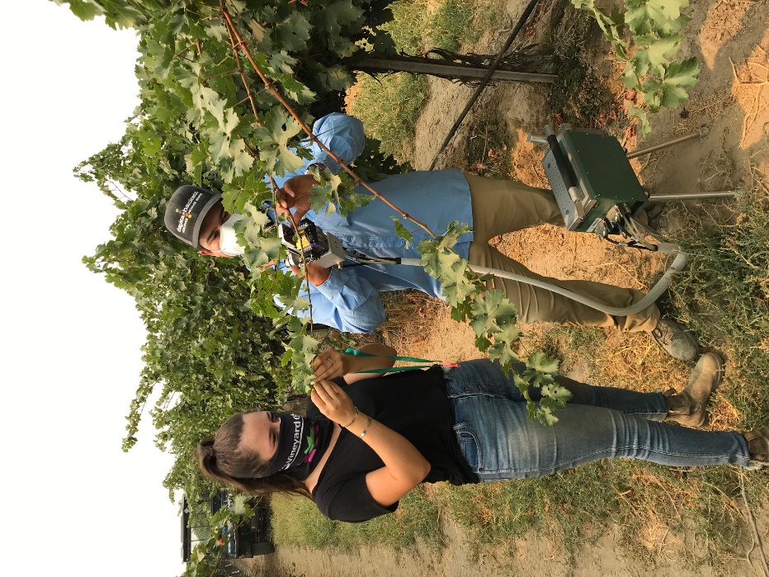Image 2. Viticulture interns of UCCE Fresno were measuring leaf gas exchange during the recent smoke events in Fresno.
Yield Formation and Raisin Drying
Grape yield is dependent on the number of clusters per vine, berry number per cluster, berry size, and soluble solids (Brix). Number of clusters per vine is determined by pruning severity and node fruitfulness, both of which were established well before the recent smoke events. Berry number per cluster is largely determined by fruit set, which for the SJV is typically somewhere in early May varying across different cultivars. Thus, fruit set was also completed well before the smoke events. This means that by the time the smoke events occurred during the 2020 growing season in the SJV; berry size and soluble solids were the yield components still to be determined. Grape berry growth follows a double sigmoid curve and berry size achieves approximate 50% of final berry size just before veraison. The smoke events after veraison might affect berry growth and final berry size. However, the influence of smoke would only be on the final 50% of berry size after veraison. And considering how late into the raisin growing season these events happened, the effect would have been even more reduced.
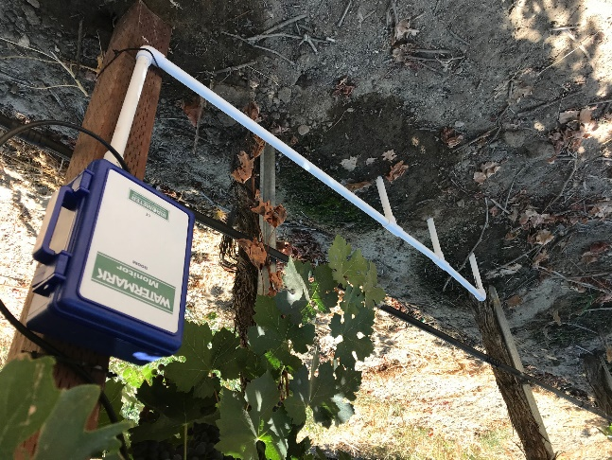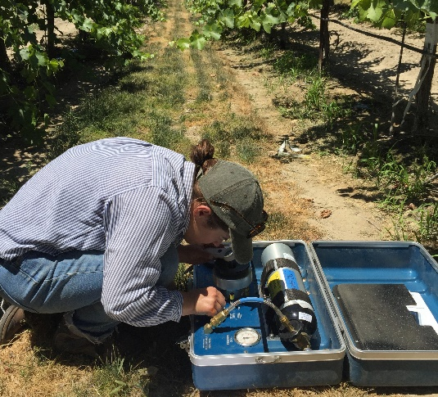Image 3. Monitor vine water stress using visual assessment, soil moisture sensor or pressure chamber. A. shoot tip regrew due to over-irrigation. B. soil moisture sensor was used to measure soil dryness. C. pressure chamber was used to measure midday leaf water potential.

A
B
C
Besides the effect on berry size, smoke also delayed the raisin drying. Berry temperature is the most important driving force in raisin drying, although low relative humidity and rapid air movement also promote drying. Dry-on-vine (DOV) grapes might normally take 4-5 weeks to dry, whereas Thompson Seedless grapes on trays normally take 2-3 weeks to dry. However, the smoke events appeared to delay drying. As for the traditional paper tray Thompson Seedless raisin, the high drying temperature is achieved by the absorption of radiant sunlight and heat accumulation at the soil and fruit surfaces during the day. The smoke blocked the sunlight reducing the solar radiation on the berry as well as lowered the ambient temperature decreasing the heat accumulation at the soil and fruit surfaces. The two weeks’ smoke event at the beginning of September has delayed the Thompson raisin drying for at least two weeks when the fruit was picked around Labor Day. As for DOV raisins, the drying might be further prolonged due to the extra leaf shading, high relative humidity, and less air movement without soil heat promoting drying.
Mitigation Strategy
The potential mitigation strategy for wine smoke taint will be shared at the upcoming grape symposium, and in this article, I will focus on how to mitigate the effect of smoke events on berry ripening, yield formation and raisin drying.
Berry ripening and yield formation:
- Maintain vine water stress target based on visual assessment (Picture 3 A), soil moisture (Picture 3 B), vine water status (Picture 3 C) without over-irrigating the vines.
- Keep close monitoring on insect damage and bunch rot, since delayed harvest might increase the risk of insect damage (raisin moth) and bunch rot for certain varieties (like Zinfandel and Colombard).
- Open the canopy and expose the fruit-zone if necessary, to decrease disease pressure and relative humidity with increased air movement.
- Monitor berry ripening (Brix) and communicate with winery or processor to delay or reschedule the harvest.
- Foliar spray of K might help the increase of berry Brix after veraison.
Raisin drying:
- Lighter tray filling improves the drying rate and is less risky for late harvests.
- Turning can be used to speed drying and reduce mold and rot under cool weather or when an excessive amount of green, undried berries are present.
- Flop or cigarette rolls dry faster than biscuit rolls when tray rolling must be performed in anticipation of possible rain.
- Remove the dried leaves on the DOV raisins to expose berries for sunlight to increase the drying rate.
- Open the canopy on the DOV raisins to lower relative humidity and increase air movement to speed the drying.
In summary, smoke events can affect SJV growers beyond smoke taint issues. In 2020, the Valley experienced COVID disruption, record summer temperatures and prolonged smoke events. All of those have caused significant challenges for growers to achieve grape production and quality goals. This article briefly summarized the impact of smoke events on grape and wine chemistry, vine production, berry ripening and raisin drying.

Pruning and Trunk Diseases
Gabriel Torres, UCCE Viticulture Advisor for Tulare and Kings Counties and UC IPM Affiliate

Grapevine trunk disease (GTD) is a general term that includes at least four distinct diseases including: Esca, Eutypa, Phomopsis, and Botryosphaeria dieback. Going a step further Esca, Eutypa and Botryosphaeria are all caused by multiple species of fungi. Overall, more than 150 species of fungi are involved in the GTD complex, and it is not difficult to find mixed infections in a vineyard. Some of the pathogens that cause trunk diseases are endophytes. This mean that they can grow inside the vines without causing outward symptoms for years. Most of the fungi that cause GTD are fungi that evolved to feed on decaying wood and are abundant in nature, but under the right conditions can infect living plants, especially those with lignified tissue (hard wood).
Most of the GTD pathogens infect grapevines through injuries such as pruning wounds. Cankers on > 95% of infected vines can be traced back to an infection that was initiated at a pruning wound. The following factors determine whether or not our vines will get infected after pruning:
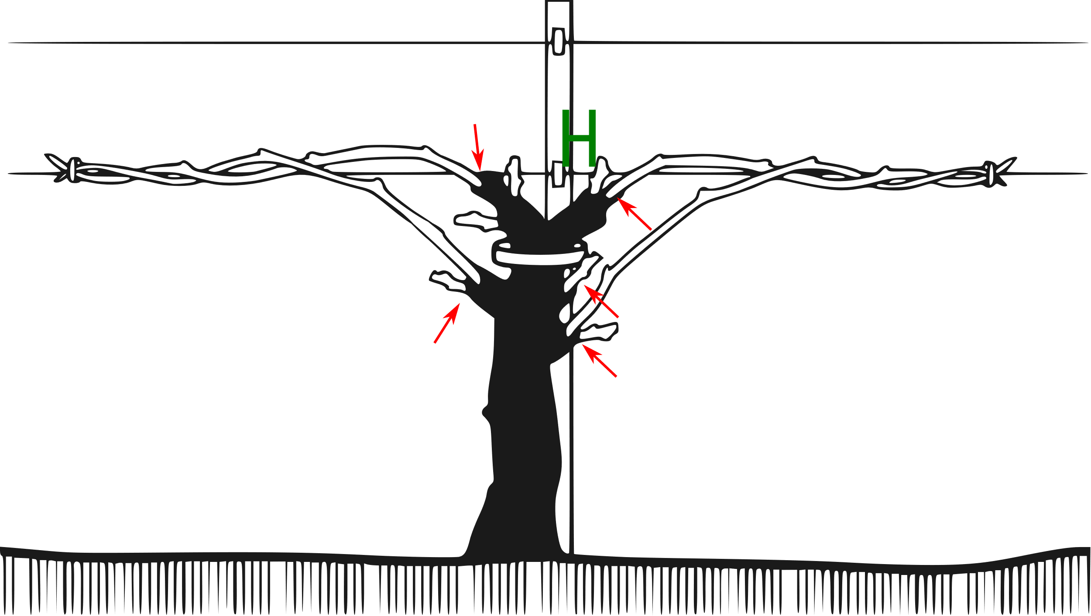
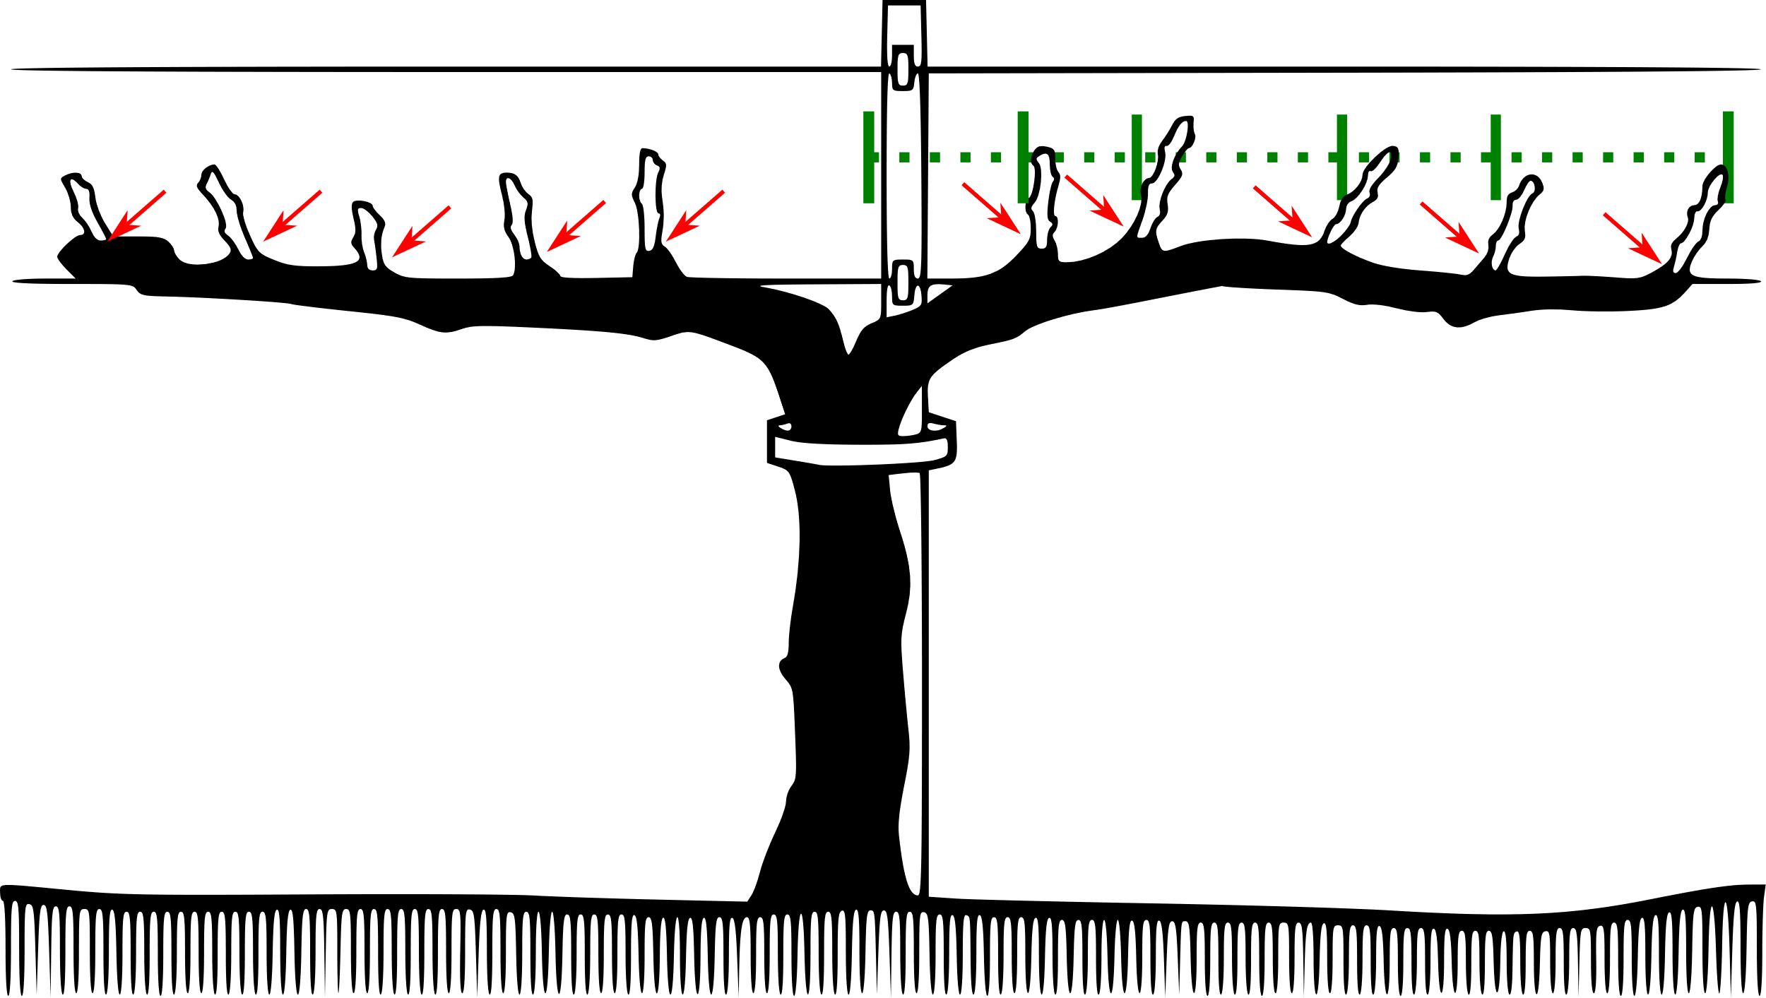 Figure 1. Cane vs Spur prunnig. Red arrows shows the pruning sites. The green ruller shows the distance to the trunk.
A

B
Cane Pruning
Spur Pruning

Type of pruning: The type of pruning will affect both the size, number, and location of pruning wounds. The size of the wound is very important to determine the risk of infection. The larger the wound, the higher the chances that a pathogenic spore from one of the GTD will land on it. Larger wounds also give the chance for multiple spores, possibly from different GTD pathogens, creating a greater opportunity for not just infection but mixed GTD infection.
Another factor to consider is the proximity to the trunk. The closer a wound is to the trunk the more dangerous it is. This is because cankers that are initiated close to the trunk can quickly compromise the entire vine and are more difficult to prune off than cankers that originate on the periphery of a vine. Vines that are head-trained and cane pruned will have all their pruning wounds closer to the trunk than cordon-trained vines (Figure 1 A).
Cordon-trained spur pruned vines may have a higher number of pruning wounds than head-trained cane-pruned vines (Figure 1 B); however, the cross-sectional area of each individual pruning wound may be smaller and further from the trunk than those created with cane pruning. Cane pruning put the lesions next to the trunk while in spur prune the distance is bigger (green marker on Figure 1) and permit replace infected spurs more easily when they get infected.
Cut angle: Cut angle depends on the viticulturist preference. Some people prefer to give some angle to the cuts to let rain if occurring to be removed from the lesion by gravity. One downside of this cutting type is that the lesion size increase as the cutting angle increases. Some viticulturists, especially in table grapes do not like to give an angle to the cuts since pointy spurs can puncture the clusters and thereby cause rot problems. Flat cuts can result in a surface for a droplet of water to pool on providing ideal conditions for GTD spore germination if present.
Pruning Tools: Fortunately, dispersion of GTD by pruning tools is minimal and does not represent a major risk in infected vineyards. That means that disinfestation is not required. However, sharpness of the tools is critical to have clean cuts. Dull tools can be problematic leading to uneven cutting zone and ripping the bark leading to larger pruning lesions the same applies for the tool size; using an undersized tool will requires several cuts to remove a cane. Selection and maintenance of a proper tool makes pruning easier and reduces damage to the vines.
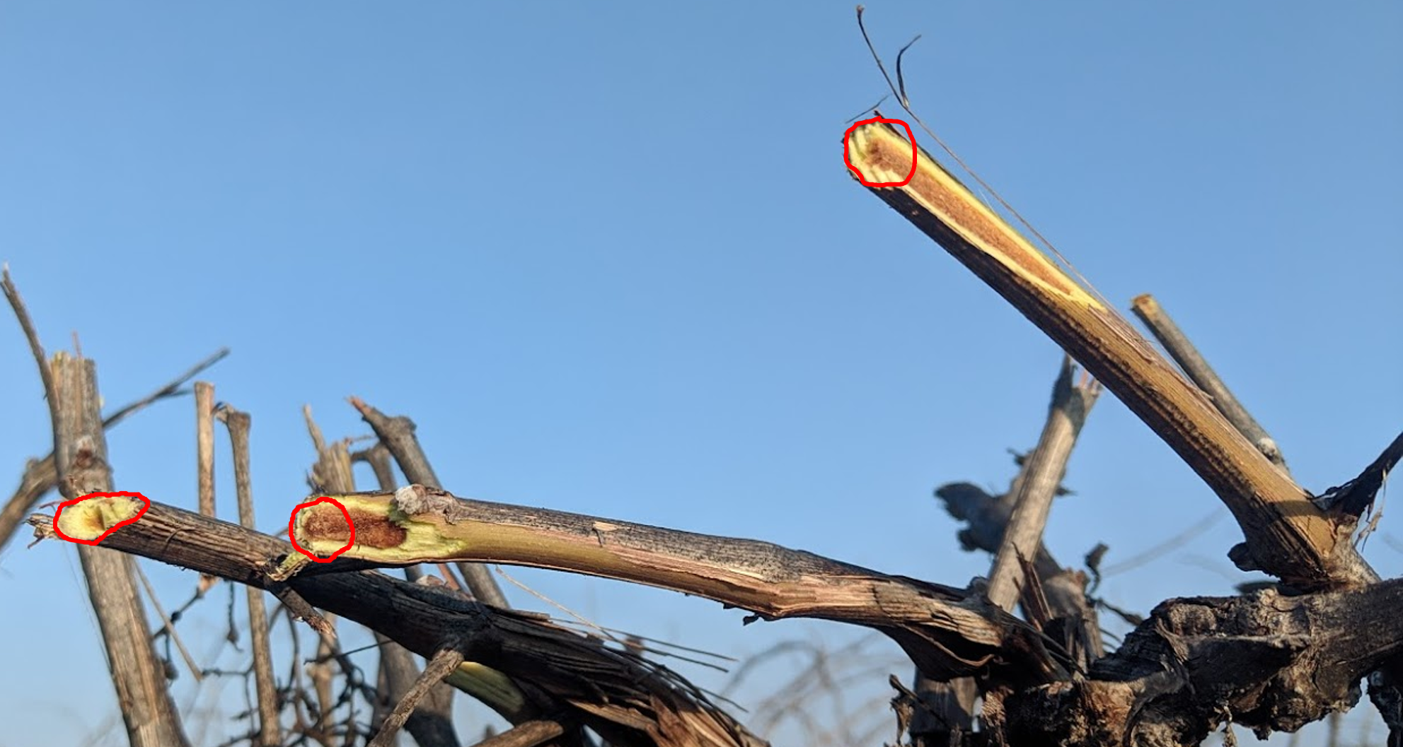 Image 1. Pruning damage on mechanical pruned vineyard. Red circles show the expected pruning lesion size if manual pruning was used.

In recent years, the use of mechanical pruning has increased as an alternative to manual pruning. This method does leave larger than expected pruning lesions and can increase the risk for GTD development (Image 1). Future research on the effect on mechanical pruning and trunk diseases is needed.
Pruning time: For California pruning is done during the dormant season between December and March. This also coincides with the rainy season in California. There is a strong correlation between rain events and spore releases for Botriosphariaceae, Eutypa, Esca and Petri disease (Urdez-Torres et al. 2010). Pruning wounds themselves also become less susceptible to GTD pathogens when pruning is done later in the dormant season (Urdez-Torres and Gubler 2011).
Based on the relationship between the principal GTD pathogens, California rain, and wound susceptibility, one of the most effective strategies is to postpone pruning until as close to budbreak as possible. Labor shortage in California, makes it impossible for all growers and companies to postpone pruning until late-winter. Forcing many vineyard managers to need to prune as soon as they have access to the farm labor to do it. In addition, recent changes in wage laws take affect January 1 in California; again, giving vineyard managers another reason to take care of pruning before the higher wages take effect. If pruning is done during the rainy months fungicide protection of the wounds is advised.
Another strategy is for growers to use a double pruning system. At the beginning of the winter the vines are pre-pruned leaving an extra 12-28 inches past the final desired cane or spur length. At the end of the winter the canes or spurs are cut to the desired length and number of shots. This normally helps to remove any infected tissue from the pe-pruning phase. However even in this system it is advised to protect the wounds.
Wound protection: Grape trunk disease infection are not curable with fungicides. However, to apply a fungicide or to puts a protective paste after pruning can help to reduce the risk of get GTD infections. Currently, Topsin-M, Rally and Mettle 125 are registered as pruning-wound protectants. In addition, pastes that include 5% boric acid and acrylic paint have been tested effectively to control Esca and Eutypa dispersion.
Month | Pruning wound susceptibility | Prune | Minimal Fungicide application if pruning take place
December A | 4 Weeks | Not Recommended | 2 Sprays
December B | 4 Weeks | Not Recommended | 2 Sprays
January A | 4 Weeks | Not Recommended | 2 Sprays
January B | 2 weeks | Not Recommended | 1 Spray
February A | 2 weeks | Not Recommended | 1 Spray
February B* | 2 days | Recommended | Only spray if rain is forecasted
March A | 2 days | Recommended | Only spray if rain is forecasted
Table 1. Susceptibility of pruning wounds, recommendation for pruning and number of fungicidal treatments needed to protect pruning wounds at different times of the year.
* Only on mild winters

There is not a single protocol that growers need to follow to manage trunk diseases. Preventive measures can prolong vineyard lifespan. Integrating pruning time, with tool selection and wound protection help reduce the number of vines affected by GTD. If you see an increase of trunk disease pressure, consult with your PCA or your local Viticulture Advisor about the best strategies to manage the disease.
Grafting: Another major wound that can allow for GTD to infest a vineyard happens during grafting and top working. Spores landing at fresh grafting points (Figure 2 arrows) or selection of infected scions or rootstocks can result in field infections. To reduce the risk of infection from nursery, always acquire your plant material from a reliable nursery, and inspect suspicious plants for internal damage. In addition to plants grafted at nursery, field grafting or regrafting always have a risk to serve as point of entrance for trunk diseases. Special attention is needed when regrafting (Figure 2) since the cut is large and the inoculum from old decaying wood is readily at hand. In all cases, it is important to protect the exposed tissue until the lesions heal.
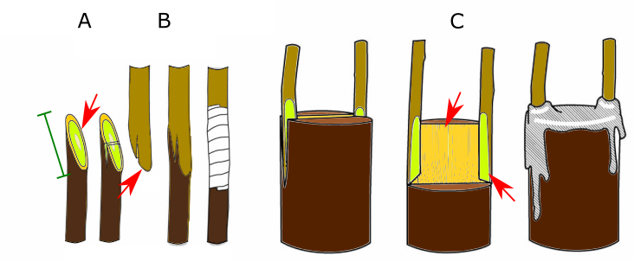Figure 2. Exposed areas on different grafting systems. A. Whip graft; B. Tongue graft; and C. Cleft graft, commonly used for regrafting.
Natural Infection: In addition to injuries associated with cultural practices, GTDs can also occur via naturally occurring wounds. A good example of a “natural injury” serving as entry port is the “J” rooted plants. J rooted plants occur when the roots are bent into the bottom of the planting hole. The geotropic nature of roots forces the tips to grow downward creating a crack that serve as point of entry for the black root or petri pathogens (Phaeomoniella and Paheoacremonium spp). Under this scenario the pathogen is obtained at planting and external symptoms of Petri disease are normally observed between the first 3 years after planting.
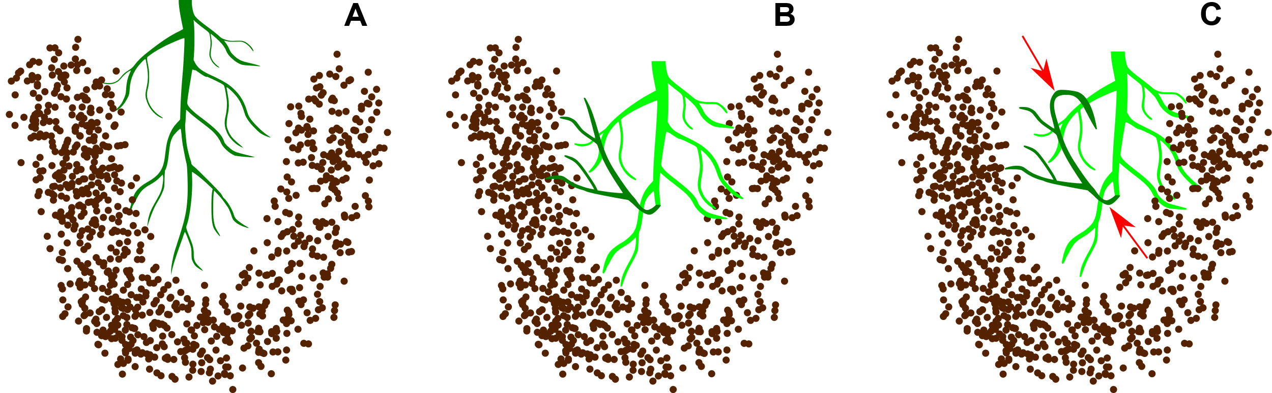 Figure 1. J root planting. A. Correct, straight root distribution; B. J root at planting; C. Cracking points at J rooted plants bend points (red arrows).

IPM Extension available in Spanish
Dr. Gabriel Torres (UCCE Viticulture advisor for Tulare and Kings counties), in collaboration with Dr. Carmen Gispert (UCCE San Bernardino, Riverside, San Diego), Dr. Monica Cooper (UCCE Napa), and Mark Battany (UCCE San Luis Obispo) were awarded grant funding by the American Vineyard Foundation to do Integrated pest management (IPM) extension in Spanish in February. Dr Torres and his collaborators are planning to develop a series of videos and online presentations for Spanish speaker growers, fieldworkers, PCAs and other people interested parties.
The primary scope is IPM, including the management of the most relevant pest such as powdery mildew, botrytis, mealybugs, ants, and spiders. New topics would be considered and proposed into a new grant based on the feedback that the team receive from the audience.
If you would like to have more information about this project, you can contact Dr. Torres at gabtorres@ucanr.edu or 559-684-3316

Vit Tips Staff
Contributing Authors
Carmen Gispert, UCCE Viticulture and Pest Management Advisor Riverside, San Bernardino & San Diego Counties
760-342-2466, cgispert@ucanr.edu
Gabriel Torres, UCCE Viticulture Advisor Tulare & Kings Counties
559-684-3316, gabtorres@ucanr.edu
George Zhuang, UCCE Viticulture Advisor Fresno County
559-241-7515,
Karl Lund, UCCE Viticulture Advisor Madera, Merced & Mariposa Counties
559-675-7879 ext. 7205, ktlund@ucanr.edu
Editors
Matthew Fidelibus, UC Davis Viticultural Extension Specialist Kearney AG Center
559-646-6510, mwfidelibus@ucdavis.edu
Karl Lund, UCCE Viticulture Advisor Madera, Merced & Mariposa Counties
559-675-7879 ext. 7205, ktlund@ucanr.edu
Upcoming Meeting
As you know, the State of California is still dealing with the spread of COVID-19. Due to the current Covid19 outbreak UCCE has postponed all large in-person meeting until the current situation has passed. We are still here to answer your questions and address needs during this unprecedented situation. Please contact us with any viticultural issues or concerns you are having. You can also get in contact with any of your other local UCCE staff by contacting them through our website.

Fresno County
George Zhuang, Viticulture Advisor Fresno County: gzhuang@ucanr.edu, 559-241-7515.
Website for other Fresno UCCE Advisors and Staff: http://cefresno.ucanr.edu/Contact_Us/

Madera, Merced & Mariposa Counties
Karl Lund, UCCE Viticulture Advisor Madera, Merced & Mariposa Counties: ktlund@ucanr.edu, 559-675-7879 ext. 7205
Website for other Madera UCCE Advisors and Staff: http://cemadera.ucanr.edu/contact_337/
Website for other Merced UCCE Advisors and Staff: http://cemerced.ucanr.edu/about/contact/
Website for other Mariposa UCCE Advisors and Staff: http://cemariposa.ucanr.edu/Staff/

Tulare and Kings Counties:
Gabriel Torres, UCCE Viticulture Advisor Tulare & Kings Counties: gabtorres@ucanr.edu, 559-684-3316
Website for other Tulare UCCE Advisors and Staff: http://cetulare.ucanr.edu/Contact_Us/
Website for other Kings UCCE Advisors and Staff: http://cekings.ucanr.edu/Contacts/

