Introduction to Edible Landscapes (Betsy Allen and Connor)
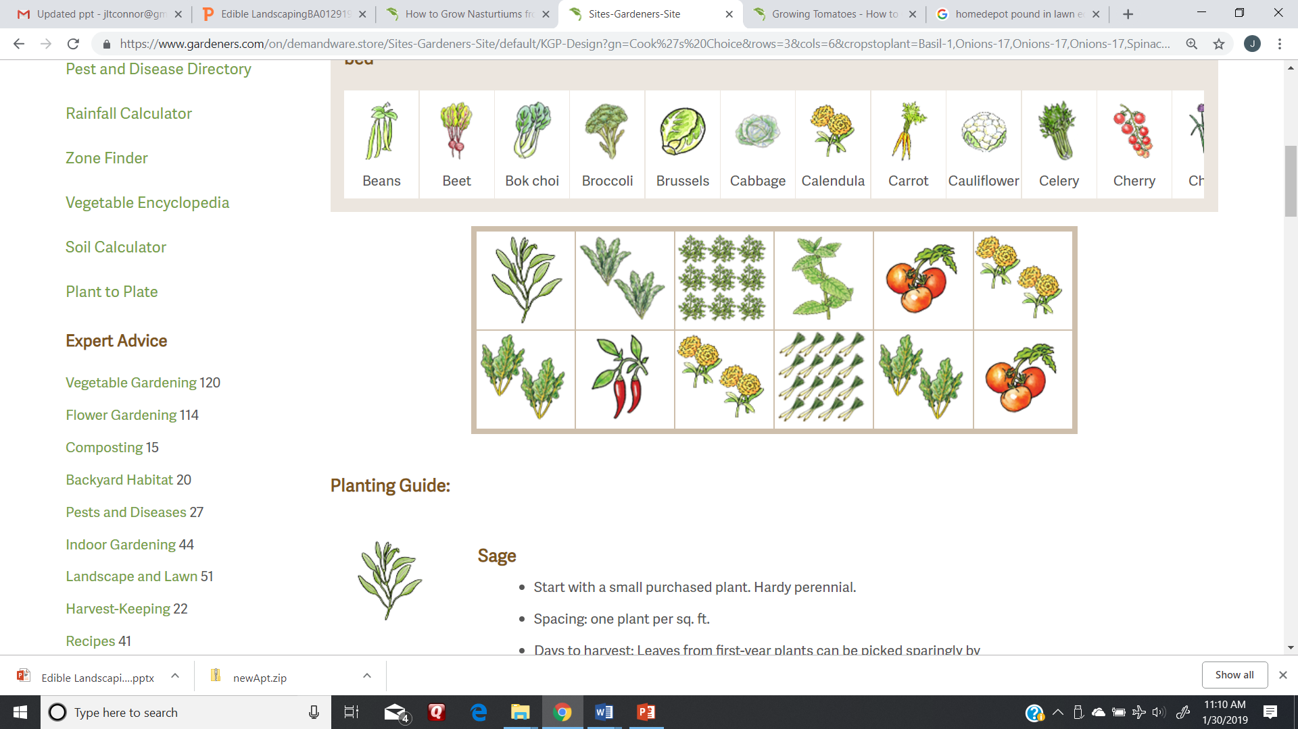

For help (Master Gardeners hotline): http://mbmg.ucanr.edu/hotline/
For class handouts, see: http://mbmg.ucanr.edu/Read_An_Article/Class_Handouts/
Web tools for garden plan: https://www.gardeners.com/kitchen-garden-planner/preplanned-gardens
http://survivalgardener.com/2014/12/what-is-companion-planting/
http://marinmg.ucanr.edu/Marin_Master_Gardener_Help_Desk/Leaflet/Companion_planting_in_the_vegetable_garden/

What are your garden goals and budget?
- Time, money and space
- Grow food you like
- Impress your friends
- Enhance property; provide privacy
- Attract wildlife and discourage pests

Containers
- Soil in containers can heat up sooner and cool down faster than garden soil.
- Container’s material affects evaporation and heat retention.
- Wet pots are heavy
- Clean used containers with 10% bleach
- Choose the best size:
  - 24” deep (~10 gallon) for most tomatoes and squash
  - 18” deep (5-gallon) for peppers, eggplants, small tomatoes
  - 12 – 16” pots are fine for herbs, carrots, beets, lettuce
Consider your site:
- Orientation: sun and shade
- Microclimates, slopes, wind
- Water availability
- Soil properties
- Drainage
- Hardscape
- Known pests and foot traffic
- Neighbors
- Compatibility with natural landscape

Betsy Allen’s 100 sq ft garden plan
