Vertebrate Pest Council
Walter E. ‘Howdy’ Howard Lifetime Achievement Award
Guidelines for Conducting the Selection Process

Introduction

This award has been established to acknowledge the tremendous lifetime contributions of individuals in the Vertebrate Pest Management profession. Potential candidates include scientists, agency personnel, educators, program managers, industry personnel, or any other qualified professional; both national and international candidates are equally welcome to apply. Nominees should be considered an expert in the field of vertebrate pest management and should have been an attendee/participant at several to numerous Vertebrate Pest Conferences throughout their career.

Nomination materials should include:
- a nomination letter highlighting the nominee’s greatest contributions,
- a Curriculum Vitae (CV), and
- three letters of support from professionals familiar with the nominee’s accomplishments.
Applicants can be self-nominated or nominated by colleagues. The submission deadline should be four months prior to the conference date (around November 1). Nominations should be submitted to the Awards Committee Chair.
Procedures for Committee Chair

- Provide the Program Chair an advertisement for the First Call for Papers. A long-form draft document from which to build from is available in Attachment 1. Subsequent advertisements should occur as necessary and should be sent by email using a longer, more complete format.
- Select Award Committee Review Panel.
  - The panel should include five members as follows:
    - Conference Chair
    - 1 Executive Board Committee member
    - 1 Council at-large Committee member
    - 1 Non-council member from academia
    - 1 Non-council member from a non-academic position
- Selection Committee Term
  - Conference chair rotates off Committee at each conference cycle
  - Additional members serve two award cycles, but must be staggered to maintain some continuity of committee members among award periods. Addendum contains a running list of past committee members.
  - A current nominee cannot serve on the award committee.
- Award will be presented by a qualified Council member based on their knowledge of the award recipient. This will be designated by the Conference Chair.

Nomination review panel considerations:
- Areas of excellence should include one or more of the following categories:
  - Advancement or development of management tools used to minimize damage or conflict caused by vertebrate pests, with a special emphasis on environmentally safe methodologies.
  - Advancement in undergraduate and graduate education in vertebrate pest management and associated disciplines.
  - Implementation of effective and innovative outreach efforts focused on the safest, most efficacious, and most cost-effective strategies for vertebrate pest management; targeted groups could include agency personnel, pest control professionals, and private citizens.
  - Effective fostering of education and research programs on vertebrate pest management.
  - Effective oversight of large management or regulatory programs designed to coordinate vertebrate pest management activities among regulatory agencies, non-governmental organizations, and/or private citizens.
  - Any other area associated with research, education, and management of damage or conflict caused by vertebrate pests that showcases excellence at the highest level.
- Each panel member should complete a Nominee Ranking sheet (Attachment 2) for each nominee prior to the selection conference call. Ranking nominees occurs as follows:
  - The ranking process should begin with each panel member reporting their numerical scores to the Committee Chair.
  - Ranking is then opened up to discussion and panel members are allowed to change their initial ranking if desired.
  - Committee Chair summarizes the discussion by repeating the final ranking of the panel (Attachment 3).
    - More than one award can be awarded, but discouraged after the 2020 conference.
  - Panel members must submit it to the Awards Committee chair after the selection conference call.

Award Process Timeline

Time from  Meeting | Approximate Date  (2019-2020) | Action
38 weeks  (9.5 mo.) | June 3 | Announce Award in the 1st Call for Abstracts and post on website
29 weeks  (7.25 mo.) | August 5 | First Call for Nominations (Attachment 1), Advertise by: Email VPC mailing list, universities, government, non-government entities
25 weeks  (6.25 mo.) | September 2 | Second call for nominations
21 weeks  (5.25 mo.) | September 30 | Announce Award in the Preliminary Program
18 weeks  (4.5 mo.) | October 21 | Email confirming interest in judging
16 weeks  (4 mo.) | November 4 | Nomination deadline, Prepare nomination packages for judges (pdfs of nominations and ranking form (Attachment 2)
15 weeks | November 11 | Distribute nomination packages to judges
11 weeks | December 9 | Conference call among judges to pick winners (Attachment 3)
10 weeks | December 16 | Notify award winners by telephone and letter (Attachment 4)
5 weeks | January 20 | Order trophy and name plate (Attachment 5)
4 weeks | January 27 | Prepare Award Recipient Bios for Final Program (Attachment 6)
0 days | February 24 | VP Conference

Attachment 1. Example Award Announcement

The Walter E. “Howdy” Howard Lifetime Achievement Award

The Vertebrate Pest Council is pleased to announce the formation of The Walter E. “Howdy” Howard Lifetime Achievement Award. This award has been established to acknowledge the tremendous lifetime contributions of individuals in the Vertebrate Pest Management profession. The Lifetime Achievement Award will be presented at the xx^{th} Vertebrate Pest Conference (to be held in location and date), and will include a plaque commemorating the award, complimentary conference registration, travel expenses, and a small honorarium for the award recipient.

Potential candidates include scientists, agency personnel, educators, program managers, industry personnel, or any other qualified professional; both national and international candidates are equally welcome to apply. Nominees should be considered an expert in the field of vertebrate pest management and should have been an attendee/participant at several to numerous Vertebrate Pest Conferences throughout their career. Areas of excellence should include one or more of the following categories:

- Advancement or development of management tools used to minimize damage or conflict caused by vertebrate pests, with a special emphasis on environmentally safe methodologies.
- Advancement in undergraduate and graduate education in vertebrate pest management and associated disciplines.
- Implementation of effective and innovative outreach efforts focused on the safest, most efficacious, and most cost-effective strategies for vertebrate pest management; targeted groups could include agency personnel, pest control professionals, and private citizens.
- Effective fostering of education and research programs on vertebrate pest management.
- Effective oversight of large management or regulatory programs designed to coordinate vertebrate pest management activities among regulatory agencies, non-governmental organizations, and/or private citizens.
- Any other area associated with research, education, and management of damage or conflict caused by vertebrate pests that showcases excellence at the highest level.

Applicants can be self-nominated or nominated by colleagues. Nomination materials should include a nomination letter highlighting the nominee’s greatest contributions, a CV, and letters of support from three professionals familiar with the nominee’s accomplishments. Please submit all necessary documents to XXX by November 1?, 20XX to ensure due consideration for the award to be presented at the XXth Conference.

<<<Include contact details here>>>

Attachment 2. Nomination Review Scoring Sheet

Walter E. “Howdy” Howard Lifetime Achievement Award
Nomination Reviewer Scoring Sheet

Nominee’s Name

Please evaluate each candidate on a scale from 1 to 10 (10 being strongest) in each of the following categories. Written comments supporting your ranking should be provided to the Committee Chair.
Contribution to vertebrate pest/wildlife damage management as a profession.  Reviewer Notes: | Score ____
Participation and/or support of the Vertebrate Pest Conference  Reviewer Notes: | Score ____
Include a written narrative of the nominee’s strengths and weaknesses related to the award.

Nominee’s Name

Please evaluate each candidate on a scale from 1 to 10 (10 being strongest) in each of the following categories. Written comments supporting your ranking should be provided to the Committee Chair.
Contribution to vertebrate pest/wildlife damage management as a profession.  Reviewer Notes: | Score ____
Participation and/or support of the Vertebrate Pest Conference  Reviewer Notes: | Score ____
Include a written narrative of the nominee’s strengths and weaknesses related to the award.

Attachment 3. Reviewer ranking Tally Sheet

Nominee | Panel Representative
Nominee | Conference Chair | Executive Board member | Council at-large member | Non-council member from academia | Non-council member from a non-academic position
Name
Name
Name
Name
TOTAL

Written Comments on Panel Discussion
Attachment 4. Example letter of congratulations to the recipient. NOTE: This should be printed and hand signed on current VPC letterhead.

Date

Recipient’s Name
Title
Affiliation
Affiliation Mailing Address

Dear Recipient,

As Chair of the Vertebrate Pest Council (VPC) I would like to congratulate you on being selected to receive the VPC’s ‘Walter E. ‘Howdy’ Howard Lifetime Achievement Award for Excellence in Vertebrate Pest Management’. This award is presented to you for your commitment to the Vertebrate Pest Conference and our profession over the past 40 years; the Council and I are very excited to be awarding it to you.

The award will be presented on date, during the Plenary Session of the XXth Vertebrate Pest Conference being held at the conference location. The VPC will reimburse you for your expenses associated with your travel to the conference. Add name of VPC Business Manager will be contacting you for further details on travel and the awards ceremony.

I want to congratulate you again and also thank you for the dedication and service you have given to the development of the Council and our profession. You are truly one of the leaders in our profession.

I am looking forward to seeing you at the conference.

Sincerely,

Name of Council Chair
Chair

Attachment 5. Source and model of individual Recipient trophy.

Craft Trophy
508 North Link Lane
Fort Collins, CO 80254
970-482-1158
Info@crafttrophy.com

Airflyte, P2303, perpetual Plaque with 36 individual plates | 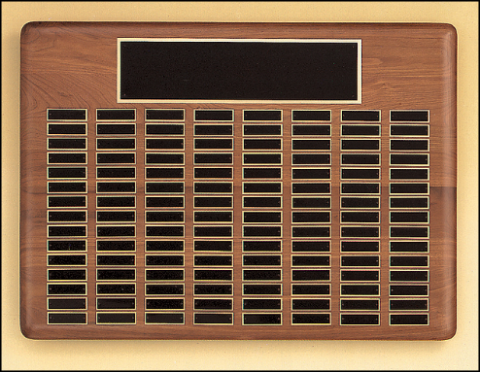
Airflyte, K9181, 5.25” x 9” Crystal/glass | 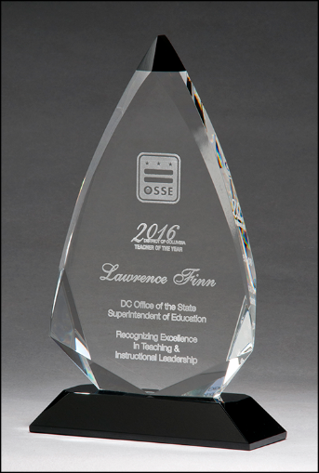

Attachment 6. Example of the announcement to be used in the conference final program

Walter E. ‘Howdy’ Howard Lifetime Achievement Award
for Excellence in Vertebrate Pest Management

The Vertebrate Pest Council is pleased to announce the presentation of first Walter E. “Howdy” Howard Lifetime Achievement Award. This award has been established to acknowledge the tremendous lifetime contributions of individuals in the Vertebrate Pest Management profession.

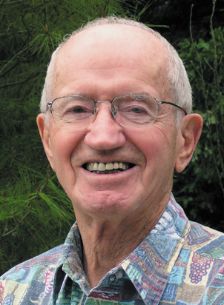
Walter E. ‘Howdy’ Howard
The Walter E. “Howdy” Howard Lifetime Achievement Award is named after a true pioneer and pillar in the vertebrate pest control profession. Born in 1917, Howdy’s love for biology began as a young child. He graduated from U.C. Berkeley, served three years during WWII, primarily focusing on disease and parasite control, and completed his M.S. and PhD at the University of Michigan. He joined the faculty at U.C. Davis in 1947 as professor of Wildlife Ecology. During his lifelong tenure at Davis, he developed the field of vertebrate ecology including vertebrate pest control, making UC Davis a premier international research and teaching institute in this field. His research focused on rodents impacting agriculture and public health, predators especially coyotes and the politics of dealing with wildlife-human conflicts. He was committed to making state and federal agencies good stewards of wildlife populations and their habitats, and that the political structure ensures wildlife populations and humans coexist. Howdy is especially known for his perspective on the balance of nature and his direct challenge of the arguments posed by groups who are opposed to controlling wildlife populations. Howdy’s impact on our profession and personal legacy live on today through the 44 Ph.D. and M.S. students he advised and mentored at U.C. Davis and the countless professionals influenced by his personal interactions and writing. It is with great honor that we name this award after Howdy.

Recipient’s Name
300 word or less bio of the recipient
Recipient’s Photo Selected by Recipient and formatted the same size as Howdy’s picture

Addendum. Past Panel Members

Year | Panel Representative
Year | Conference Chair | Executive Board member | Council at-large member | Non-council member from academia | Non-council member from a non-academic position
2018 | John Eisemann | Roger Baldwin | Ed Duarte | Nicki Frey  (Berryman Inst.) | Wendy Anderson (Wildlife Services)
2020 | Stella McMillin
2022
2024
2026

