
Workshop on Maintaining and Improving Rural Roads

November 30, 2017
8:00 a.m. – 5:00 p.m.
Sly Park Recreation Area Events Center
Pollock Pines, CA
Map to Event Center from Pollock Pines

Agenda:
8:00-8:15 Registration

8:15-8:30 Introductions (Mark Egbert, Richard Harris)

8:30-9:00 Fundamentals of Rural Roads (Richard Harris)

9:00-9:30 Rural Roads and Emergency Access (Tom Tinsley)

9:30-9:45 Break

9:45-10:30 Diagnosing Road Related Problems (Richard Harris)

10:30-11:15 Solving Road Drainage Problems (Gordon Keller)

11:15-11:45 Shallow Slope Stabilization and Erosion Control (Gordon Keller)

11:45-12:00 Key Winterizing and Storm-proofing Measures (Gordon Keller)

12:00-12:30 Lunch (bring your own)

12:30-4:00 Field Trip

4:00 Adjourn
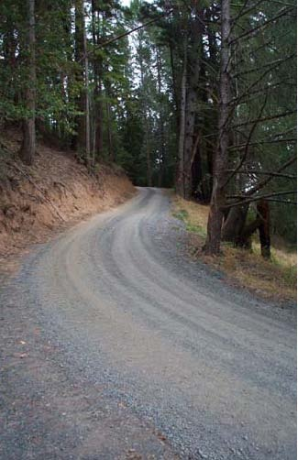

Sponsored by:
Northern California Society of American Foresters, Georgetown Divide and El Dorado County Resource Conservation Districts, UC Cooperative Extension; El Dorado Irrigation District.

Support for this program has been provided in part by USDA-Forest Service, State and Private Forestry.

Remember to bring your lunch and dress for the weather. The field trip will involve short easy walking. Please let us know if you have any special needs. Contact Mark Egbert at (530) 295-5633 or Richard Harris at (707 685-5508

Links to Useful Resources

Keller, G; Sherar, J. 2003. Low-Volume Roads Engineering-Best Management Practices Field Guide. USDA Forest Service, Office of International Programs and US Agency for International Development, Washington, DC. 158 p. (Also available in Spanish, Portuguese and French)
[Online] http://pdf.usaid.gov/pdf_docs/Pnadb595.pdf

Keller, G.; Ketcheson, G. 2015. Storm Damage Risk Reduction Guide 1277-1814—SDTDC. San Dimas, CA: U.S. Department of Agriculture, Forest Service, San Dimas Technology and Development Center. 230 p.
http://www.fs.fed.us/t-d/pubs/pdfpubs/pdf12771814/pdf12771814dpi100.pdf
or for the option of a high-resolution version, go to:
http://www.fs.fed.us/eng/php/library_card.php?p_num=1277%201814

Updated Handbook for Forest, Ranch and Rural Roads download at www.pacificwatershed.com

See stream crossing design handbook at http://calfire.ca.gov/resource_mgt/downloads/100%20yr%20revised%208-08-17%20(final-a).pdf

See DANR publications at http://anrcatalog.ucdavis.edu. Search on “road management”

See multi-session webinar series on rural roads at http://ucanr.edu/sites/forestry/webinars/rural_roads_webinar_series/

