2017 Alfalfa and Forage Field Day
Wednesday, September 20, 2017
Kearney Agricultural Research and Extension Center
9240 S. Riverbend Ave., Parlier, CA 93648

7:30 AM Registration

8:00 TRAM LEAVES FOR FIELD TOUR
- Alfalfa Varieties for Pest and Disease Management – Shannon Mueller, Agronomy Advisor and County Director, UCCE Fresno
- Remote Sensing in Sorghum to Phenotype Drought Stress – Jeffery Dahlberg, Director at Kearney Agriculture Research & Extension Center
- Sub-Surface Drip Irrigation Alfalfa Management – Daniel Putnam, CE Agronomy & Forage Specialist, UC Davis
9:15 TRAM RETURNS

9:20 Managing Weeds in Agronomic Crop Rotations – Kurt Hembree, Weed Management Farm Advisor, UCCE Fresno

9:40 Alfalfa Weevil Management – Rachael Long, CE Agronomy & Pest Management Advisor, UCCE Sacramento, Solano, & Yolo Counties

10:00 Managing Sugarcane Aphid in Forage Sorghum – Nicholas Clark, CE Agronomic Cropping Systems & Nutrient Management Advisor, UCCE Kings, Tulare, & Fresno Counties

10:20 Irrigation & Nitrogen Fertility Management in Forage Sorghum & Corn – Robert Hutmacher, CE Specialist, UC Davis, & Director of West Side Research & Extension Center

10:40 Break

11:00 Irrigation Systems and Salinity Management in Forage Production– Daniel Munk, CE Agronomy & Irrigation Advisor, UCCE Fresno

11:20 Low Lignin Alfalfa & GMO vs. Conventional Varieties for Export – Dan Putnam, UC Davis

11:40 Optimizing Surface Irrigation in High Flow Systems – Marsha Campbell-Matthews, CE Agronomy Advisor Emeritus, UCCE Stanislaus

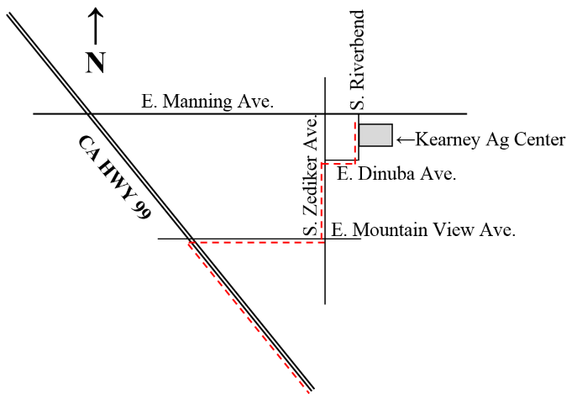
12:00 PM Lunch Sponsored by Bayer Crop Science

Approved DPR CEU: 1.5 hours of Other
Approved CCA CEU: NM 0.5, SWM 1, IPM 1, CM 1.5 (4 total)

Thanks to our sponsors: Netafim, Verdegaal Brothers Inc., & BASF

For more information, contact:
Nicholas Clark
(559) 852-2788
neclark@ucanr.edu

Nonprofit Org
US Postage Paid
Visalia CA 93277
Permit No. 240
University of California
Cooperative Extension
Tulare County
4437B S Laspina St
Tulare CA 93274-9537

Field Crop & Nutrient Notes
August 2017
Nicholas Clark
Area Farm Advisor - Kings, Tulare & Fresno Counties
Field Crops & Nutrient Management
neclark@ucdavis.edu
559-852-2788

It is the policy of the University of California (UC) and the UC Division of Agriculture & Natural Resources not to engage in discrimination against or harassment of any person in any of its programs or activities on the basis of race, color, national origin, religion, sex, gender, gender expression, gender identity, pregnancy (which includes pregnancy, childbirth, and medical conditions related to pregnancy or childbirth), physical or mental disability, medical condition (cancer-related or genetic characteristics), genetic information (including family medical history), ancestry, marital status, age, sexual orientation, citizenship, or service in the uniformed services (as defined by the Uniformed Services Employment and Reemployment Rights Act of 1994 [USERRA]), as well as state military and naval service. This policy is intended to be consistent with the provisions of applicable state and federal laws and University policies. University policy also prohibits retaliation against any employee or person in any of its programs or activities for bringing a complaint of discrimination or harassment pursuant to this policy. This policy also prohibits retaliation against a person who assists someone with a complaint of discrimination or harassment, or participates in any manner in an investigation or resolution of a complaint of discrimination or harassment. Retaliation includes threats, intimidation, reprisals, and/or adverse actions related to employment or to any of its programs or activities. In addition, it is the policy of the University and ANR to undertake affirmative action, consistent with its obligations as a Federal contractor, for minorities and women, for persons with disabilities, and for covered veterans. The University commits itself to apply every good faith effort to achieve prompt and full utilization of minorities and women in all segments of its workforce where deficiencies exist. These efforts conform to all current legal and regulatory requirements, and are consistent with University standards of quality and excellence. In conformance with Federal regulations, written affirmative action plans shall be prepared and maintained by each campus of the University, including the Division of Agriculture and Natural Resources. Such plans shall be reviewed and approved by the Office of the President and the Office of the General Counsel before they are officially promulgated. Inquiries regarding the University’s nondiscrimination policies may be directed to Linda Marie Manton, Affirmative Action Contact, University of California, Agriculture and Natural Resources, 2801 Second Street, Davis, CA 95618, (530) 750-1318.

