

CHUALAR 4-H
ROLLER SKATING PARTY
FRIDAY, APRIL 7TH
6:30 PM – 8:30 PM
WATER CITY SKATE
2801 2nd Ave, Marina
[



Bring a new Teddy Bear
Teddy Bears for Hearts- As a community service project; we will be collecting new teddy bears for the Monterey County Sheriff Department.
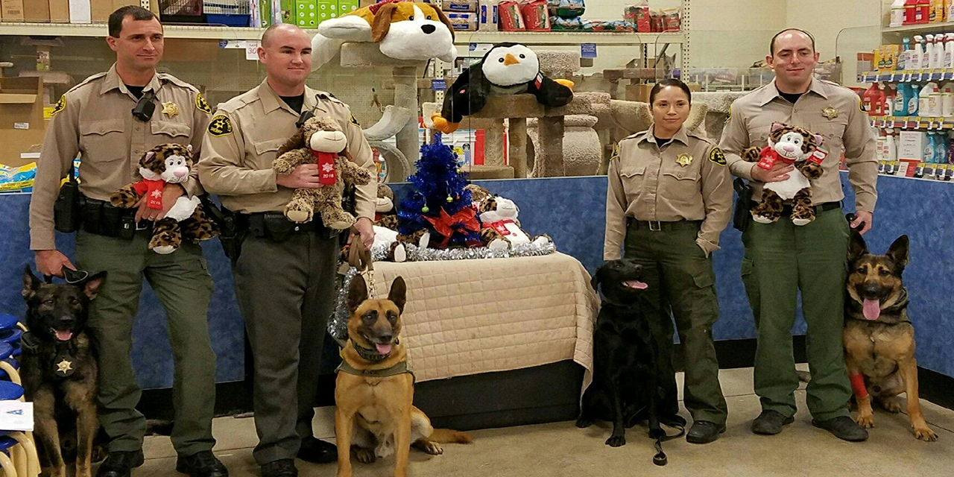

Includes skate rentals, skating, pizza, dessert, & beverage
Cost: $4 per 4-H member & non-skaters
$10 for parents and Non 4-H siblings
4-Hers don’t forget your medical release forms.
Please RSVP to tracy24246@aol.com
DenaJenkinson@sbcglobal.net
Or update via invitd app

It is the policy of the University of California (UC) and the UC Division of Agriculture & Natural Resources not to engage in discrimination against or harassment of any person in any of its programs or activities (Complete nondiscrimination policy statement can be found athttp://ucanr.edu/sites/anrstaff/files/169224.pdf) Inquiries regarding ANR’s nondiscrimination policies may be directed to Linda Marie Manton, Affirmative Action Contact, University of California, Davis, Agriculture and Natural Resources, 2801 Second Street, Davis, CA 95618, (530) 750-1318.

