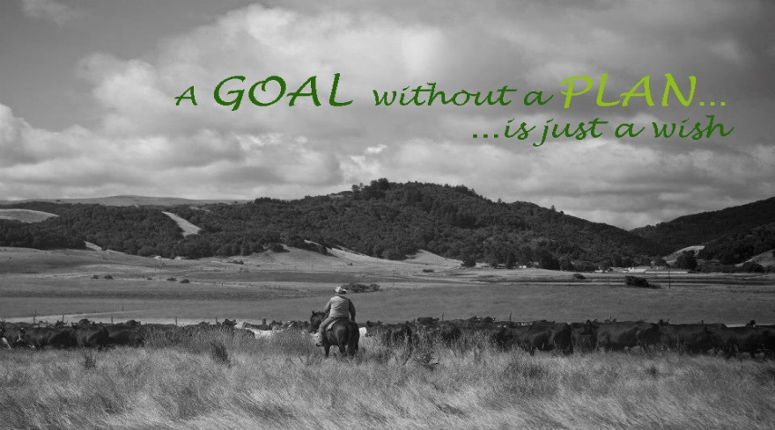
It’s Time to Make a Plan
Draft Agenda
November 16-17, 2016
Lucchesi Center, Petaluma
Day 1

8:30am | Registration and coffee
9:00am | Welcome - David Lewis, UCCE and Steve Kinsey, Marin County Supervisor
9:15am | Taking Inventory & Identifying Crucial Conversations; Succession vs. Estate planning - Dick Wittman
12:00pm | Lunch Break
1:00pm | Case Study Exercise Phase I - Dick Wittman
2:00pm | Estate tax Principles and Structuring Options For Successful Family Business Traditions - Paul Neiffer, CPA, Clifton Larson Allen
3:00pm | Managing Personality Styles and Family Meetings, Enhancing Succession Planning Communications  - Cori Wittman
4:00pm | Case Study Exercise Phase II - Dick Wittman
5:00pm | Social hour, networking, and informal Q & A with speakers

Day 2

8:30am | Coffee
9:00am | Welcome – David Lewis, UCCE
9:15am | Legal Issues and Strategies for Successful Family Business Transitions - Shannon Ferrell
10:30am | Case study review - Dick Wittman
11:30am | Speaker Q&A session, workshop presenter’s field general questions from audience participants
12:30pm | Lunch Break
1:30pm | Actionable Steps for Building a Succession and Estate Plan - Dick Wittman

