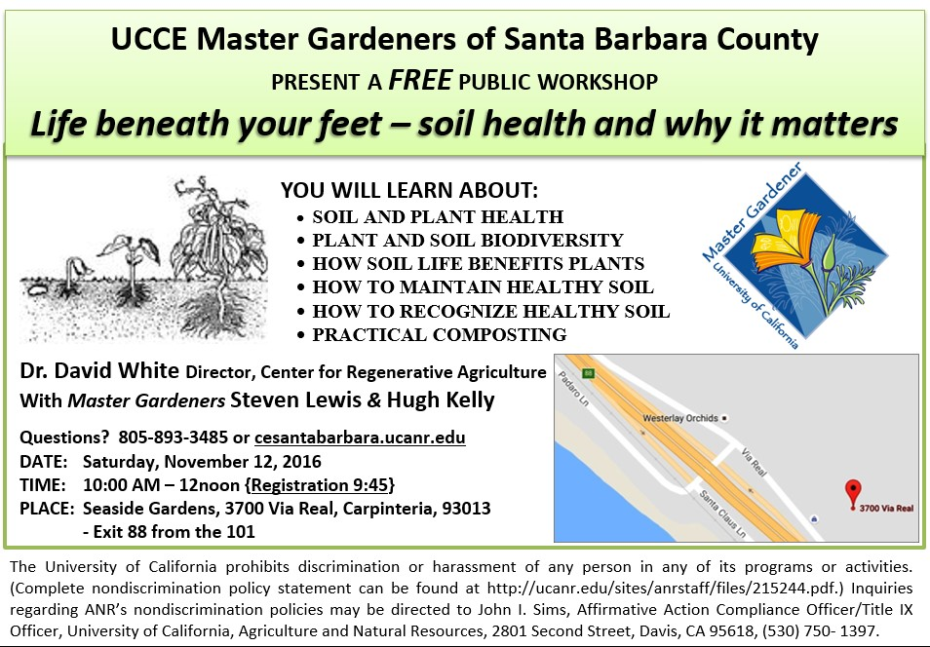
Flyer

Master Gardeners
UCCE Master Gardeners of Santa Barbara County are volunteers who are trained to provide science-based information, workshops, and educational programs for home gardeners. Resources offered by Master Gardeners include plant and pest identification, best practices for problem-solving, soil health and compost production, and cultural guidelines for growing a wide variety of edible and ornamental plants suitable to Santa Barbara County.

Workshop
This two-hour workshop introduces the theory and practice of soil health for home gardeners.
Participants will learn:
- Why the USDA proclaims that “A good soil is a live soil”.
- The essential functions performed by healthy soil.
- The extent to which plant health is dependent on soil health.
- How to maintain soil health.
- How to recognize healthy soil.
- What the Soil Food Web is, and why it matters.
- Where to find more information about soil health.

Presenters
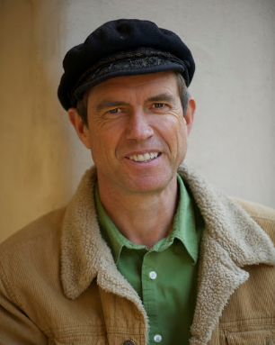
Dr. David White, PhD, is Director of the Center for Regenerative Agriculture, with over 25 years’ experience working with environmental groups throughout Ventura County. David also directs environmental education for the Food for Thought Ojai's Healthy Schools program and coordinates garden and farm-based learning programs for over 20 schools in Ventura County.

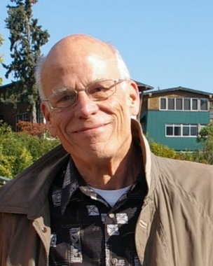
Steven Lewis, grew up in Southern California and has lived in Santa Barbara since 1970. He joined Master Gardeners in 2011 after retiring from careers at Santa Barbara Harbor and Santa Barbara City College. Master Gardening has given him the opportunity to continue learning and teaching home horticulture.

Hugh Kelly, is the Founder and Project Director of permEzone, a non-profit program training and supporting farmers in less-developed countries. He moved from England to Santa Barbara in 2010, and joined the Master Gardeners in 2014. He is President of the non-profit Mesa Harmony Garden which is an approved project of the Master Gardeners.
