
Curriculum Description and Evidence-Base

EatFit (Grades 6 to 9) is a goal setting nutrition and physical activity curriculum designed to challenge middle school students to improve eating and fitness choices. This program uses computer technology to assist with diet assessment and guided goal setting for making healthy lifestyle choices. EatFit contains nine hands-on lessons consisting of skill building activities and social support to help students reach their goals.

The Lessons
The EatFit curriculum featuring nine nutrition and fitness lessons was developed to help students develop critical thinking skills in service of making better food and exercise choices. It is based on Bandura’s successful application of Social Cognitive Theory to change health behaviors. All activities are hands-on and interactive providing exciting experiences for adolescents. The lessons also support California common core state standards for middle school students and other learners.
This curriculum provides student feedback on personal eating and physical activity in the form of printed personal analyses. Students have the freedom to select from a menu of eating and physical activity goals. Using current nutrition and physical activity research, the following is the EatFit menu of guided goal options.


Guided Eating Goals:
- Improved eating habits
- Increased dairy and calcium intake
- Increased fruit and vegetable intake
- Increased healthy protein intake
- Decreased saturated fat intake
- Decreased added sugar intake
Guided Physical Activity Goals:
- Increased aerobic activity
- Improved lifestyle activity
- Increased strength activity
- Increased flexibility activity
Lesson Titles and Focus
- EatFit Foundation Provides students with the fundamental concepts of nutrition and fitness.
- What Are You Eating? Engages students with immediate feedback on current eating patterns and then challenge them to focus on the habits that need the most improvement.
- Get Psyched for Fitness Demonstrates fitness activities and their benefits to help students choose areas for improvement and assists with selection of a fitness goal.
- Energy Demonstrates the connection between exercise and food.
- Food Label Facts Highlights the parts of the label that coincide with their goals and how to choose foods that support them.
- Got Breakfast? Promotes healthy eating habits at breakfast to help gain confidence in their ability to control food choices, making them more likely to succeed in improving eating behaviors.
- BodyWork Emphasizes incorporating various activities into one’s lifestyle to develop self-confidence and increase odds of continuing activities after the completion of the program.
- EatFit@FastFood Guides the choices students make at restaurants to help reach nutrition goals.
- Screen Time Training Raises awareness of the content and intention of the media which can influence food choices.

Curriculum Components

Component | Description
Social Cognitive Theory (SCT) | The theoretical framework upon which the curriculum is based. Three major SCT constructs are applied in EatFit: self-efficacy, outcome expectancies, and self-regulation. Curriculum strategies used to achieve self-efficacy and behavior change include modeling, contracting, goal setting, skills mastery, rewarding, barrier counseling, cue management, relapse prevention, and cognitive restructuring.
California Common Core State Standards | The lessons align to California Common Core State Standards in Math and English Language Arts adopted by the California Department of Education in 2010.
California Content Standards | The lessons align with Physical Education Model Content Standards for California Public Schools adopted by the California State Board of Education in 2005 and Health Education Content Standards for California Public Schools adopted by the California State Board of Education in 2008.

Guided Goal Setting | Improving eating and fitness habits is difficult. Goal setting directs attention to the task or new behavior. It identifies personal motivators and then targets self-efficacy by practicing selected tasks. Goal setting is a powerful behavior change technique. Goal attainment is promoted using skill building experiences, tracking, rewards and social support. Goal setting is a practical and accessible life skill with many applications beyond nutrition. Guided goal setting was developed for, and introduced in, EatFit.
Eating Analysis | Students have an opportunity to track eating. They enter their 24-hour food record into an on-line analysis. A youth- focused program responds with an analysis. It then provides feedback to students on those areas where they are doing well and where they need to make improvements. Many familiar foods, popular with adolescents, were added into this adaptation of the USDA foods database.
Community Involvement | Involvement opportunities include parental participation, support from schools and/or nonprofit organizations, and peer support.

EatFit Package

Teacher Curriculum/Guide:  - Introduction  - 9 lessons  - Workbook answer sheets  Student Workbook:  - Full color magazine style workbook for each students (20 pages) that includes all “handouts”  www.eatfit.net Website:  - EatFit eating analysis for students featuring “guided” goal setting. |   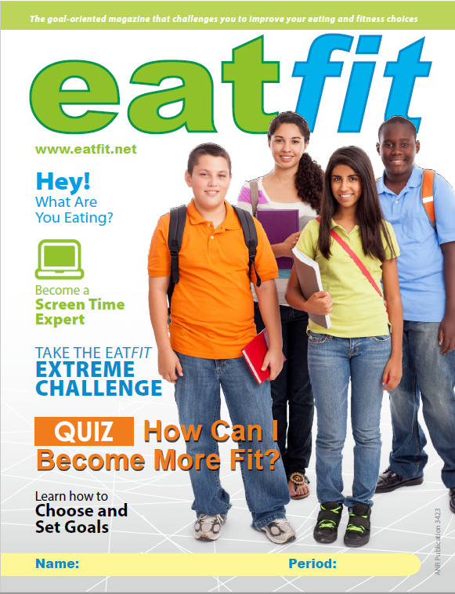  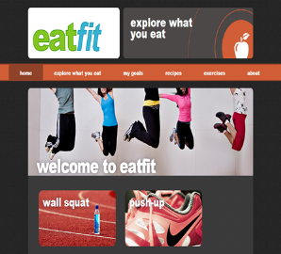

Awards

- Dannon Institute Award: EatFit is the recipient of the distinguished Dannon Institute Award (2003) for Excellence in Community Nutrition. The program was evaluated using four criteria: innovation/creativity, replicability, theory base, and evaluation data.

- National 4-H Curriculum “Nationally Reviewed and Recommended”: In September 2002, the National 4-H Curriculum Jury determined that the EatFit curriculum fully met the fourteen National 4-H Criteria for Youth Development. It was published in the October 2002 Abstracts and made available at the National 4-H Agents Association Conference at Norfolk, VA.

- Western Extension Director’s Award of Excellence for 2011 for “Eatfit: health promotion for adolescents.” The award was presented at the Western Regional Meeting of Land Grant University Agriculture Deans, Agriculture Extension Directors and Directors Agriculture Experiment Stations.

Research Results

To assess the effectiveness of EatFit, 46 students participated in a crossover, controlled field trial. Results show that the intervention promotes positive changes in dietary behaviors and physical activity self-efficacy. Participants reported high goal commitment, evidence that the goal setting procedures were well accepted. 10

To investigate the effectiveness of the guided goal setting component of EatFit, 94 students participated in a randomized controlled field trial. The addition of the guided goal setting component to this nutrition and physical activity intervention for middle school students improved students’ dietary behaviors, physical activity self-efficacy, and physical activity behaviors as compared to the same intervention without goal setting. We assessed treatment participants’ goal commitment as well as control participants’ spontaneous goal setting to investigate the true impact of guided goal setting. The observed spontaneous goal setting was in itself significant in that the goals did not contain important goal attributes, known to increase goal effectiveness - specific, proximal, difficult, and attainable. Guided goal setting ensures that selected goals contain desired attributes for effectiveness while allowing adolescents to select their own goals. In both studies, the target population is low income, ethnically diverse, male and female, 7th and 8th grade students. Details on these research projects may be found, along with other EatFit materials, at http://efnep.ucanr.edu/ . 2,8

To assess the impact of EatFit on academic performance, 84 students participated in a quasi- experimental crossover-controlled study. Results show changes in total scores were statistically different, with treatment scores generating more gains. Using standardized tests, results of this pilot study suggest that EatFit can improve academic performance measured by achievement of specific mathematics and English Language content standards. School administrators and wellness committee members can be assured that this program can positively impact academic performance in math and language arts, while promoting healthful eating and physical activity. 9

To evaluate impact on education content standards and academic performance, an outline of an 8-step process was created. This process could be used with any curriculum.
References to specific materials in the article are meant as examples. Documenting and promoting standards achievement may be the key to survival of nutrition education programs in schools. This 8-step process could be duplicated by nutrition education practitioners evaluating their program’s impact on education content standards, and hence academic performance. 7
- Shilts M, Horowitz M, Townsend MS. Goal Setting as a Strategy for Dietary and Physical Activity Behavior Change: A Review of the Literature. Amer J Health Promotion 2004; 19:81-93.
- Shilts M, Horowitz M, Townsend MS. An Innovative Approach to Goal Setting for Adolescents: Guided Goal Setting. J Nutrition Edu & Behav. 2004; 36:155-156. (Eatfit is the curriculum.)
- Horowitz M, Shilts M, Townsend MS. Eatfit: A goal oriented intervention that challenges adolescents to improve their eating and fitness choices. J Nutrition Edu & Behav. 2004;36:43-44.
- Shilts M, Smith D, Ontai L, Townsend MS. Evidence to support the use of the retrospective pretest method to measure dietary and physical activity behavior and self-efficacy in adolescents. J Youth Development 2008;3 (1): Article 080301RS002. (Eatfit is the curriculum.)
- Horowitz M, Shilts M, Townsend MS. Adapting a Diet Analysis Application for an Adolescent Audience. J Nutrition Edu & Behav. 2005;37:43-44. (www.Eatfit.net is described.)
- Shilts M, Martin A, Townsend M. Dose: Comparison of 6 and 12 Nutrition and Physical Activity Sessions Targeting Middle School Adolescents. J Youth Development. 2009;4(4):Feature Article 090404FA004. Winter issue, 2009. (Eatfit is the curriculum.)
- Horowitz M, Shilts MK, Lamp C, Townsend MS. A standards-driven evaluation of academic performance: an 8-step process for nutrition educators. J Nutrition Edu Behav 2008, 40:401-403. (Eatfit is the curriculum.)
- Shilts MK, Horowitz M, Townsend MS. Effectiveness of guided goal setting in a dietary and physical activity intervention with low-income adolescents. Intl J Adoles Medicine Health: 2009;20(1):111-122. (Eatfit is the curriculum.)
- Shilts M, Lamp C, Horowitz M, Townsend MS. Eatfit impacts academic performance in mathematics and English: a pilot study. J Nutrition Educ Behavior. 2009; 41(2):127-131.
- Shilts MK, Townsend MS. A Goal Setting Intervention Positively Impacts Adolescents’ Dietary Behaviors and Physical Activity Self-Efficacy. J Youth Development. 2012: vol 7 (4) Winter. Article 120704PA001. (Eatfit is the curricul
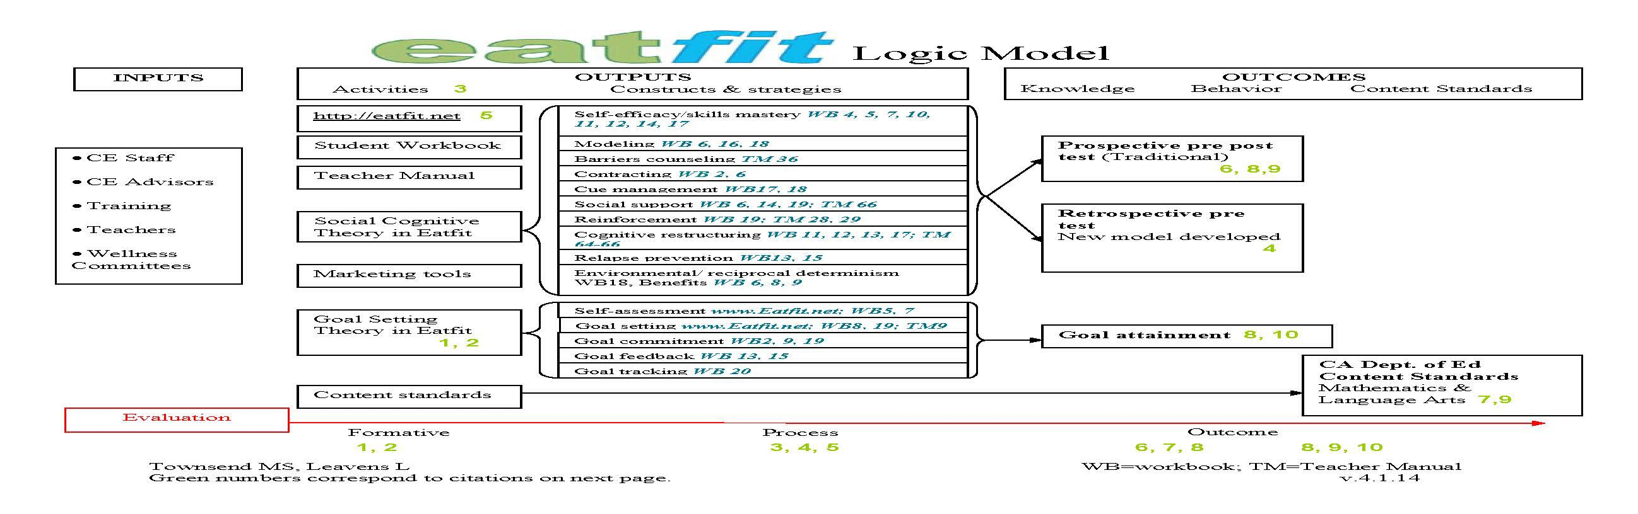

EatFit Funders: University of California Cooperative Extension, Expanded Food and Nutrition Education Program, Food Stamp Nutrition Education Program, UC Davis School/University Partnership, The Center for Advanced Studies in Nutrition & Social Marketing-UCD, University of California Agriculture & Natural Resources, American Distance Education Consortium.

This work is/was supported by the U.S. Department of Agriculture (USDA), National Institute of Food and Agriculture, the Expanded Food and Nutrition Education Program. Any opinions, findings, conclusions, or recommendations expressed in this publication are those of the author(s) and do not necessarily reflect the view of the USDA.

It is the policy of the University of California (UC) and the UC Division of Agriculture & Natural Resources not to engage in discrimination against or harassment of any person in any of its programs or activities (Complete nondiscrimination policy statement can be found at http://ucanr.edu/sites/anrstaff/files/187680.pdf ) Inquiries regarding ANR’s nondiscrimination policies may be directed to Linda Marie Manton, Affirmative Action Contact, University of California, Agriculture and Natural Resources, 2801 Second Street, Davis, CA 95618, (530) 750-1318.

