Santa Barbara County 4-H GIS Project: Building a UCSB Scavenger Hunt

This project is aimed at teaching participants about geographic information systems (GIS) through the creation of a scavenger hunt on the UCSB campus. In the process participants will hone their map reading skills, collect spatial data using a GPS receiver, and finally put all the elements together to create a map and scavenger hunt from their own imagination!


Who may participate?
Santa Barbara County 4-H Club members, ages 11 to 19
Limited to 24 participants – so sign up soon!

When?
February 1, 8, and 15 (Saturdays) from 2-5 pm

Where?
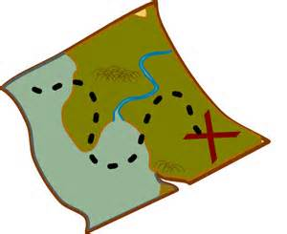
UCSB Campus, Ellison Hall, Room 2620
(We will be inside and outside - so dress accordingly)

Free of Cost for Santa Barbara County 4-H Members!

Not currently a 4-H Club member, but want to participate?
Join a local 4-H Club! Find a club near you at: http://www.sb4h.org/Club_Websites/. Contact the club leader listed, or 4-H Program Representative Sherry Mills at 805-893-3409 or smmills@ucanr.edu for club enrollment instructions and fees.

Registration Information:
Current 4-H Club members can sign up by adding it to their enrollment in
the Santa Barbara County 4-H online enrollment system https://ca.4honline.com/
**Enroll under Goleta 4-H Club – GIS/GPS: County-wide GIS/GPS **

Questions?
Contact 4-H Program Representative Sherry Mills at 805-893-3409 or smmills@ucanr.edu or 4-H SET Key Leader Kathy Foltz at kathy.foltz@lifesci.ucsb.edu.

The Project Leaders are 4-H Adult Volunteers from the UC Santa Barbara Department of Geography and the Center for Spatial Studies.

It is the policy of the University of California (UC) and the UC Division of Agriculture & Natural Resources not to engage in discrimination against or harassment of any person in any of its programs or activities (Complete nondiscrimination policy statement can be found at http://ucanr.edu/sites/anrstaff/files/169224.pdf )Inquiries regarding ANR’s nondiscrimination policies may be directed to Linda Marie Manton, Affirmative Action Contact, University of California, Davis, Agriculture and Natural Resources, One Shields Avenue, Davis, CA 95616, (530) 752-0495.

