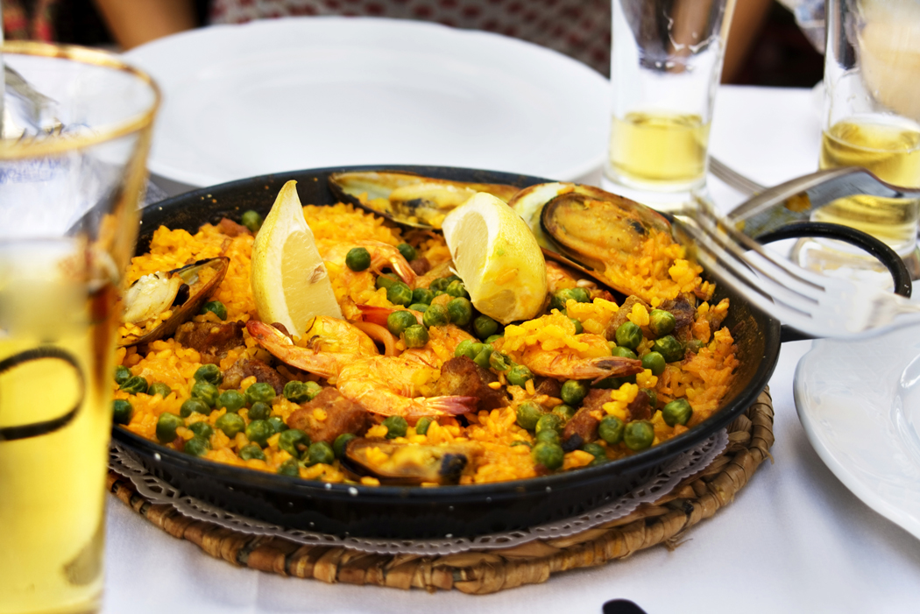
Favorite Foods Day Criteria

Read the attached Favorite Foods Information plus below information-
Categories- Mexican, Italian or American entrée OR if a dessert it must be a healthier dessert.

- On entry form, you need to write your recipe of your favorite food on backside of form. No entries will be accepted without the recipe.
- Prepare your ONE favorite dish and bring it along with the Menu/Cost per serving card to the event to place on the table.
- Provide a sample menu on the yellow or green card and the cost per serving information. This is placed on the table.
- Make sure you have enough for the 3 judges to sample and to share after the judging.
- Remember to keep hot food hot and cold food cold. A microwave or oven will be provided.
- If your favorite food is a tuna sandwich, decorate like a summer picnic, or if it is an ethnic food, use those country’s colors, flag, etc. The table setting should look nice and neat. Use your imagination!
- Bring a card table just incase there is not enough table space.
- Make sure you are tidy with hands clean, hair neat, and wear clothing that reflects the theme of your dish or 4-H uniform.
- Remember you will be asked questions about your dish such as cost per serving, calorie count, recipe, etc. How many times have you made your favorite dish may be asked?
- Have a good time sharing your favorite dish!

