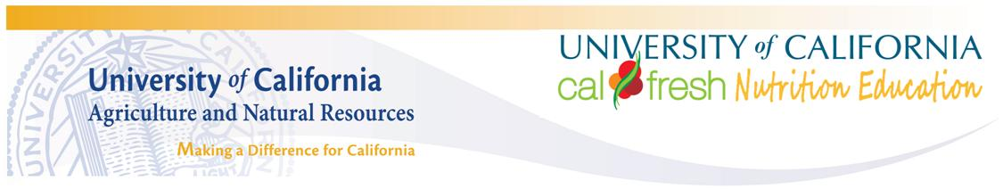

What does nutrition education look like? Anything seen here can be recorded as hours worked providing nutrition education on the Nutrition Activity Reporting Form (NARF). Be creative, have fun, and teach nutrition in a variety of ways! Together we are “Growing Healthy Families!” –UC CalFresh Team
Nutrition Education…

…At Special Events
- Back to School Night, Open House, health fairs, career fairs, school assemblies.
- Nutrition education field trips (do not include travel time).

…With Parents
Teach parents about:
- Starting the day with healthy breakfast.
- Healthy food options for the class.
- Packing a healthy lunch from home.
- Healthy classroom tastings; review Parent Newsletters at conferences.
- Adult classes offered through UC CalFresh.

…Staff Training/Development
- Develop/attend nutrition education events such as workshops, conferences, seminars, trainings.
- Only record time spent on nutrition education.

…Outside A Classroom
- Garden-based nutrition education.
- Cafeteria-based nutrition education activities which are part of a structured program that is connected to classroom instruction.
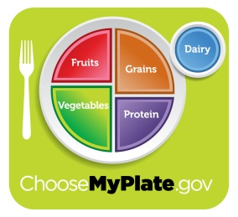
The University of California prohibits discrimination or harassment of any person on the basis of race, color, national origin, religion, sex, gender identity, pregnancy (including childbirth, and medical conditions related to pregnancy or childbirth), physical or mental disability, medical condition (cancer-related or genetic characteristics), ancestry, marital status, age, sexual orientation, citizenship, or status as a covered veteran (covered veterans are special disabled veterans, recently separated veterans, Vietnam era veterans, or any other veterans who served on active duty during a war or in a campaign or expedition for which a campaign badge has been authorized) in any of its programs or activities. University policy is intended to be consistent with the provisions of applicable State and Federal laws. Inquiries regarding the University's nondiscrimination policies may be directed to the Affirmative Action/Staff Personnel Services Equal Opportunity Director, University of California, Agriculture and Natural Resources, 1111 Franklin Street, 6th Floor, Oakland, CA 94607, (510) 987-0096. Funding provided by the United States Department of Agriculture (USDA) Supplemental Nutrition Assistance Program.
Fresno County, 2012. For Additional Resources and Information: Shelby MacNab, (559) 600-7222, smacnab@ucdavis.edu. For more information on the way the University of California Cooperative Extension is building a healthier California, visit cefresno.ucdavis.edu.

…In A Classroom Setting
- Nutrition education lessons/activities from UC CalFresh curriculum or integrated with other subjects e.g. math, language arts, science, social studies.
- As part of healthy cooking or taste testing.
- Use of MyPlate to discuss foods brought into the breakfast and lunch menu.
- Reading books on nutrition/food and followed with activities.
- Artwork, essays, and projects on nutrition.
- Review of the monthly Parent Newsletters.
- Teaching nutrition using computer programs.
- Holiday units e.g. exploring cultural foods, healthy potlucks, healthy choices.
- Plant science e.g. plant parts we eat.
- Farming e.g. where our foods come from.
- Dental health e.g. sugar, calcium.
- Food Safety e.g. hand washing, germs, kitchen safety.
- Healthy eating to support successful state testing.
- How-to select healthy foods in a variety of settings.

…During Physical Activity
Promote increased physical activity as a component of a nutrition education intervention e.g. physical activities or S.P.A.R.K. activities with a nutrition message.

